**EYE Blink detection and Analysis**

Eye blinking analysis is a very important topic in the field of computer vision. It is applied in face/emotion analysis to solve various problems. Blink analysis has a wide range of application in Sleep detection and prevention for safe driving. The proposed method focuses on face and eye detection and calculating the eye blink rate of a person. The detection of eye structure from the facial landmarks in video streams is performed by knowing the indices of particular face parts. Further, the eye aspect ratio is computed using the 6-coordinate system of the eye. The eye aspect ratio (EAR) is approximately constant when the eye is open then rapidly drops to zero and increases again, indicating that a blink has taken place. Depending on the value obtained for EAR, the total number of blinks happened in a particular span of time is computed. This value will be compared to the manual value obtained and further analysis is being performed. This detection can be further used in research fields like drowsiness detection. It can also be applied to calculate the level of attentiveness.

**Technologies used:**

1. Python
2. OpenCV
3. DLIB

**Interface –** Ubuntu

**Pre-Installations –** Python Virtual Environment, OpenCV, DLIB

**Download** (shape_predictor_68_face_landmarks.dat) **–**

<https://drive.google.com/file/d/1NazJ1t0YH9XK_IsyTesrm0RsMItRE09i/view>

**Project Done by:**

1. Swathi R – <https://www.linkedin.com/in/swathir01/>
2. Sivaramakrishnan S - <https://www.linkedin.com/in/srkjs/>
3. Shredha Ganesh
4. Vijey Aditiya

**Screenshots:**

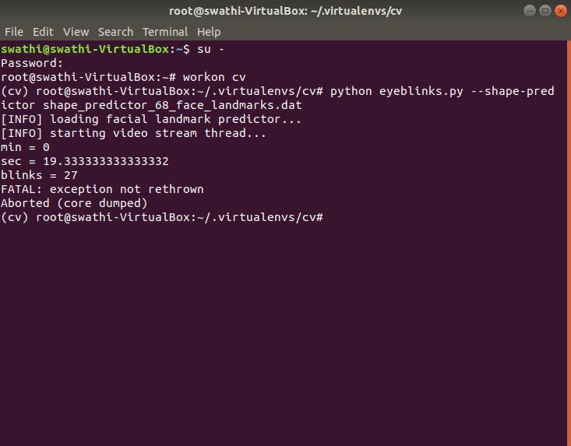Ubuntu Terminal -

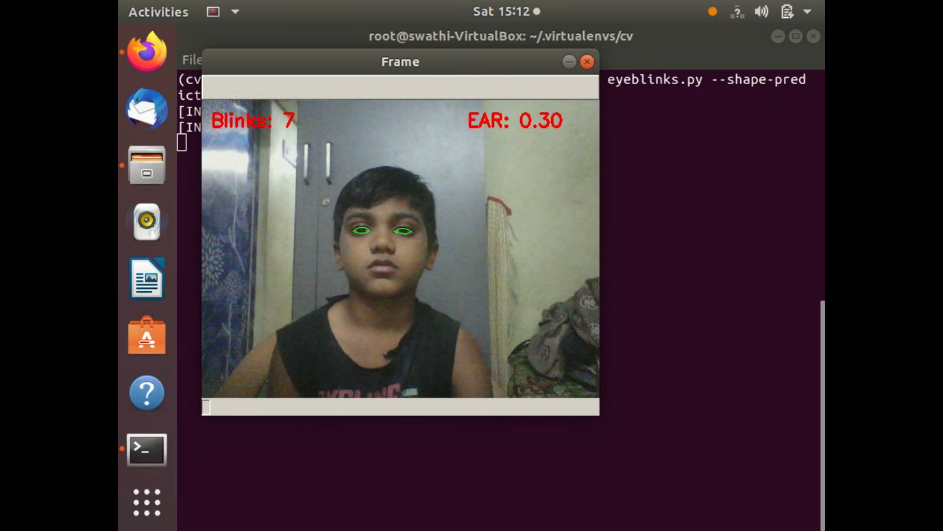Eye Blink Detection –

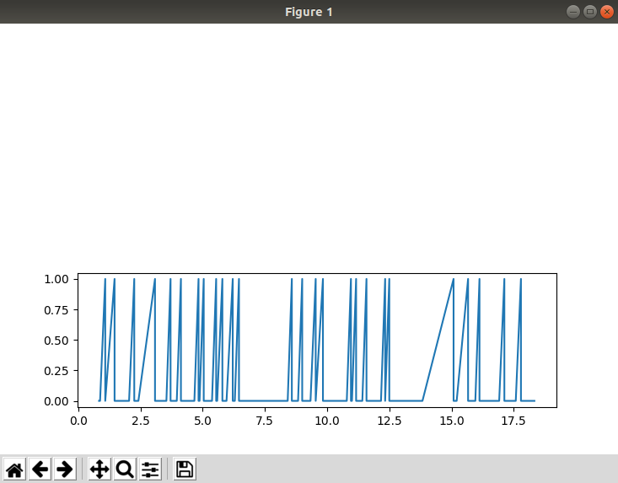Output Graph:

X-axis represents the time in seconds.

Y-axis represents eye blink (Rises to 1.00 when a blink is detected).