CHAPTER 1
INTRODUCTION

1.1 Overview
This project is aimed at developing an online ticket reservation system for Cinema Halls. The Ticket Reservation System is an Internet based application that can be accessed throughout the net and can be accessed by any one who has a net connection. This application will automate the reservation of tickets and enquires about availability of the tickets. This application includes message confirmation for the tickets.
1.2 Existing System
The existing system of an online application has features like booking tickets online, to know the information of the movie(cast and crew information). Customer can view the trailer of the movies. Customers get the confirmation of their booking through an email.
1.3 Proposed System
The proposed system is aimed at enhancing the existing system by enabling the following features.
- The customer will receive the confirmation of booking through message.
- In the existing system to view trailers customer is redirected to youtube but in the proposed system videos have been uploaded so that the video will be available throughout.

1.4 Problem Statement & Scope of the project
Development of a feature rich, online Tickets reservation system for cinema halls.

This system is basically made for providing the customer an anytime and anywhere service for booking the seat in the cinema hall and to gather information about the movies online. The user can easily be able to know about the movies released and then make their choice.
1.5 Mission
The mission of the project is to develop feature rich web application to book tickets online for cinema halls.
1.6 Vision
The vision of this project is to make the application more reliable and flexible for further enhancement or development of the system and addition of new features.
1.7 Objectives
- To allow users & admin to login successfully through the application’s first page.
- The user will be able to gather information about newly released movies and make his/her choice.
- To allow users to book tickets online.

CHAPTER 2
REQUIREMENTS

2.1 Functional Requirements
Following is a list of functionalities of the system.
- A customer should be able to
  - login to the system through the first page of the application
  - change the password after logging into the system.
  - No reservation before one day can be done.
  - See his/her current reservations on different movies along with the details.
  - Able to choose the seats which are available for a certain class.
  - Can select seats from different classes as well for same show and screen also.
  - Give details about the details about the credit card.

- A message should be sent to the concerned customer about the confirmation of the ticket to the specified mobile number.

- The login Id and password should be sent to the mentioned email address if a new account is created.

- The system should automatically show the fare for the corresponding shows and amount of money needs to be paid for selected seats.

2.2 Non-Functional Requirements
Reliability:
This application is a web based application that runs on any device that has a browser. The application should respond within not more than 5 seconds with consistent results.
Availability and Maintenance:
The application will be available for most (99%) of the time and the remaining is held for maintenances.
Security:
The application is secured as it has authorised users and restricted access to data helps in preventing any illegal access or data corruption.
Portability:
Portability is the ability of the system or application that can run in various environments. As the application is web based the application can run on any operating system.
2.3 HARDWARE REQUIREMENTS
- A PC with Processor-Intel i3 core
- RAM :4 GB
- Hard Disk :400 GB free space
2.4 SOFTWARE REQUIREMENTS
- Operating System :Windows XP/7/8/10
- Database :MYSQL
- Database connectivity :JDBC
- Server :Apache Tomcat 5/6
- IDE :Eclipse
- Language used :Java, HTML, JSP
- Scripting Language :JavaScript
- Java Version :JDK 1.6

CHAPTER 3
SYSTEM DESIGN

3.1 DATAFLOW DIAGRAM

Level 0:
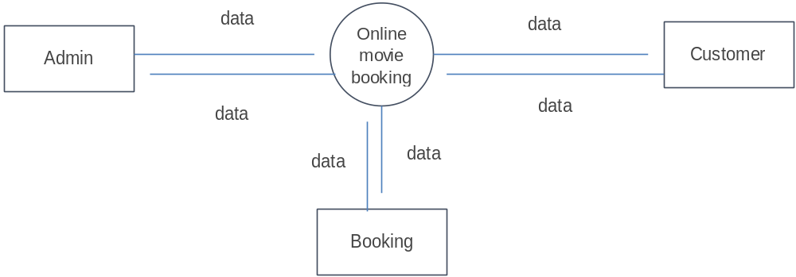 Fig. 3.1: DFD Level 0

Level 1:
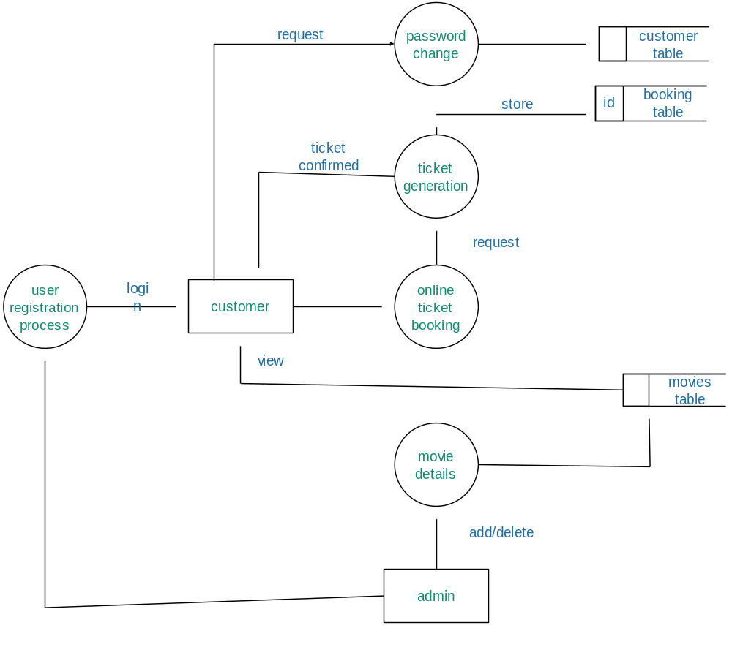
Fig. 3.2: DFD Level 1

3.2 E-R DIAGRAM

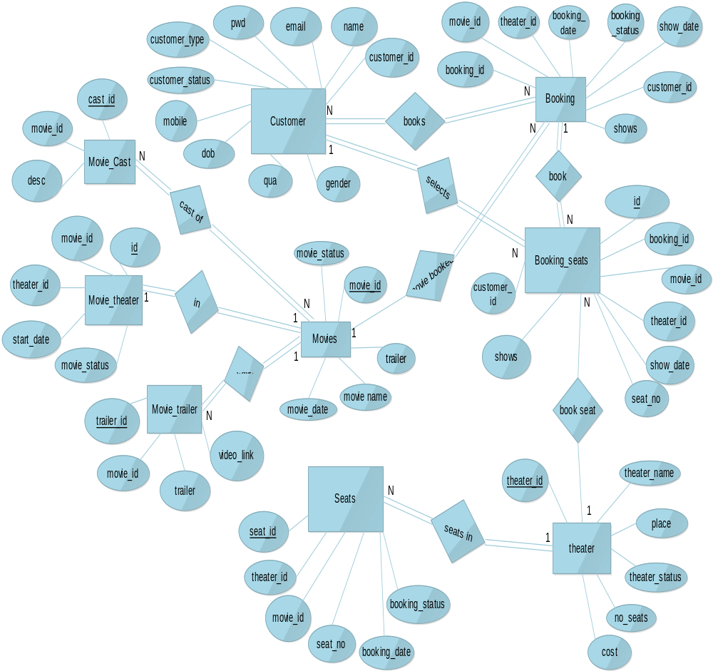
Fig. 3.3: ER-Diagram

3.3 USE CASE DIAGRAM

. 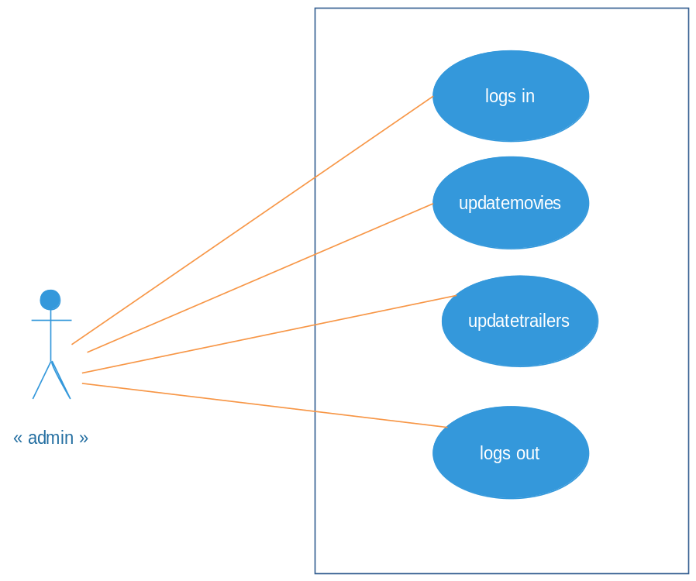
Fig. 3.4: Use Case Diagram For Admin
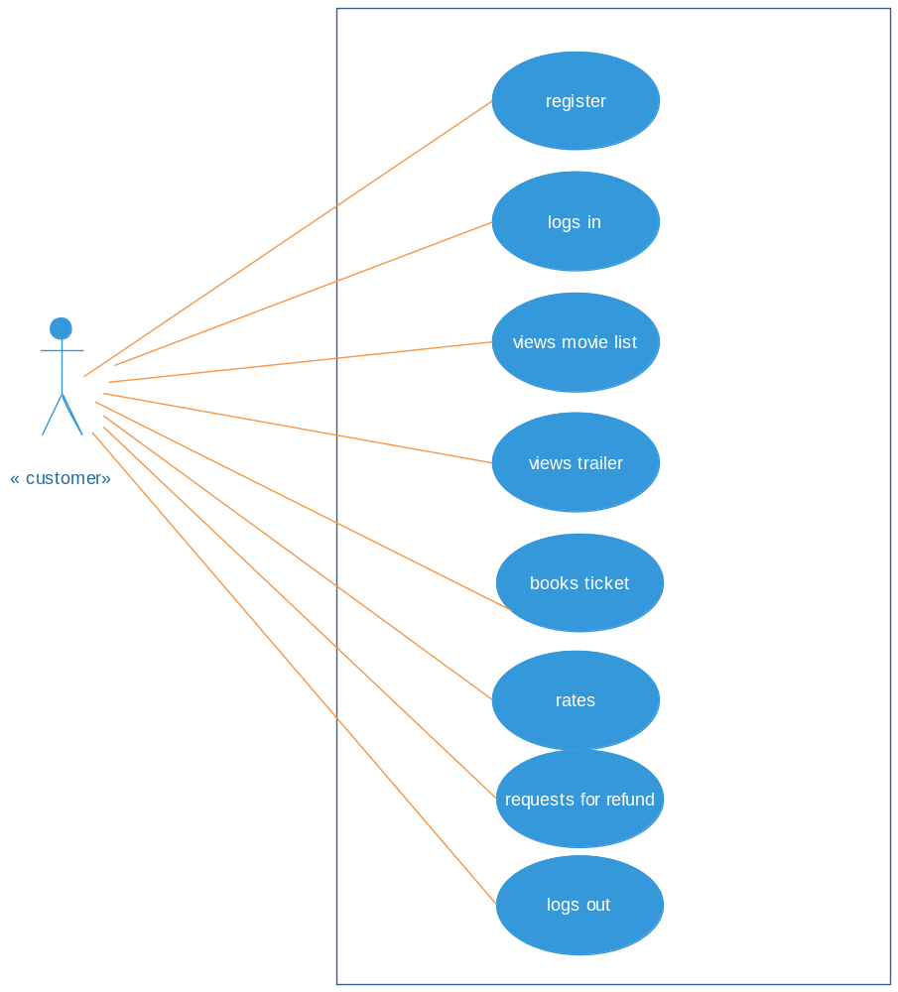
Figure 3.5: Use Case for Customer

3.4 SEQUENCE DIAGRAM

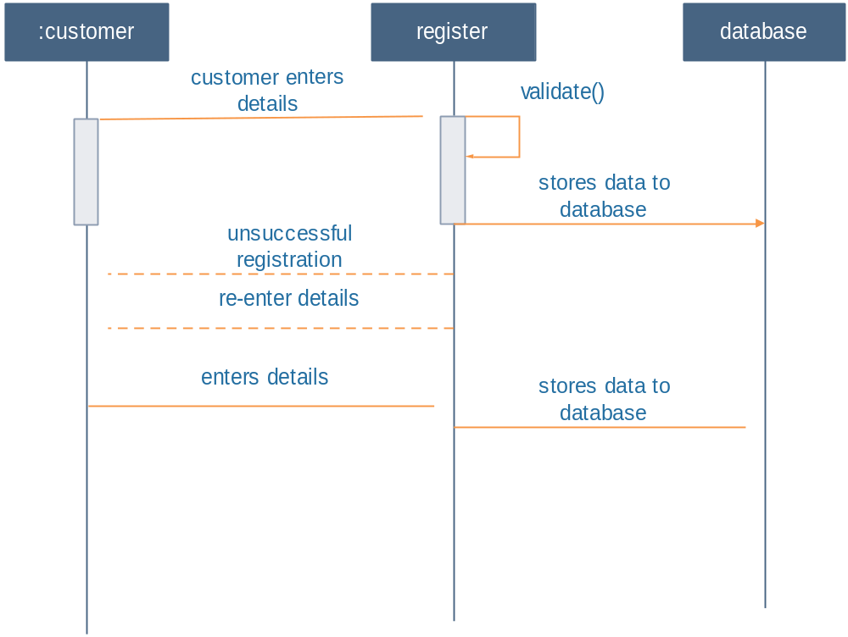
Figure 3.6:Sequence Diagram for registration

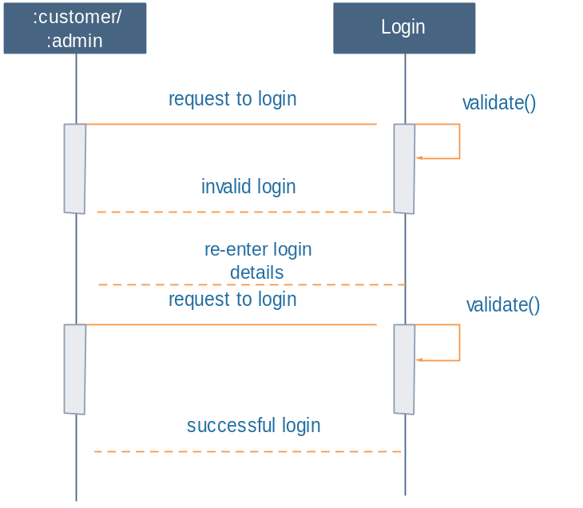
Figure 1.7: Sequence Diagram for login

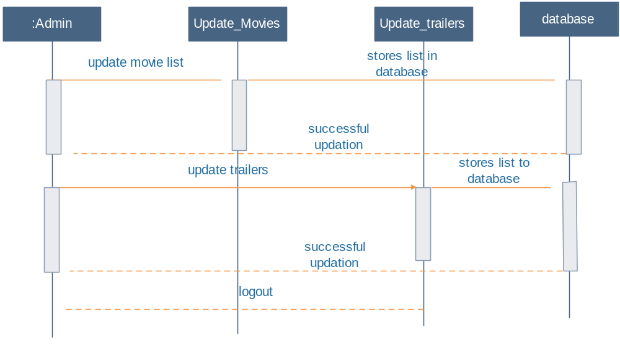
Figure 3.8 :Sequence Diagram for updation

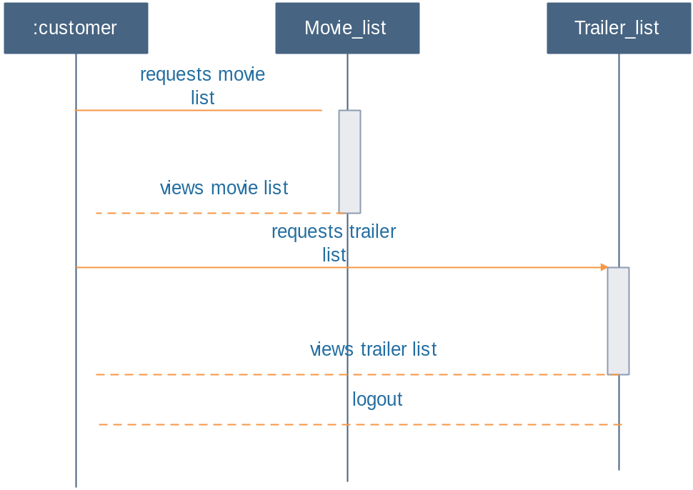
Figure 3.9 : Sequence diagram to view list

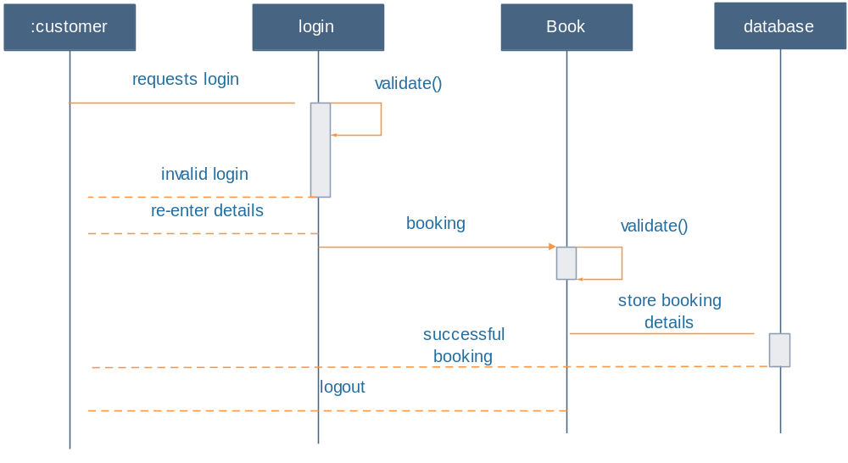

Figure 3.10 : Sequence diagram for booking

3.5 ACTIVITY DIAGRAM
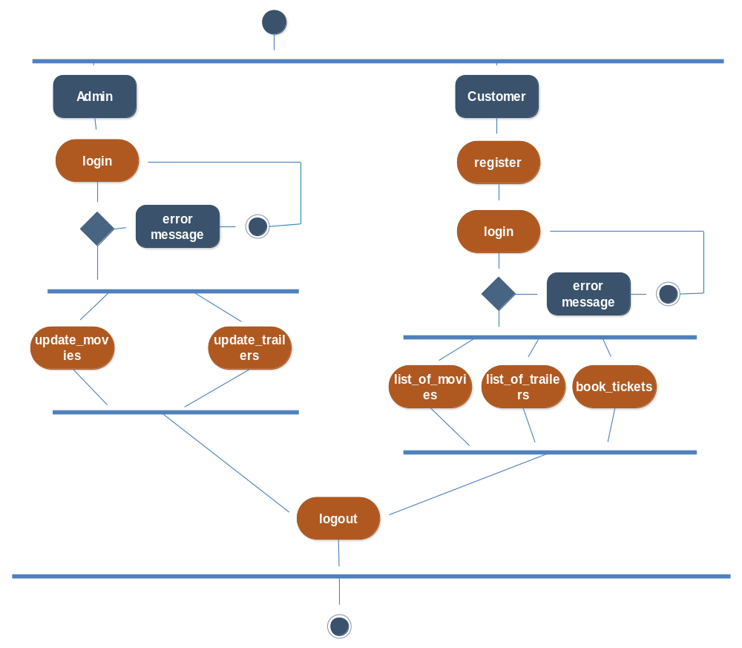
Fig. 3.11: Activity Diagram

CHAPTER 4
IMPLEMENTATION
4.1. SOFTWARE REQUIREMENTS
JavaScript supports the development of both client and server components of Web-based applications on the client side, it can be used to write program that are executed by Web browsers within the context of Web page. JavaScript is almost as easy to learn as HTML, and JavaScript statements can be included in HTML documents by enclosing the statements between a pair of scripting tags.

The Java Platform
The Java platform has two components:
- The Java Virtual Machine (Java VM)
- The Java Application Programming Interface (Java API)
The Java API is a large collection of ready-made software components that provide many useful capabilities, such as graphical user interface (GUI) widgets. The Java API is grouped into libraries of related classes and interfaces; these libraries are known as packages.

Model View Controller or MVC as it is popularly called, is a software design pattern for developing web applications. A Model View Controller pattern is made up of the following three parts:
- Model - The lowest level of the pattern which is responsible for maintaining data.
- View - This is responsible for displaying all or a portion of the data to the user.
- Controller - Software Code that controls the interactions between the Model and View.
MVC is popular as it isolates the application logic from the user interface layer and supports separation of concerns. Here the Controller receives all requests for the application and then works with the Model to prepare any data needed by the View.
The View then uses the data prepared by the Controller to generate a final presentable response. The MVC abstraction can be graphically represented as follows.
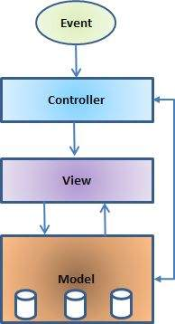
Fig:4.1 MVC Model

Struts2 is a MVC based framework. Struts2 is popular and mature web application framework based on the MVC design pattern.

Struts 2 framework features
- POJO forms and POJO actions - With Struts2, you can use any POJO to receive the form input. Similarly, you can now see any POJO as an Action class.
- Tag support - Struts2 has improved the form tags and the new tags allow the developers to write less code.
- AJAX support - Struts2 has recognized the take over by Web2.0 technologies, and has integrated AJAX support into the product by creating AJAX tags, that function very similar to the standard Struts2 tags.
- Easy Integration - Integration with other frameworks like Spring, Tiles and SiteMesh is now easier with a variety of integration available with Struts2.
- Template Support - Support for generating views using templates.
- Plugin Support - The core Struts2 behaviour can be enhanced and augmented by the use of plugins. A number of plugins are available for Struts2.
- Profiling - Struts2 offers integrated profiling to debug and profile the application. In addition to this, Struts also offers integrated debugging with the help of built in debugging tools.
- Easy to modify tags - Tag markups in Struts2 can be tweaked using Freemarker templates. This does not require JSP or java knowledge. Basic HTML, XML and CSS knowledge is enough to modify the tags.
- Promote less configuration - Struts2 promotes less configuration with the help of using default values for various settings. You don't have to conFig. something unless it deviates from the default settings set by Struts2.
- View Technologies - Struts2 has a great support for multiple view options (JSP, Freemarker, Velocity and XSLT)
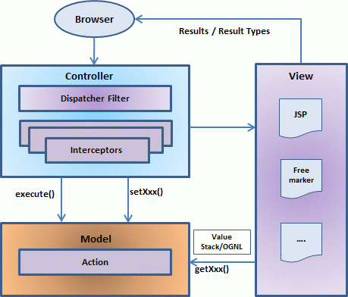
Fig.4.2 MVC-Strts2 Architecture

The above diagram depicts the Model, View and Controller to the Struts2 high level architecture. The controller is implemented with a Struts2 dispatch servlet filter as well as interceptors, the model is implemented with actions, and the view as a combination of result types and results. The value stack and OGNL provide common thread, linking and enabling integration between the other components.
Apart from the above components, there will be a lot of information that relates to configuration. Configuration for the web application, as well as configuration for actions, interceptors, results, etc.

Tomcat 6.0 web server
Tomcat is an open source web server developed by Apache Group. Apache Tomcat is the servlet container that is used in the official Reference Implementation for the Java Servlet and JavaServer Pages technologies.
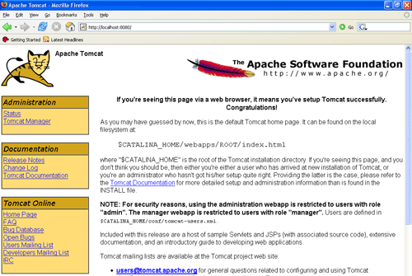
Fig.4.3 Tomcat Webserver

CHAPTER 5
MODULES
There are two modules in this project, they are
1.Admin
2.Customer
Admin:
In this module admin will login, then he/she can add categories such as theatre name, movie name, trailers, seating capacity, ticket cost etc.,
Customer:
A customer should be able to
  - login to the system through the first page of the application
  - Should be able to create a new login for the accessing the reservation facility.
  - Query the films on show
  - Can select seats for same and different show and screen also.
  - Give details about the details about the credit card.

CHAPTER 6
SYSTEM TESTING

Unit testing involves the design of test cases that validate that the internal program logic is functioning properly, and that program inputs produce valid outputs. All decisions branches and internal code flow should be validated.
Integration tests are designed to test integrated software components to determine if they actually run as one program. Testing is event driven and is more concerned with the basic outcome of screens or fields.
Functional tests provide systematic demonstrations that functions tested are available as specified by the business and technical requirements, system documentation, and user manuals.
Functional testing is on the following items:
Valid Input: identified classes of valid input must be accepted.
Invalid Input: identified classes of invalid input must be rejected.
Functions: identified functions must be exercised.
Output: identified classes of application outputs must be exercised.
Systems/Procedures: interfacing systems or procedures must be invoked.
System testing ensures that the entire integrated software system meets requirements. It tests a configuration to ensure known and predictable results.
Test Results
All the test cases mentioned above passed successfully. No defects encountered.

6.1 TEST CASES
1 | USER | TESTCASE NAME | INPUT | EXPECTED OUTPUT
T1 | Admin | Login | Username, password | Successful Login
 |  |  | If Username, password or both are incorrect | Unsuccessful Login
T2 | Customer | Register | Fill the customer details correctly | Successfully added to customer table
 |  |  | If there is any Incomplete Field | Unsuccessful: Please fill in this field
T3 | Admin | Manage Theatres | Enter the Theatre details | Successfully added to theatre table
 |  |  | If the theatre details is not entered | Unsuccessful: Please fill in this field
T4 | Admin | Manage Movies | Enter the movie details | Successfully added to movies table
 |  |  | If any field is left empty | Unsuccessful: Please fill in this field
T5 | Admin | Manage Trailers | Enter trailer details | Successfully added to trailer table
 |  |  | If any field is left empty | Unsuccessful: Please fill in this field
T6 | Customer | Register | Username, password | Successful Login
 |  |  | If Username, password or both are incorrect | Unsuccessful Login
T7 | Customer | Book Ticket | Enter the valid booking details | Successful: Sends confirmation message
 |  |  | Enter the invalid booking details | Unsuccessful: Redirects to home page
Table 6.1: Test cases

CHAPTER 7
SNAPSHOTS

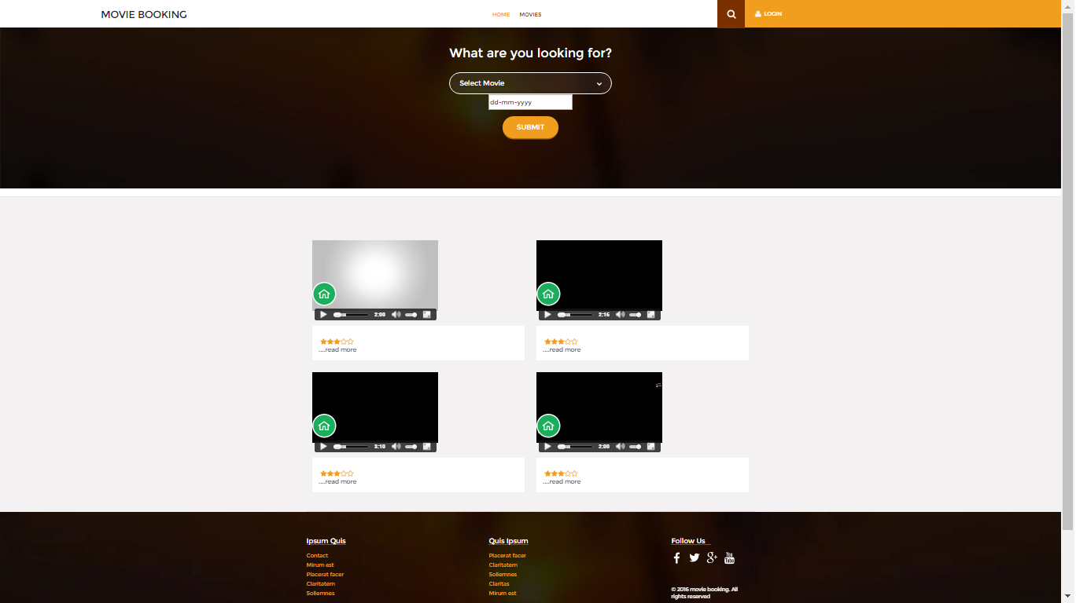
Fig 7.1: Home Page

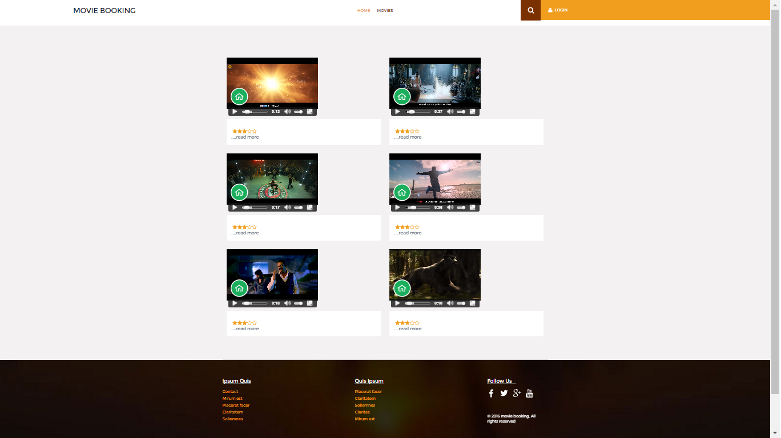
Fig 7.2: Movies Page

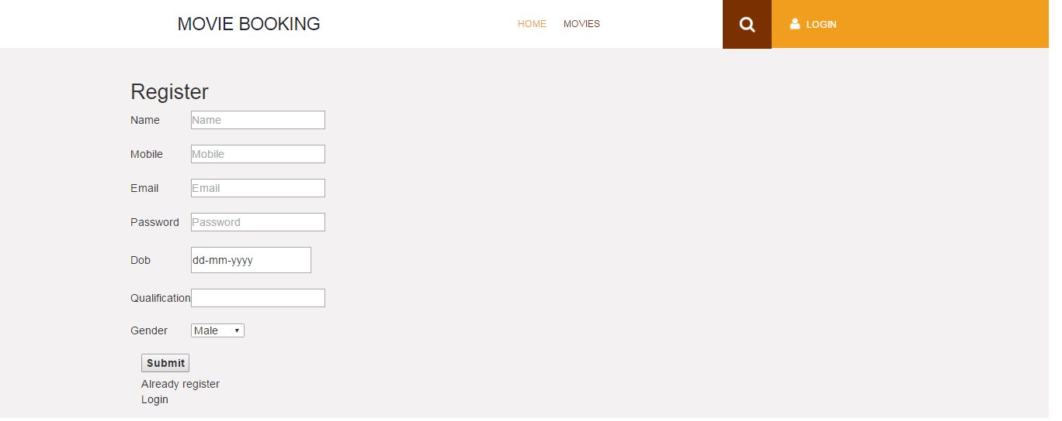
Fig 7.3: Registration form

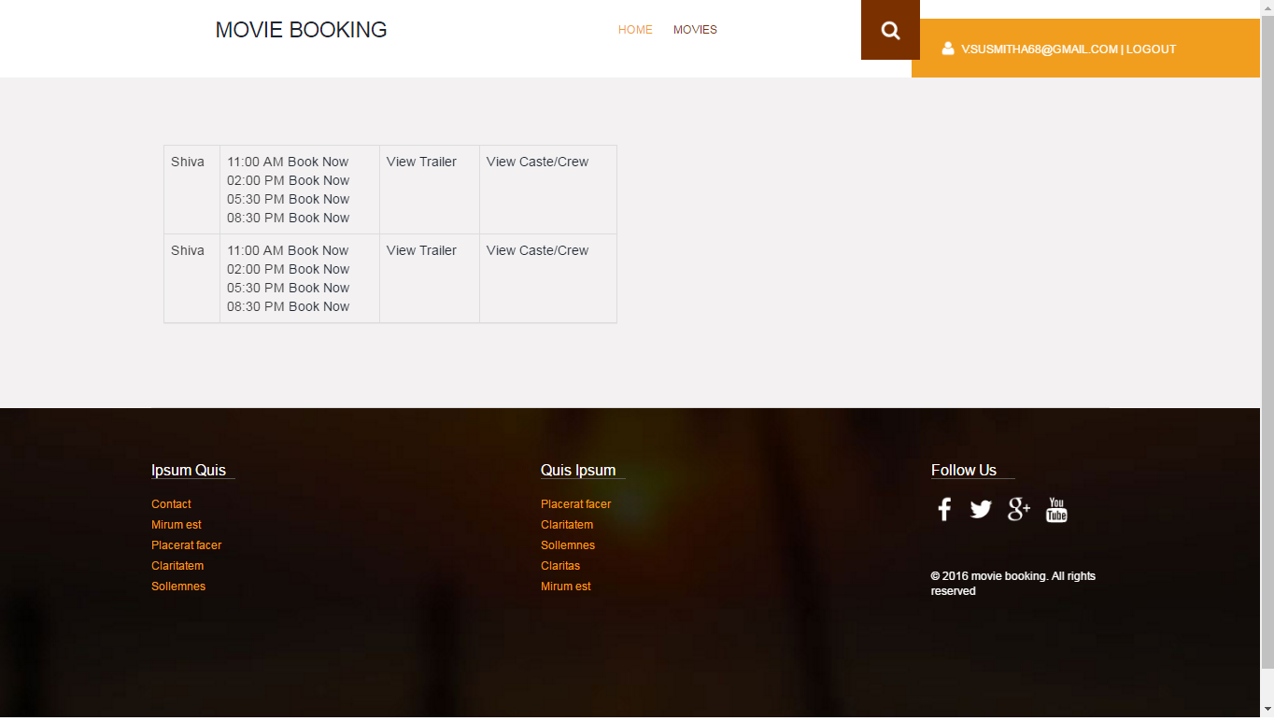
Fig 7.2 Booking

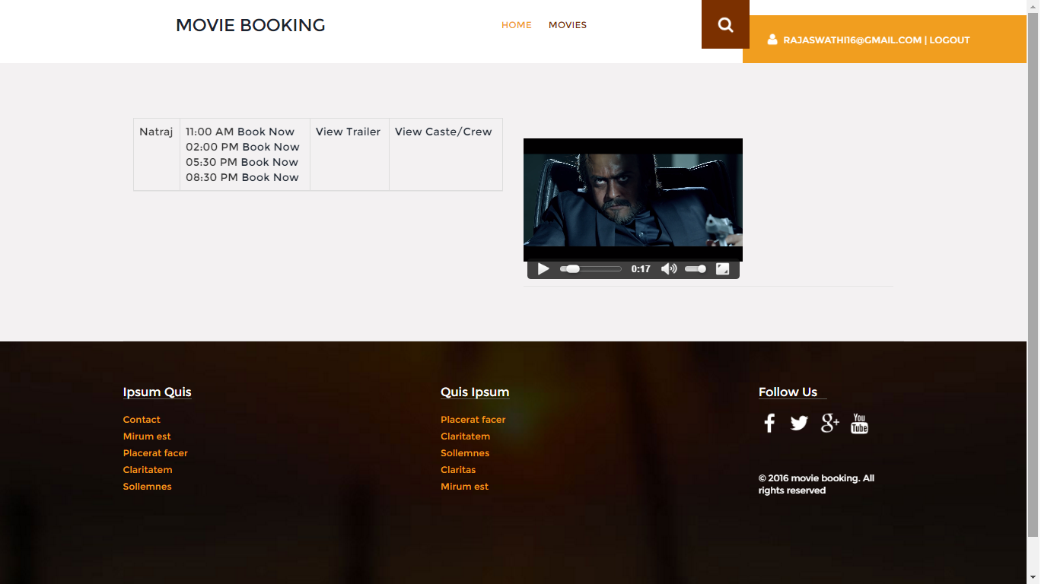
Fig 7.3: View trailers

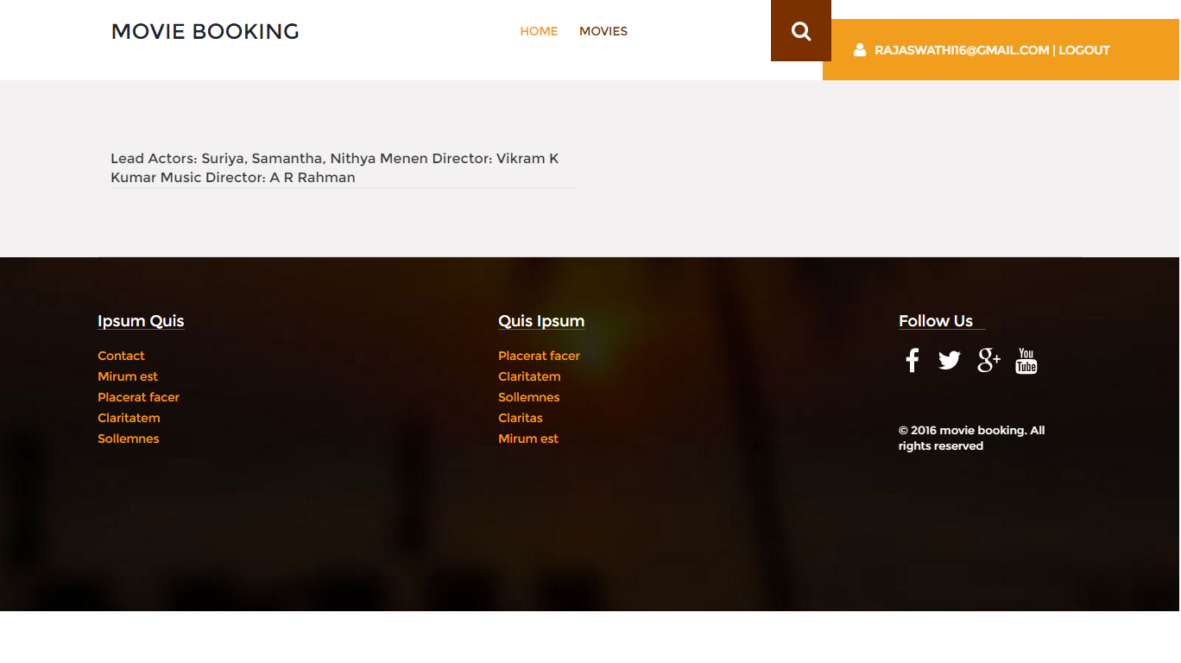
Fig 7.3: View cast

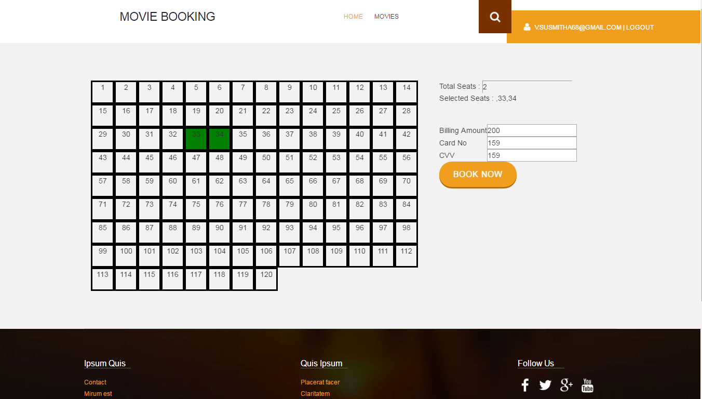
Fig 7.3: Seat Selection

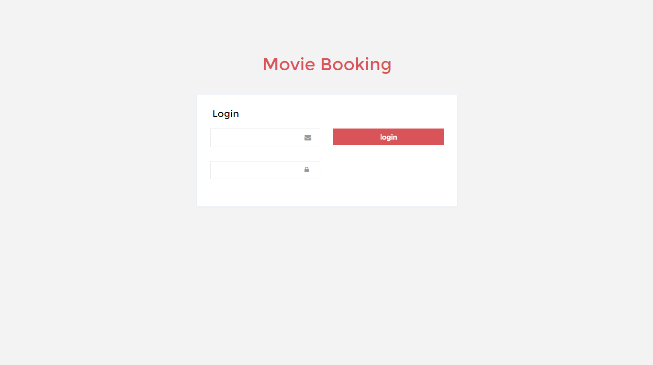
Fig 7.4 Admin will Login

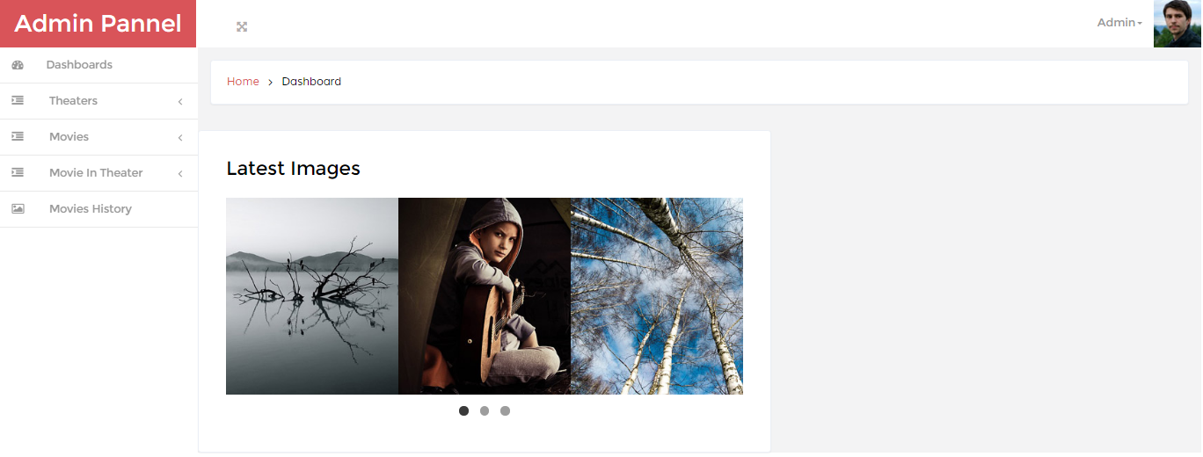
Fig 7.5 Dashboard

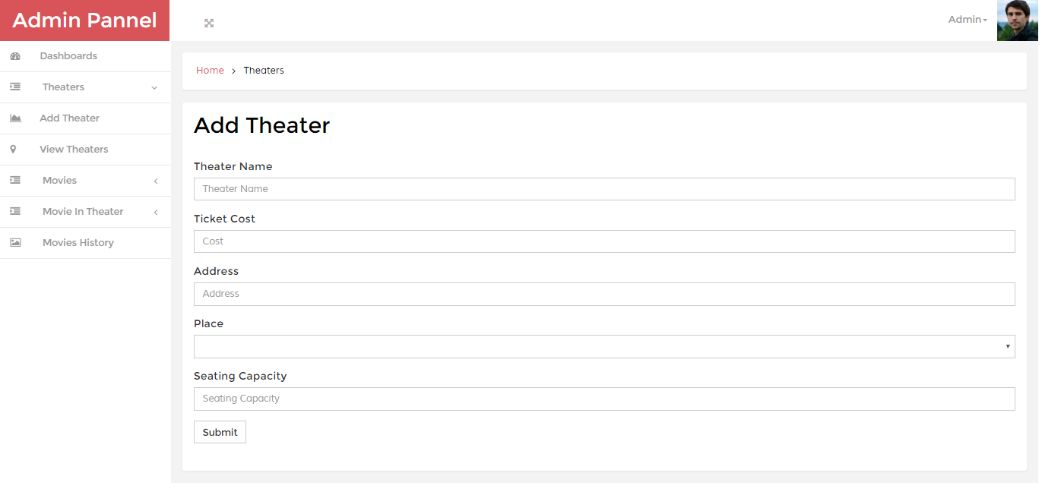
Fig 7.6 Add theatre details
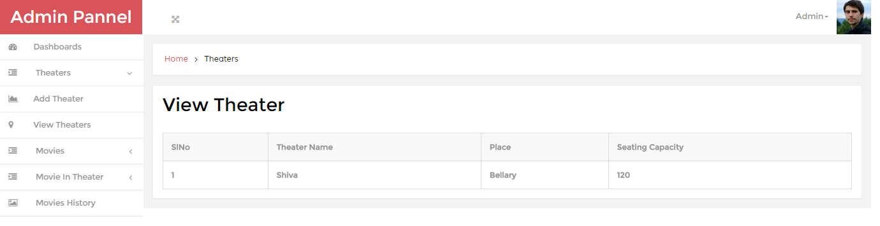
Fig 7.7 To view theatre details

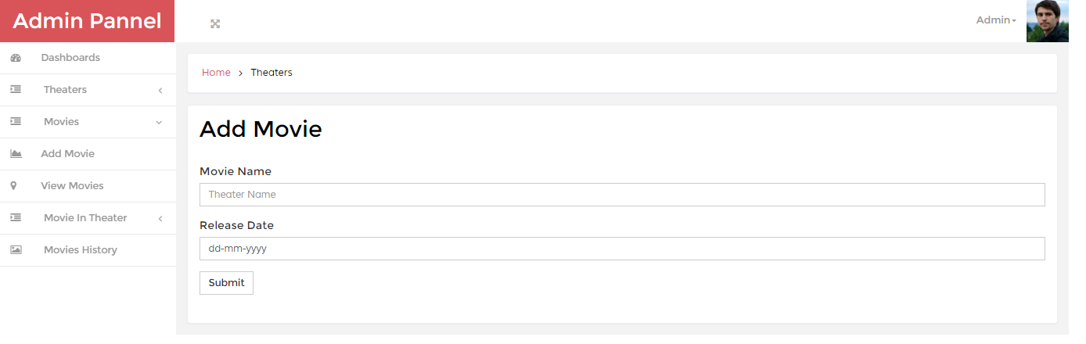
Fig 7.8 Add movie details

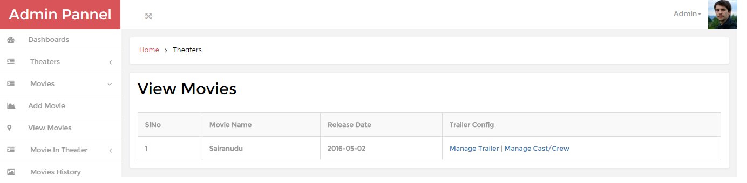
Fig 7.9 To view movie details

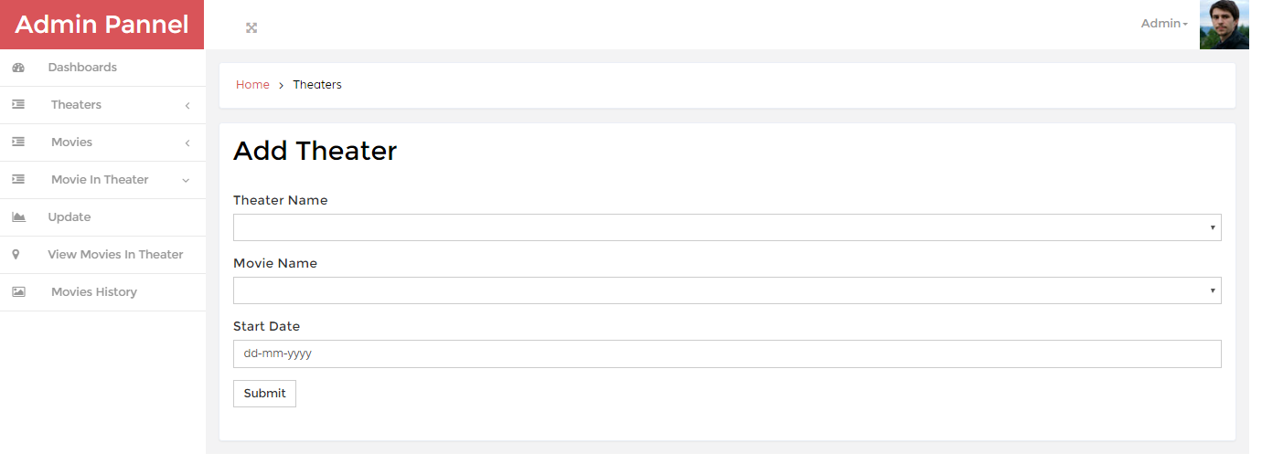
Fig 7.10 To add movie in theatre

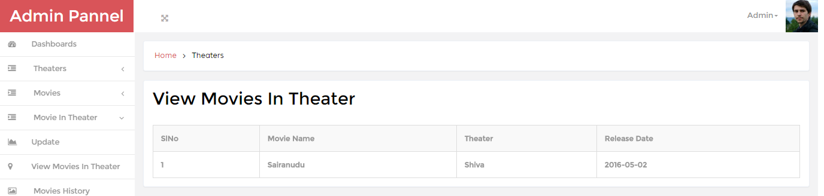
Fig 7.11 View movie in theatre

Fig 7.12 View movie in theatre

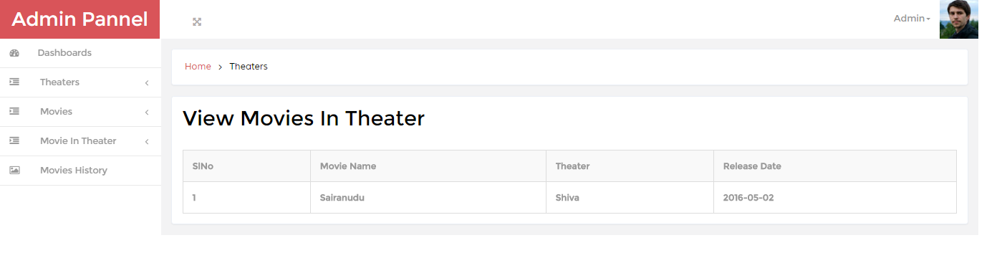
Fig 5.13 Movie History

CHAPTER-8
CONCLUSION

This paper proposes the web based online system which is time saving for the customers by booking the tickets online. This system is designed using modern system architecture to cope with changing requirement. This web based can further be implemented as a mobile app which can be accessed by the customers to book tickets online and to have information about the newly released movies. This system is more secure as it is developed on java platform with strut framework.

REFERENCES

1.http://www.Javatpoint.com/struts-2-tutorial
2.http://www.tutorialspoint.com/struts_2/basic_mvc_architecture.htm
3.http://www.bookmyshow.com
4.http://www.wideskills.com/jdbc-tutorial/jdbc-driver-types
5.http://www.pvrcinemas.com

READ ME

1.Install JDK software which is provided in the software folder i.e. in the CD using the default settings.
2.Install Apache Tomcat web server in the port 8089 which provided in the software folder i.e. in the CD using default settings.
3.Go to the Tomcat and select monitor tomcat and start the tomcat service and click on the welcome page of the tomcat to see whether the tomcat is installed correctly or not.
4.Install MySql database system which is provided in the software folder i.e. in the CD using default settings.
5.To run the Application open any browser and enter
http://localhost:8089/SPLITSCREEN/ URL in the address bar and enter appropriate username and password and log in.
6.Perform appropriate operations as required.

