There seems to be a lot of misconceptions on the difference between the document and window objects for javascript.

WINDOW object and DOCUMENT object ARE NOT THE SAME!!!!!

I have set out to clarify this for you in the most visual manor as possible.

So, what is the difference between the document object and window object you ask? Good question.

# download.png

Javascript Window Object with Document Loaded

Well, the window is the first thing that gets loaded into the browser. This window object has the majority of the properties like length, innerWidth, innerHeight, name, if it has been closed, its parents, and more.

What about the document object?

The document object is your html, aspx, php, or other document that will be loaded into the browser. The document actually gets loaded inside the window object and has properties available to it like title, URL, cookie, etc. What does this really mean? That means if you want to access a property for the window it is window.property, if it is document it is window.document.property which is also available in short as document.property.

An iframe actually is considered as a new window with its own document loaded into it. Here is where it may seem a little odd, but does make sense if you think about it. The original, parent window, is responsible for other windows to be loaded, not the document.

Syntax

document.property_name;

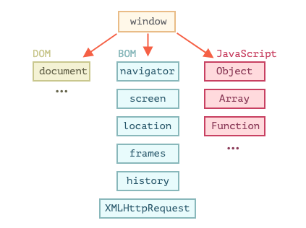

**Document Object:**

The document object represent a web page that is loaded in the browser. By accessing the document object, we can access the element in the HTML page. With the help of document objects, we can add dynamic content to our web page. The document object can be accessed with a **window.document**or just**document.**

**Window Object:**

The window object is the topmost object of the DOM hierarchy. It represents a browser window or frame that displays the contents of the webpage. Whenever a window appears on the screen to display the contents of the document, the window object is created.

**Syntax:**

window.property_name;