Course 5 Task 3

1. **Logistic Regression Results**

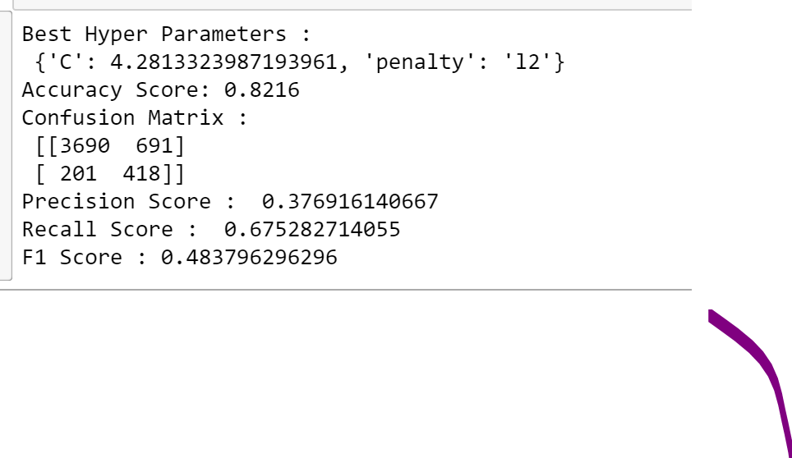

1. **Decision Tree Results :**

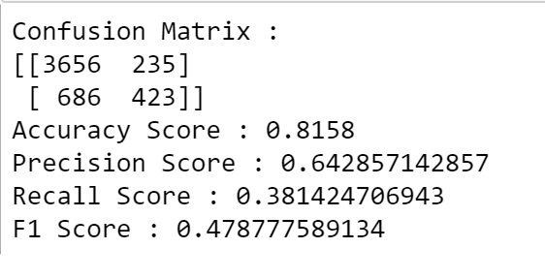

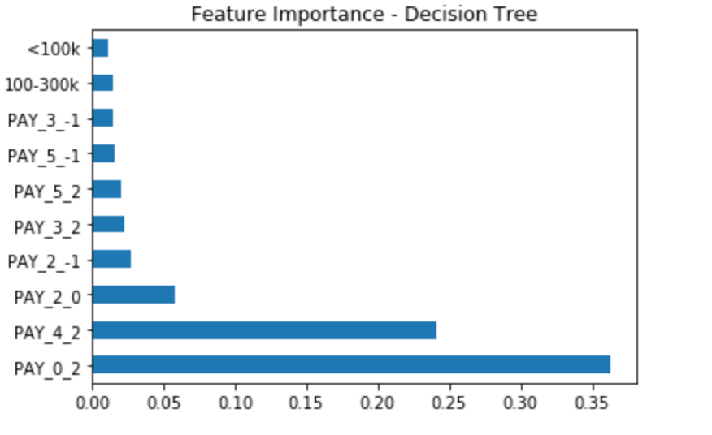

1. **Random Forest Results :**

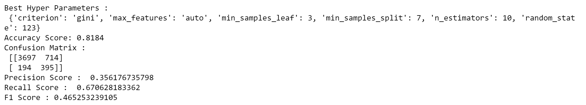

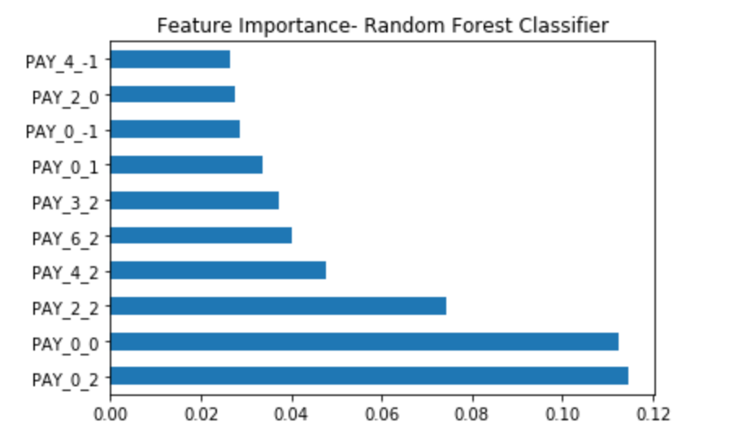

1. How do you ensure that customers can/will pay their loans?

There is no way to ensure the EXISTING customers will pay their loans. We can only predict where the person(who has already borrowed the loan ) will repay it or not.

Top 5 attributes contributing to the prediction is “Pay_X “ attributes . That means that customers who have consistently paid in the past will not most likely default. AS seen in the images above, attributes PAY_0,PAY_2,PAY_4,PAY_6 with value as 2(payment delay for 2 months) are the major contributors which means that the customers whose defaulted those payments are most likely to default again in the future.

2.Can we approve customers with high certainty?

In regards to customers who are taking up a new loan and the data is about the past loans they had taken, we can consider the individuals who have high payment rate based on the attributes like PAY_0,PAY_2,PAY_4,PAY_6 .Such customers can be approved.