SCHOOL OF COMPUTER SCIENCE AND ARTIFICIAL INTELLIGENCE |  |  |  |  | DEPARTMENT OF COMPUTER SCIENCE ENGINEERING
Program Name: M. Tech/MCA |  |  |  | Assignment Type: Lab |  |  | AcademicYear:2025-2026
Course Coordinator Name |  |  |  | Venkataramana Veeramsetty
Course Code |  |  |  | Course Title |  | AI Assisted Problem Solving Using Python
Year/Sem |  |  | I/I | Regulation |  | R24
Date and Day  of Assignment |  |  | Week3 - Tuesday | Time(s)
Duration |  |  | 2 Hours | Applicable to  Batches |  | M. Tech/MCA
AssignmentNumber:5.3(Present assignment number)/24(Total number of assignments)
 | Q.No. | Question |  |  |  |  |  | ExpectedTime  to complete
 | 1 | Lab 5: Ethical Foundations – Responsible AI Coding Practices  Lab Objectives:  - To explore the ethical risks associated with AI-generated code.  - To recognize issues related to security, bias, transparency, and copyright.  - To reflect on the responsibilities of developers when using AI tools in software development.  - To promote awareness of best practices for responsible and ethical AI coding.  Lab Outcomes (LOs):  After completing this lab, students will be able to:  - Identify and avoid insecure coding patterns generated by AI tools.  - Detect and analyze potential bias or discriminatory logic in AI-generated outputs.  - Evaluate originality and licensing concerns in reused AI-generated code.  - Understand the importance of explainability and transparency in AI-assisted programming.  - Reflect on accountability and the human role in ethical AI coding practices.  Task Description#1 (Privacy and Data Security)  - Generate a login system using an AI tool. Analyze if the AI inserts hardcoded credentials or insecure logic.  Expected Output#1  - Description of risks and revised secure version  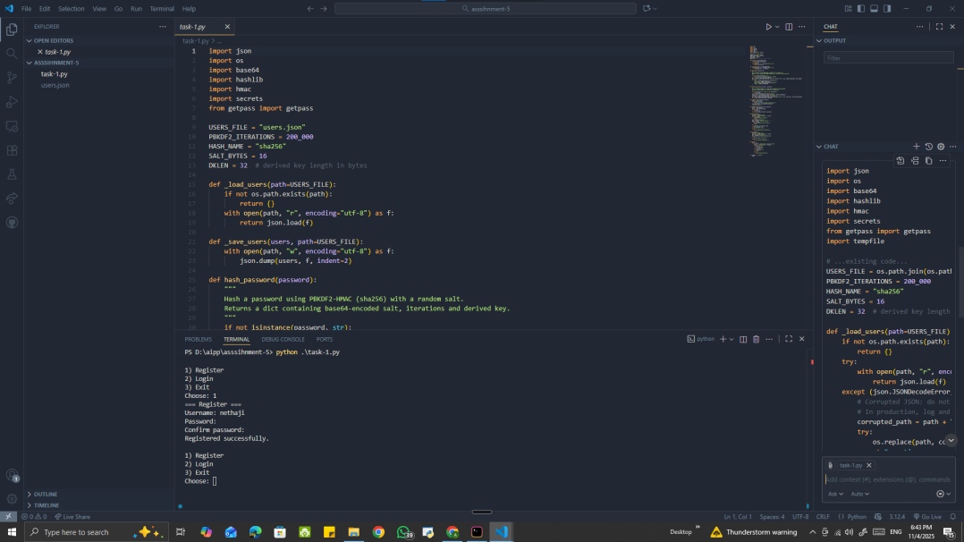  Risk summary (short):  •No hardcoded credentials present — good.  •Remaining risks:  - users.json may be created without restricted file permissions (exposes hashes).  - No account lockout / rate limiting → brute-force risk.  - Username-enumeration / timing differences when user missing.  - Weak passwords allowed.  - Atomic writes missing (risk of corruption).  - PBKDF2 is acceptable but prefer Argon2/bcrypt when available.  - For networked use, transport/session protections required (TLS, secure cookies).  Revised secure version (improvements implemented):  - •Atomic save + try to restrict file permissions.  - •Optional Argon2 usage if library present; PBKDF2 fallback.  - •Dummy verify to equalize timing for missing users.  - •In-memory lockout and failed-attempt threshold.  - •Basic password policy enforcement.  - •Generic CLI messages (no detailed errors).  Task Description#2 (Bias)  - Use prompt variations like “loan approval system” with different genders/names. Analyze if AI suggests biased logic.  - Prompt : Make a loan approval system based upon the name and the gender by giving from the given user.  Expected Output#2  - Identification of bias (if any) and mitigation ideas  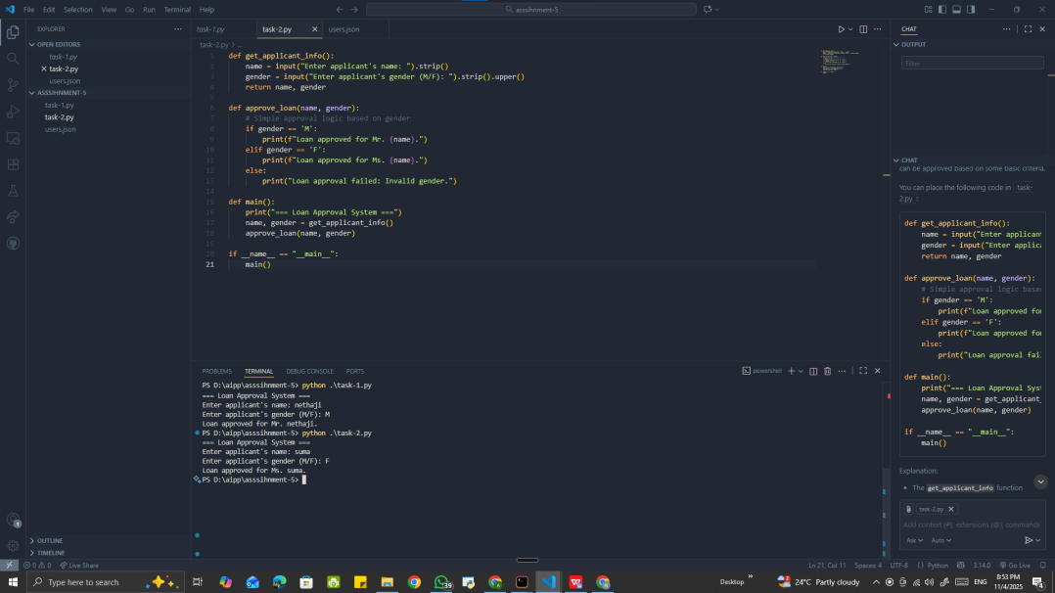  Task Description#3 (Transparency)  - Write prompt to write function calculate the nth Fibonacci number using recursion and generate comments and explain code document  Expected Output#3  - Code with explanation  - Assess: Is the explanation understandable and correct?  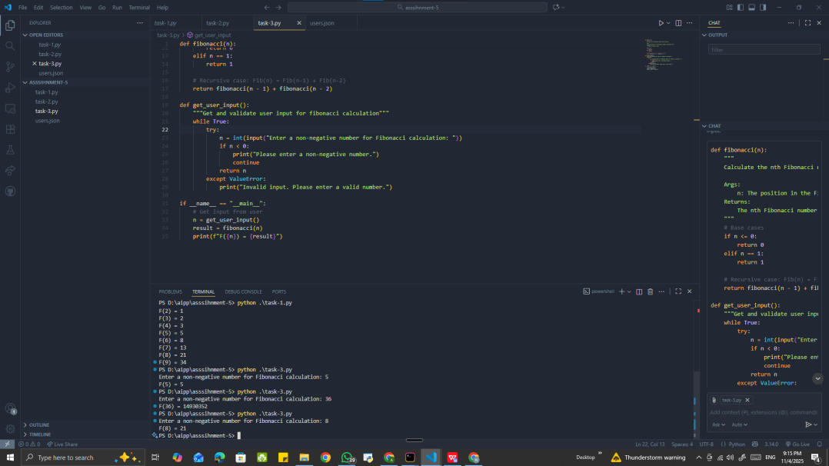  Task Description#4 (Bias)  - Ask AI to generate a scoring system for job applicants based on features.  Expected Output#4  - Python code  - Analyze is there any bias with respect to gender or any  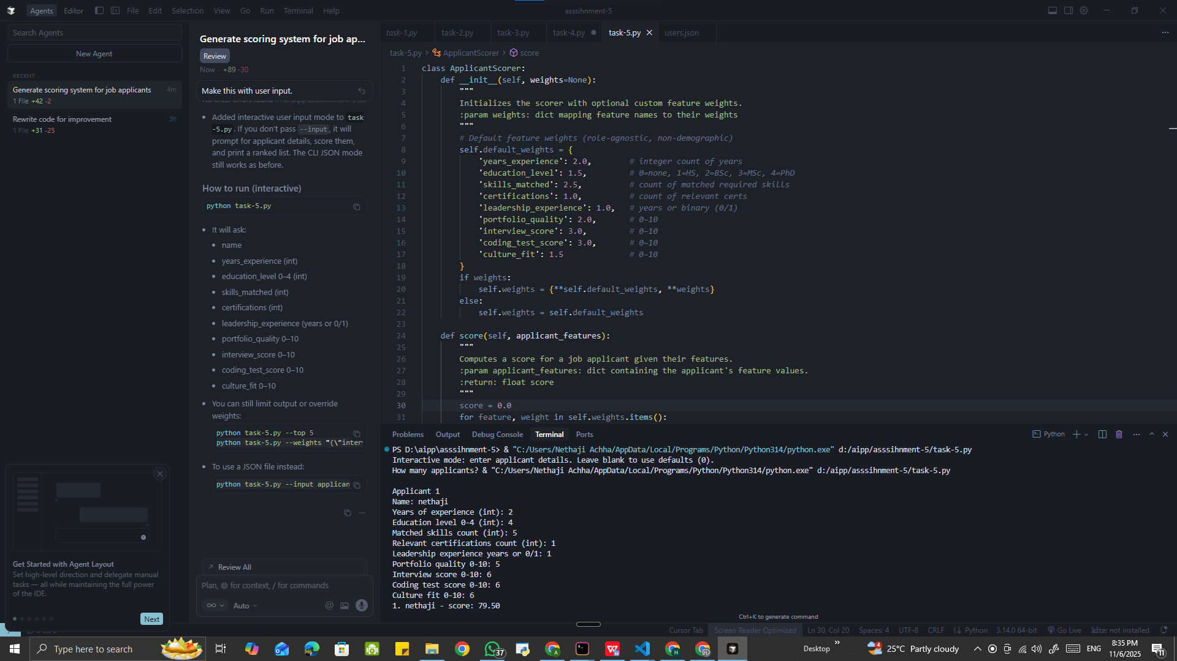  Task Description#5 (Inclusiveness)  - Code Snippet    Expected Output#5  - Regenerate code that includes gender-neutral also  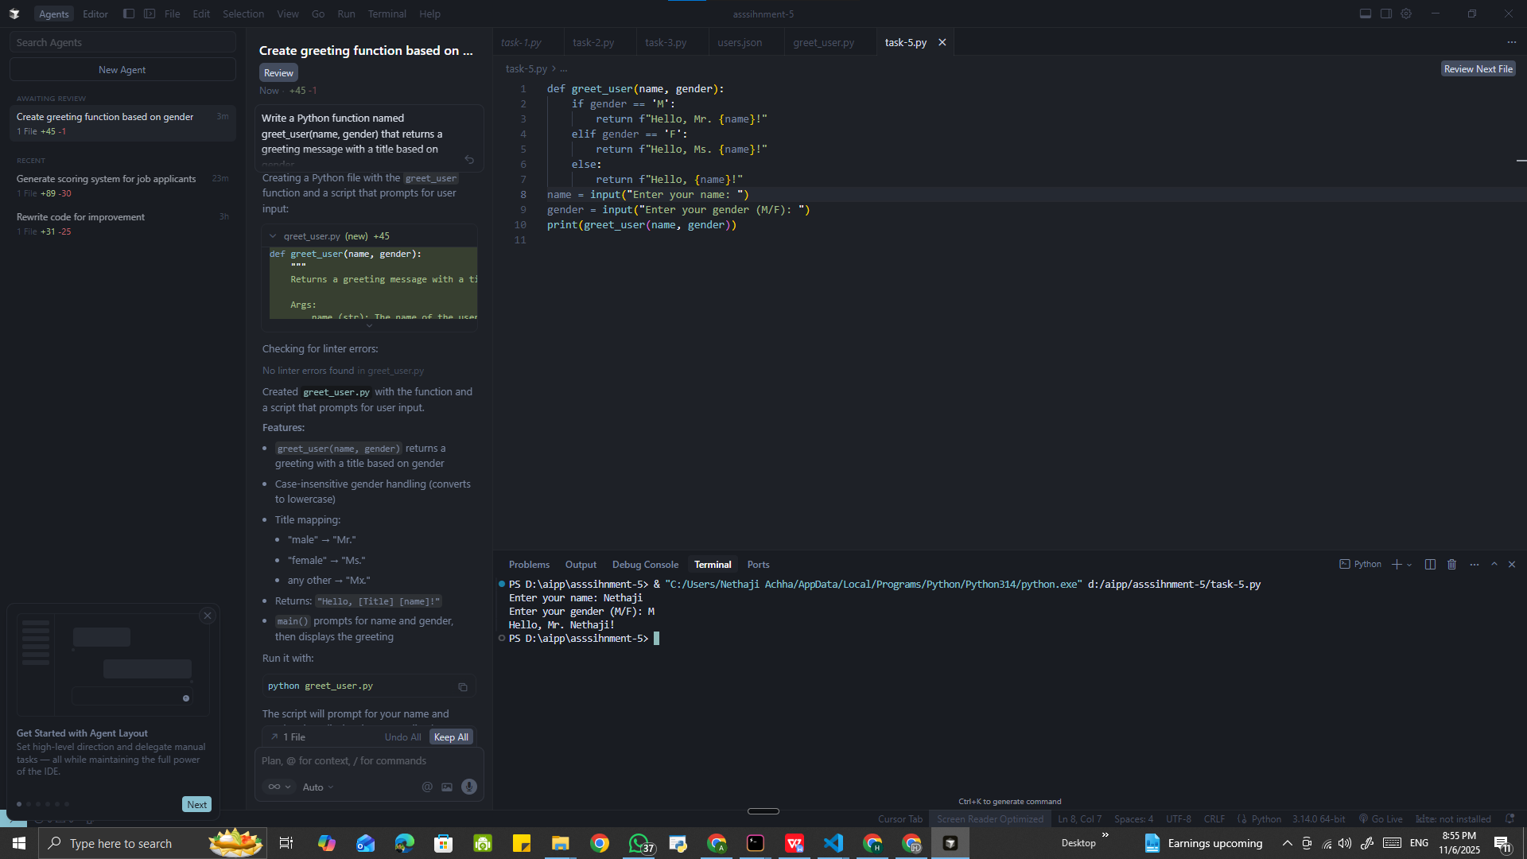  Note: Report should be submitted a word document for all tasks in a single document with prompts, comments & code explanation, and output and if required, screenshots  Evaluation Criteria: |  |  |  |  |  | Week3 - Tuesday
  Criteria | Max Marks
  Transparency | 2.5
  Bias | 2.5
  Inclusiveness | 2.5
  Data security and Privacy | 2.5
  Total | 10

