Ex.no:2 | EDA-DATA IMPORT AND EXPORT

Aim:
To inspect dataset features, detect null values, and export data into CSV, Excel, and SQLite database formats.
Algorithm:
- Import Pandas, OS, and sqlite3 libraries.
- Upload and read the Google Play Store CSV dataset into a Pandas DataFrame.
- Inspect the dataset structure using .head(), .tail(), .info(), .describe(), and .isnull().sum().
- Display the dataset shape, column names, data types, and duplicate records.
- Analyze important attributes such as application categories, ratings, reviews, installs, content ratings, and application types.
- Identify the top applications based on the number of reviews.
- Analyze the distribution of free and paid applications.
- Export the DataFrame into CSV and Excel formats using .to_csv() and .to_excel().
- Connect to a SQLite database using sqlite3 and store the dataset in an SQL table using .to_sql().
- Close the database connection and display a confirmation message after successful export.
- .
Program:
import os
import pandas as pd
import sqlite3
from google.colab import files

print("Please upload the Google Play Store CSV file:")

uploaded = files.upload()

csv_file = list(uploaded.keys())[0]

print("\nCSV file:", csv_file)

df = pd.read_csv(
csv_file,
encoding="latin1",
low_memory=False
)

print("\nDataset path:", csv_file)

print("\nFirst 5 rows:")
display(df.head())

print("\nLast 5 rows:")
display(df.tail())

print("\nDataset information:")
df.info()

print("\nShape:")
print(df.shape)

print("\nColumns:")
print(df.columns.tolist())

print("\nData types:")
print(df.dtypes)

print("\nStatistical description:")
display(df.describe(include="all").T)

print("\nMissing values:")
display(df.isnull().sum().sort_values(ascending=False))

print("\nDuplicate rows:")
print(df.duplicated().sum())

if "Category" in df.columns:
print("\nApplication categories:")
display(df["Category"].value_counts())
else:
category_columns = [
col for col in df.columns
if col.startswith("Category_")
]

if category_columns:
df["Category"] = (
df[category_columns]
.idxmax(axis=1)
.str.replace("Category_", "", regex=False)
)

print("\nApplication categories:")
display(df["Category"].value_counts())

if "Content Rating" in df.columns:
print("\nContent Rating:")
display(df["Content Rating"].value_counts())

if "Type" in df.columns:
print("\nFree and Paid Applications:")
display(df["Type"].value_counts())

if "Reviews" in df.columns:
print("\nTop applications based on reviews:")
display(
df[["App", "Reviews"]]
.sort_values("Reviews", ascending=False)
.head(10)
)

if "Installs" in df.columns:
print("\nTop applications based on installs:")
display(
df[["App", "Installs"]]
.sort_values("Installs", ascending=False)
.head(10)
)

if "Category" in df.columns and "Rating" in df.columns:
print("\nCategory-wise Average Rating:")
display(
df.groupby("Category")["Rating"]
.mean()
.sort_values(ascending=False)
)

print("\nCorrelation:")
display(df.corr(numeric_only=True))

df.to_csv(
"Google_Play_Store_Output.csv",
index=False
)

df.to_excel(
"Google_Play_Store_Output.xlsx",
index=False
)

connection = sqlite3.connect(
"Google_Play_Store.db"
)

df.to_sql(
"play_store_data",
connection,
if_exists="replace",
index=False
)

connection.close()

print("\nCSV, Excel and SQLite database files created successfully.")Output:
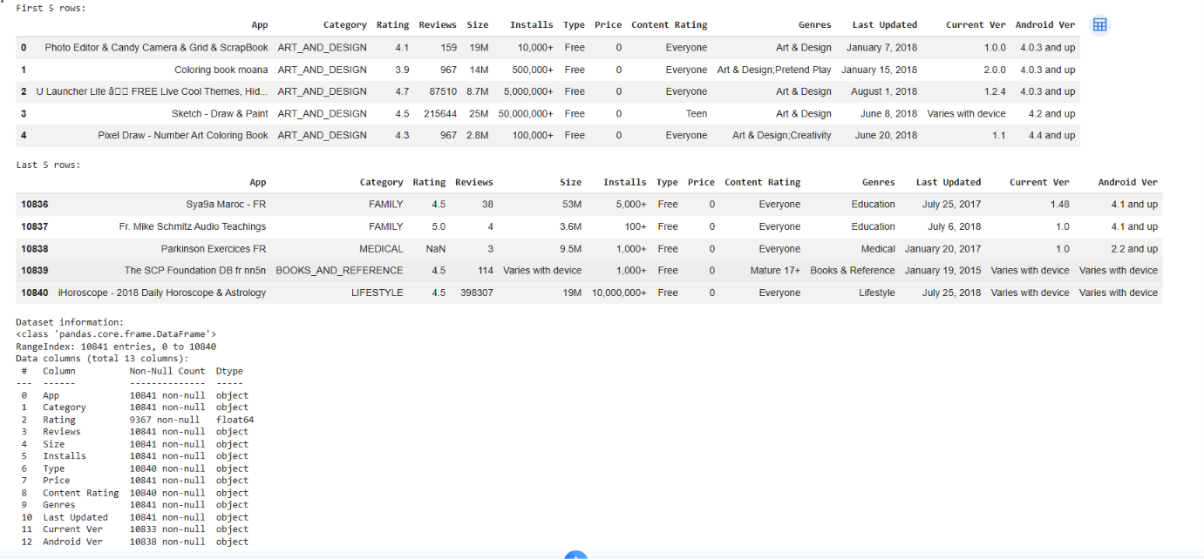

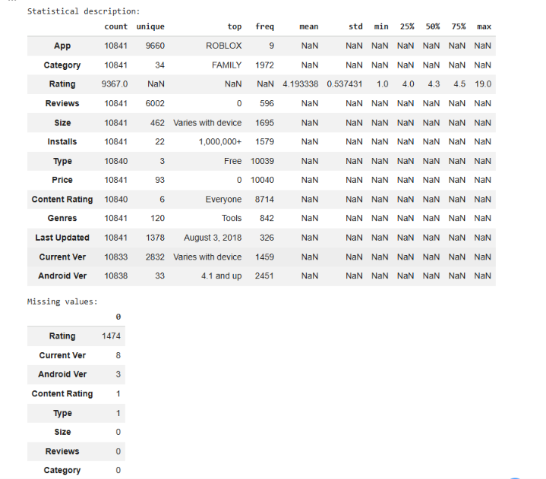

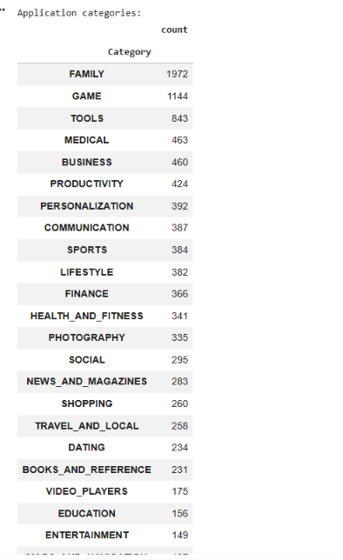

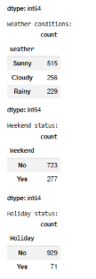
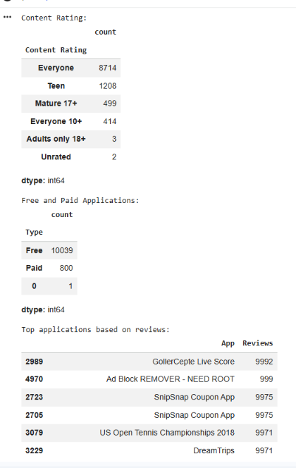

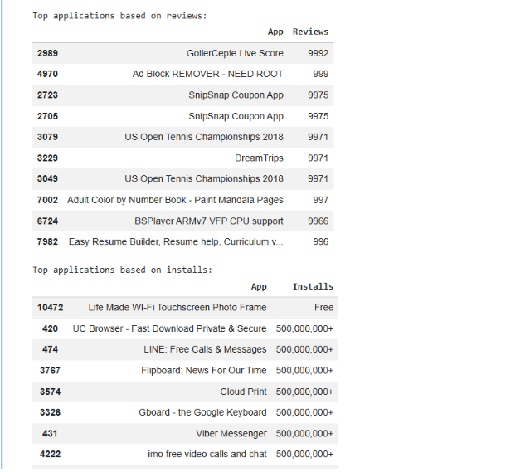

Result:

