EX No:1b | EDA DATA CLEANING

AIM

To perform exploratory data analysis on the Google Play Store Dataset by examining the dataset structure, dimensions, data types, statistical characteristics, missing values, category-wise application distributions, review patterns, rating analysis, top-performing applications, free and paid application distributions, correlation between numerical attributes, and creating visualizations and an interactive dashboard for effective app performance analysis and decision-making.

ALGORITHM

1. Import the required libraries such as Pandas, NumPy, Matplotlib, and Seaborn.

2. Load the Google Play Store Dataset into a Pandas DataFrame.

3. Display the first five and last five records of the dataset.

4. Display the dataset information, shape, column names, and data types.

5. Generate descriptive statistical information for the numerical attributes.

6. Identify the number of missing values present in each column.

7. Remove blank rows and duplicate records from the dataset.

8. Perform data cleaning and standardization on the required categorical and numerical attributes.

9. Calculate the Review Percentage using the Reviews and Installs attributes.

10. Analyze the distribution of applications across different categories.

11. Analyze the total number of reviews across different application categories.

12. Analyze the average rating of applications across different categories.

13. Identify and analyze the top applications based on the number of reviews and installs.

14. Create visualizations including bar charts, pie charts, correlation plots, category-wise analysis, Free vs Paid application analysis, and an interactive Google Play Store Analysis Dashboard.

15. Export the cleaned Google Play Store dataset into CSV, Excel, and JSON formats and display a confirmation message after successful file creation.

CODE
import os
import pandas as pd
import numpy as np

path = "/content/cleaned_googleplaystore.csv"

print("Dataset path:", path)

df = pd.read_csv(path)

print("\nFirst 5 rows:")
display(df.head())

print("\nLast 5 rows:")
display(df.tail())

print("\nDataset information:")
df.info()

print("\nShape:")
print(df.shape)

print("\nColumns:")
print(df.columns.tolist())

print("\nData types:")
print(df.dtypes)

print("\nStatistical description:")
display(df.describe())

print("\nMissing values:")
display(df.isnull().sum())

df = df.dropna(how="all")
df = df.drop_duplicates()

print("\nDataset after removing blank rows and duplicates:")
print(df.shape)

# Reconstruct Category from one-hot encoded columns
category_cols = [col for col in df.columns if col.startswith("Category_")]

df["Category"] = (
df[category_cols]
.idxmax(axis=1)
.str.replace("Category_", "", regex=False)
)

# Calculate Review Percentage
df["Review_Percentage"] = (
df["Reviews"] / df["Installs"]
) * 100

print("\nReview Percentage:")

display(
df[
[
"App",
"Reviews",
"Installs",
"Review_Percentage"
]
].head()
)

print("\nCategory-wise Number of Apps:")

display(
df.groupby("Category")["App"]
.count()
.sort_values(ascending=False)
)

print("\nCategory-wise Total Reviews:")

display(
df.groupby("Category")["Reviews"]
.sum()
.sort_values(ascending=False)
)

print("\nCategory-wise Average Rating:")

display(
df.groupby("Category")["Rating"]
.mean()
.sort_values(ascending=False)
)

print("\nTop 10 Apps by Reviews:")

display(
df[
["App", "Reviews"]
]
.sort_values("Reviews", ascending=False)
.head(10)
)

print("\nFree and Paid Apps:")

display(
df.groupby("Type")["App"]
.count()
.sort_values(ascending=False)
)

print("\nCorrelation:")

display(
df.corr(numeric_only=True)
)

df.to_csv(
"Google_Play_Store_Cleaned.csv",
index=False
)

df.to_excel(
"Google_Play_Store_Cleaned.xlsx",
index=False
)

df.to_json(
"Google_Play_Store_Cleaned.json",
orient="records",
indent=4
)

print("\nCSV, Excel and JSON files created successfully.")

OUTPUT

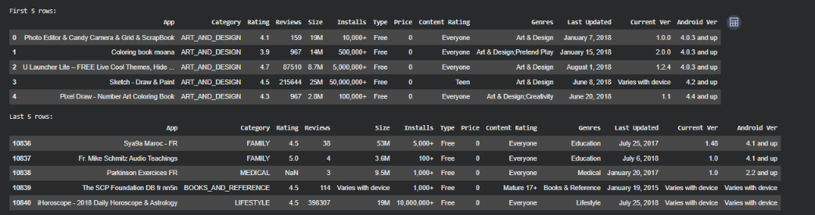

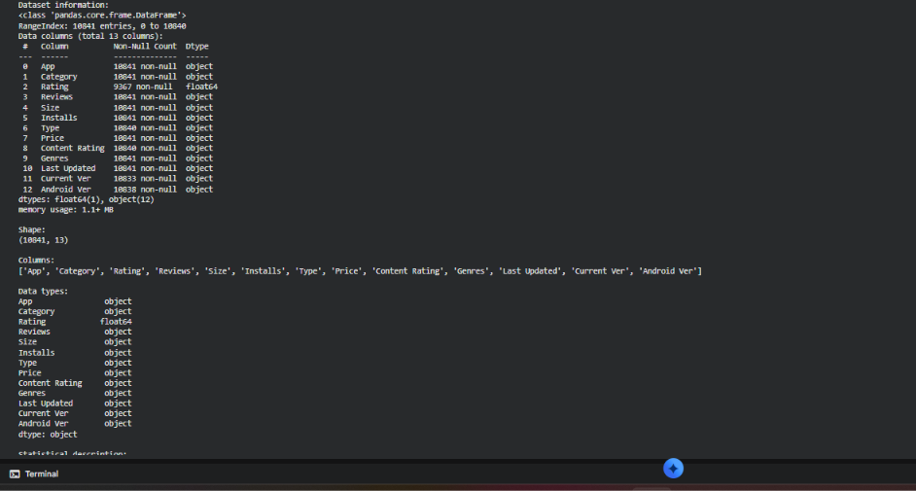

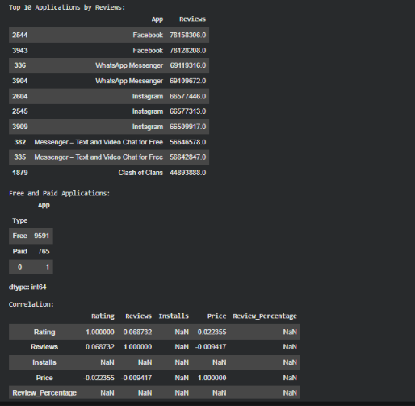
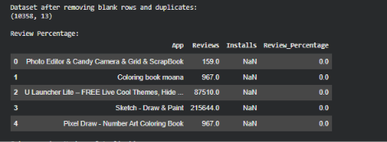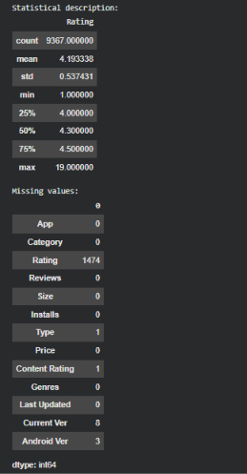

RESULT

