PROJECT DOCUMENTATION REPORT
Student Performance Analytics System
EWB Courses | Python with AI Project Assignment

1. Project Overview & Metadata
Field | Detail
Project Title | Student Performance Analytics System
Student Name | Swathi Talak
Email Address | swathitalak28@gmail.com
Course | Python with AI (EWB Courses)
Programming Language | Python 3.13
Primary Libraries | NumPy, Pandas
GitHub Repository | https://github.com/swathitalakk-hub/python-ai
Operating System | Windows 11 / Cross-Platform
2. Abstract & Problem Statement
2.1 The Problem
In modern academic institutions, faculty members frequently manage large volumes of raw examination and attendance data across multiple courses and departments. Evaluating performance manually using conventional spreadsheets or hand calculations is time-consuming, prone to human calculation errors, and fails to provide instantaneous diagnostic insights such as:
- • Which subject exhibits the lowest average score and requires syllabus review?
- • How strongly does attendance correlate with student examination performance?
- • What are the precise root causes behind individual student failures (e.g., subject-specific score deficit vs. attendance shortfall)?
- • How do different academic departments compare in student pass percentage?
2.2 The Solution
The Student Performance Analytics System is a robust, modular Python analytics application powered by NumPy and Pandas. It automates the entire analytical lifecycle: validating tabular records, computing scores and averages via vectorization, enforcing grading and pass/fail rules, computing rankings, and generating multi-dimensional statistical summaries.
3. System Architecture & Workflow
The workflow follows a 4-tier pipeline: Data Ingestion & Schema Validation (functions.load_data) -> Vectorized Numerical Calculation (calculate_total_and_average) -> Academic Rules Evaluation & Ranking (check_result, assign_grade, add_results_and_grades) -> Multi-Dimensional Reporting & CSV Export.
4. Dataset Specification
The system processes students.csv, comprising 20 student records equally partitioned across four academic departments: Computer Science, Electronics, Mechanical, and Civil (5 students per department).
Column | Data Type | Constraints / Description
Student_ID | String | Unique identifier format (S001 - S020)
Name | String | Full student name
Department | Categorical | Academic department (CS, EC, ME, Civil)
Maths | Integer | Marks obtained out of 100 (0 <= Marks <= 100)
Physics | Integer | Marks obtained out of 100 (0 <= Marks <= 100)
Chemistry | Integer | Marks obtained out of 100 (0 <= Marks <= 100)
English | Integer | Marks obtained out of 100 (0 <= Marks <= 100)
Computer_Science | Integer | Marks obtained out of 100 (0 <= Marks <= 100)
Attendance | Integer | Attendance percentage (0 <= Attendance <= 100)
5. Mathematical Formulations & Evaluation Criteria
Total Marks and Average are computed on 2D NumPy matrices using np.sum(axis=1) and np.mean(axis=1).
Pass Condition: A student passes only if they score >= 40 in every single subject AND have >= 75% attendance.
Grading Criteria:
Average Range | Grade | Passing Condition
>= 90% | A+ | Must satisfy pass condition
80% to 89.99% | A | Must satisfy pass condition
70% to 79.99% | B | Must satisfy pass condition
60% to 69.99% | C | Must satisfy pass condition
50% to 59.99% | D | Must satisfy pass condition
40% to 49.99% | E | Must satisfy pass condition
< 40% or Failed | F | Automatic override on any rule violation
6. Key Findings & Analytics Results
• Overall Class Average: 70.89 / 100 (Median: 72.50, Std Dev: 15.01)
• Pass Percentage: 85.0% (17 Passed, 3 Failed)
• Attendance Correlation: 0.973 (Extremely strong positive correlation)
Top 5 Academic Achievers
Rank | Student ID | Name | Department | Total | Average | Grade
1 | S008 | Meera Nair | Computer Science | 471 | 94.20% | A+
2 | S016 | Pooja Joshi | Civil | 450 | 90.00% | A+
3 | S004 | Ananya Iyer | Electronics | 446 | 89.20% | A
4 | S001 | Aarav Sharma | Computer Science | 440 | 88.00% | A
5 | S012 | Kavya Krishnan | Computer Science | 435 | 87.00% | A
Subject-Wise Benchmark Comparison
Subject | Average | Highest | Lowest | Std Dev | Pass % | Topper
English | 75.05 | 94 | 55 | 11.60 | 100.0% | Pooja Joshi (94)
Computer Science | 73.20 | 99 | 42 | 16.76 | 100.0% | Meera Nair (99)
Maths | 69.30 | 95 | 33 | 17.67 | 95.0% | Meera Nair (95)
Chemistry | 68.85 | 92 | 44 | 15.51 | 100.0% | Meera Nair (92)
Physics | 68.05 | 97 | 38 | 16.12 | 95.0% | Meera Nair (97)
Department-Wise Performance Breakdown
Department | Students | Avg Marks | Avg Attendance | Passed | Pass %
Computer Science | 5 | 82.56 | 92.2% | 5 | 100.0%
Electronics | 5 | 71.20 | 86.2% | 4 | 80.0%
Civil | 5 | 66.92 | 83.2% | 4 | 80.0%
Mechanical | 5 | 62.88 | 81.6% | 4 | 80.0%
Failure Diagnosis (At-Risk Students)
ID | Name | Department | Avg | Attnd | Diagnosis Reason
S005 | Karthik Naidu | Mechanical | 48.6 | 70% | Physics < 40 (38); Attendance < 75%
S013 | Rahul Das | Civil | 45.6 | 68% | Maths < 40 (33); Attendance < 75%
S018 | Lakshmi Prasad | Electronics | 52.4 | 73% | Attendance < 75% (Shortfall of 2%)
7. Program Execution Screenshots
Output Part 1: Dataset Overview, Rules, and Student Report Card:
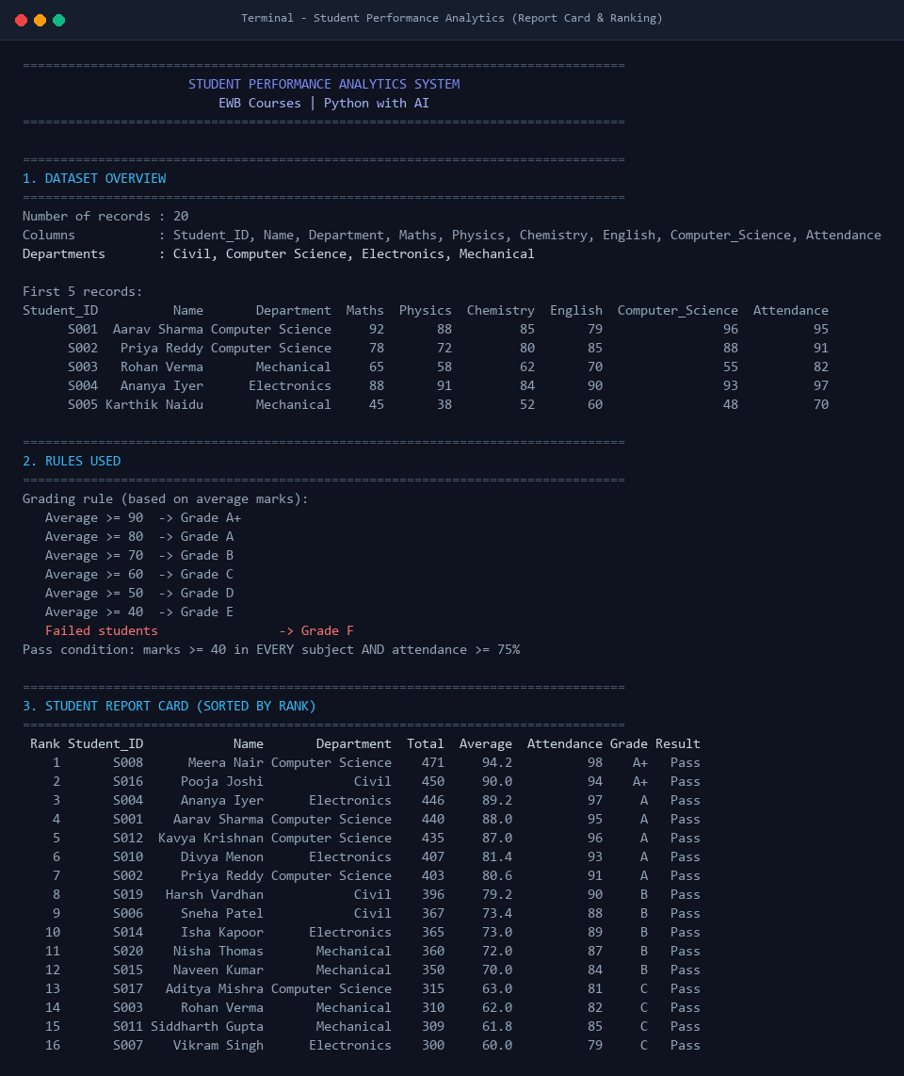

Output Part 2: Statistical Analytics, Subject & Department Benchmarks:
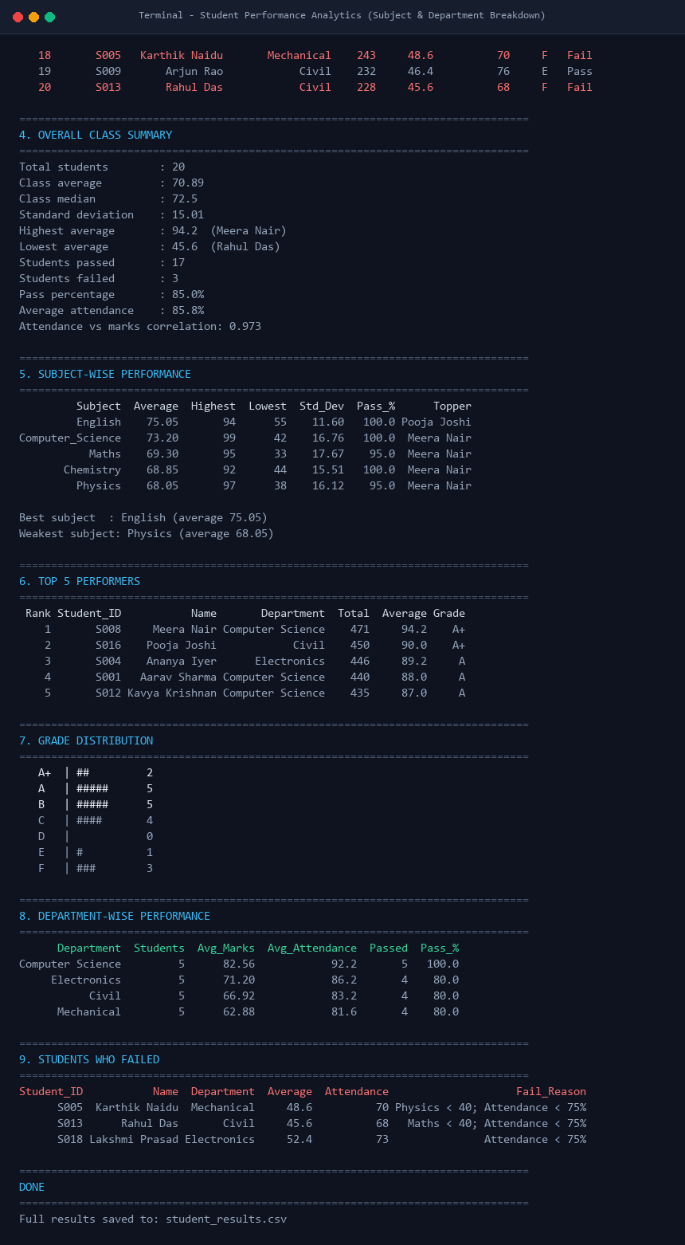
8. Execution Instructions
1. Clone repository: git clone https://github.com/swathitalakk-hub/python-ai.git
2. Install requirements: pip install -r requirements.txt
3. Run system: python main.py

