**DESIGN AND ANALYSIS OF ALGORITHMS**

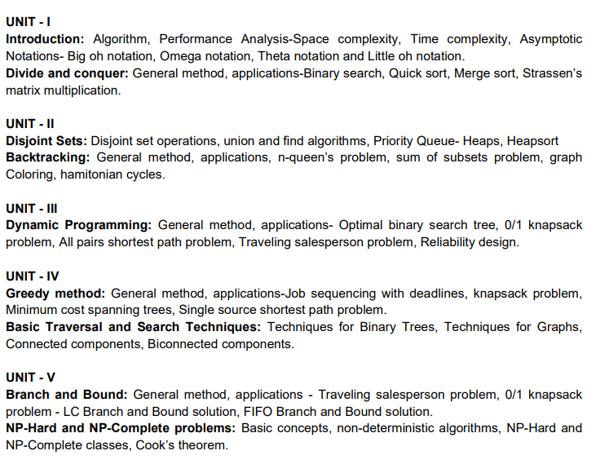

**COMPUTER NETWORKS**

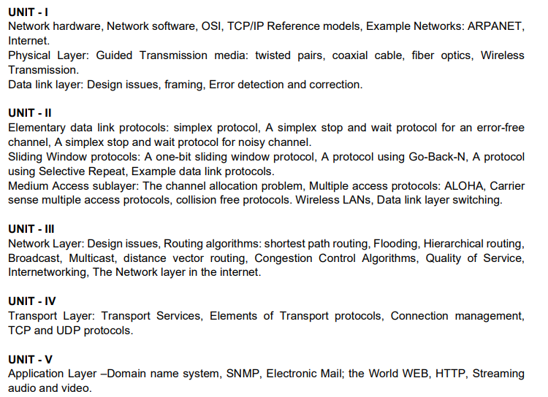

**DEVOPS**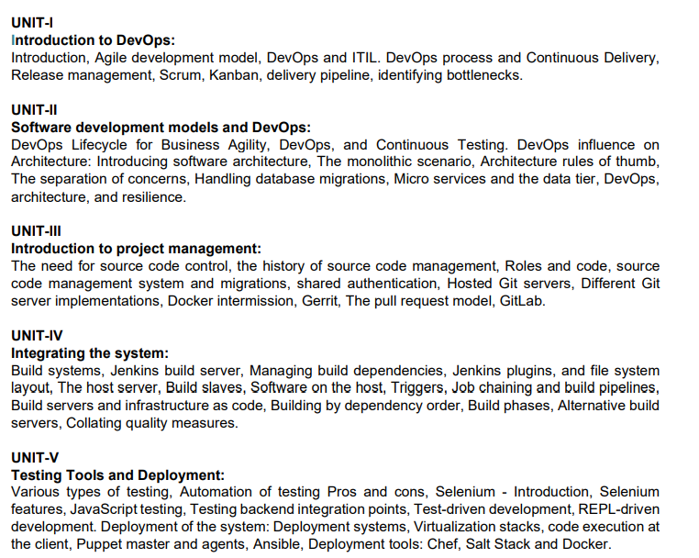

**DATA ANALYTICS**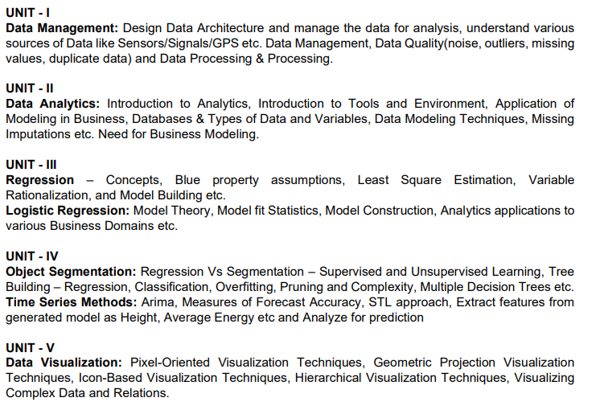

**NATURAL LANGUAGE PROCESSING**

