Assignment

1. Create an Author component which will have 3 fields Author Name-single line text field-Mandetry Author Bio-multiline text field-Mandetry Dob-date picker-Mandetry create the component with above dialog fields Fetch these value directly using htl properties tag

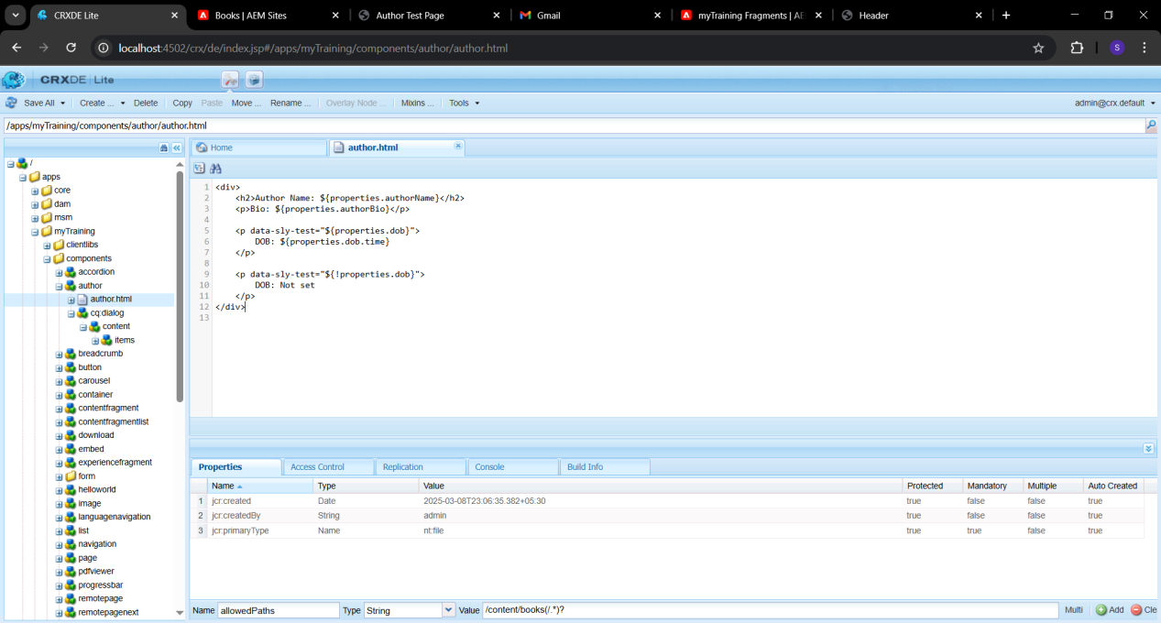

I have created the author component in the components folder with the necessary three specified fields.

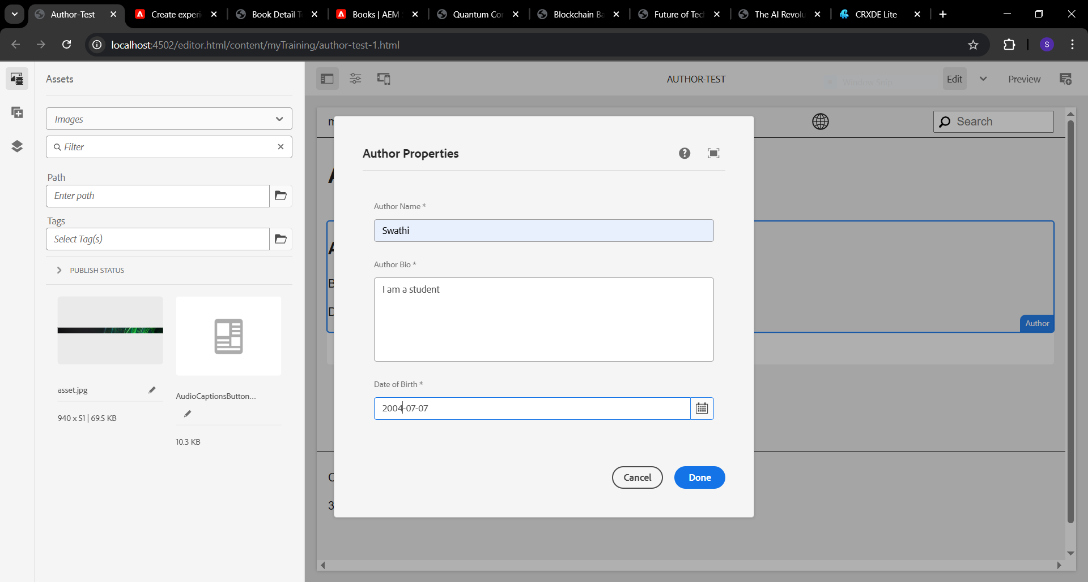

Here, I opened a web page in the AEM editor and entered field values for the author component.

