ASSIGNMENT:

Create Book Detail Template Create 10 pages from above template make sure name and urls should be unique for each page eg-can search 10 books name on internet and can use Create header it should have logo, Books, about me and reach me page for header we will need those above pages and should be created then use in navigation component inside header XF make sure Styling should be there from ui.frontend footer should have 4 section 4x3 grid system 1 grid will have books pages created above 2Grid will have about us 3reach me section 4 Social media should have 5 should have copyright section and apply styling from ui.frontend and should be responsive Create multi field component.

In this step, we are creating a template inside the folder.

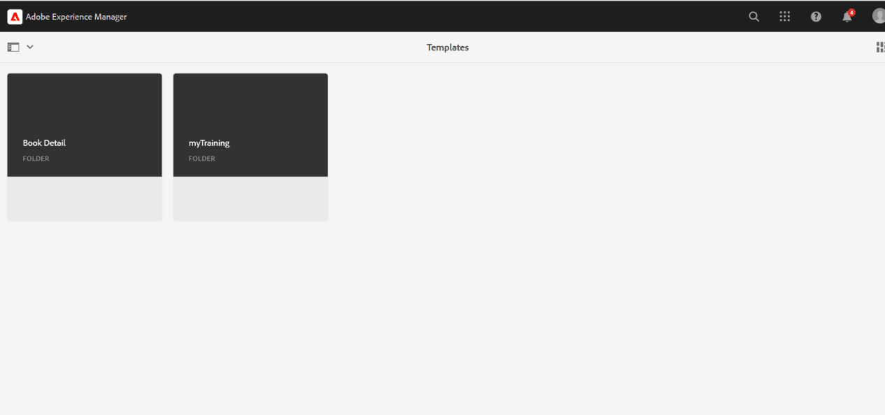

After creating the header component, we are creating pages like About us , Reach us and Books at the sites page of AEM.

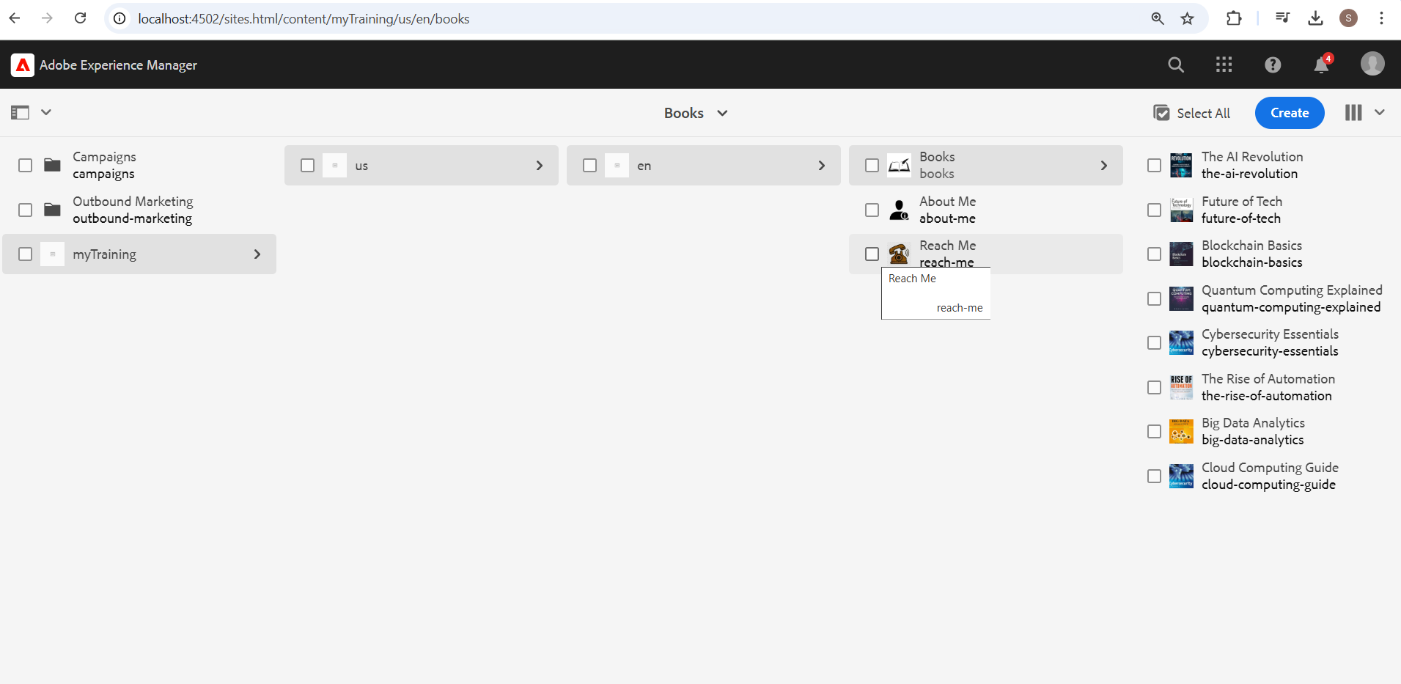

I have created 10 pages for 10 different books with a specified name, author name and description of the book.

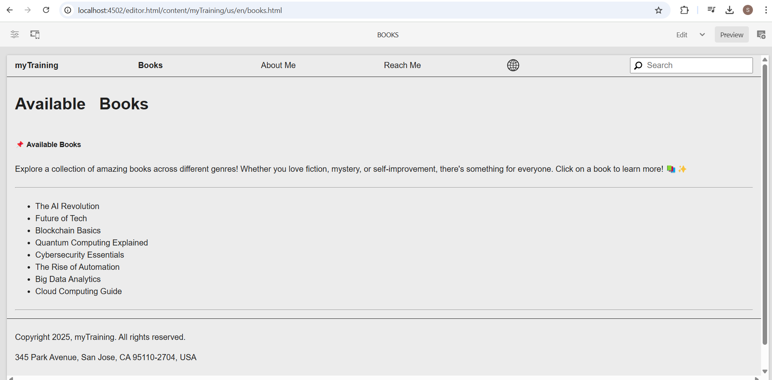

In the main page, when we click on Reach Me, it redirects to this ReachMe page.This is done with help of navigation component.

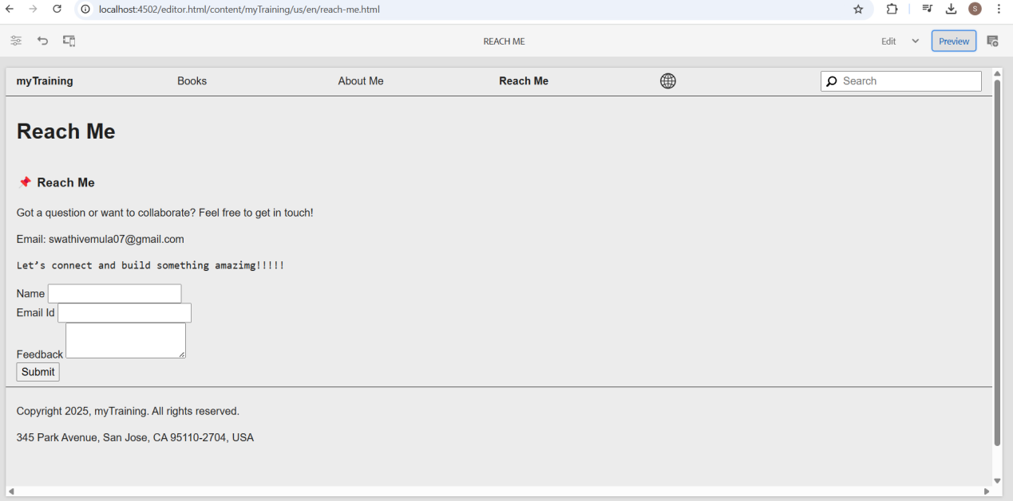

Here, clicking on a single book, will redirect to the page containing the book name , author name and the description of the book.Examples are shown below this image.

