ASSIGNMENT-3

Start the AEM server to open this page.

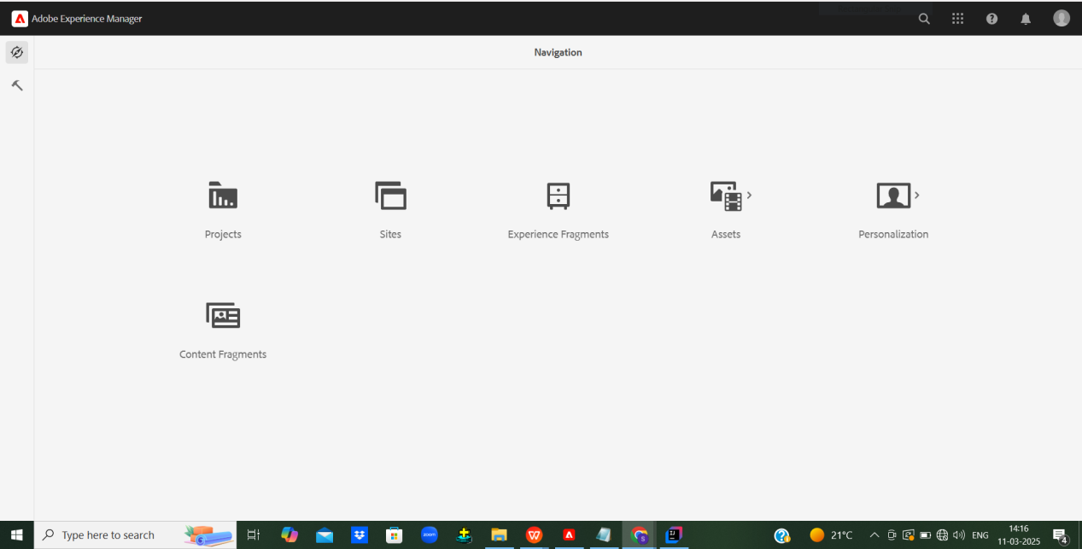

This is the styling for the header.html.I have created a header.scss file and added styles.

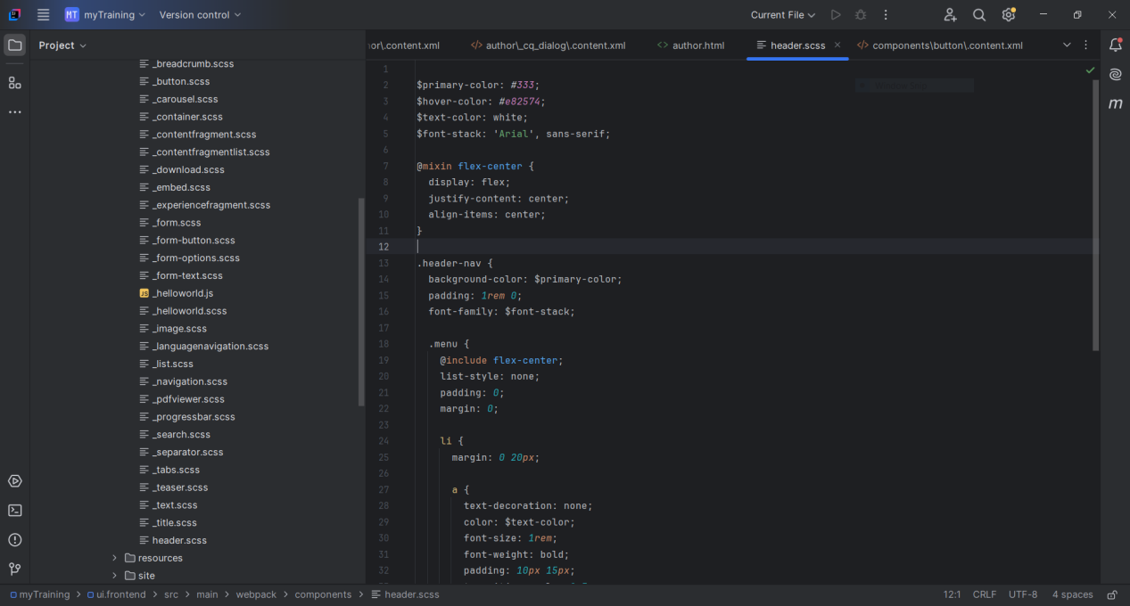

This is the styling for the footer.html. I have created a footer.scss file and added styles.

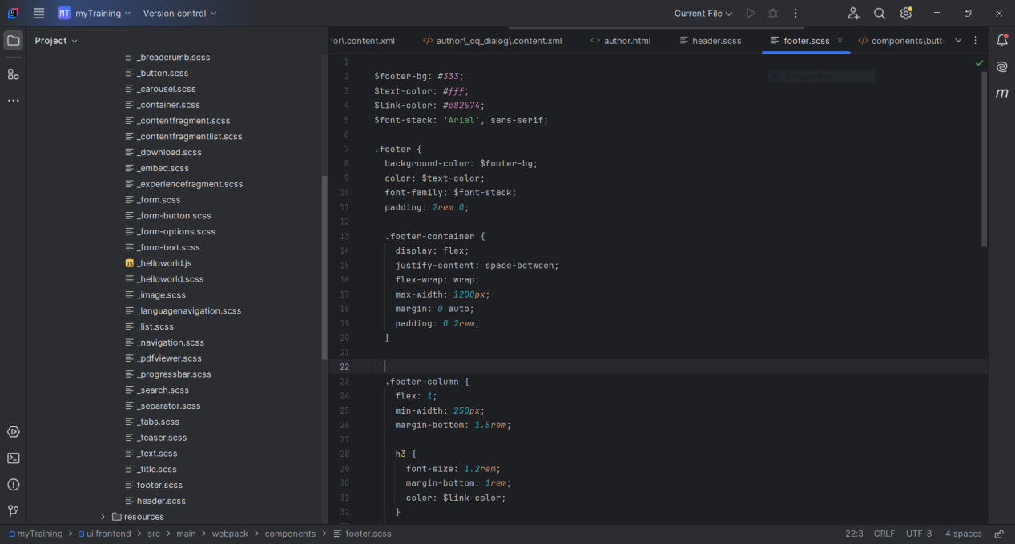

I have updated the author component to add another text field as multi field.

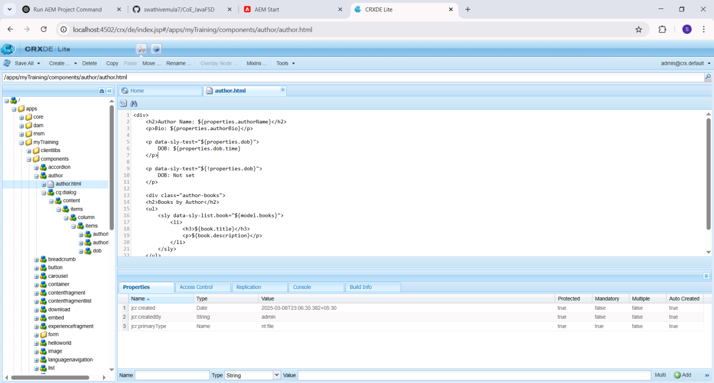

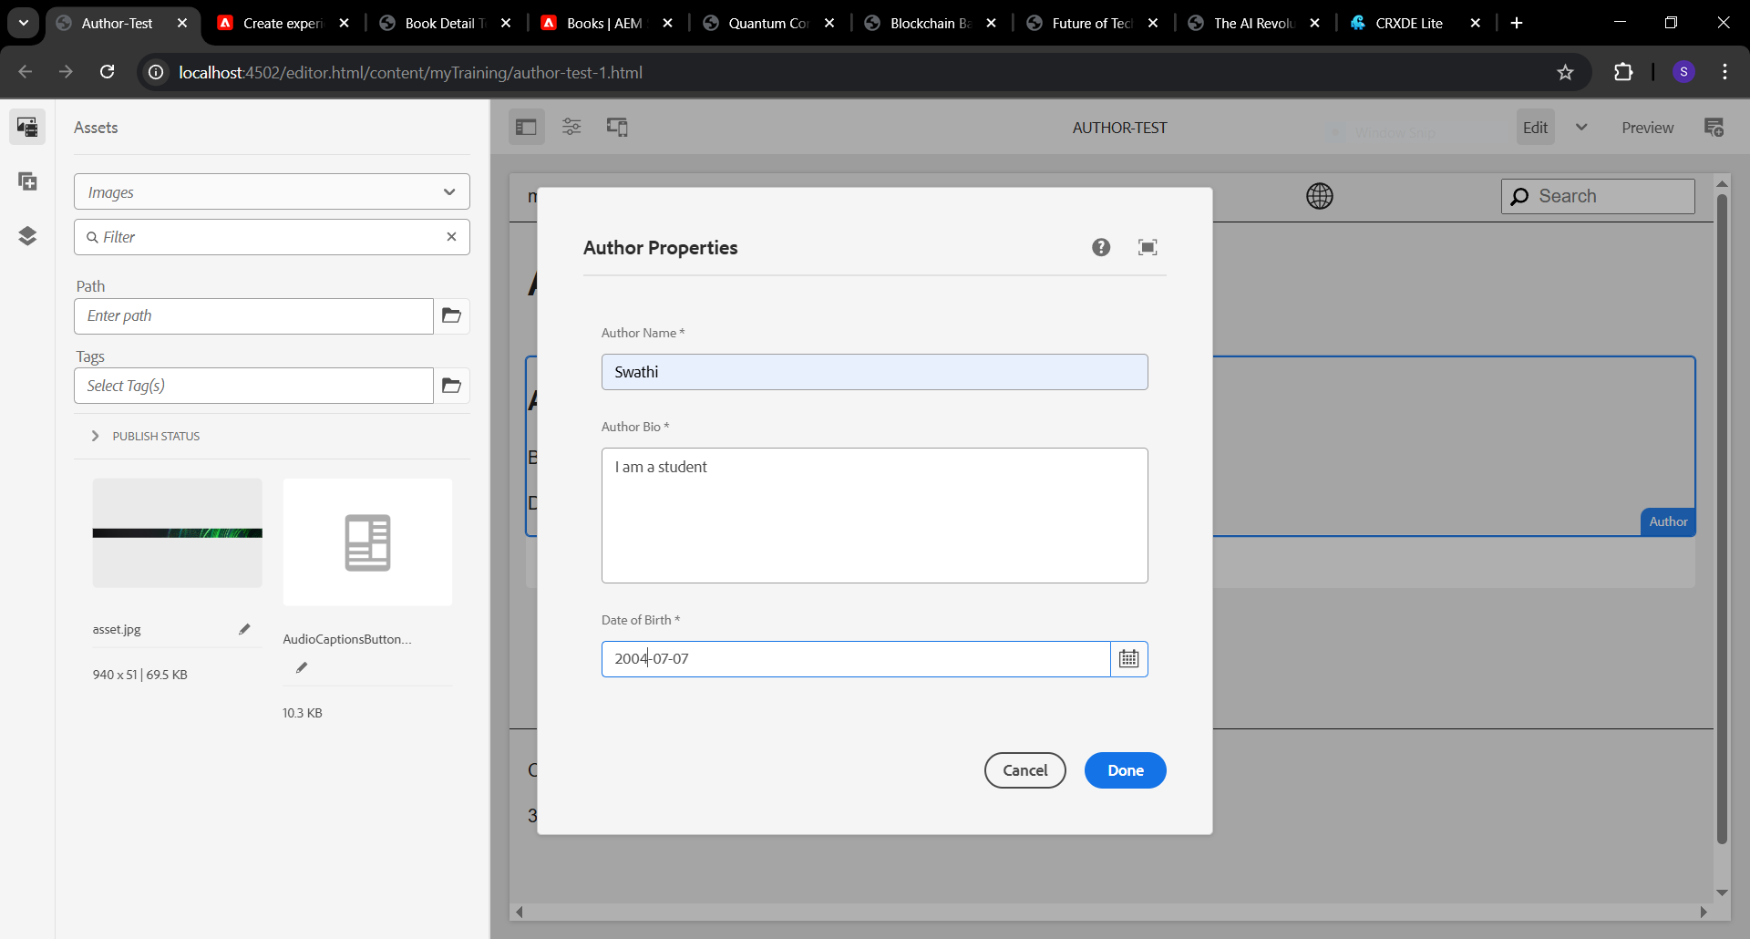

Template Creation:

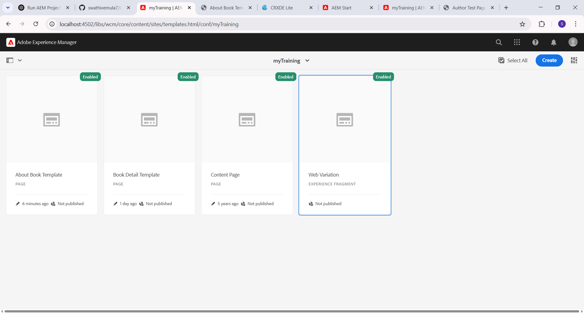

These are the book pages created.

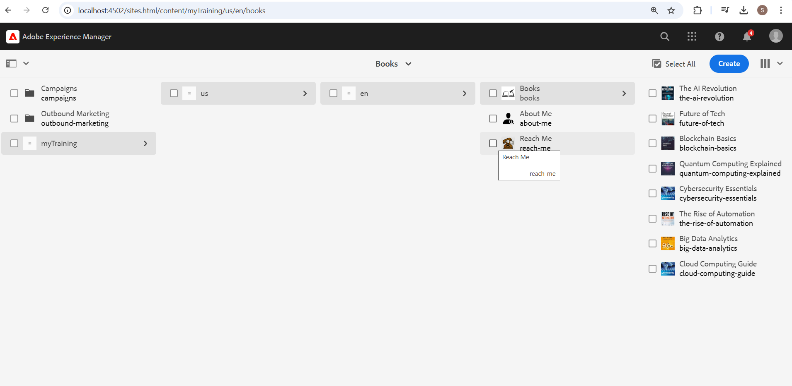

The Book component template containing the title, author name cover image and description of the book.

