ASSIGNMENT - 4

This contains the HTML and CSS to display a group of books in a card like structure both in vertical and horizontal manner.

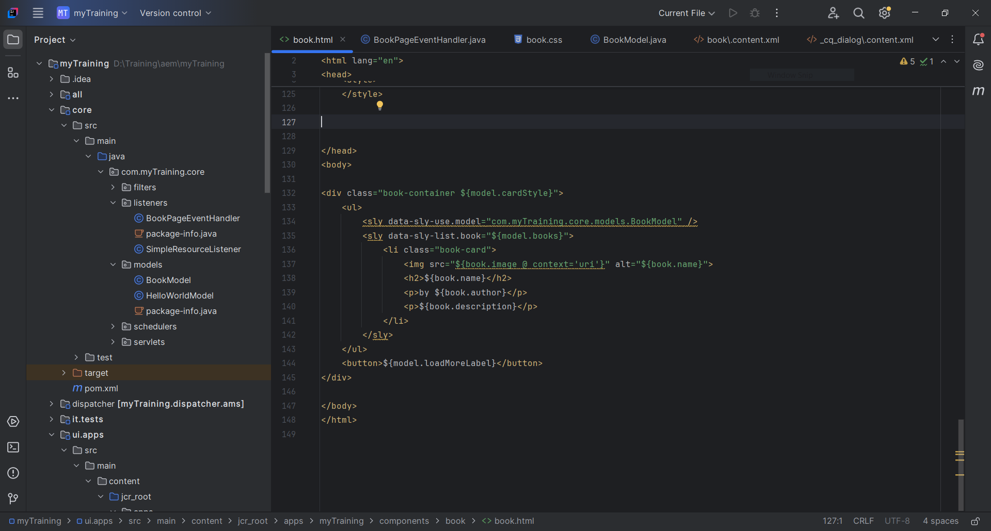

This BookModel.java code contains the backend logic to query and get the book properties which are passed to book.html.

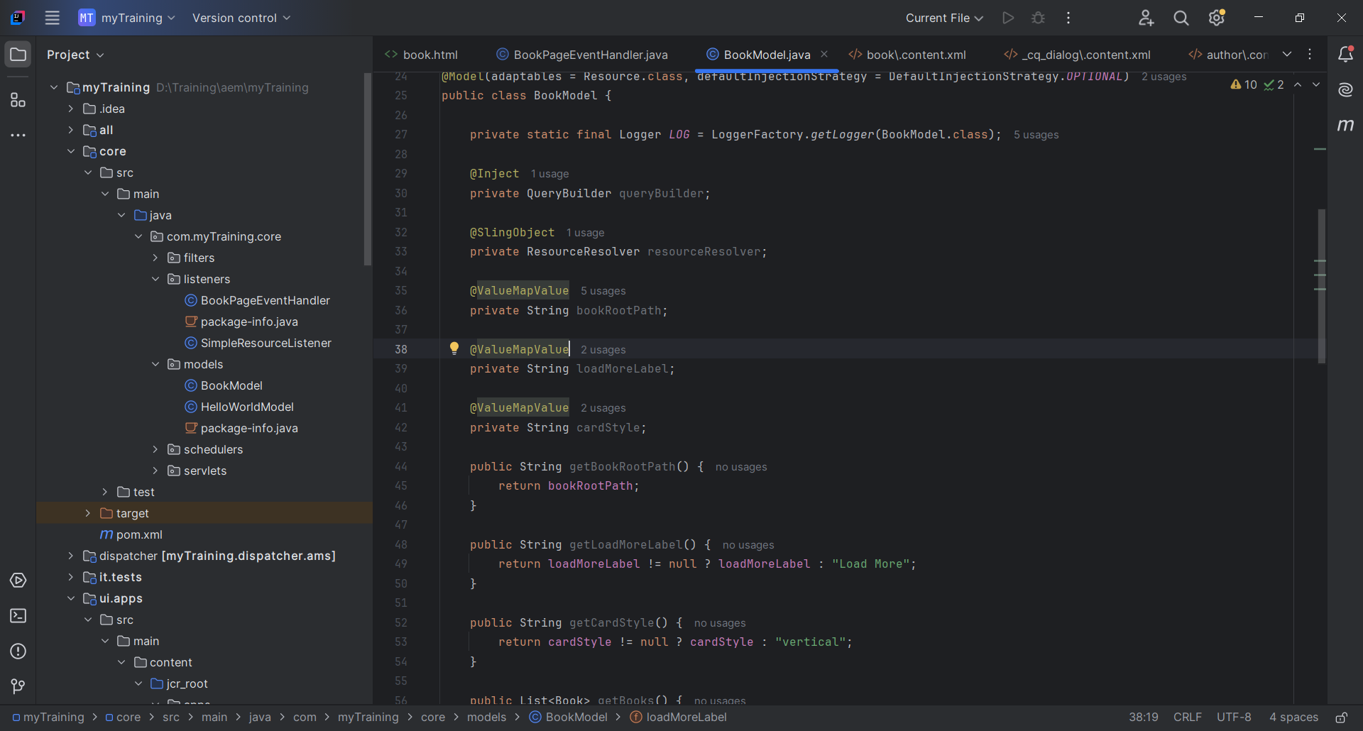

This is the eventhandler code to log the page name whenever a new page is created.

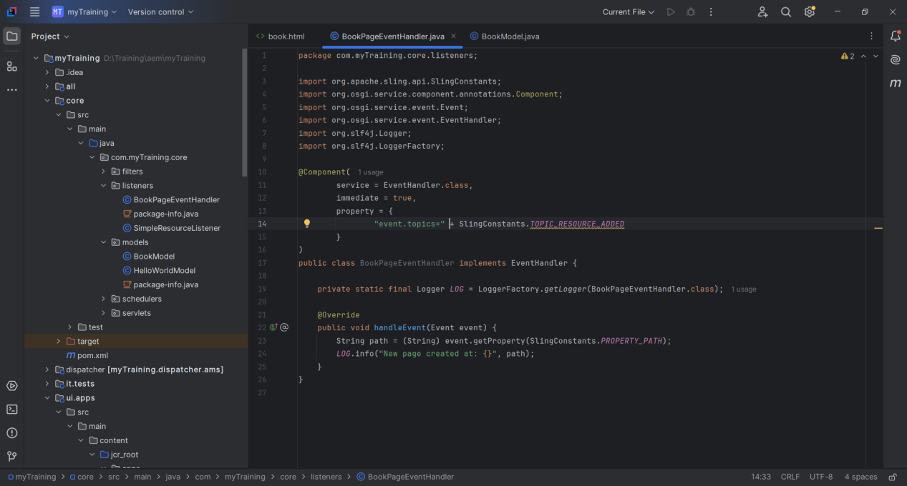

These are the book pages created with some properties added like book name, image, description of book and date of publish.

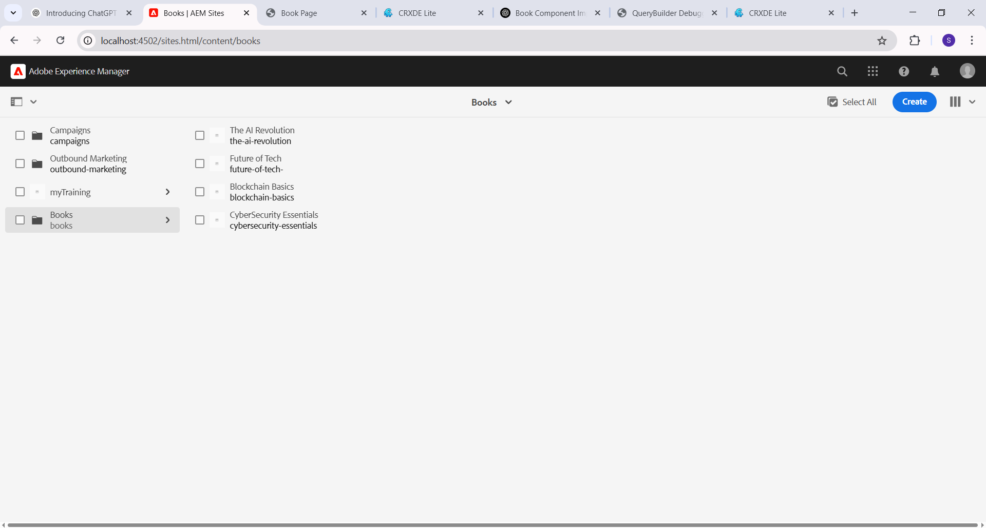

OUTPUT:

