ASSIGNMENT - 5

I have created the template to create pages on top on it in the AEM author instance.

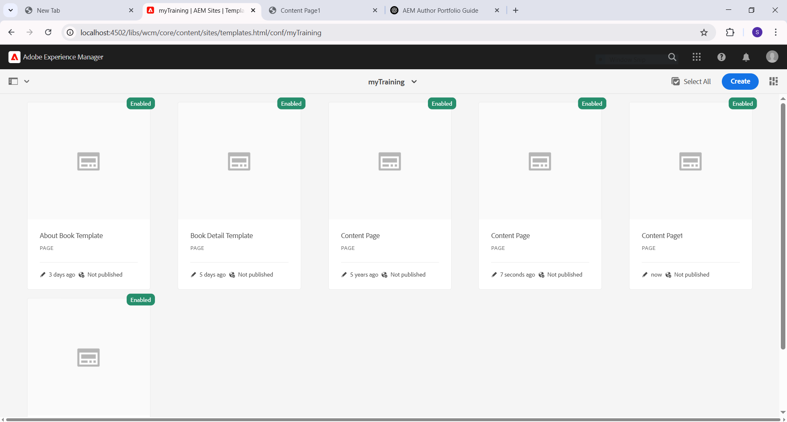

These are the pages, that is about-me, contact-me and Home page.

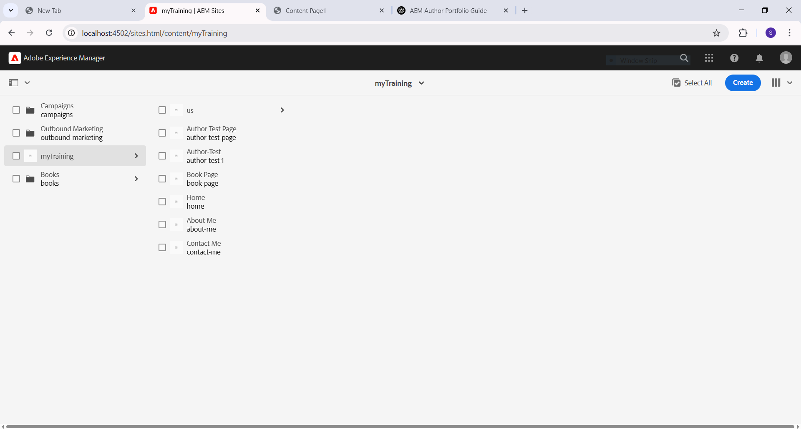

These are the books pages built on top of the Book Detail template shown in the first screenshot.

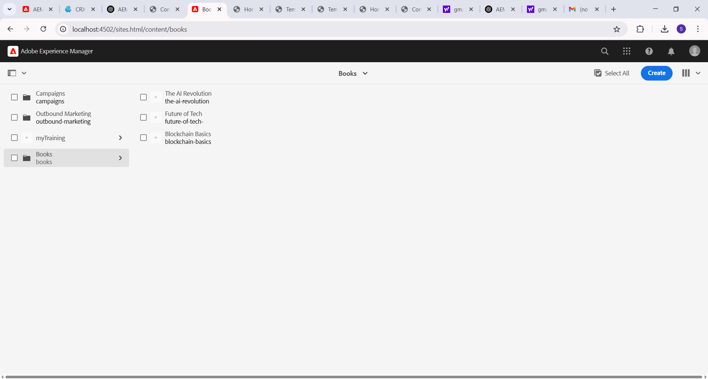

This About Me page includes both the header and the footer. Header with four links ,(i.e, home, books, about me, reach me) with global navigation.The footer contains the contact secion and the social media handle of the author.

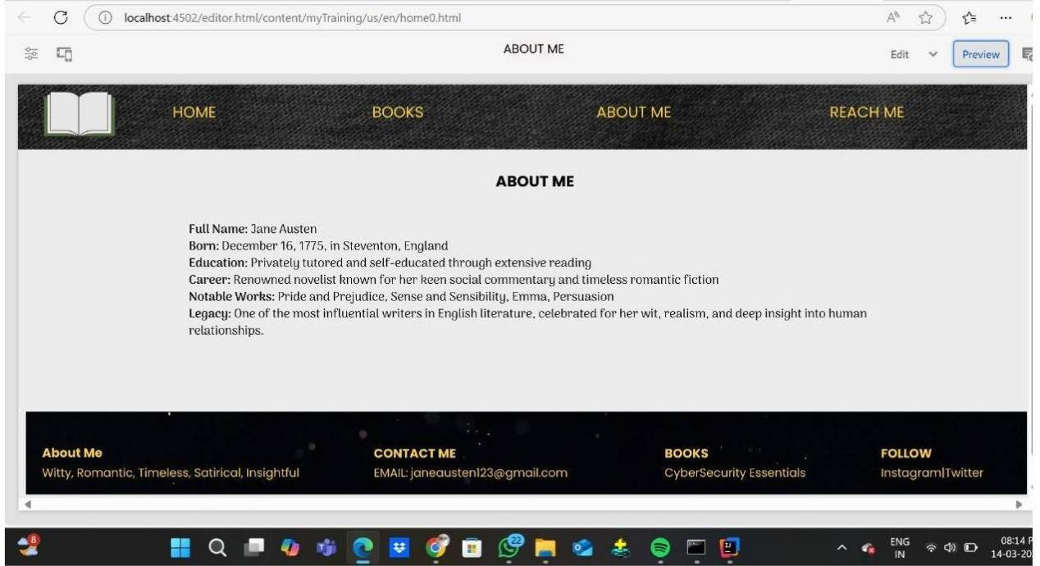

The Home page which describes a list of awards that navigate to that particular award page on click.

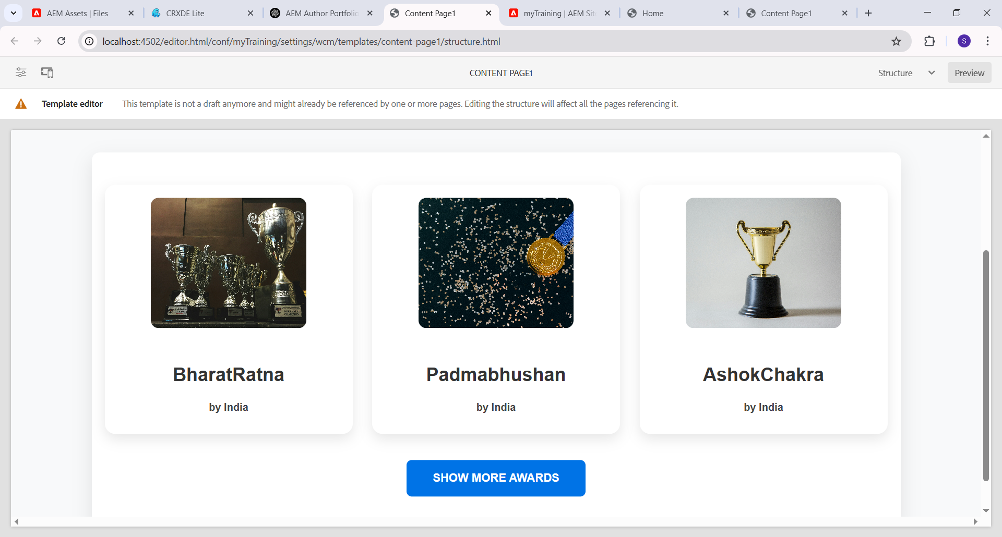

The page also has authors listed with title, (using title component), image(using image component) and also some description of the author.

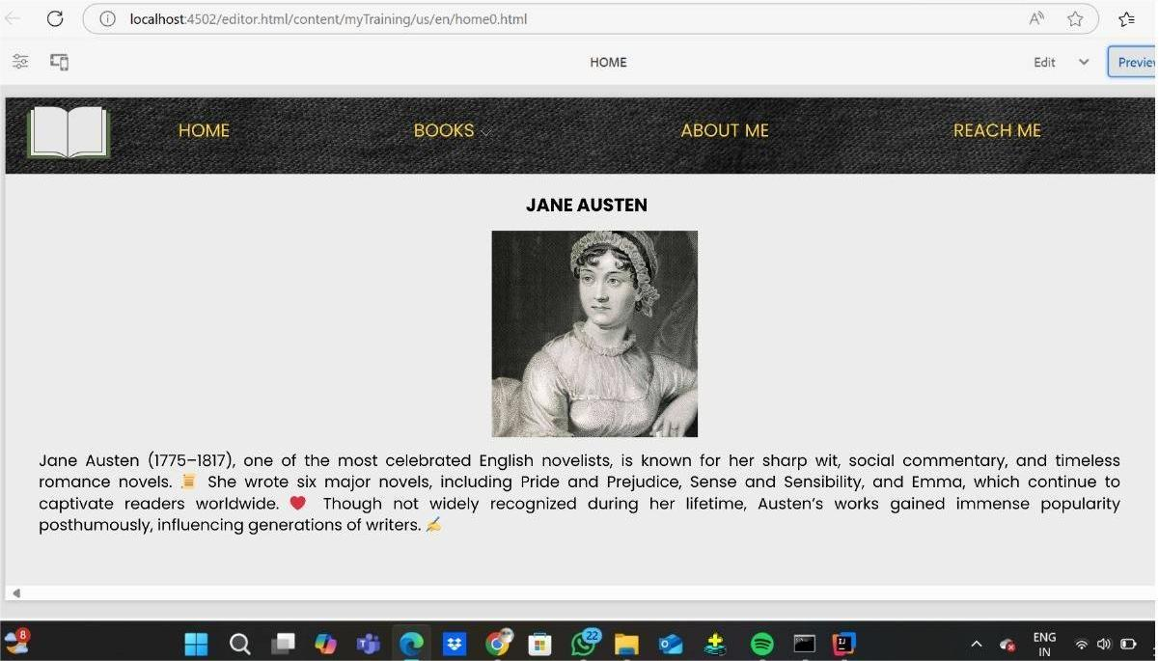

This is the Reach-Me page with the contact details of the author. And also I have style it as a list with a contrast brown background using css.

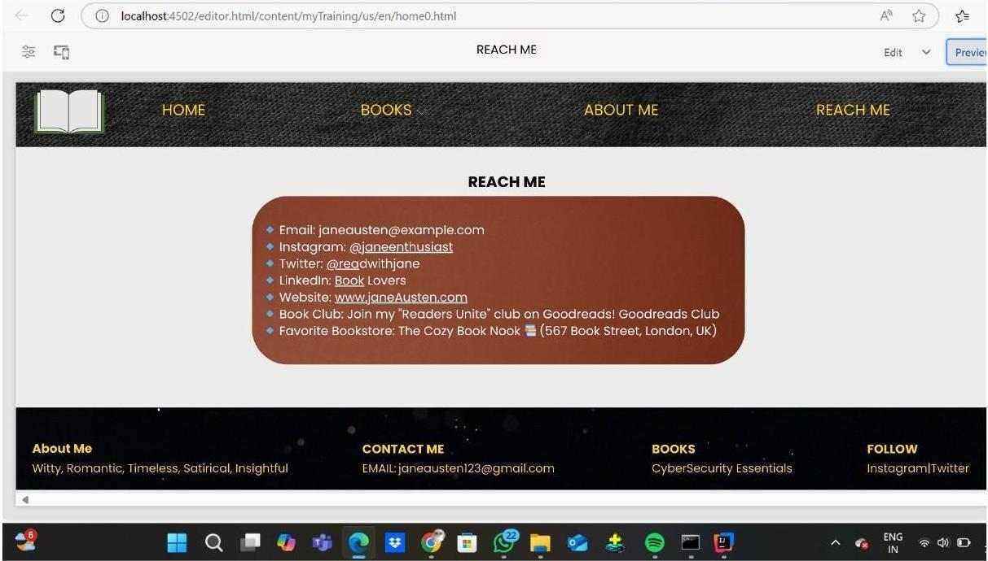

This is the single page view of the book with the details of the book listed with its image cover and title.

