Image1:

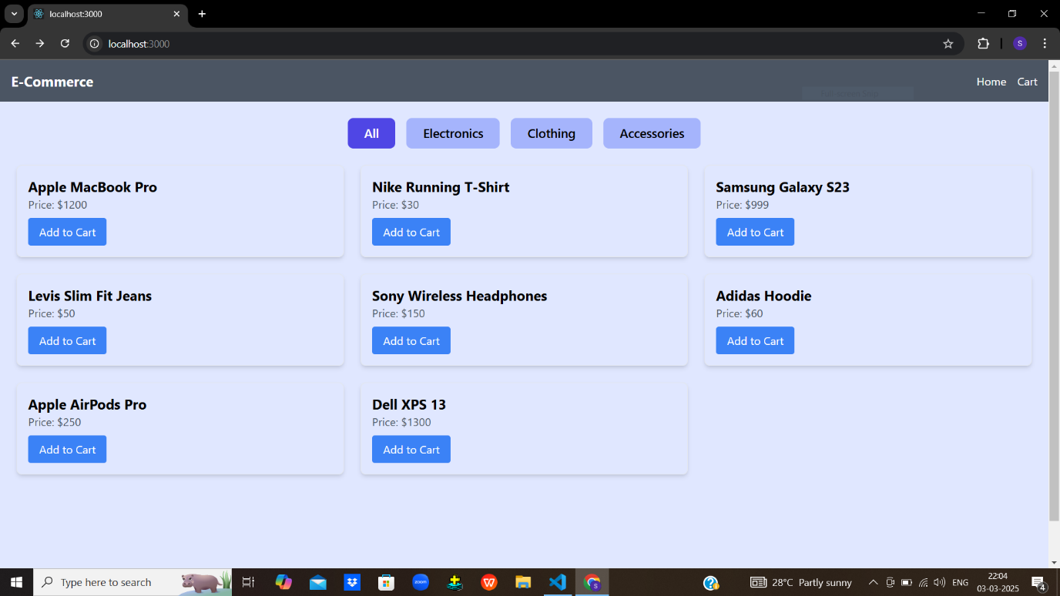  
The **Home Page** displays a variety of products, each shown in a card layout. Each card contains the product's name, price in USD, and an "Add to Cart" button. The products are dynamically rendered from the products array, ensuring that any new product added to the data source appears automatically. The design is clean and minimal, allowing users to easily browse and add products to their cart with a single click.

Image2:

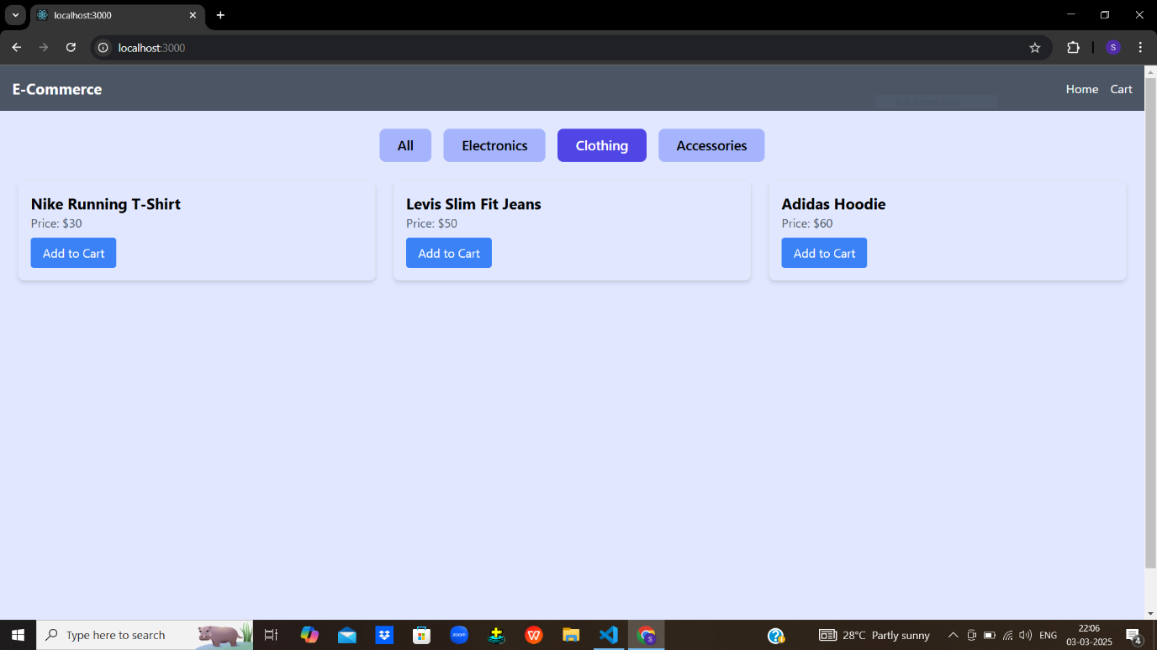

The **Filtering Products** feature allows users to filter items by category, such as "All", "Electronics", and "Clothing". Clicking on a category updates the displayed products without reloading the page. This is achieved by updating the selectedCategory state and using the filter() method to show only the relevant products. The active category button highlights visually, giving users clear feedback on their selection.

Image3:

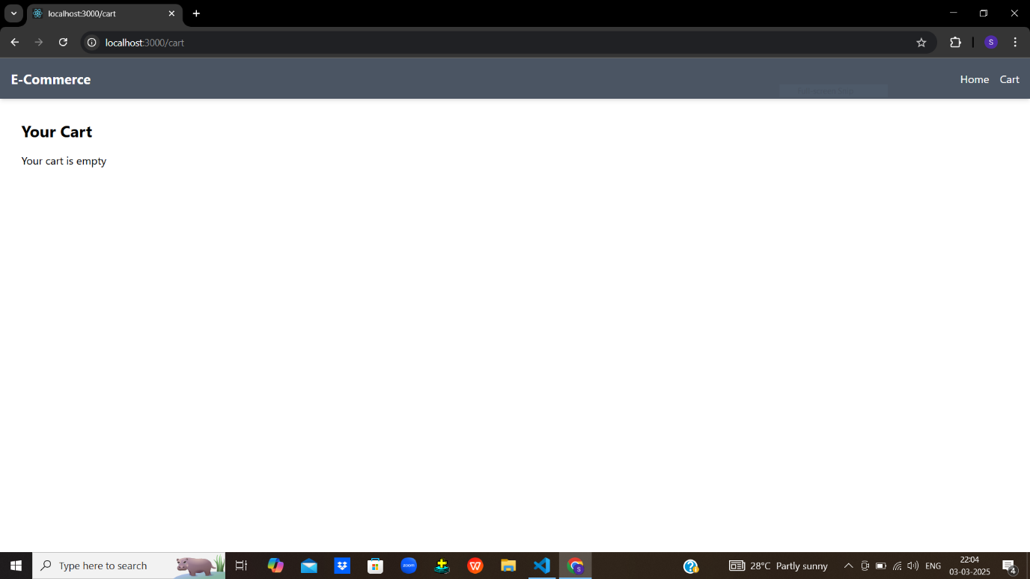

The **Empty Cart Page** provides a simple message — "Your cart is empty" — when no products have been added to the cart. The cart items are managed using a cart array from the CartContext, and the empty state is conditionally rendered when the array length is zero. This ensures users receive immediate feedback if they visit the cart without adding anything, keeping the experience intuitive.

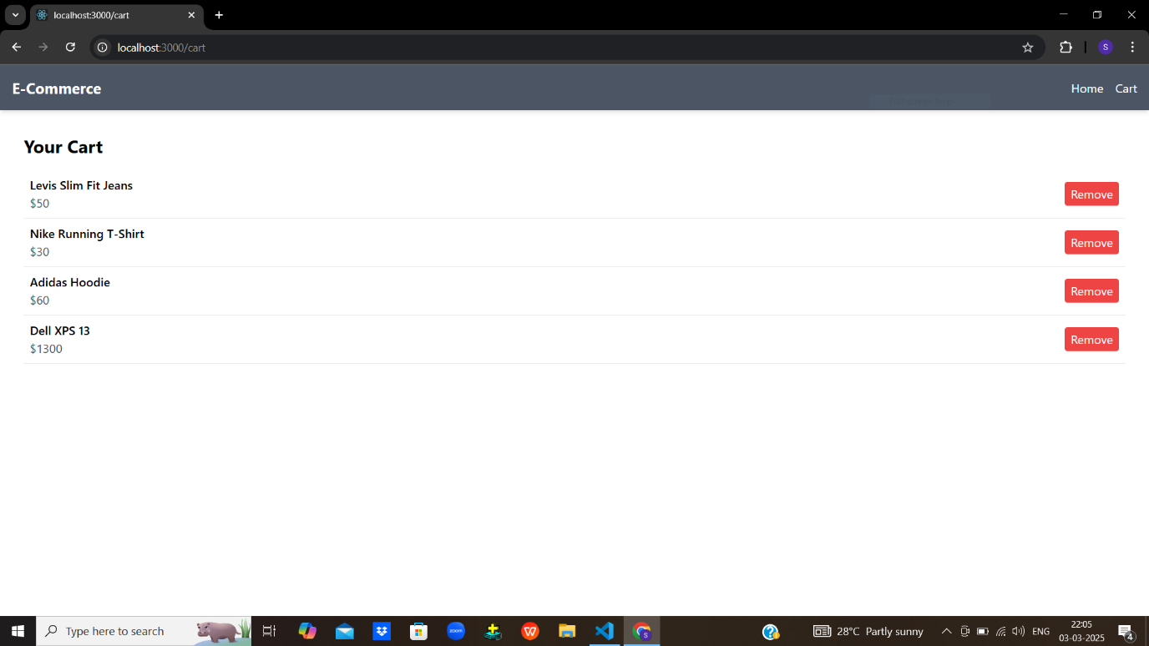

The **Cart Page with Products** shows all items the user has added to their cart. Each product is listed along with its name, price, and a "Remove" button. The remove functionality works by calling the removeFromCart() function, which removes the item using its unique id. The layout remains clean and organized, allowing users to review their selected products and remove them easily.