After Deploying to aws output of springboot app.

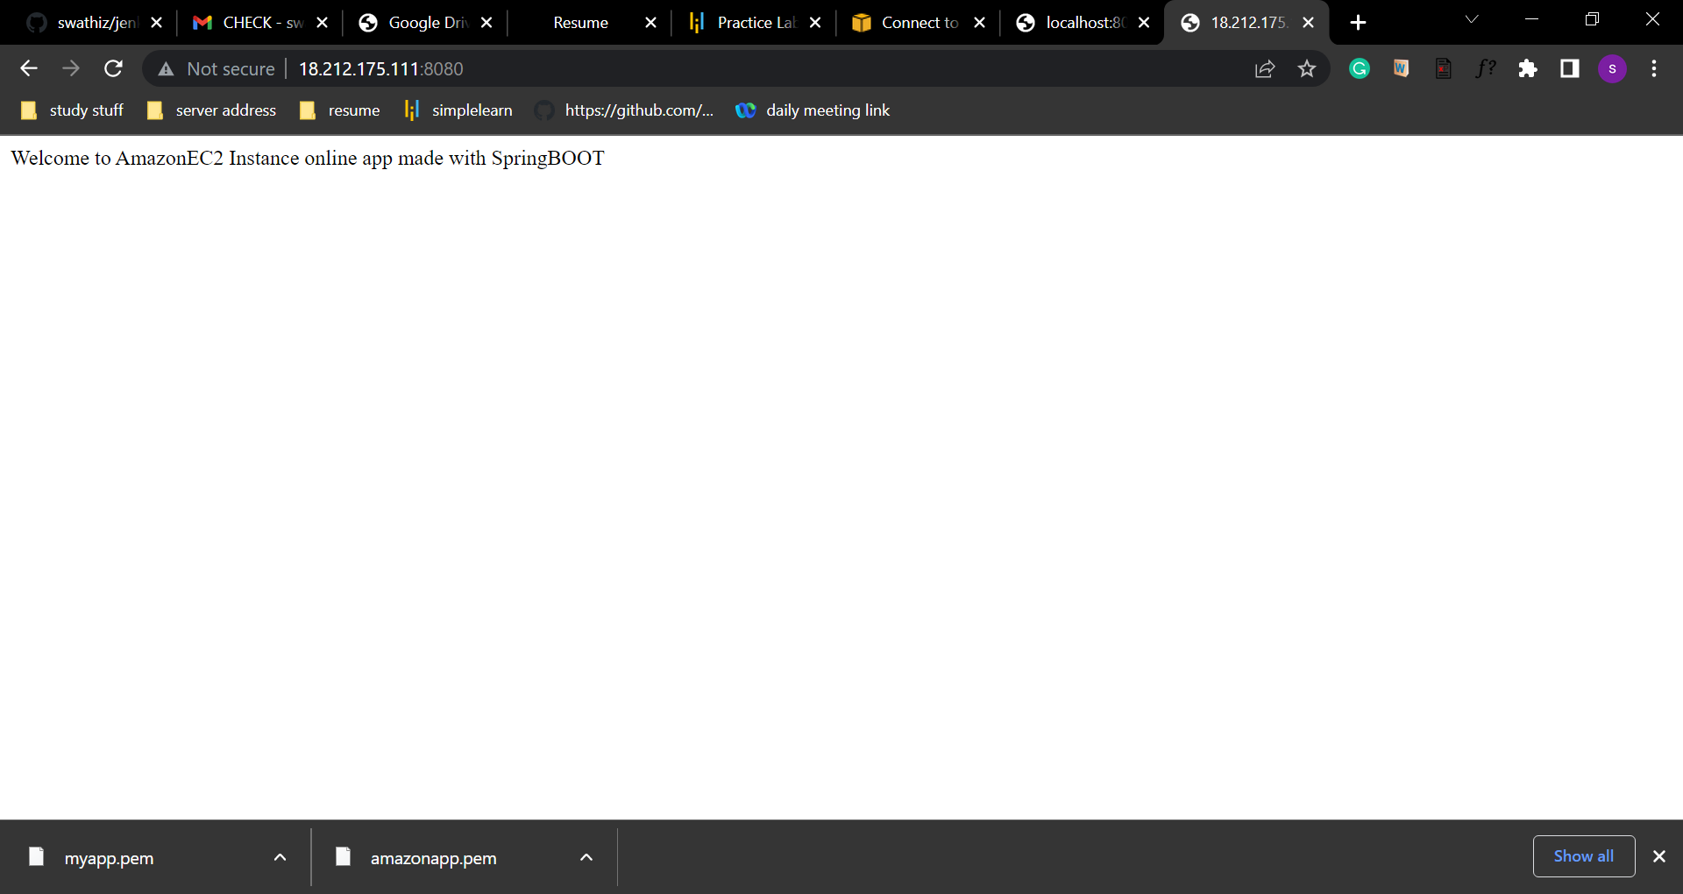

Output of spring boot app in localhost

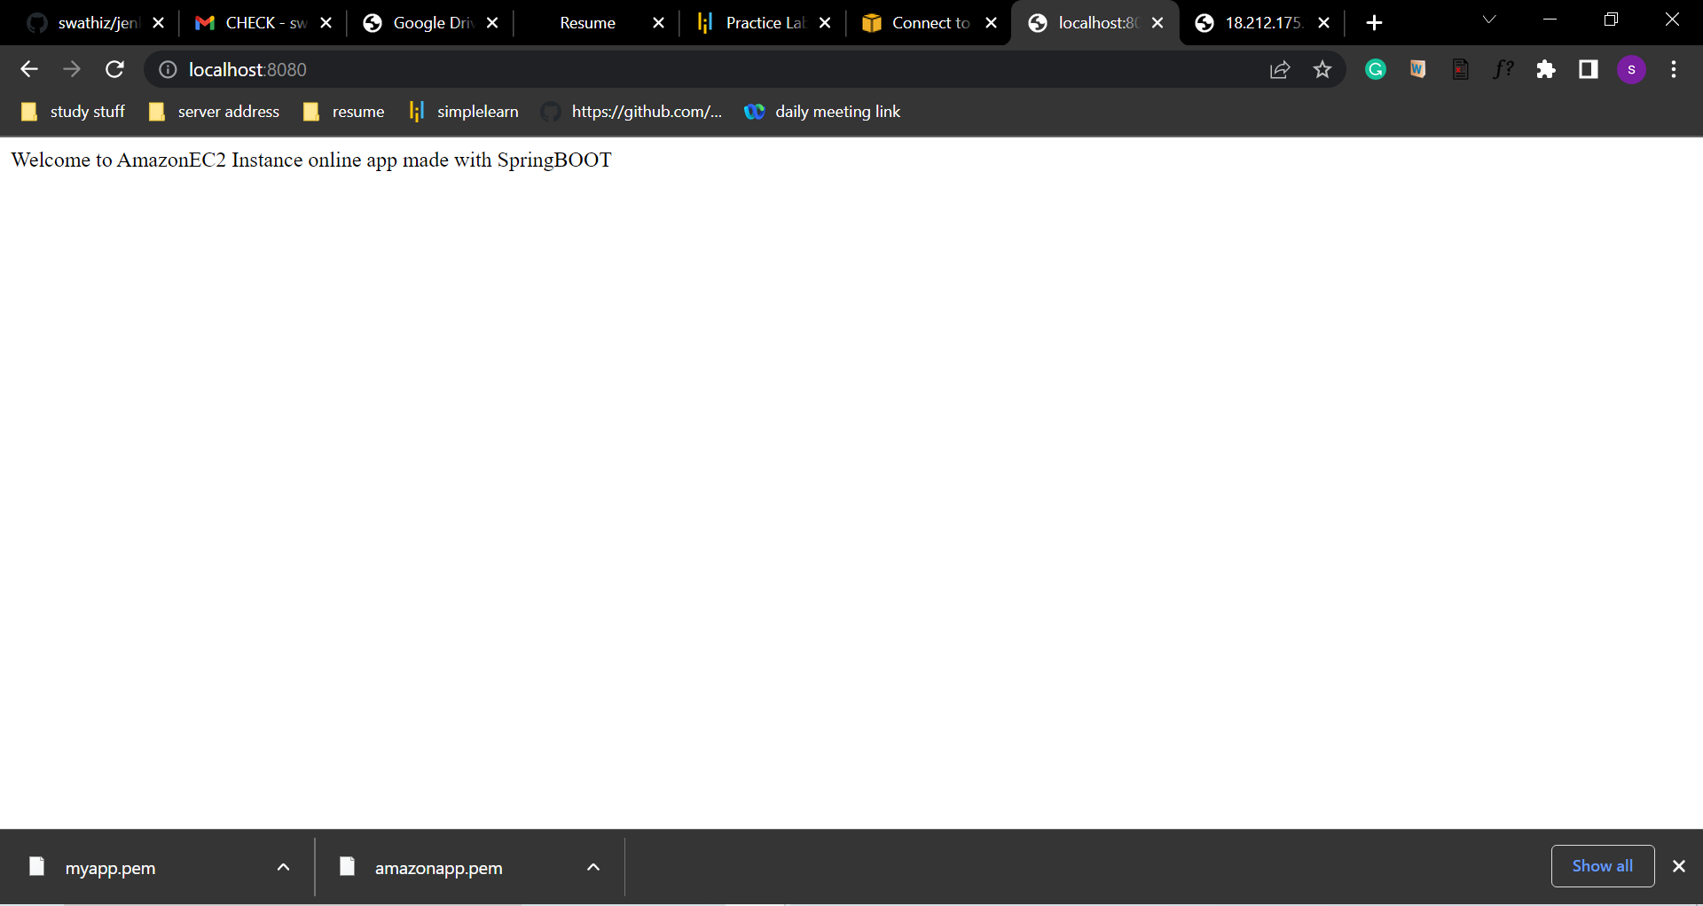

Console output of executing the springboot app in mobaxterm console.

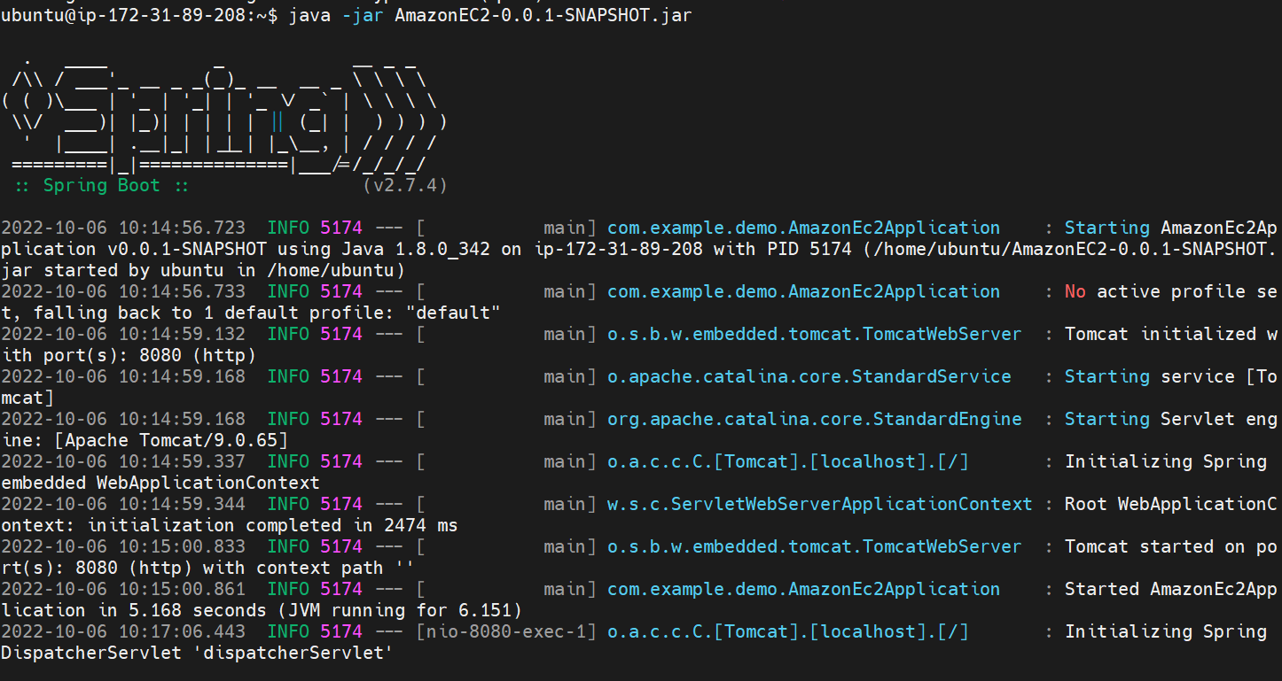

Installing the maven in ec2 instance to run the springboot app.

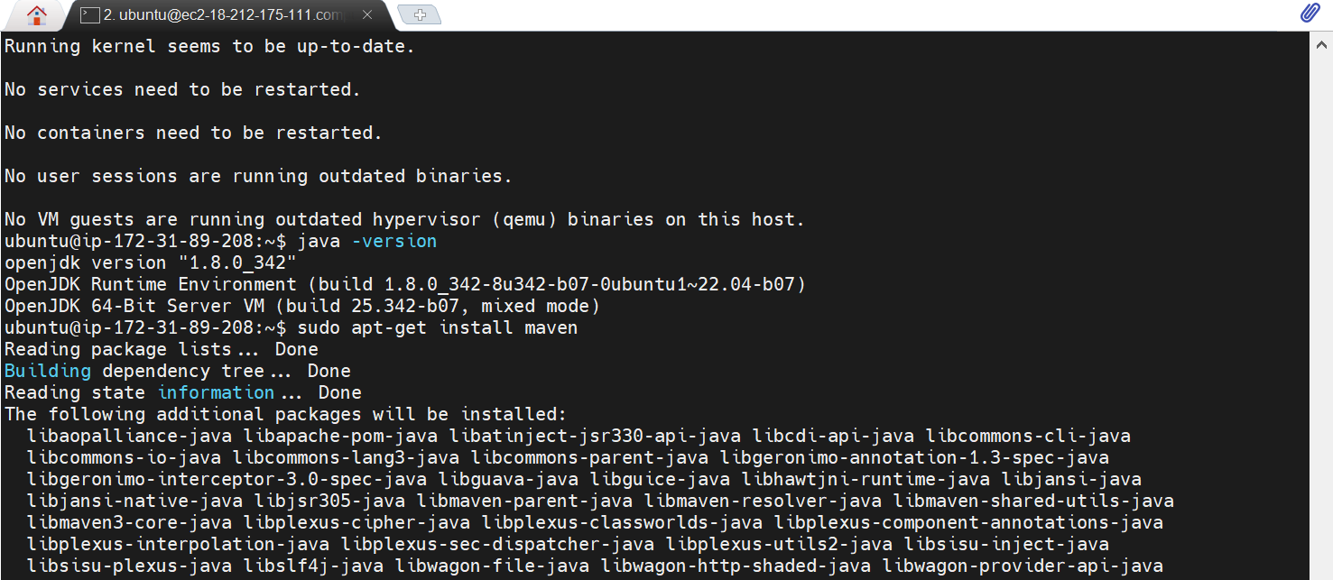

Add the jar file of the springboot app and pem file of ec2 instance to one folder and redirect to that folder and give the ssh cmd under the (select ec2 instance then > connect> goto ssh client tab> copy the content under Exapmle: --) “ec2-18-212-175-111.compute-1.amazonaws.com”

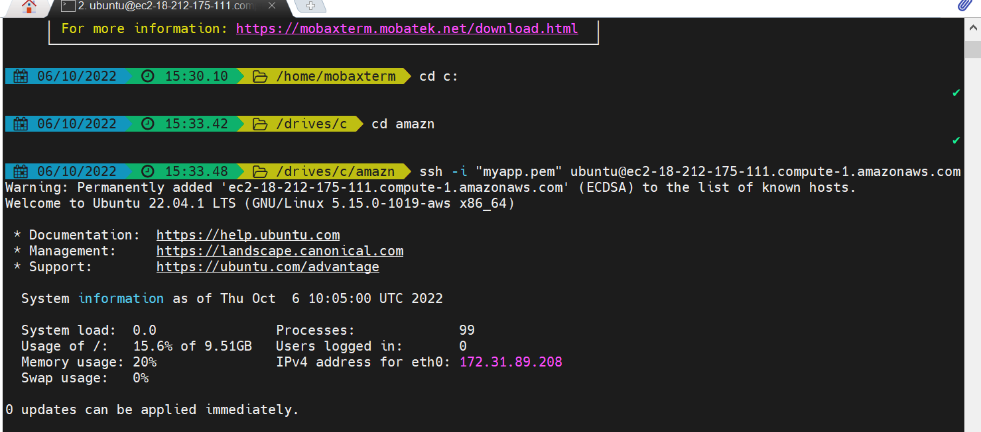

Output of amazon myapp details

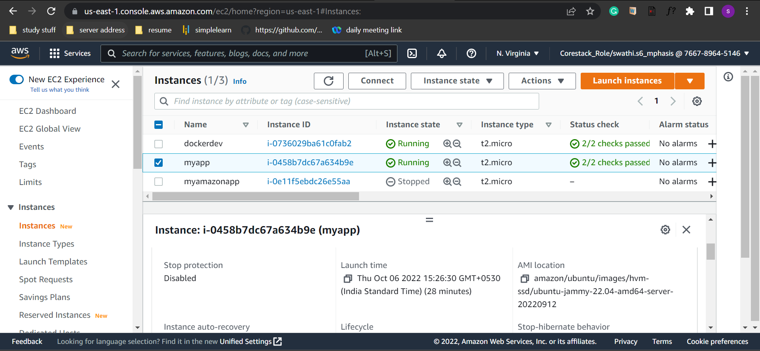

Amazon myapp instance details

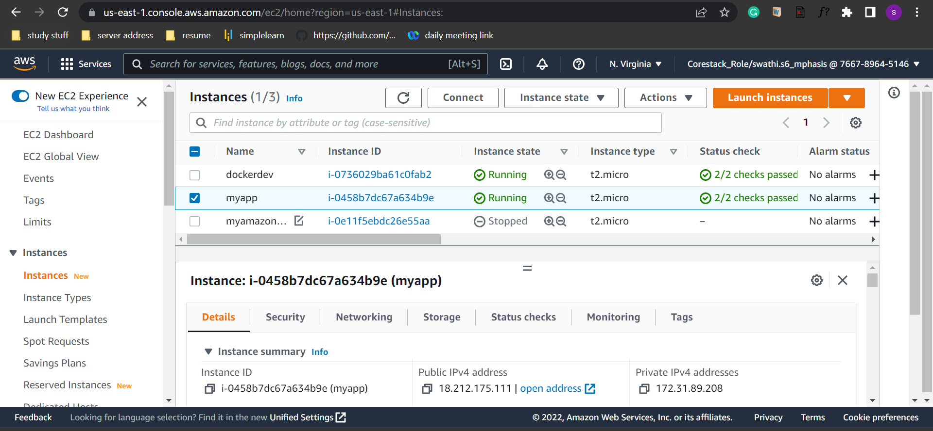

Amazon myapp ec2 instance security group inbound rules details

