INTRODUCTION

INTRODUCTION

The rapid growth of digital technology has transformed the way people buy and sell vehicles. Traditional methods of purchasing used cars often involve visiting multiple dealers, searching through advertisements, and depending on intermediaries, which can be time-consuming and less convenient. To overcome these limitations, an online car reselling system provides a platform where users can easily view, search, and purchase vehicles through a web-based application.
The Car Reselling System is a web application developed to simplify the process of buying and selling used cars. The system allows users to explore available vehicles, view detailed information about cars, and interact with the platform efficiently. It provides a user-friendly interface where customers can access car details, submit requests, and manage their activities online.
The system also includes an administrator module that helps manage the overall application. The administrator can manage users, car details, brands, categories, complaints, and other system activities. This centralized management approach improves efficiency, reduces manual work, and maintains proper organization of vehicle-related information.
The project is developed using the Django framework, which provides a secure and structured environment for building web applications. The system uses database management to store and retrieve information related to users, vehicles, and transactions. By implementing this online platform, the project aims to provide a convenient, reliable, and efficient solution for car reselling operations.

2. Objective

The main objective of the Car Reselling System is to develop a web-based platform that simplifies and improves the process of buying and selling used cars. The system aims to provide an easy and efficient way for users to search, view, and manage vehicle information online.
The objectives of the project are:
  - To develop an online platform for reselling cars through a simple and user-friendly interface.
  - To allow users to view available cars with detailed information such as brand, category, specifications, and price.
  - To reduce the time and effort required for customers to find suitable vehicles.
  - To provide a centralized system for administrators to manage car details, users, categories, and other activities.
  - To maintain accurate and organized records of vehicles and user information.
  - To improve communication between customers and the car reselling platform.
  - To provide a secure and reliable system for managing car resale operations.
  - To minimize manual work involved in traditional car selling and purchasing processes.

ABOUT THE ORGANIZATION

ABOUT THE ORGANIZATION

Progressive Software Solutions & Training is a fast developing, well established Information Technology enterprise with highly talented and efficient staff meeting the needs of clients throughout the world. The company is so popular that the clients feed the company with repeat orders, having faith in the capabilities. The staff includes management and engineering personnel, programmers, web developers, graphic designer, business analysts, technical writers etc. apart from the regular commercial and administrative hands. The motto of this reliable software provider is ‘DO BEST; GET BEST’ Progressive Software Solutions & Training committed to provide what they have promised. Progressive Software Solutions & Training strives for the satisfaction of their clients and dedicates themselves for the better services to their customers.
Progressive Software Solutions & Training are famous in providing high quality, cost cutting, requirement oriented and value added web and software solutions with remarkable cyber services. Progressive Software Solutions & Training are specialist in developing ever rewarding internet existence for ambitious companies which are in the hangover of swift moving internet facilities. Their aim is to grow with such organizations in a very fruitful manner. Their main concentration is to collect business oriented technological know-how and utilize them for the wellbeing of business concerns.
Progressive Software Solutions & Training experts in various technologies are committed to deliver effective and creative service to customers.
Services
- Software Development
- Web Development
- SEO Services (Search Engine Optimization)

SYSTEM ANALYSIS

SYSTEM ANALYSIS

EXISTING SYSTEM
The existing system for purchasing electronic products mainly relies on physical stores, where customers must visit the shop to view and buy products. Product information, inventory details, and order records are often managed manually, making the process time-consuming and less efficient. Customers face difficulties in comparing products, checking availability, and tracking orders, while sellers may encounter challenges in managing inventory and customer records accurately.

Limitation: The system requires customers to be physically present at the store, reducing convenience and accessibility.

PROPOSED SYSTEM
The proposed system, CarReselling, is a web-based electronics e-commerce platform that allows users to browse, search, and purchase products online. It provides secure user registration, product management, order processing, and delivery tracking. The system improves convenience, reduces manual work, and offers an efficient shopping experience for customers, shop owners, and delivery personnel.

Advantage: Customers can shop anytime and anywhere through the online platform.

SOFTWARE REQUIREMENTS SPECIFICATION HARDWARE SPECIFICATION
The use of sufficient hardware is very important for the proper working of any software. Following are the hardware required by the system.

Processor | Intel Core i5
Processor Speed | 1.5 GHz or higher
System Bus | 32 Bit
Memory | 1 GB RAM or higher
Hard Disk | 40 GB or higher
Monitor | 15.6” LCD Monitor
Keyboard | 104 Keys

SOFTWARE SPECIFICATION
Software is a part of a computer system that consists of encoded information or computer instructions, in contrast to the physical hardware from which the system is built. Following are the software required by the system.

Operating System | Windows 11
IDE | Visual Studio code
Front End | PYTHON DJANGO, HTML 5
Back End | SQLITE3
Web Server | APACHE
Browser | Microsoft Edge, Mozilla  Firefox, Chrome

FEASIBILITY STUDY
The main objective of this study is to determine whether the proposed system is feasible or mainly there are three types of feasibility study to which the proposed system is subjected to as described below:
    - Economic feasibility
    - Technical feasibility
    - Behavioral feasibility

The proposed system must be evaluated from a technical viewpoint first, and if technically feasible then their impact on organization must be accessed. If compatible, the behavioral system can be devised. Then those must be tested for economic feasibility.

ECONOMIC FEASIBILITY
The proposed system is economically feasible as it is developed using open-source technologies such as Python, Django, and SQLite. The development cost is low, and the system reduces manual work, paperwork, and operational expenses, making it cost-effective.

TECHNICAL FEASIBILITY
The system is technically feasible because it uses modern and widely available technologies such as Django, HTML, CSS, JavaScript, and SQLite. The required hardware and software resources are easily accessible, and the system can be implemented without major technical difficulties.

BEHAVIORAL FEASIBILITY
The proposed system is user-friendly and easy to operate. Users, shop owners, delivery personnel, and administrators can easily understand and use the system with minimal training. The system improves efficiency and is expected to be readily accepted by all users.

DATA FLOW DIAGRAM
To start the system design, something analogue to the architecture blueprint as a starting point to design is required. It is a way to focus on functions rather than physical implementation. One such tool is a DFD.
Structured analysis is a set of techniques and graphical tools that help the analyst to develop a new kind of system specification that are easily understandable to the user. DFD’s show the major decompositions of the system functions and their interfaces. The DFD is graphic and presents a picture of what is being specified and is conceptually easy to understand presentation of the application.
One important feature of DFD’s is that it is logical rather than physical. The elements of the system do not depend on vendor or hardware. They specify in precise, concise manner the working of the system and how it hangs together.
DFD is the graphic representation of data movement process, and files used in support of an information system. There are several rules of thumb used in drawing DFDs.
    - Process should be named and numbered for easy references.
    - The direction of flow is from top to bottom and from left to right.
    - When a process is imported in the lower level’s details, they must be numbered.
    - Process and data flow names have the first letter of each word must be a capital letter.

The symbol used in DFD are shown be.

Source or destination of data Data flow

Process that transforms data flow

Data store

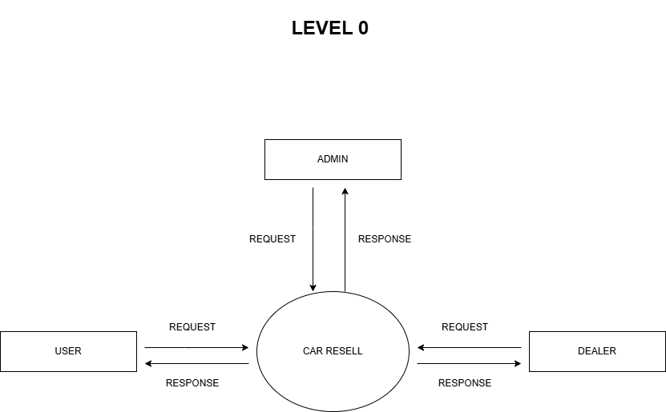

LEVEL 1 FOR DEALER

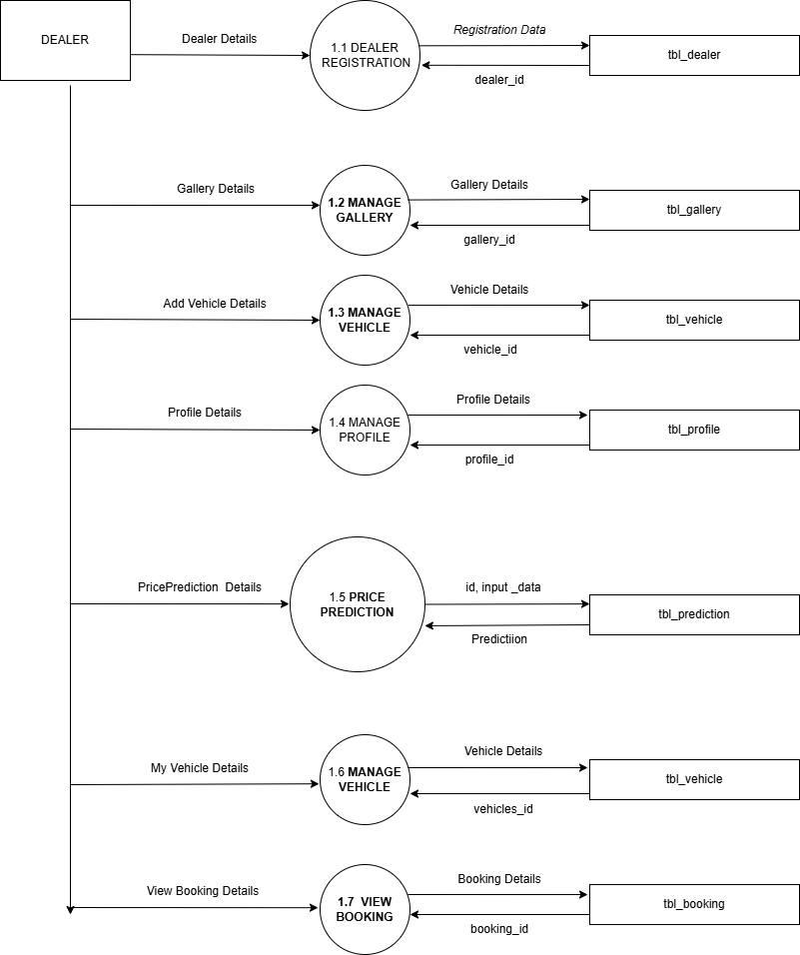

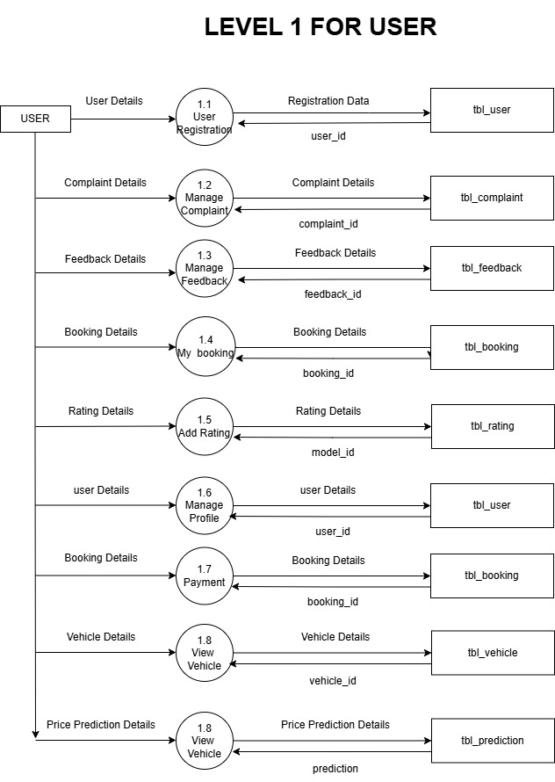

L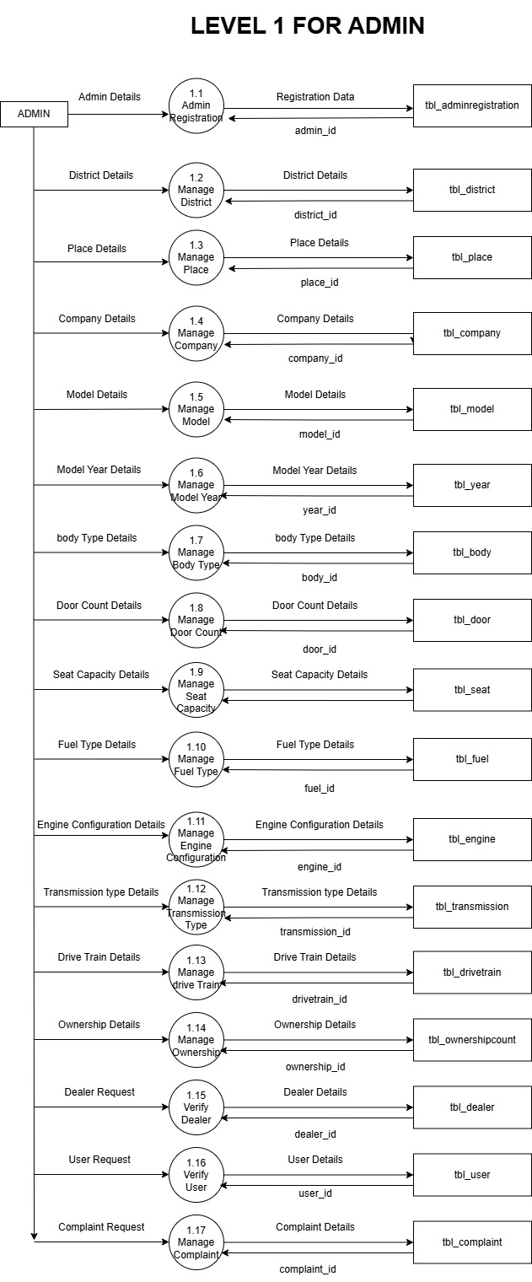

SYSTEM DESIGN

SYSTEM DESIGN
System design is the creative act of invention developing new inputs, a database offline files, method, procedures, and output for processing business data to meet organization objectives. The design phase focuses on the detailed implementation of the system recommended in the feasibility study. The design phase is a transition from user-oriented document to a document oriented to the programmers or database personnel. Characteristics of a well-designed system are:
- Accessibility
- Decision making ability.
- Economy
- Flexibility
- Reliability
- Simplicity
The design will determine the success of the system. System design is based on the information gathered during system analysis. System design goes through two phases of development.
  - Logical design- DFD shows the logical flow of a system and defines the boundaries of the system. For the candidate the system it describes the input, outputs, databases, and procedures-all in a format that meets the user’s requirements.
  - Physical design - This produces the working system by defining the design specification that tells programmers exactly what the candidate system must do.

INPUT DESIGN
Input design is the link that ties the information system into the world of its users. The input design involves determining what the inputs are, how the data should be performed, how to validate data, how minimize data entry and how to provide a multi-user facility inaccurate.
Input data are the most common cause of error in data processing. Errors entered by data entry operators can be controlled by input design. Input design is the process of converting user.

Originated inputs to a computer-based format. Input data are collected and organized into groups of similar data. Once identified, appropriate input media are selected for processing. All the input data validated in the order and if any data violates any condition, the user is warned by a message. If the data satisfies all the conditions, then it is transferred to the appropriate tables in the database.

OUTPUT DESIGN
Output design involves specifying how production of on-screen reports and page-based reports will occur. Output may occur to database or file for storing information entered or also for use by other systems. Computer output is the most important and direct source of information to the user. Output design is a very important phase because the output needs to be in an attractive manner. Efficient, intelligible output design improves the system relationship with the user and help in decision making. A major form of the output is the hard copy from the printer and screen reports. Printouts are designed around the output requirements of the user. Allowing the user to view to the sample screen is important because the user is ultimate judge of the quality of output. The output model of this system is the user-friendly window. These user-friendly windows are meant for the purpose of easy view of the stored information.

TABLE DESIGN
A database is a collection of data. Database design refers to the design of the tables used to store data. The database involves name of records, data item with its name, type and size. In the design of the database program first we must thoroughly look into the requirements of the program for the design of database. Then we must design how much tables are required in the database. Thereafter as per the requirement of the end users we can decide which fields that must be in this table. As per a general rule a provision must be taken in the design for the future enhancement of the program. Some of important tables are:

TABLE STRUCTURE

- Table name: tbl_adminregistration
Table description: To store the details of admin.

Field Name | Data Type | Constraints (Primary key, foreign key, not null, null) | Field Descrition
admin_id | int(10) | Primary key | Unique ID of the administrator
admin_name | varchar(30) | - | Name of the administrator
email | varchar(30) | - | Email address of the administrator
phone | varchar(30) | - | Contact number of the administrator
username | varchar(30) | - | Login username of the administrator
password | varchar(30) | - | Password for administrator login

- Table name: tbl_district

Table description: To store the details of district

Field Name | Data Type | Constraints (Primary key, foreign key, not null, null) | Field Description
district_id | int(10) | Primary key | Unique ID of the district
district_name | varchar(30) | - | Name of the district

- Table name: tbl_place

Table description: To store the details of place

Field Name | Data Type | Constraints (Primary key, foreign key, not null, null) | Field Description
place_id | int(10) | Primary key | Place id
place_name | varchar(50) | Not null | Name of the place
district_id | int(10) | Foreign key (tbl_district) | District id

- Table name: tbl_subcategory
Table description: To store the details of subcategory of the product.

Field Name | Data Type | Constraints (Primary key, foreign key, not null, null) | Field Description
subcategory_id | int(10) | Primary key | subcategory id
subcategory_name | varchar(30) | Not null | Name of subcategory
Category_name_id | varchar(30) | Foreign key | Category_id
- Table name: tbl_brand
Table description: To store the details of category of the product

Field Name | Data Type | Constraints (Primary key, foreign key, not null, null) | Field Description
brand_id | int(10) | Primary key | Brand id
brand_name | varchar(30) | Not null | Name of brand

- Table name: tbl_user
Table description: To manage user details.

Field Name | Data Type | Constraints (Primary key,  foreign key, not null, null) | Field Description
  user_id
  int(10)
  Primary key
  Unique ID of the user
user_name | varchar(25) | Not null | Name of user
user_gender | varchar(25) | Not null | Gender of user
user_contact | varchar(25) | Not null | Contact number of the use
user_email | varchar(20) | Not null | Email of the user
user_password | int(10) | Not null | Password of the user
user_address | int(10) | Not null | Adrees of the User
user_photo | varchar(30) | Not null | Photo of the user
user_proof | varchar(30) | Not null
  Proof of user
place_id | varchar(30) | Foreign key (tbl_place) | Place id
user_status | int(10)
  Not null
  Status of user

- Table name: tbl_feedback
Table description: To manage user feedback details.

Field Name | Data Type | Constraints (Primary key, foreign key, not null, null) | Field Description
feedback_id | int(10) | Primary key | Feedback id
 | varchar(300) | Foreign key | User Id
  user_id
feedback_content | varchar(50) | Not null | Feedback details
feedback_date | int(10) | Not null | Date of feedback
feedback_status | Varchar | Not null | Status of feedback

- Table name: tbl_complaint
Table description: To manage user complaint details.

Field Name | Data Type | Constraints (Primary key, foreign key, not null,  null) | Field Description
complaint_id | int(10) | Primary key | Complaint Id
user_id | int(10) | Foreign key (tbl_user) | User Id
complaint_content | varchar(250) | Not null | Complaint details
complaint_date | date | Not null | Date of complaint
complaint_status | int(10) | Not null | Status of complaint
- Table name: tbl_booking
Table description: To manage user booking details.

Field Name | Data Type | Constraints (Primary key, foreign key, not null, null) | Field Description
booking_id | int(10) | Primary key | Booking id
user_id |  | Foreign key (tbl_user) | User Id
  int(10)
car_id | int(10) | Foreign key  (tbl_car) | Car Id
booking_date | date | Not null | Date of  Booking
 | Int(10) | Not null | Status of booking
  booking_status

- Table name: tbl_company
Table description: To store the details of the company.

Field Name | Data Type | Constraints (Primary key, foreign key, not null, null) | Field Description
cart_id | int(10) | Primary key | Company Id
company_name | varchar(50) | Not null | Name of company
company_details | varchar(300) | Not null | Details of company
company_logo | varchar(300) | Not null | Logo of company

- Table name: tbl_model
Table description: To store the details of company model.

Field Name | Data Type | Constraints (Primary key, foreign key, not null, null) | Field Description
model_id | int(10) | Primary key | Rating Id
company_id | Int(10) | Not null | Data of rating
model_name |  | Foreign key (tbl_user) | User Id
  varchar(50)
model_details | varchar(300) | Not null | Review of user

- Table name: tbl_car
Table description: To store car
details

Field Name | Data Type | Constraints (Primary key, foreign key, not null, null) | Field Description
car_id | int(10) | Primary key | Shop Id
model_id | varchar(25) | Not null | shop name
category_id | varchar(25) | Not null | Shop email
 | varchar(25) | Not null | Password Of shop
  car_name
car_year | varchar(100) | Not null | Address of shop
car_price | int(25) | Not null | Contact of shop
shop_photo | varchar(25) | Not null | Photo of shop
shop _proof | varchar(25) | Not null | Id proof of shop
shop _status | int(10) | Not null | Status of shop
place_id | varchar(30) | Foreign key (tbl_place) | Place_id

- Table name: tbl_gallery
Table description: To store photo of the product.

Field Name | Data Type | Constraints (Primary key, foreign key, not null, null) | Field Description
gallery_id | int(10) | Primary key | Gallery_Id
gallery_file | file | Not null | File of gallery
Product_id | date | Foreign key (tbl_product) | Product_id

- Table name: tbl_cart
Table description: To store cart details.

Field Name | Data Type | Constraints (Primary key, foreign key, not  null, null) | Field Description
cart_id | int(10) | Primary key
  Cart Id
user_id | int(10) |  | User Id
  Foreign key (tbl_user)
car_id | int(10) | Foreign key (tbl_car)
  Car Id
cart_date | date | Not null | Time of safetybutton

- Table name: tbl_payment
Table description: To store payment details.

Field Name | Data Type | Constraints (Primary key,  foreign key, not null, null) | Field Description
payment_id | int(10) | Primary key | Payment Id
booking_id | int(10) | Not null | Booking Id
payment_date | date | Not null | Payment Date
payment_amount |  | Foreign key (tbl_car)
  varchar(50)
  Payment Amount
payment_status | int(10) |  | Payment Status
  Not null

- Table name: tbl_rating
Table description: To store car rating details.

Field Name | Data Type | Constraints (Primary key, foreign key, not null, null) | Field Description
rating_id | int(10) |  | Rating Id
  Primary key
user_id | int(10) | Foreign key (tbl_user) | User Id
car_id | int(10) | Foreign key (tbl_car) | Car Id
rating | int(10) | Not null | Rating Value
review | varchar(300) | Not null | Review

PROCESS DEIGN
There are 4 modules in the system.

- Admin
- Dealer
- User

ADMIN
❖ Manage Dealer
Admin has the duty to manage dealer details. Admin can verify, approve, reject, and maintain dealer information in the system.
❖ Manage User
Admin has the duty to manage user details. Admin can view and control user registrations and maintain user information.
❖ Manage Car Details
Admin has the duty to manage car details. Admin can monitor and maintain car information added by dealers.
❖ Manage Company and Model
Admin has the duty to manage car company and model details. Admin can add, update, and maintain company and model information.
❖ Manage Category
Admin has the duty to manage car categories. Admin can add and maintain different categories of cars.
❖ Manage Booking
Admin has the duty to manage booking details. Admin can view and monitor booking requests made by users.
❖ Manage Complaint and Feedback
Admin has the duty to manage complaints and feedback submitted by users. Admin can review and take necessary actions.

- Seller
❖ Add Car
Dealer has the duty to add cars for reselling in the system. Dealer can enter and manage car details such as company, model, category, price, and other specifications.
❖ Manage Booking
Dealer has the duty to manage booking requests. Dealer can view user bookings and update the booking status according to availability.
❖ Add Gallery
Dealer has the duty to add gallery images for cars. Dealer can upload and maintain car images to help users view vehicle details clearly.
❖ Add Stock
Dealer has the duty to add and manage car stock details. Dealer can update available car stock and maintain vehicle availability in the system.

USER
  - User can login
All user can login.
  - Viewproduct list
User can view the product list.
  - Mybooking
User can manage mybooking.
  - My cart
User can add products to mycart.
  - Add feedback
User can add feedback.
  - Add complaint
User can add product complaints.
  - Add rating
User can add product rating.

SYSTEM TESTING AND IMPLEMENTATION

SYSTEM TESTING & IMPLEMENTATION
Testing is the process of examining the software to compare the actual behaviour with that of the excepted behaviour. The major goal of software testing is to demonstrate that faults are not present. In order to achieve this goal the tester executes the program with the intent of finding errors. Though testing cannot show absence of errors but by not showing their presence it is considered that these are not present.
System testing is defined as the process by which one detects the defects in the software. Any software development organization or team has to perform several processes. Software testing is one among them. It is the final opportunity of any programmer to detect and rectify any defects that may have appeared during the software development stage. Testing is a process of testing a program with the explicit intention of finding errors that makes the program fail. In short system testing and quality assurance is a review in software products and related documentation for completion, correctness, reliability, and maintainability.
System testing is the first stage of implementation, which is aimed at ensuring that the system works accurately and efficiently before live operation commences. Testing is vital to the success of the system. System testing makes a logical assumption that if all the parts of the system are correct and the goal will be successfully achieved. A series of testing are performed for the proposed system before the proposed system is ready for user acceptance testing.
The testing steps are:
    - Unit Testing

    - Integration Testing

    - Validation Testing

    - Output Testing
    - Acceptance Testing

System Testing provides the file assurance that software once validated must be combined with all other system elements. System testing verifies whether all elements have been combined properly and that overall system function and performance is achieved. After the integration of modules, the validation test was carried out over the system. It was found that all the modules work well together and meet the overall system function and performance.

UNIT TESTING

Unit testing is carried out screen-wise, each screen being identified as an object. Attention is diverted to individual modules, independently to one another to locate errors. This has enabled the detection of errors in coding and logic. Various test cases are prepared. For each module these test cases are implemented and it is checked whether the module is executed as per the requirements and outputs the desired result. In this test each service input and output parameters are checked. In unit testing,
- Module interface was tested to ensure that information properly flows into and out of the program under test.
- Boundary condition was tested to ensure that module operates properly at boundaries established to limit or restrict processing.
- All independent paths through the control structures were executed to ensure that all statements in the modules have been executed at least once.
- Error handling paths were also tested.

INTEGRATION TESTING
Integration testing is a systematic technique for constructing the program structure at the same time conducting tests to uncover errors associated with interfacing. Unit tested module were taken and a single program structure was built that has been dictated by the design. Incremental integration has been adopted here.

Integration testing is a systematic technique for constructing the program structure at the same time conducting tests to uncover errors associated with interfacing. Unit tested module were taken and a single program structure was built that has been dictated by the design. Incremental integration has been adopted here.
Integration testing is a systematic technique for constructing the program structure at the same time conducting tests to uncover errors associated with interfacing. Unit tested module were taken and a single program structure was built that has been dictated by the design. Incremental integration has been adopted here. The modules are tested separately for accuracy and modules are integrated together using bottom-up integration i.e., by integrating from moving from bottom to the top. The system is checked and errors found during integration are rectified. In this testing, all the individual modules were combined, and the module wise shifting was verified to be alright. The entire software was developed and tested in small segments, where errors were easy to locate and rectify. Program builds (group of modules) were constructed corresponding to the successful testing of user interaction, data manipulation analysis, and display processing and database management.

VALIDATION TESTING
Validation testing is done to ensure complete assembly of the error free software. Validation can be termed successful only if it functions in manner. Reasonably expected by the customer under validation is alpha and beta testing. Alpha testing is where the end user tests the system rather than the developer, but in a controlled environment. The software is used on a natural setting with the developer monitoring the user using the system. The developer records the errors and usage problems encountered by the user. Alpha testing is simulated or actual operational testing by potential users/customers or an independent test team at the developers’ site. Alpha testing is often employed for off-the- shelf software as a form of internal acceptance testing, before the software goes to beta testing. Beta testing comes after alpha testing. Versions of the software, known as beta versions, are released to a limited audience outside of the programming team. The software is released to groups of people so that further testing can ensure the product has few faults or bugs.

Sometimes, beta versions are made available to the open public to increase the feedback field to a maximal number of future users. The user person conducts beta testing at one more site. The developer is not present during these tests. Hence, beta test can be said as the live application of software on an environment that cannot be controlled by the developer. The salesperson takes down the problems encountered during beta testing and reports to the developer at regular intervals. The developer makes suitable modifications to the software henceforth. The client-side validation is done in this testing phase. It is checked whether the data passed to each service is valid or not. Entering incorrect values in the field of email id, passwords, mobile number and name are checked in this project. If any, those values are discarded, and a message will be appeared on the screen. Like this the errors are rectified.

OUTPUT TESTING
After performing the validation testing the next step is output testing of the proposed system, since no system could be useful if it does not produce the required output in a specific format. Asking the users about the format required by them, testing the output generated are considered into two ways. One is onscreen and another is printed format. The output format on the screen was found to be correct as the format was designed in the system design phase according to the user needs. For the hard copy also, the output comes out as specified requirement by the user. Hence output testing does.not result in any correction in the system.
“CarReselling” is developed based on the user choice. It is user friendly. The output format is very clear to user.

ACCEPTANCE TESTING
Acceptance testing generally involves running a suite of tests on the completed system. Each individual test, known as a case, exercises a particular operating condition of the user's environment or feature of the system, and will result in a pass or fail, or Boolean, outcome.
Acceptance testing is the user testing. I.e., whether the user is accepted or rejected the system. “CARRESELLING” is developed for peoples. Its screens are created as the base of user's choice. CARRESELLING, it helps to restore and preserve rivers through community-led cleanups. The software passed the acceptance test correctly. Screens are created as the base of user's choice.

DEBUGGING

Debugging is the process of detecting and removing of existing and potential errors (also called as ‘bugs’) in a software code that can cause it to behave unexpectedly or crash. To prevent incorrect operation of a software or system, debugging is used to find and resolve bugs or defects. When various subsystems or modules are tightly coupled, debugging becomes harder as any change in one module may cause more bugs to appear in another. Sometimes it takes more time to debug a program than to code it.
To debug a program, user has to start with a problem, isolate the source code of the problem, and then fix it. A user of a program must know how to fix the problem as knowledge about problem analysis is expected. When the bug is fixed, then the software is ready to use. Debugging tools (called debuggers) are used to identify coding errors at various development stages. They are used to reproduce the conditions in which error has occurred, then examine the program state at that time and locate the cause. Programmers can trace the program execution step-by-step by evaluating the value of variables and stop the execution wherever required to get the value of variables or reset the program variables. Some programming language packages provide a debugger for checking the code for errors while it is being written at run time.

Here is the debugging process:
- Reproduce the problem.
- Describe the bug. Try to get as much input from the user to get the exact reason.
- Capture the program snapshot when the bug appears. Try to get all the variable values and states of the program at that time.
- Analyse the snapshot based on the state and action. Based on that try to find the cause of the bug.
- Fix the existing bug, but also check that any new bug does not occur.

IMPLEMENTATION

The implementation is the final state, and it is an important phase. It involves the individual programming; system testing, user training and the operational running of developed proposed system that constitutes the application subsystems. A major task of preparing for implementation is education of users, which should really have been taken place much earlier in the project when they were being involved in the investigation and design work. During the implementation phase system actually takes physical shape. To develop a system implemented planning is very essential.
The implementation phase of the software development is concerned with translating design specification into source code. The user tests the developed system and changes are made according to their needs. Our system has been successfully implemented. Before implementation several tests have been conducted to ensure that no errors are encountered during the operation. The implementation phase ends with an evaluation of the system after placing into the operation for a period.
The process of putting the developed system in actual use is called system implementation. This includes all those activities that take place to convert from old system to new system. The system can be implemented only after testing is done and is found to be working to specifications. The implementation stage is a systems project. The implementation stage involves following tasks:

IMPLIMENTATION PLANS:

  - Test system with sample data
  - Detection and correction of errors
  - Make necessary changes in the system.
  - Check with the existing system.
  - Installation of hardware and software utilities Training and involvement of user personnel

SECURITY TECHNOLOGIES AND POLICIES

.

SECURITY TECHNOLOGIES AND POLICIES

SYSTEM SECURITY
Threats to System Security
Any act or object that poses a danger to computer assets is known as threats. Management must be aware of the various kinds of threats facing the organization. By examining each threat category, the management can effectively protect the assets through policy, training and technology.

A threat can be either "intentional" (i.e., hacking: an individual cracker or a criminal organization) or "accidental" (e.g., the possibility of a computer malfunctioning, or the possibility of a natural disaster such as an earthquake, a fire, or a tornado) or otherwise a circumstance, capability, action, or event. There are several types of threats.

- Attempt to access websites and modify or destroy its contents.
- Send malicious programs such as viruses, worms and Trojans to a web server by a browser.
- Earthquake
- Excess electric supply
- Natural disasters.

SECURITY TECHNOLOGIES AND POLICIES

Maintenance involves the software industry captive, typing up system resources, it means restoring something to its original condition. Maintenance follows conversion to the extend. That change is necessary to maintain satisfactory operations relative to changes in the user’s environment. Maintenance often includes minor enhancements or corrections to problems that surface in the system's operation. Maintenance is also done based on fixing the problems reported, changing the interface with other software or hardware enhancing the so its software. Any system developed should be secured and protected against possible hazards. Security measures are provided to prevent.

unauthorized access of the database at various levels. An uninterrupted power supply should be so that the power failure or voltage fluctuations will not erase the data in the files. Password protection and simple procedure to prevent the unauthorized access are provided to the users. The system allows the user to enter the system only through proper username and password.

SYSTEM SECURITY MEASURES

Security for e-commerce means complying with several key requirements, while making sure that online security measures are adopted. Having the right security measures in place is essential to maintain customer trust and confidence, and to ensure customer retention and loyalty.
To protect the confidential data from intruders, there are several security measures available today.
1. Passwords
The most inexpensive and perhaps the easiest method of security is achieved through password protection. A password is a secret word or string of characters that is used for user authentication to prove identity, or for access approval to gain access to a resource. Now passwords are commonly used by people to login to a computer system, access ATMs, etc. A password is also known as a passkey. It serves as a security measure against unauthorized access to data. Password security adds no cost to the network and is potentially a useful security measure.

MAINTENANCE

MAINTENANCE
Maintenance is the process of modifying a software system or component a after its delivery in order to correct faults, improve the performance and other attributes or to adapt to the changed environment. In “CARRESELLING” maintenance covers a wide range of activities including correcting the coding and design errors, updating the documentation and test data and upgrading the user support. Maintenance involves the software industry captive, typing up system resources. It means restoring something to its original condition. Maintenance follows conversion to the extend. The change is necessary to maintain satisfactory operations relative to changes in the user's environment. Maintenance often includes minor enhancements or corrections to problems that surface in the system's operations. Maintenance is also done based on fixing the problems reported, changing the interface with other software or hardware enhancing the software. Hardware also requires periodic maintenance to keep the system in to its standards.
The future updates and maintenance can be done in this system even if it is delivered to the user. By modifying system after it has been put into use. Modifies the existing components and adds new components to the system. Maintenance is not only bug fixing but also adapting the software to changing requirements, changing environment etc.
Software maintenance is a very broad activity that includes error correction, enhancements of capabilities, deletion of obsolete capabilities, and optimization. Because change is inevitable, mechanisms must be developed for evaluating, controlling, and making modifications. So, any work done to change the software after it is in operation is maintenance work. The purpose is to preserve the value of software over time. The value can be enhanced by expanding the customer base, meeting additional requirements, becoming easier to use, more efficient and employing newer technology.
The categories of maintenance are:
- Corrective Maintenance
- Adaptive Maintenance
- Perfective Maintenance

CORRECTIVE MAINTENANCE
This refers to modifications initiated by defects in the software. A defect can result from design errors, logic errors and coding errors. Design errors occur when changes made to software are incorrect, incomplete, wrongly communicated or the change request is misunderstood. Logic errors result from invalid tests and conclusions, incorrect implementation of design specifications, faulty logic flow or incomplete test data. Coding errors are caused by implementation of detailed logic design and incorrect use of the source code logic. Defects are also caused by data processing errors and system performance errors.
In the event of system failure due to an error, actions are taken to restore the operation of the software system. Due to pressure from management, maintenance personnel sometimes resort to emergency fixes known as “patching”. The adhoc nature of this approach often gives rise to a range of problems that include increased program complexity and unforeseen ripple effects. Unforeseen ripple effects imply that a change to one part of a program may affect other sections in an unpredictable manner, thereby leading to distortion in the logic of the system. This is often due to lack of time to carry out through “impact analysis” before effecting the change.

ADAPTIVE MAINTENANCE
It includes modifying the software to match changes in the ever-changing environment. The term environment in this context refers to the totality of all conditions and influences which act from outside upon the software. A change to the whole or part of this environment will require a corresponding modification of the software.
Thus, this type of maintenance includes any work initiated as consequences of moving the software to a different hardware or software platform compiler, operating system, or new processor. Any change in the government policy can have far-reaching ramifications on the software.

PERFECTIVE MAINTENANCE
It means improving processing efficiency or performance or restricting the software to improve changeability. When the software becomes useful, the user tends to experiment with new cases beyond the scope for which it was initially developed. Expansion in requirements can take the form of enhancement of existing system functionality or improvement in computational efficiency.
Hence, perfective maintenance refers to enhancements: making the process better, faster, smaller, better documented, cleaner structured, with more functions or reports.

CONCLUSION

CONCLUSION
  - Scope for Future Enhancement
The Car Reselling project successfully developed an intelligent e-commerce platform that provides a complete online shopping environment for customers, sellers, delivery personnel, and administrators. The system simplifies various activities such as product management, order processing, inventory control, and delivery management through an easy-to-use web interface. A key feature of the system is the integration of Machine Learning-based Demand Prediction, which helps forecast future product demand using historical sales data. This enables better inventory planning, reduces stock shortages, and improves business efficiency. Developed using Python, Django, HTML, CSS, JavaScript, and SQLite, the system offers a secure, reliable, and scalable solution for modern online shopping requirements.

Although the current system satisfies the major requirements of an e-commerce platform, there is significant scope for future enhancement. Online payment gateway integration can be added to support digital transactions through UPI, credit/debit cards, and digital wallets. Mobile applications for Android and iOS can improve accessibility and user convenience. Advanced AI-based recommendation systems can be implemented to provide personalized product suggestions. Real-time GPS-based order tracking and AI-powered chatbot support can further enhance customer satisfaction. The demand prediction module can be improved using advanced machine learning and deep learning techniques for more accurate forecasting. Additional features such as multi-vendor marketplace support, inventory automation, multi-language support, and cloud deployment can increase the scalability and functionality of the system.

In conclusion, Car Reselling demonstrates how web technologies and machine learning can be effectively integrated to create a smart and efficient e-commerce platform. With future enhancements, the system can evolve into a more advanced, intelligent, and scalable solution capable of meeting the growing demands of the e-commerce industry.

BIBLIOGRAPHY

BIBLIOGRAPHY

- Award, Elias M. ”System Analysis and Design”, Galgotia Publications Pvt Ltd,Year:2002,Edition 2.
- Silberschatz, Abraham, F, Henry and “Database System Concepts”, McGraw-Hill Education,Year:1986,Edition 6
- Aggarwal, K K, and Singh,Yogesh “Software Engineering” ,New Age International,Year:2005,Edition

REFERENCES

  - www.google.com
  - www.wikipedia.com
  - www.python.org
  - www.freecodecamp.org
  - www.w3schools.com
  - https://stacksoverflow.com

APPENDIX

APPENDIX
  - Screenshort
ADMIN

Login Page:

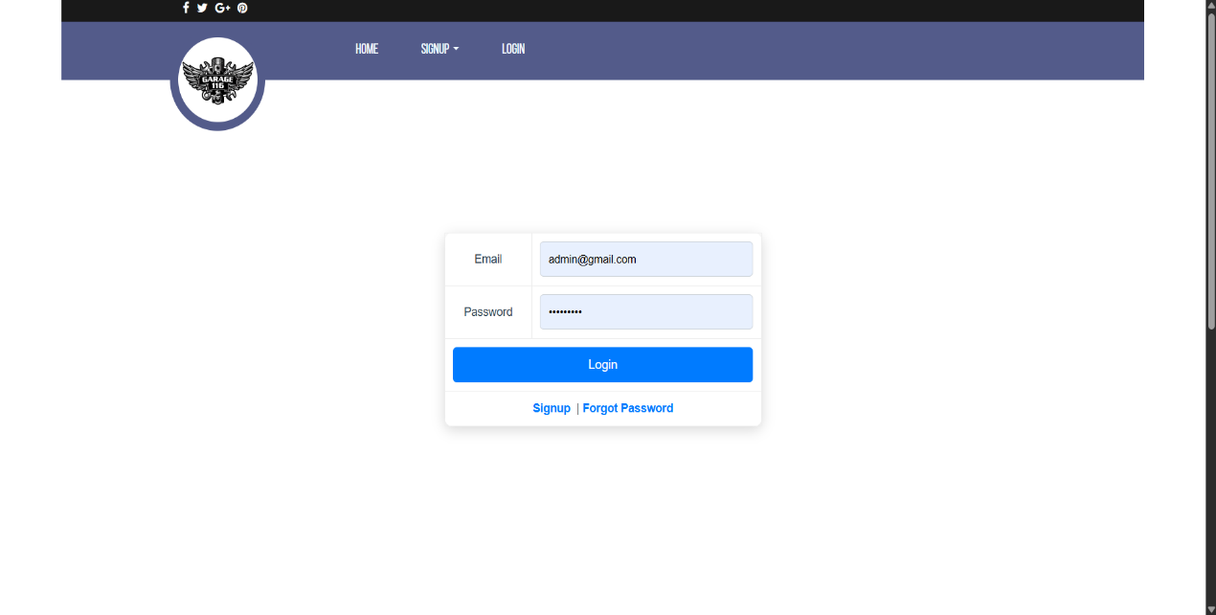

Home Page:

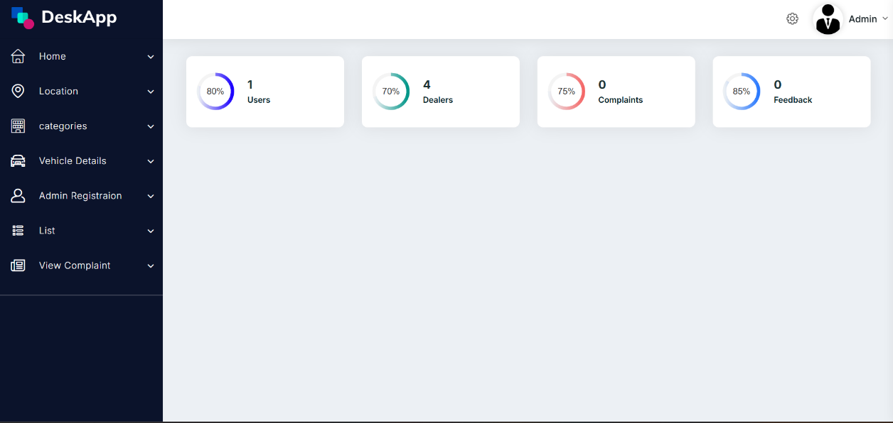

User List:

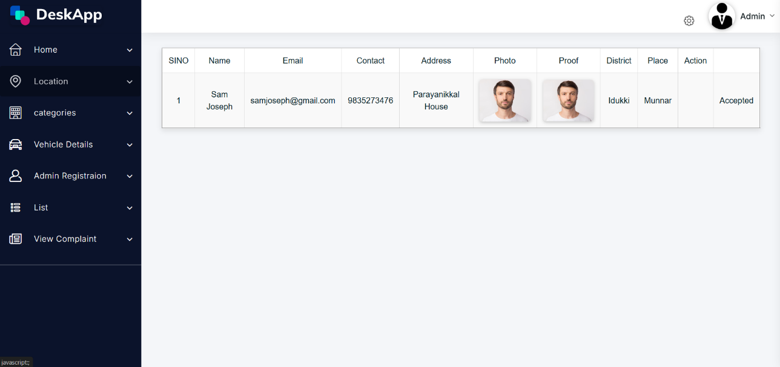

Delaer List:

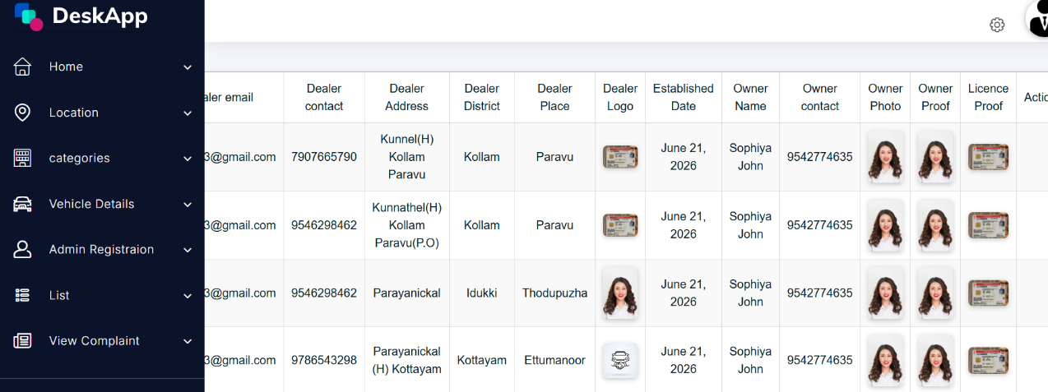

USER
Registration:

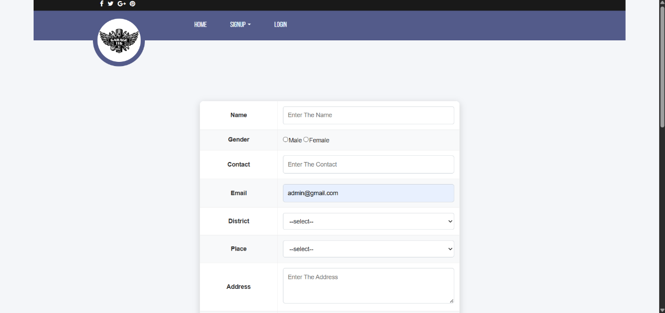

Login:

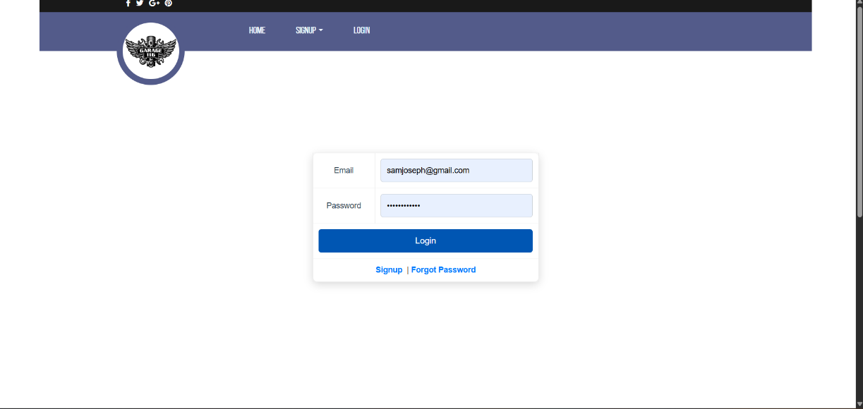

My Booking:

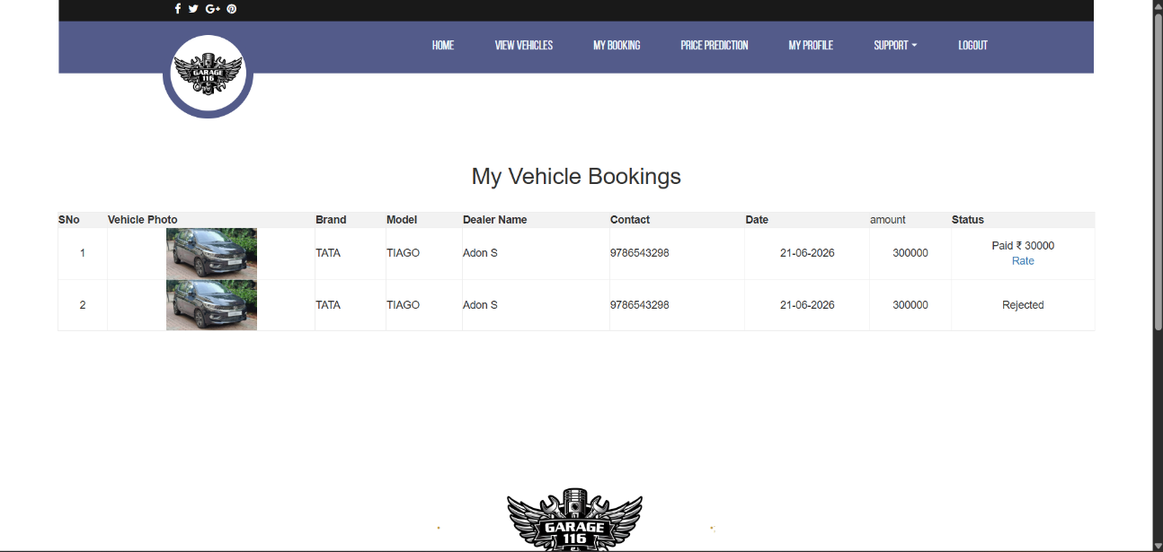

User Complaint:

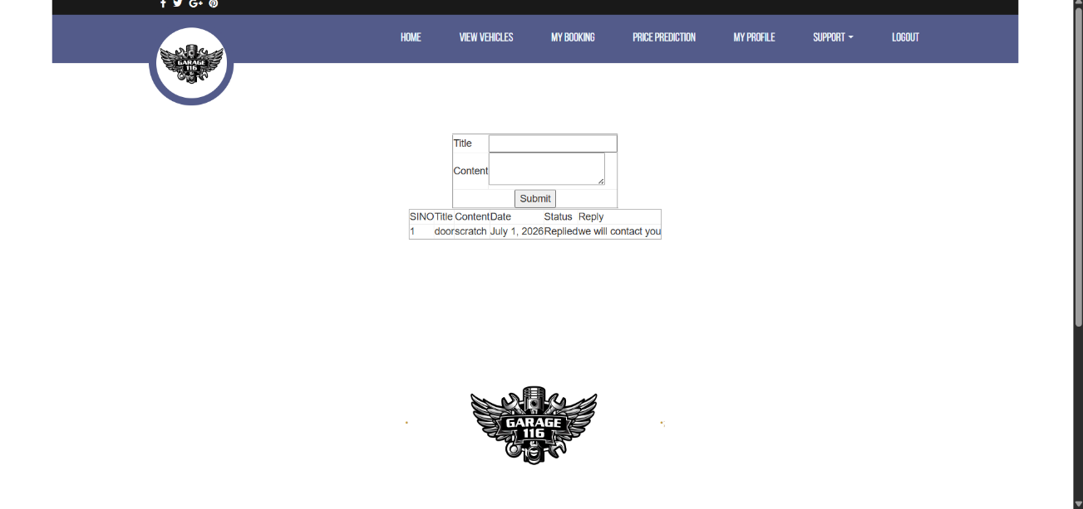

User Feedback:

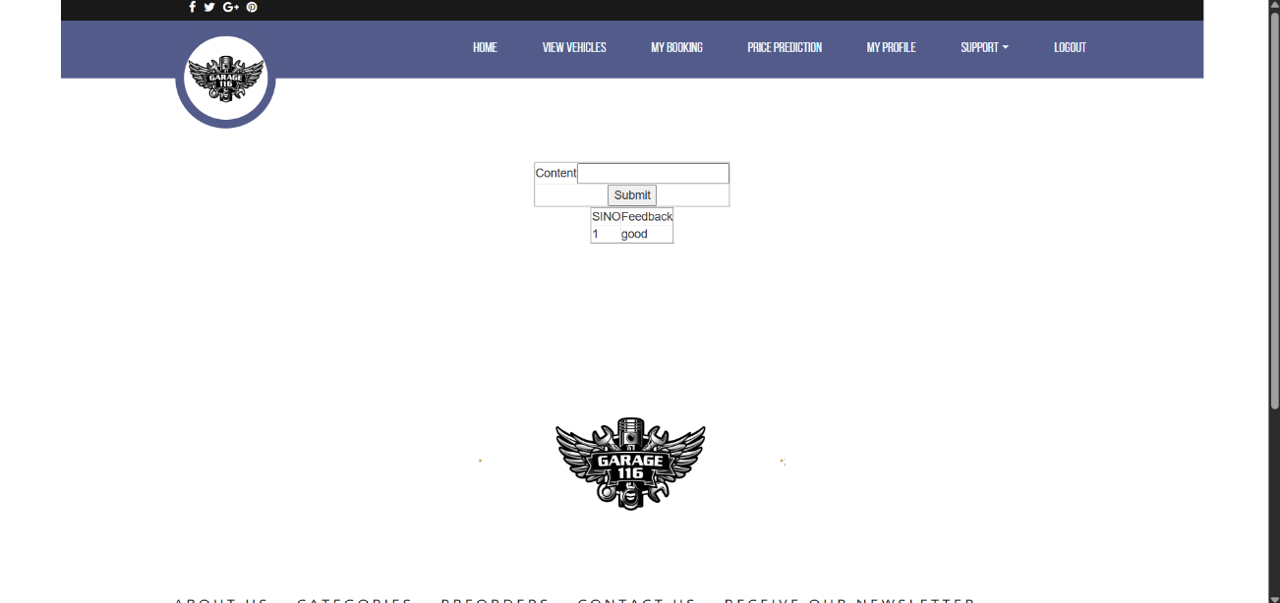

Dealer
Login:

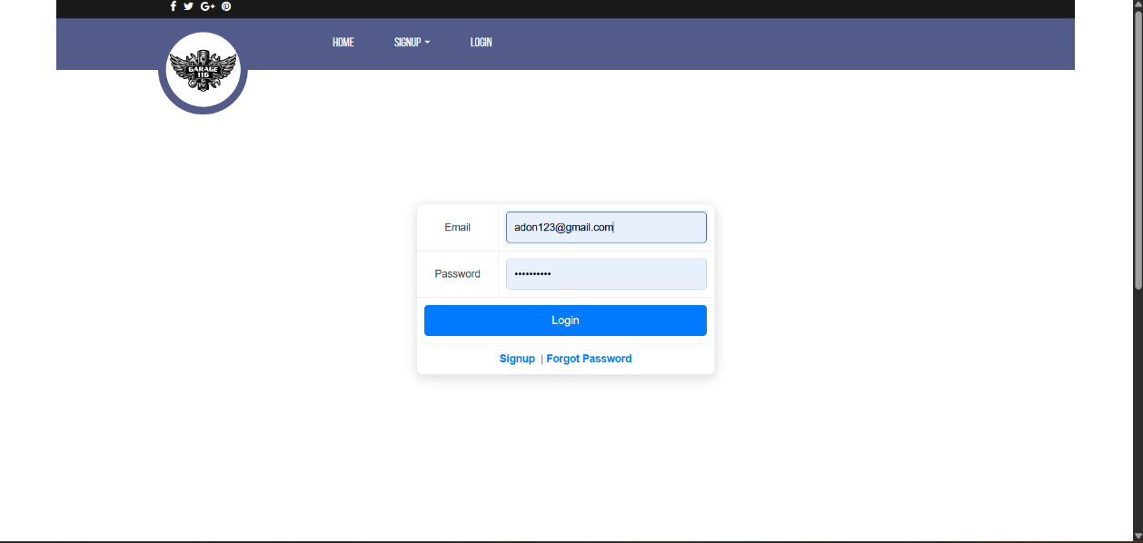

Home Page:

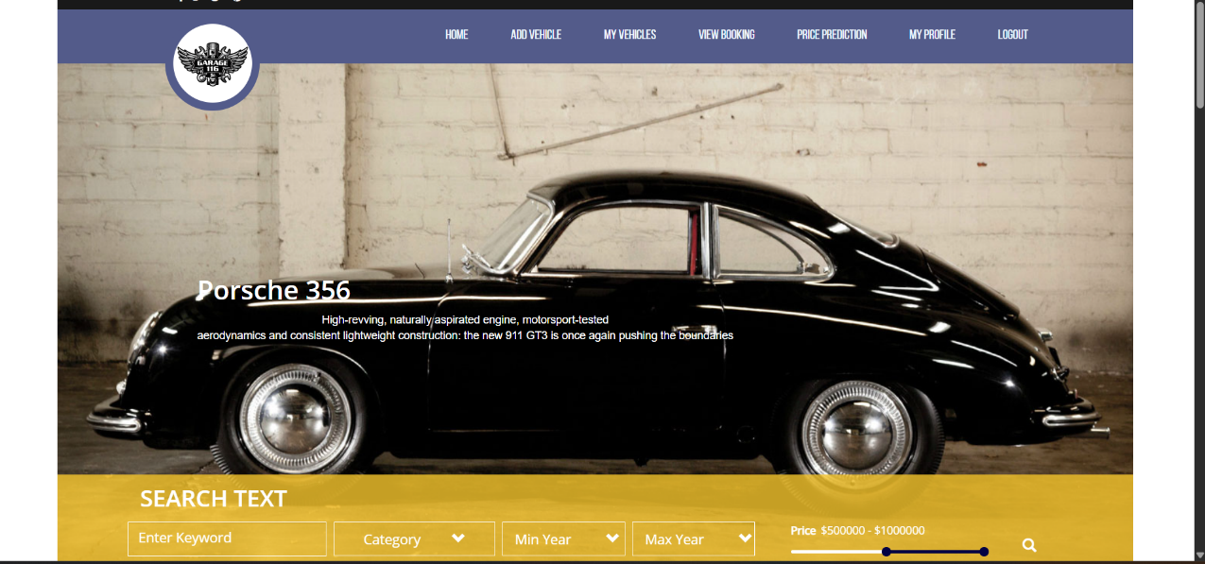

View booking: 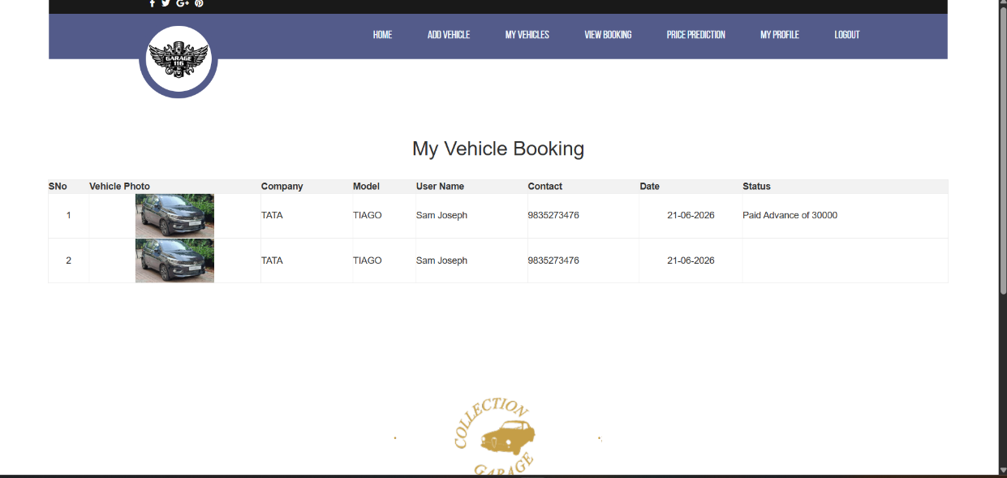

Add Vechicle:

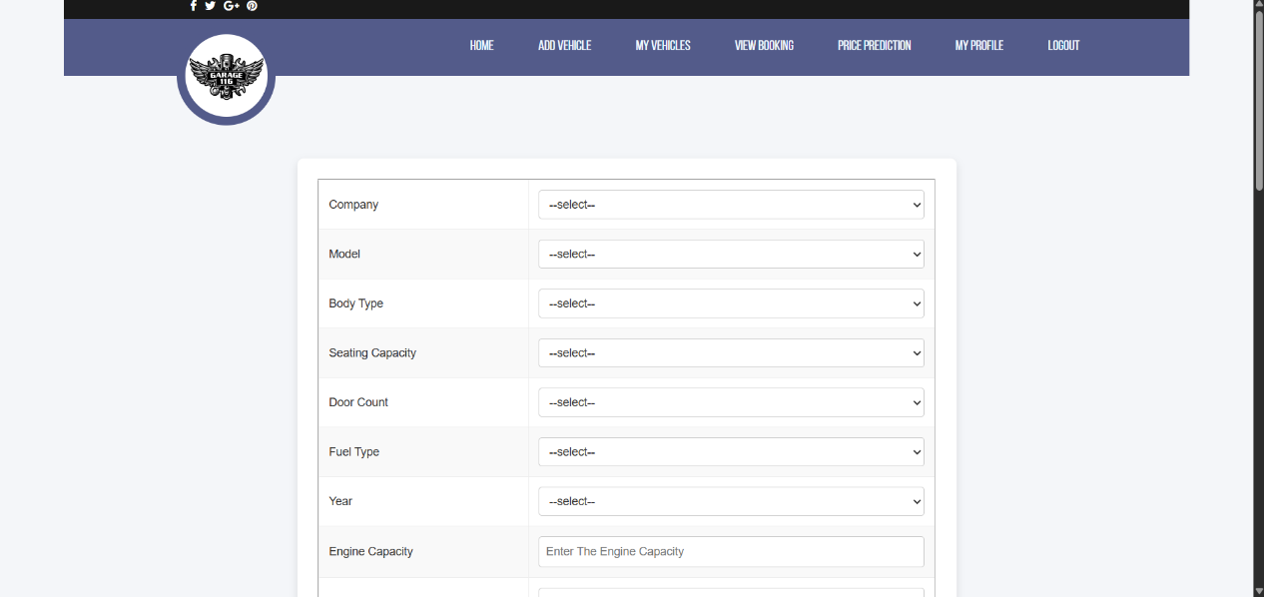

CODING

Login:
{% extends 'Guest/Header.html' %}
{% block content %}
<!DOCTYPE html>
<html lang="en">
<head>
<meta charset="UTF-8">
<meta name="viewport" content="width=device-width, initial-scale=1.0">
<title>Login</title>
<style>

.login-containerjj {
width: 400px;
margin: 80px auto;
}

.login-box {
background: #ffffff;
padding: 25px;
border-radius: 10px;
box-shadow: 0px 4px 15px rgba(0,0,0,0.15);
}

.login-title {
text-align: center;
color: #2c3e50;
margin-bottom: 20px;
}

table {
width: 100%;
border-collapse: collapse;
border: none;
}

td {
padding: 10px;
}

input[type="email"],
input[type="password"] {
width: 100%;
padding: 10px;
border: 1px solid #ced4da;
border-radius: 5px;
box-sizing: border-box;
}

input[type="email"]:focus,
input[type="password"]:focus {
outline: none;
border-color: #007bff;
box-shadow: 0 0 5px rgba(0,123,255,0.3);
}

input[type="submit"] {
background: #007bff;
color: white;
border: none;
padding: 10px 25px;
border-radius: 5px;
cursor: pointer;
width: 100%;
font-size: 15px;
}

input[type="submit"]:hover {
background: #0056b3;
}

.jja {
text-decoration: none;
color: #007bff;
font-weight: bold;
}

.jja:hover {
color: #0056b3;
}
</style>

</head>
<body>
<form method="POST" class="login-containerjj">
{% csrf_token %}
<table border="2px" class="login-box">
<tr>
<td class="login-title">Email</td>
<td><input type="email" name="txt_email" required placeholder="Enter The Email"></td>

</tr>
<tr>
<td class="login-title">
Password
</td>
<td><input type="password" name="txt_password" required placeholder="Enter The Password" ></td>
</tr>

<tr>
<td colspan="2" align="center"><input type="submit" name="btn_login" value="Login"></td>
</tr>
<tr>
<td class="login-title" colspan="2"><a class="jja" href="{% url 'Guest:NewUser' %}">Signup</a>&nbsp;&nbsp;|
<a class="jja" href="{% url 'Guest:forgotpassword' %}">Forgot Password</a>
</td>
</tr>
</table>
</form>

</body>
</html>
{% if msg %}
<script>
alert("{{msg}}")
window.location="{% url 'Guest:Login' %}"
</script>
{% endif %}

{% endblock %}

Views:
def Login(request):
if request.method=="POST":
email=request.POST.get("txt_email")
password=request.POST.get("txt_password")
admincount=tbl_adminregistration.objects.filter(adminregistration_email=email,adminregistration_password=password).count()
usercount= user=tbl_user.objects.filter(user_email=email,user_password=password).count()
dealercount=tbl_dealer.objects.filter(dealer_email=email,dealer_password=password).count()
if admincount>0:
admin=tbl_adminregistration.objects.get(adminregistration_email=email,adminregistration_password=password)
request.session['aid']=admin.id
return redirect("Admin:HomePage")
elif usercount>0:
user=tbl_user.objects.get(user_email=email,user_password=password)
if user.user_status==0:
return render(request,'Guest/Login.html',{'msg':"Registration is pending"})
elif user.user_status==2:
return render(request,'Guest/Login.html',{'msg':"Registration is Rejected"})
else:
request.session['uid']=user.id
return redirect("User:HomePage")
elif dealercount>0:
dealer=tbl_dealer.objects.get(dealer_email=email,dealer_password=password)
if dealer.dealer_status == 0:
return render(request,"Guest/Login.html",{'msg':"Registration is pending"})
elif dealer.dealer_status == 2:
return render(request,"Guest/Login.html",{'msg':"Registration is rejected"})
else:
request.session['did']=dealer.id
return redirect("Dealer:HomePage")
else:
return render(request,'Guest/Login.html')

return render(request,'Guest/Login.html')

ADD VEHICLE

{% extends 'Dealer/Header.html' %}
{% block content %}
<!DOCTYPE html>
<html lang="en">

<head>
<meta charset="UTF-8">
<meta name="viewport" content="width=device-width, initial-scale=1.0">
<title>Add Vehical</title>
<style>
body {
font-family: Arial, sans-serif;
background: #f4f6f9;
margin: 0;
/* padding: 20px; */
}

form {
max-width: 800px;
margin: auto;
background: #fff;
padding: 25px;
border-radius: 8px;
box-shadow: 0 4px 10px rgba(0,0,0,0.1);
}

table {
width: 100%;
border-collapse: collapse;
}

table td {
padding: 12px;
vertical-align: middle;
}

table tr:nth-child(even) {
background: #f9f9f9;
}

select, input[type="text"], input[type="file"] {
width: 100%;
padding: 8px;
border: 1px solid #ccc;
border-radius: 4px;
outline: none;
transition: border-color 0.3s;
}

select:focus, input:focus {
border-color: #007bff;

}

input[type="submit"], input[type="reset"] {
background: #007bff;
color: #fff;
border: none;
padding: 10px 20px;
margin: 5px;
border-radius: 4px;
cursor: pointer;
transition: background 0.3s;
}

input[type="reset"] {
background: #6c757d;
}

input[type="submit"]:hover {
background: #0056b3;
}

input[type="reset"]:hover {
background: #5a6268;
}

h1, h2, h3 {
text-align: center;
color: #333;
}
</style>

</head>

<body>
<form method="POST" enctype="multipart/form-data">
{% csrf_token %}
<table border="2px">
<tr>
<td>Company</td>
<td> <select name="sel_company" id="sel_company">
<option>--select--</option>
{% for i in company %}
<option value="{{i.id}}">
{{i.company_name}}</option>
{% endfor %}

</select>
</td>
</tr>
<tr>
<td>Model</td>
<td><select name="sel_model" id="sel_model">
<option value="">--select--</option>

</select></td>
</tr>
<tr>
<td>Body Type</td>
<td><select name="sel_body" id="sel_body">
<option>--select--</option>
{% for i in bodytype %}
<option value="{{i.id}}">
{{i.body_name}}</option>
{% endfor %}</td>
</tr>
<tr>
<td>Seating Capacity</td>
<td><select name="sel_seat" id="sel_seat">
<option>--select--</option>
{% for i in seat %}
<option value="{{i.id}}">
{{i.seat_value}}</option>
{% endfor %}</td></td>
</tr>
<tr>
<td>Door Count</td>
<td><select name="sel_door" id="sel_door">
<option>--select--</option>
{% for i in door %}
<option value="{{i.id}}">
{{i.door_value}}</option>
{% endfor %}</td></td></td>
</tr>
<tr>
<td>Fuel Type</td>
<td><select name="sel_fuel" id="sel_fuel">
<option>--select--</option>
{% for i in fuel %}
<option value="{{i.id}}">
{{i.fuel_value}}</option>
{% endfor %}</td></td></td></td>
</tr>
<tr>
<td>Year</td>
<td><select name="sel_year" id="sel_year">
<option>--select--</option>
{% for i in year %}
<option value="{{i.id}}">
{{i.year_value}}</option>
{% endfor %}</td></td></td></td></td>
</tr>
<tr>
<td>Engine Capacity</td>
<td><input type="text" name="txt_engcapacity" required placeholder="Enter The Engine Capacity" minlength="4"></td>
</tr>
<tr>
<td>Engine Comfigrations</td>
<td><select name="sel_engine" id="sel_engine" required>
<option>--select--</option>
{% for i in engine %}
<option value="{{i.id}}">
{{i.engine_value}}</option>
{% endfor %}

</td>

</tr>
<tr>
<td>Power</td>
<td><input type="text" name="txt_power" required placeholder="Enter The Power" minlength="4"></td>
</tr>
<tr>
<td>Torque</td>
<td><input type="text" name="txt_torque" required placeholder="Enter TheTorque" minlength="4"></td>
</tr>
<tr>
<td>Transmission</td>
<td><select name="sel_transmission" id="sel_transmission">
<option>--select--</option>
{% for i in transmission %}
<option value="{{i.id}}">
{{i.transmission_value}}</option>
{% endfor %}</td>
</tr>
<tr>
<td>Drive Train</td>
<td><select name="sel_drive" id="sel_drive">
<option>--select--</option>
{% for i in drivetrain %}
<option value="{{i.id}}">
{{i.drivetrain_type}}</option>
{% endfor %}</td>
</tr>
<tr>
<td>Ownership Count</td>
<td><select name="sel_ownership" id="sel_ownership">
<option>--select--</option>
{% for i in ownershipcount %}
<option value="{{i.id}}">
{{i.ownershipcount_type}}</option>
{% endfor %}</td></td>
</tr>
<tr>
<td>Mileage</td>
<td><input type="text" name="txt_milage" required placeholder="Enter The Mileage" minlength="1" maxlength="2"></td>
</tr>
<tr>
<td>Odometer</td>
<td><input type="text" name="txt_odometer"required placeholder="Enter The Odometer" minlength="4"></td>
</tr>
<tr>
<td>Registration No</td>
<td><input type="text" name="txt_registration" required placeholder="Enter The registration no" minlength="4"></td>
</tr>
<tr>
<td>Vehicle RC</td>
<td><input type="file" name="file_vehiclerc" required accept="image/*"> </td>
</tr>
<tr>
<td>Vehicle Photo</td>
<td><input type="file" name="file_vehiclephoto" required accept="image/*"></td>
</tr>
<tr>
<td>Insurance</td>
<td><input type="file" name="file_insurance" required accept="image/*"></td>
</tr>
<tr>
<td>price</td>
<td><input type="number" name="txt_price" required placeholder="Enter The Price" minlength="5" maxlength="7"></td>
</tr>
<tr>
<td colspan="2" align="center"><input type="submit" name="btn_submit">
<input type="reset" name="btn_reset">
</td>

</tr>
</table>
</form>

</body>

</html>
<script src="https://ajax.googleapis.com/ajax/libs/jquery/3.6.0/jquery.min.js"></script>
<script>
$("#sel_company").change(function () {
var did = $(this).val();
var ur = "{% url 'Dealer:ajaxmodel' %}"
$.ajax({
url: ur,
data: { did: did, },
success: function (data) {
$("#sel_model").html(data);
},
});
});
</script>
{% endblock %}

VIEWS

def AddVehicle(request):
if 'did' not in request.session:
return redirect('Guest:Login')

dealer_id = request.session.get('did')
if not dealer_id:
dealer_id = 1

addvehicle_data = tbl_vehicle.objects.all()
company = tbl_company.objects.all()
model = tbl_model.objects.all()
bodytype = tbl_body.objects.all()
engine = tbl_engine.objects.all()
seat = tbl_seat.objects.all()
door = tbl_door.objects.all()
fuel = tbl_fuel.objects.all()
transmission = tbl_transmission.objects.all()
drivetrain = tbl_drivetrain.objects.all()
ownershipcount = tbl_ownershipcount.objects.all()
year = tbl_year.objects.all()

if request.method == "POST":

current_dealer, created = tbl_dealer.objects.get_or_create(
id=dealer_id,

)

comid = tbl_model.objects.get(id=request.POST.get("sel_model"))
companys = tbl_company.objects.get(id=request.POST.get("sel_company"))
years = tbl_year.objects.get(id=request.POST.get("sel_year"))
bodytypes = tbl_body.objects.get(id=request.POST.get("sel_body"))
engines = tbl_engine.objects.get(id=request.POST.get("sel_engine"))
seats = tbl_seat.objects.get(id=request.POST.get("sel_seat"))
doors = tbl_door.objects.get(id=request.POST.get("sel_door"))
fuels = tbl_fuel.objects.get(id=request.POST.get("sel_fuel"))
transmissions = tbl_transmission.objects.get(id=request.POST.get("sel_transmission"))
ownershipcounts = tbl_ownershipcount.objects.get(id=request.POST.get("sel_ownership"))
drivetrains = tbl_drivetrain.objects.get(id=request.POST.get("sel_drive"))

tbl_vehicle.objects.create(
dealer=current_dealer,
vehicle_company=companys,
vehicle_model_name=comid,
vehicle_bodytype=bodytypes,
vehicle_engine_configuration=engines,
vehicle_seating_capacity=seats,
vehicle_door_count=doors,
vehicle_fuel_type=fuels,
vehicle_transmission_type=transmissions,
vehicle_drive_train=drivetrains,
vehicle_ownership_count=ownershipcounts,
year_count=years,
vehicle_engine_capacity=request.POST.get("txt_engcapacity"),
vehicle_power=request.POST.get("txt_power"),
vehicle_torque=request.POST.get("txt_torque"),
vehicle_mileage=request.POST.get("txt_milage"),
vehicle_odometer_count=request.POST.get("txt_odometer"),
registration_no=request.POST.get("txt_registration"),
vehicle_price=request.POST.get("txt_price"),
vehicle_re=request.FILES.get("file_vehiclerc"),
vehicle_photo=request.FILES.get("file_vehiclephoto"),
insurance=request.FILES.get("file_insurance"),
)
return redirect("Dealer:AddVehicle")

return render(request, 'Dealer/AddVehicle.html', {
'addvehicle': addvehicle_data, 'model': model, 'company': company,
'bodytype': bodytype, 'engine': engine, 'seat': seat, 'door': door,
'fuel': fuel, 'transmission': transmission, 'drivetrain': drivetrain,
'ownershipcount': ownershipcount, 'year': year
})

VEHICLE REGISTRATION

{% extends 'Guest/Header.html' %}
{% block content %}<!DOCTYPE html>
<!DOCTYPE html>
<html lang="en">

<head>
<meta charset="UTF-8">
<meta name="viewport" content="width=device-width, initial-scale=1.0">
<title>VDregistration</title>
<style>
body {
background: #f4f6f9;
font-family: Arial, sans-serif;
}

h1 {
color: #2c3e50;
margin-top: 20px;
margin-bottom: 20px;
}

table {
width: 60%;
background: #ffffff;
border-collapse: collapse;
border-radius: 10px;
overflow: hidden;
box-shadow: 0 4px 12px rgba(0,0,0,0.15);
}

td {
padding: 12px;
}

tr:nth-child(even) {
background-color: #f8f9fa;
}

td:first-child {
font-weight: bold;
color: #333;
width: 30%;
}

input[type="text"],
input[type="email"],
input[type="password"],
input[type="date"],
input[type="file"],
select,
textarea {
width: 100%;
padding: 8px 10px;
border: 1px solid #ccc;
border-radius: 5px;
box-sizing: border-box;
font-size: 14px;
}

textarea {
resize: vertical;
min-height: 80px;
}

input:focus,
select:focus,
textarea:focus {
border-color: #007bff;
outline: none;
box-shadow: 0 0 5px rgba(0,123,255,0.4);
}

input[type="submit"] {
background: #28a745;
color: white;
border: none;
padding: 10px 25px;
border-radius: 5px;
cursor: pointer;
font-size: 15px;
}

input[type="submit"]:hover {
background: #218838;
}

input[type="reset"] {
background: #dc3545;
color: white;
border: none;
padding: 10px 25px;
border-radius: 5px;
cursor: pointer;
font-size: 15px;
}

input[type="reset"]:hover {
background: #c82333;
}
</style>

</head>

<body>
<h1 align="center">New Dealer</h1>
<form method="POST" enctype="multipart/form-data">
{% csrf_token %}
<table border="2px" align="center">
<tr>

<tr>
<td>Dealer Name</td>
<td>
<input type="text" name="txt_name" required placeholder="Enter The Name" minlength="3" title="Name Allows Only Alphabets,Spaces and First Letter Must Be Capital Letter" pattern="^[A-Z]+[a-zA-Z ]*$">
</td>
</tr>

<tr>
<td>Dealer Contact</td>
<td>
<input type="text" name="txt_contact" required placeholder="Enter The Contact" minlength="10" maxlength="10">
</td>
</tr>
<tr>
<td>Dealer Email</td>
<td>
<input type="email" name="txt_email" required placeholder="Enter The Email">
</td>
</tr>

<td>District</td>
<td>
<select name="sel_district" id="sel_district" required>
<option>---select---</option>
{% for i in district %}
<option value="{{i.id}}">
{{i.district_name}}</option>
{% endfor %}
</select>
</td>
</tr>
<tr>
<td>Place</td>
<td>
<select name="sel_place" id="sel_place" required>
<option value="">---select---</option>

</select>
</td>
</tr>
<tr>
<td>Dealer Address</td>
<td>
<textarea name="txt_address" required placeholder="Enter The Address"></textarea>
</td>
</tr>
<tr>
<td>Dealer Logo</td>
<td>
<input type="file" name="file_logo"required accept="image/*" >
</td>
</tr>
<tr>
<td>Established Date</td>
<td><input type="date" name="txt_date" required></td>
</tr>
<tr>
<td>Owner Name</td>
<td>
<input type="text" name="txt_oname" required placeholder="Enter The Name" minlength="3" title="Name Allows Only Alphabets,Spaces and First Letter Must Be Capital Letter" pattern="^[A-Z]+[a-zA-Z ]*$">
</td>
</tr>
<tr>
<td>Owner Contact</td>
<td>
<input type="text" name="txt_ocontact" required placeholder="Enter The Contact" minlength="10" maxlength="10">
</td>
</tr>
<td>Owner photo</td>
<td>
<input type="file" name="file_photo" required accept="image/*">
</td>
</tr>

<tr>
<td>Owner proof</td>
<td>
<input type="file" name="file_photo"required accept="image/*">
</td>
</tr>

<tr>
<td>Licence proof</td>
<td>
<input type="file" name="file_proof"required accept="image/*">
</td>
</tr>
<tr>
<td>Dealer Password</td>
<td>
<input type="password" name="txt_psw" required placeholder="Enter The Password" pattern="(?=.*\d)(?=.*[a-z])(?=.*[A-Z]).{8,}"
title="Must contain at least one number and one uppercase and lowercase letter, and at least 8 or more characters" >
</td>
</tr>
<tr>
<td colspan="2" align="center">
<input type="submit" name="btn_submit" value="Submit">
<input type="reset" name="btn_cancel" value="Cancel">
</td>
</tr>
</table>
</form>
</body>

</html>
<script src="https://ajax.googleapis.com/ajax/libs/jquery/3.6.0/jquery.min.js"></script>
<script>
$("#sel_district").change(function ()
{
var did = $(this).val();
var ur = "{% url 'Guest:ajaxplace' %}"
$.ajax({
url: ur,
data: { did: did, },
success: function (data) {
$("#sel_place").html(data);
},
});
});
</script>
{% endblock %}

VIEWS

def VehicledealerRegistration(request):
VehicledealerRegistration_data=tbl_user.objects.all()
district=tbl_district.objects.all()
place_data=tbl_place.objects.all()
if request.method=="POST":
name=request.POST.get("txt_name")
contact=request.POST.get("txt_contact")
email=request.POST.get("txt_email")
password=request.POST.get("txt_psw")
address=request.POST.get("txt_address")
date=request.POST.get("txt_date")
oname=request.POST.get("txt_oname")
ocontact=request.POST.get("txt_ocontact")
photo=request.FILES.get("file_photo")
oproof=request.FILES.get("file_photo")
photo=request.FILES.get("file_photo")
proof=request.FILES.get("file_proof")
logo=request.FILES.get("file_logo")
placeid=tbl_place.objects.get(id=request.POST.get("sel_place"))
tbl_dealer.objects.create(
dealer_name=name,
dealer_contact=contact,
dealer_email=email,
dealer_password=password,
dealer_address=address,
established_date=date,
owner_name=oname,
owner_contact=ocontact,
owner_photo=photo,
owner_proof=oproof,
licence_proof=proof,
dealer_place=placeid,
dealer_logo=logo
)
return redirect("Guest:VehicledealerRegistration")
return

render(request,'Guest/VehicledealerRegistration.html',{'dealer':VehicledealerRegistration_data,'place':place_data,'district':district})

