**Software Requirements Specification**

**For**

**Cafeteria Ordering System**

**Version 1.0 approved**

**Prepared by: The Requirements Wizards**

Vidula Bharat Mahamulkar ([vidula.mahamulkar@csu.fullerton.edu](mailto:%76%69%64%75%6c%61.%6d%61h%61m%75%6ck%61%72@%63%73u.%66u%6cl%65r%74%6f%6e.e%64%75))

Swathy Jayaseelan ([swathyjayaseelan@csu.fullerton.edu](mailto:swathyjayaseelan@csu.fullerton.edu))

Jabeen Shazia Iqbal ([jabeenshazia@csu.fullerton.edu](mailto:j%61b%65%65%6e%73%68%61%7a%69a@%63%73%75%2ef%75%6c%6c%65%72%74%6fn%2ee%64%75))

**Course:** CPSC 541 (Section 70) Systems and Software Standards and Requirements

**Instructor:** Song-James Choi, Ph.D.

**Created Date:** March 12, 2016

**Submission Date:** May 19, 2016

Table of Contents

1. Introduction 1

1.1 Purpose 1

1.2 Scope features should be included 1

1.3 Definitions, acronyms, and abbreviations 2

1.4 References 3

1.5 Overview go section by section 3

2. Overall Description 3

2.1 Product Perspective 3

2.2 Product Features 4

2.3 User Classes and Characteristics 5

2.4 Operating Environment 5

2.5 Design and Implementation Constraints 5

2.6 User Documentation 6

2.7 Assumptions and Dependencies 6

3. Use case diagrams and Use case descriptions 6

3.2 Use Case Descriptions 9

4. External Interface Requirements 34

4.1 User Interfaces 34

4.2 Hardware Interfaces 34

4.3 Software Interfaces 34

4.4 Communications Interfaces 34

5 Other Nonfunctional Requirements 35

5.1 Performance Requirements 35

5.2 Safety Requirements 35

5.3 Security Requirements 35

5.4 Software Quality Attributes 35

6 Other Requirements 35

7 Data Flow Diagram 36

8 Functional Requirements (FRs) 39

9 Initial and Modified class diagram 54

10 Sequence Diagram 56

11 Class Diagram 62

# 

List of Figures

**Figure 1:** Context Diagram of COS 4

**Figure 2:** Use Case diagram for COS 6

**Figure 3:** Use Case diagram for COS (Contd.) 7

**Figure 4:** UC 1 and UC 2 7

**Figure 5:** UC 3 to UC 7 8

**Figure 6:** UC 8 and UC 9 8

**Figure 7:** UC 18 to UC 22 9

**Figure 8:** Level 0 Data flow diagram for COS 36

**Figure 9:** Level 1 Data flow diagram for COS 37

**Figure 10:** Level 2 data flow diagram for “Manage Account” 38

**Figure 11:** Level 2 data flow diagram for "Order Meals" 39

**Figure 12:** Initial class diagram of COS 55

**Figure 13:** Modified Class Diagram for COS (need to change diagram) 56

**Figure 14:** Sequence diagram for Create account and accept payment method 57

**Figure 15:** Sequence diagram for Request Internet Access **(need to change diagram)** 58

**Figure 16:** Sequence diagram for Manage Meal Subscription **(need to change diagram)** 58

**Figure 17:** Sequence diagram for Order meals, offer discount and chat with nutritionist 59

**Figure 18:** Sequence diagram for Get Order details and update order status **(need to change diagram)** 60

**Figure 19:** Sequence diagram for Check order status and provide feedback 61

**Figure 20:** Sequence diagram for Gift a meal or add credit to friend’s account 62

**Figure 21:** Detailed Class diagram 63

|  |  |  |  |
| --- | --- | --- | --- |
| **Name** | **Date** | **Reason For Changes** | **Version** |
| The Requirements Wizards | 03/12/2016 | Initial draft | 1.0 draft 1 |
| The Requirements Wizards | 04/16/2016 | Addition of dataflow diagrams, sequence diagrams, and class diagrams | 1.0 draft 2 |
| The Requirements Wizards | 05/19/2016 | Baseline | 1.0 approved |

Revision History

# Introduction

## Purpose

This software requirement specification document describes the functional and non-functional requirements of the Online Cafeteria Ordering System for Fullerton House. This document will be used by developers implementing the software and all the other stakeholders to verify if the product satisfies the requirements.

## 1.2 Scope

The Cafeteria Ordering System (COS) is an application which lets Fullerton House employees order meal online from either the cafeteria or any local restaurant. The employees can access the system using the company’s Intranet or from home through the Internet. COS will allow employees to order their favorite food online without having to go directly in person to the cafeteria and have it delivered to their location also. This increases the employees’ productivity. From the cafeteria point of view the system will let them know the demand in advance and hence reduce wastage. Below are the features that will be implemented in COS.

1. Order meal from the cafeteria menu to be picked up or delivered

* The customer can order meals from the cafeteria menu through the COS. The customer can opt for meal delivery or pick up the meal from cafeteria.

1. Order meal to be delivered from local restaurants after **comparing their prices**

* The customer can order meal from cafeteria menu or from local restaurant. If

Customer opts to order meal from local restaurant, the COS will prompt the customer to enter zip code and display list of all available restaurants**.**

1. Create, view, modify, and delete meal service subscriptions

* Customer can manage the meal subscriptions in COS. The customer can create, modify, delete and view his meal subscription plans.

1. Register for meal payment options

* Customer can opt either for payroll deduction or for payment using credit/debit card. The COS will prompt customer to provide employee id or card credentials.

1. Request meal delivery

* Customer can request for meal delivery. The COS will prompt customer to provide the delivery address and time.

1. Create, view, modify, and delete cafeteria menus with **images**

* Cafeteria manager can manage the cafeteria menu in COS. The manager can create, modify, delete and view the menu and upload images for menu.

1. Order custom meals that aren’t on the cafeteria menu

* Customer can order customized meal in COS, by selecting ingredients of his choice.

1. Produce recipes and ingredient lists for custom meals from cafeteria

* COS will provide the recipes and ingredient lists for the customized meals

1. Provide system access through corporate Intranet or through outside Internet access by authorized employees

* Customer can access the COS through corporate Intranet or through outside Internet. The customer will raise a request to access the COS through Internet

1. **Customer can provide feedback for the cafeteria service**

* COS will allow customer to provide feedback on cafeteria service and food.

1. **Menus available in both English and Spanish**

* The Cafeteria Menu’s in COS will be displayed both in English and Spanish.

1. **Discounts to regular customers (20th meal order will be free in a month) and discounts for group orders**

* COS will offer discounts on single order for regular customers and also offer discount on group orders.

1. **Gift a meal**

* Customer can offer a gift meal to a friend or add credit to his/her COS account through COS.

1. **Options to know the calorie value of the meal and discuss with a nutritionist**

* Customer can chat with nutritionist available online and plan the meals as per the discussion.

## 1.3 Definitions, acronyms, and abbreviations

**COS-** The Cafeteria Operating System

**SRS -** Software Requirement Specification

**PF -** Product Features

**UC**- Use Case

**FR** – Functional Requirement

**UI –** User Interface

**SI –** Software Interface

**CI –** Communication Interface

## 1.4 References

R1: Cafeteria Ordering System Vision and Scope Document, Fullerton House

R2: “Software Requirements, Third Edition”, Karl Weigers and Joy Beatty

## 1.5 Overview

The SRS document begins with an introduction section that clearly describes the purpose, scope and features of the COS. This section also includes the list of abbreviations used throughout the document and also cites the list of references used. The next section of overall description provides the product perspective and context diagram of COS. It also mentions the product features, brief description of different user class, operating environment. It also includes the design constrains, assumptions and dependencies of the COS.

The following section then provides the use case diagrams and their descriptions. The section after use case description, talks about the different interfaces such as user, hardware, software and communication interfaces. The fifth section describes the non-functional requirements of COS such as performance, safety, security and other quality attribute requirements. The next sections displays the level 1 and 2 data flow diagrams of COS followed by detailed description of the functional requirements. The section after this, provides the sequence diagrams of COS. The SRS document concludes with the class diagrams that depicts all the classes with relationship, attributes and services.

# Overall Description

## Product Perspective

The cafeteria ordering system is an outcome of the multiple requests from the employees to develop an online system for ordering food during their working hours. This new system is a replacement of the traditional system wherein the employees ordered their meals manually from the cafeteria which is at approximately 20 minutes walking distance from their office.

The context diagram given below explains the various entities of the cafeteria ordering system.

Customer

Manager

Cafeteria Employee

Delivery person

Local Restaurants

Payroll Department

Order Meal

Receive the order confirmation

Get order details

Update order status after delivery

Process payment

Request Payroll deduction

Receive Request

Manage

Menu

Cafeteria Ordering System

Give delivery details

**Figure 1:** Context Diagram of COS

## Product Features

The cafeteria ordering system enables the company employees to order meal online. Below are the list of some major features of this system.

PF-1: Order meal from the cafeteria menu to be picked up or delivered

PF-2: Order meal to be delivered from local restaurants after **comparing their prices**

PF-3: Create, view, modify, and delete meal service subscriptions

PF-4: Register for meal payment options

PF-5: Request meal delivery

PF-6: Create, view, modify, and delete cafeteria menus with **images**

PF-7: Order custom meals that aren’t on the cafeteria menu

PF-8: Produce recipes and ingredient lists for custom meals from cafeteria

PF-9: Provide system access through corporate Intranet or through outside Internet access by authorized employees

**PF-10: Customer can provide feedback for the cafeteria service**

**PF-11: Menus available in both English and Spanish**

**PF-12: Discounts to regular customers (20th meal order will be free in a month) and discounts for group orders**

**PF-13: Gift a meal**

**PF-14: Options to know the calorie value of the meal and discuss with a nutritionist**

## User Classes and Characteristics

Below are the various user classes for the cafeteria ordering system.

**USC-1: Employee/ Customer (favored):** The company employee who will use the cafeteria ordering system to order meals is the favored user class of this system. The customer can order meals from the cafeteria or from the local restaurants. The customer has an option to get the meal delivered to his office or to pick up the meal from cafeteria. The customer will be able to customize his meal and can also use meal subscription option to plan for a week in advance.

**USC-2: Cafeteria Employee:** The cafeteria employee is responsible to take the orders and to process these orders. The cafeteria employee who takes the order details from the COS, should inform the chef about the order and will also inform the delivery person about the delivery address of the order.

**USC-3: Delivery Person:** The delivery person will deliver the meal to the desired destination. Post-delivery, the delivery person will update the status in cafeteria ordering system.

**USC-4: Payroll department (Secondary**): The payroll department is responsible to process the payments of the customer. The payroll department will process payments through payroll deductions.

**USC-5: Local restaurants (Secondary**): The customer can order meals from local restaurants through the cafeteria ordering system. The local restaurant will deliver the meal to the customer’s office.

**USC-6: Manager:** The manager will manage the menu of the COS. She/he is responsible for create, update, delete the menus details such as ingredients, images and prices.

## Operating Environment

**OE-1:**  COS shall operate on following web browser such as Google chrome versions 49.0 and 50.0, Microsoft Internet Explorer version 11, Microsoft edge version 25.1, and Safari 9.1.

**OE-2**: COS shall be accessible from Windows 7, Windows 8.1, Windows 10, Mac 10.7 and above, Android 4.0 and above, Blackberry, and IOS 5 and above.

## Design and Implementation Constraints

**CO-1:** The COS shall use MySQL Database.

## User Documentation

**UD-1:** The COS shall provide an online user tutorial to guide the users to create and manage account and to place orders

**UD-2:** The COS shall provide help features to assist the users

## Assumptions and Dependencies

**AS-1:** Assume that cafeteria works 24/7 and so the online system should be available always

**AS-2:** Assume that local restaurants have online ordering websites

# Use case diagrams and Use case descriptions

**3.1**  **Use Case Diagrams**

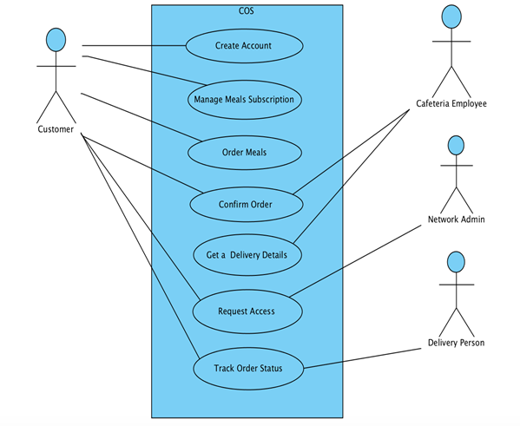Below are the use case diagrams for the Cafeteria Ordering System.

**Figure 2:** Use Case diagram for COS

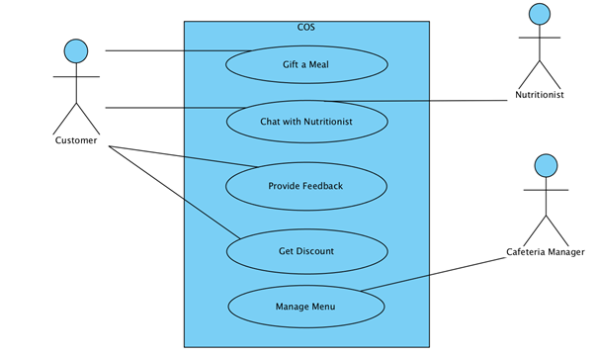

**Figure 3:** Use Case diagram for COS (Contd.)

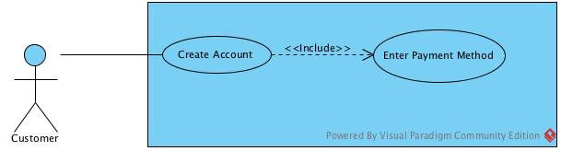

**Figure 4:** UC 1 and UC 2

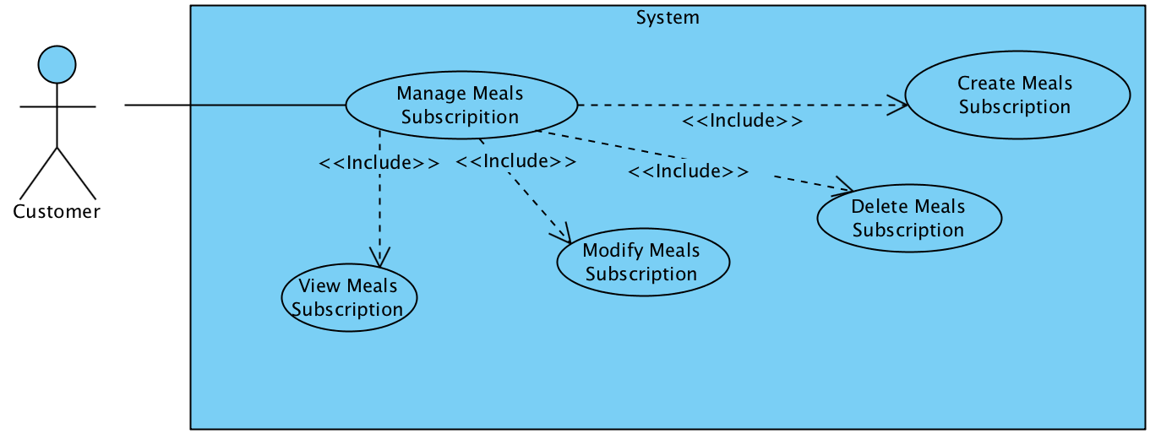

**Figure 5:** UC 3 to UC 7

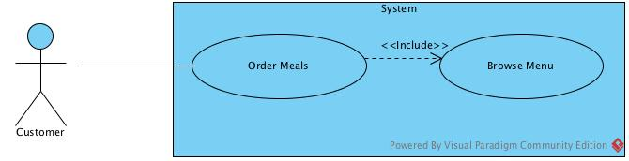

**Figure 6:** UC 8 and UC 9

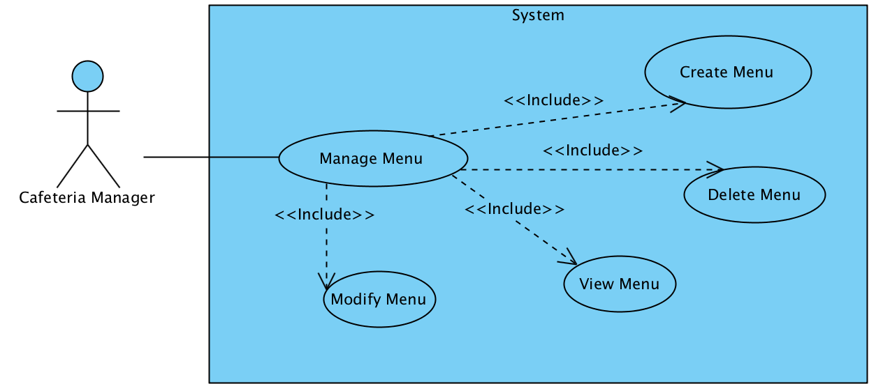

**Figure 7:** UC 18 to UC 22

## 

## 3.2 Use Case Descriptions

|  |  |  |  |  |
| --- | --- | --- | --- | --- |
| **Use Case ID:** | UC-1 | | | |
| **Use Case Name:** | Create Account | | | |
| **Created By:** | The Requirements Wizards | | **Last Updated By:** | The Requirements Wizards |
| **Date Created:** | 3/10/2016 | | **Last Revision Date:** | 3/12/2016 |
| **Actors:** | | Customer(Primary),Payroll Department Admin, Cafeteria Ordering System | | |
| **Description:** | | The customer access the COS from corporate intranet or from home to create an account. The customer enters the details such as name, employee id, company name and selects the preferable payment method. | | |
| **Trigger:** | | Customer select create account option in COS | | |
| **Preconditions:** | | 1. Customer is authorized to access COS | | |
| **Postconditions:** | | 1. Customer account is created in COS  2. Customer receives email notification after account creation | | |
| **Normal Flow:** | | 1.0 Create Account  1. Customer selects create account option in COS  2. System prompts customer to enter language preference English or Spanish  3. Customer selects language preference  4. System will prompt to enter mandatory values  5. Customer provides necessary details  6. Customer account is created and system will display success message. | | |
| **Alternative Flows:** | | None | | |
| **Exceptions:** | | 1.0.E.1 Mandatory fields are not completely filled.  1. Customer does not provide necessary details  2. System will prompt message to fill the missed mandatory fields.  3. Return to Step 5. | | |
| **Includes:** | | Enter Payment Method | | |
| **Frequency of Use:** | | Approximately 25 customers per month will create new account | | |
| **Special Requirements:** | | 1. Customers details have to be secured from any unauthorized access | | |
| **Assumptions:** | | Customer understands either English or Spanish language. | | |
| **Notes and Issues:** | | 1. Customer can opt to save the entered details and return later to complete the same. | | |

|  |  |  |  |  |
| --- | --- | --- | --- | --- |
| **Use Case ID:** | UC-2 | | | |
| **Use Case Name:** | Enter Payment Method | | | |
| **Created By:** | The Requirements Wizards | | **Last Updated By:** | The Requirements Wizards |
| **Date Created:** | 3/10/2016 | | **Last Revision Date:** | 3/12/2016 |
| **Actors:** | | Customer(Primary),Payroll Department Admin, Cafeteria Ordering System | | |
| **Description:** | | The customer access the COS from corporate intranet or from home to create an account. The customer selects the preferable payment method. | | |
| **Trigger:** | | Customer selects payment method during account creation | | |
| **Preconditions:** | | 1. Customer is valid employee of Fullerton House Company  2. Customer has already started creating an account | | |
| **Postconditions:** | | 1. Customer payment details are recorded  2. Customer account is created in COS  3. Customer receives notification after account creation | | |
| **Normal Flow:** | | 2.0 Enter Payment Method  1. Customer selects create account option in COS  2. System prompts customer to enter language preference English or Spanish  3. Customer selects language preference  4. System will prompt to enter mandatory values  5. Customer provides necessary details  6. System will prompt to select payment option  7. Customer will select register for payroll deduction  8. System will prompt the customer to enter employee id  9. Customer enters employee id  10. System will verify the employee id  11. System will register the customer for payroll deduction  12. Customer account is created and system will display success message. | | |
| **Alternative Flows:** | | 2.1 Enter Card Details (After step 6, customer will select enter card details payment option)  1. Customer selects enter card details option  2. System will prompt the customer to card details  3. Customer enters card details  4. System will verify the card details  5. Return to step 12 | | |
| **Exceptions:** | | 2.0.E.1 No employee id exists. (After step 10)  1. System will inform the employee id is invalid and prompt the customer to enter correct employee id.  2. Return to Step 9 | | |
| **Includes:** | | None | | |
| **Frequency of Use:** | | None | | |
| **Special Requirements:** | | None | | |
| **Assumptions:** | | None | | |
| **Notes and Issues:** | | None | | |

|  |  |  |  |  |
| --- | --- | --- | --- | --- |
| **Use Case ID:** | UC-3 | | | |
| **Use Case Name:** | Manage Meals Subscription | | | |
| **Created By:** | The Requirements Wizards | | **Last Updated By:** | The Requirements Wizards |
| **Date Created:** | 3/10/2016 | | **Last Revision Date:** | 3/12/2016 |
| **Actors:** | | Customer(Primary) , Cafeteria Ordering System | | |
| **Description:** | | The customer access the COS from corporate intranet or from home to manage meal subscription. The customer can perform various activities such as create, view, modify, and delete subscriptions. | | |
| **Trigger:** | | Customer opts for meal subscriptions | | |
| **Preconditions:** | | 1. Customer has a valid account in COS | | |
| **Postconditions:** | | 1. Customer is able to create a new meal subscription plan and manage it | | |
| **Normal Flow:** | | 3.0 Manage Meals Subscriptions.  1. Customer logs into COS account  2. Customer selects manage meal subscription option  3. System prompts customer to select option from create, view, modify or delete subscription  4. Customer selects desired option and continues  5. System performs the selected function | | |
| **Alternative Flows:** | | None | | |
| **Exceptions:** | | None | | |
| **Includes:** | | Create Meal Subscription, View Meal Subscription, Modify Meal Subscription, Delete Meal Subscription | | |
| **Extends:** | |  | | |
| **Frequency of Use:** | | Approximately 70 customers per month will opt for meal subscription | | |
| **Special Requirements:** | | None | | |
| **Assumptions:** | | Assume 30 percent of customers will opt for manage meal subscription | | |
| **Notes and Issues:** | | Customer should apply for meal subscription before 5th of every month | | |

|  |  |  |  |  |
| --- | --- | --- | --- | --- |
| **Use Case ID:** | UC-4 | | | |
| **Use Case Name:** | Create Meals Subscription | | | |
| **Created By:** | The Requirements Wizards | | **Last Updated By:** | The Requirements Wizards |
| **Date Created:** | 3/10/2016 | | **Last Revision Date:** | 3/12/2016 |
| **Actors:** | | Customer(Primary) , Cafeteria Ordering System | | |
| **Description:** | | The customer access the COS from corporate intranet or from home to manage meal subscription. The customer can create meal subscriptions. | | |
| **Trigger:** | | Customer opts for create meal subscriptions | | |
| **Preconditions:** | | 1. Customer has a valid account on COS  2. Customer has selected manage meal subscription option | | |
| **Postconditions:** | | 1. Customer is able to create his new meal subscription  2. System stores the created meal subscriptions plan | | |
| **Normal Flow:** | | 4.0 Create Meals Subscription  1. Customer logs into COS account  2. Customer selects manage meal subscription option  3. System prompts customer to select option from create, view, modify or delete subscription  4. Customer selects create meal subscription option  5. System prompts customer to enter the starting date and duration of meal subscription  6. Customer enters the dates and selects the meals for specified dates  7. System validates the input details  8. System will display the total price and registers the customer for meal subscription | | |
| **Alternative Flows:** | | None | | |
| **Exceptions:** | | 4.0.E.1 Customer enters wrong date (After 6 of normal flow)  1. Customer selects the past date as starting date for creating meal subscription  2. System prompts error message  3a. Customer aborts the create subscription  3b. System terminates the use case  4a. Customer selects another date  4b. Return to step 7 of normal flow | | |
| **Includes:** | | None | | |
| **Frequency of Use:** | | Approximately 35 customers per month opt for meal subscription | | |
| **Special Requirements:** | | None | | |
| **Assumptions:** | | Assume 10 percent of customers will opt for manage meal subscription | | |
| **Notes and Issues:** | | Customer should apply for meal subscription before 5th of every month | | |

|  |  |  |  |  |
| --- | --- | --- | --- | --- |
| **Use Case ID:** | UC-5 | | | |
| **Use Case Name:** | View Meals Subscription | | | |
| **Created By:** | The Requirements Wizards | | **Last Updated By:** | The Requirements Wizards |
| **Date Created:** | 3/10/2016 | | **Last Revision Date:** | 3/12/2016 |
| **Actors:** | | Customer(Primary) , Cafeteria Ordering System | | |
| **Description:** | | The customer access the COS from corporate intranet or from home to manage meal subscription. The customer can view meal subscriptions. | | |
| **Trigger:** | | Customer opts for view meal subscriptions | | |
| **Preconditions:** | | 1. Customer has a valid account on COS and is logged in  2. Customer has an existing meal subscription plan  3. Customer has selected manage meal subscription option in COS | | |
| **Postconditions:** | | 1. Customer is able to view his meal subscriptions | | |
| **Normal Flow:** | | 5. 0 View Meals Subscriptions  1. Customer selects view meal subscription option  2. System prompts customer to enter the specific dates for viewing the subscription  3. Customer enters the dates  4. System will display the subscribed meal menus for the selected date | | |
| **Alternative Flows:** | | None | | |
| **Exceptions:** | | None | | |
| **Includes:** | | None | | |
| **Frequency of Use:** | | Approximately 100 customers per month opt for view meal subscription | | |
| **Special Requirements:** | | None | | |
| **Assumptions:** | | Assume 50 percent of customers will opt for view meal subscription | | |
| **Notes and Issues:** | | None | | |

|  |  |  |  |  |
| --- | --- | --- | --- | --- |
| **Use Case ID:** | UC-6 | | | |
| **Use Case Name:** | Modify Meals Subscription | | | |
| **Created By:** | The Requirements Wizards | | **Last Updated By:** | The Requirements Wizards |
| **Date Created:** | 3/10/2016 | | **Last Revision Date:** | 3/12/2016 |
| **Actors:** | | Customer(Primary) , Cafeteria Ordering System | | |
| **Description:** | | The customer access the COS from corporate intranet or from home to manage meal subscription. The customer can as modify meal subscriptions. | | |
| **Trigger:** | | Customer opts for modify meal subscriptions | | |
| **Preconditions:** | | 1. Customer has a valid account on COS and is logged in  2. Customer has an existing meal subscription plan  3. Customer has selected manage meal subscription option in COS | | |
| **Postconditions:** | | 1. Customer is able to modify his meal subscriptions  2 . System will store the modified details | | |
| **Normal Flow:** | | 6.0 Modify Meal Subscriptions  1. Customer selects modify meal subscription option  2. System will display the existing meal subscription list  3. System prompts customer to enter the specific dates for modifying the subscription  4. Customer enters the dates  5. System displays the subscribed menu for selected date  6. Customer makes changes in the selected meal subscription  7. System will record and display the updated subscribed meal menus for the selected date | | |
| **Alternative Flows:** | | None | | |
| **Exceptions:** | | None | | |
| **Includes:** | | None | | |
| **Frequency of Use:** | | Approximately 20 customers per month opt for modify meal subscription | | |
| **Special Requirements:** | | None | | |
| **Assumptions:** | | Assume 5 percent of customers will opt for modify meal subscription | | |
| **Notes and Issues:** | | None | | |

|  |  |  |  |  |
| --- | --- | --- | --- | --- |
| **Use Case ID:** | UC-7 | | | |
| **Use Case Name:** | Delete Meals Subscription | | | |
| **Created By:** | The Requirements Wizards | | **Last Updated By:** | The Requirements Wizards |
| **Date Created:** | 3/10/2016 | | **Last Revision Date:** | 3/12/2016 |
| **Actors:** | | Customer(Primary) , Cafeteria Ordering System | | |
| **Description:** | | The customer access the COS from corporate intranet or from home to manage meal subscription. The customer wishes to delete meal subscriptions. | | |
| **Trigger:** | | Customer opts for delete meal subscriptions | | |
| **Preconditions:** | | 1. Customer has a valid account on COS and is logged in  2. Customer has an existing meal subscription plan  3. Customer has selected manage meals subscription option | | |
| **Postconditions:** | | 1. Customer is able to delete his meal subscriptions  2 . System will store the modified details | | |
| **Normal Flow:** | | 7.0 Delete Meals Subscription  1. Customer selects delete meal subscription option  2. System will display the existing meal subscription list  3. System prompts customer to enter the specific dates for deleting the subscription  4. Customer enters the dates  5. System displays the subscribed menu for selected date  6. Customer deletes the selected meal subscription  7. System will record and display the updated subscribed meal menus for the selected date | | |
| **Alternative Flows:** | | None | | |
| **Exceptions:** | | None | | |
| **Includes:** | | None | | |
| **Frequency of Use:** | | Approximately 20 customers per month opt for modify meal subscription | | |
| **Special Requirements:** | | None | | |
| **Assumptions:** | | Assume 5 percent of customers will opt for modify meal subscription | | |
| **Notes and Issues:** | | None | | |

|  |  |  |  |  |
| --- | --- | --- | --- | --- |
| **Use Case ID:** | UC-8 | | | |
| **Use Case Name:** | Order Meals | | | |
| **Created By:** | The Requirements Wizards | | **Last Updated By:** | The Requirements Wizards |
| **Date Created:** | 3/10/2016 | | **Last Revision Date:** | 3/12/2016 |
| **Actors:** | | Customer(Primary), Cafeteria Ordering System | | |
| **Description:** | | Customer access the COS from corporate intranet or from home, browse the menu for specific date from cafeteria menu or restaurant menu, and will place the regular order or customized order. | | |
| **Trigger:** | | Customer logs into COS to order meals | | |
| **Preconditions:** | | 1.    Customer has an account and is logged in | | |
| **Postconditions:** | | 1. Customer selects either regular or customized meal | | |
| **Normal Flow:** | | 8.0 Order Meals   1. Customer logs into COS 2. Customer selects the option to browse the cafeteria menu 3. System shows the list of available items for the day 4. Customer selects the regular meals option 5. System displays the price, image, ingredients for the selected items 6. Customer confirms the order and makes the payment 7. System accepts the order and sends the information to Cafeteria employee   8. COS updates the cafeteria inventory system and updates the available delivery times | | |
| **Alternative Flows:** | | 8.1  Customer prefers to customize his meal (After step 3 of normal flow)   1. Customer selects the customized meal option 2. System displays the available ingredients 3. Customer selects the ingredients as per his wish 4. Return to step 6 of normal flow | | |
| **Exceptions:** | | None | | |
| **Includes:** | | Browse Menu | | |
| **Frequency of Use:** | | Approximately 600 Customers per day, 20 logins per hour | | |
| **Special Requirements:** | | Performance – Display the requested page in less than 2 seconds  Usability – Help Menu to guide the customer | | |
| **Assumptions:** | | 20% of the Customers will order customized meal  (source: previous six months of cafeteria data) | | |
| **Notes and Issues:** | | Peak usage load is between 11:00am to 2:00pm | | |

|  |  |  |  |  |
| --- | --- | --- | --- | --- |
| **Use Case ID:** | UC-9 | | | |
| **Use Case Name:** | Browse Menu | | | |
| **Created By:** | The Requirements Wizards | | **Last Updated By:** | The Requirements Wizards |
| **Date Created:** | 3/10/2016 | | **Last Revision Date:** | 3/12/2016. |
| **Actors:** | | Customer(Primary) , Cafeteria Ordering System | | |
| **Description:** | | Customer access the COS from corporate intranet or from home to browse the meal menu | | |
| **Trigger:** | | Customer opts to browse the cafeteria menu | | |
| **Preconditions:** | | 1. Customer is logged into COS | | |
| **Postconditions:** | | 1. Customer has viewed the menu | | |
| **Normal Flow:** | | 9.0 Browse Menu   1. Customer selects the browse menu option 2. Customer opts to view cafeteria menu 3. Customer selects the date to view menu 4. System displays the menu available for the selected date | | |
| **Alternative Flows:** | | 9.1 Browse restaurant menu ( After step 1)   1. System asks the zip code of the customer 2. System displays the list of available restaurants near that area 3. Customer makes a selection from that list 4. System redirects to the online ordering system of that restaurant 5. Customer selects the order and makes the payment to the restaurant ordering system | | |
| **Exceptions:** | | None | | |
| **Includes:** | | None | | |
| **Frequency of Use:** | | Approximately 600 Customers per day, 20 logins per hour | | |
| **Special Requirements:** | | System should display the requested page within 2 seconds | | |
| **Assumptions:** | | None | | |
| **Notes and Issues:** | | None | | |

|  |  |  |  |  |
| --- | --- | --- | --- | --- |
| **Use Case ID:** | UC-10 | | | |
| **Use Case Name:** | Confirm Order | | | |
| **Created By:** | The Requirements Wizards | | **Last Updated By:** | The Requirements Wizards |
| **Date Created:** | 3/10/2016 | | **Last Revision Date:** | 3/12/2016 |
| **Actors:** | | Customer(Primary) , Cafeteria Employee, Cafeteria Ordering System, Cafeteria Inventory | | |
| **Description:** | | The customer’s meal order is confirmed by the system and Cafeteria Employee is informed after validating the details provided by the customer. The meal order is rejected if the details provided by the customer are improper. | | |
| **Trigger:** | | Customer places an order for meal | | |
| **Preconditions:** | | 1. Customer has a valid account in COS 2. Customer has ordered a meal on COS | | |
| **Postconditions:** | | 1. Customers meal order is either accepted or rejected | | |
| **Normal Flow:** | | 10.0 Confirm Order   1. Customer places a meal order through COS 2. Customer provides the delivery address and delivery time 3. System verifies the details provided by the customer 4. System accepts the order of the employee 5. System sends order confirmation e-mail to the customer 6. System notifies the cafeteria employee of the new order 7. Cafeteria employee receives the order and informs the chef about the menu details in the order 8. COS updates the cafeteria inventory system and updates the available delivery times | | |
| **Alternative Flows:** | | None | | |
| **Exceptions:** | | 10.0.E.1 Customer enters wrong delivery time (After step 3 of normal flow)  1. System displays error message notifying the customer about delivery time is after cut-off  2a. Customer cancels the order  2b. System terminates the use case  3a. Customer opts for pick up from the cafeteria  3b. Return to step 4 | | |
| **Includes:** | | None | | |
| **Frequency of Use:** | | Approximately 45 customers per hour | | |
| **Special Requirements:** | | Customer will be allowed to cancel the order at any time before confirming the order | | |
| **Assumptions:** | | None | | |
| **Notes and Issues:** | | Heavy traffic between 11am to 2pm | | |

|  |  |  |  |  |
| --- | --- | --- | --- | --- |
| **Use Case ID:** | UC-11 | | | |
| **Use Case Name:** | Get Delivery Details | | | |
| **Created By:** | The Requirements Wizards | | **Last Updated By:** | The Requirements Wizards |
| **Date Created:** | 3/10/2016 | | **Last Revision Date:** | 3/12/2016 |
| **Actors:** | | Cafeteria Employee(Primary) , Cafeteria Ordering System | | |
| **Description:** | | The customer’s meal order’s delivery details are provided to the delivery person by the cafeteria employee. The delivery person delivers the meal to customer and updates the status in COS | | |
| **Trigger:** | | Customer places an order for meal | | |
| **Preconditions:** | | 1. Customer has ordered a meal in COS 2. COS has accepted the customer’s meal order | | |
| **Postconditions:** | | 1. Meal order delivery details retrieved from COS 2. Order delivery status updated in COS | | |
| **Normal Flow:** | | 11. 0 Get Delivery Details   1. System accepts customer’s meal order 2. Cafeteria employee prints the delivery address details of the customer 3. Cafeteria employee provides the meal item and delivery details to delivery person 4. Delivery person delivers the meal to the customer at the mentioned delivery time | | |
| **Alternative Flows:** | | None | | |
| **Exceptions:** | | None | | |
| **Includes:** | | None | | |
| **Frequency of Use:** | | Approximately 35 users per hour | | |
| **Special Requirements:** | | None | | |
| **Assumptions:** | | None | | |
| **Notes and Issues:** | | Heavy traffic between 11am to 2pm | | |

|  |  |  |  |  |
| --- | --- | --- | --- | --- |
| **Use Case ID:** | UC-12 | | | |
| **Use Case Name:** | Request Access | | | |
| **Created By:** | The Requirements Wizards | | **Last Updated By:** | The Requirements Wizards |
| **Date Created:** | 3/10/2016 | | **Last Revision Date:** | 3/12/2016 |
| **Actors:** | | Customer(Primary) , Network Admin, Cafeteria Ordering System | | |
| **Description:** | | The customer is granted access to use the COS from home. The Network Admin verifies the employee credentials and grants access. | | |
| **Trigger:** | | Customer requests to access the COS using Internet | | |
| **Preconditions:** | | 1. Customer is valid employee of Fullerton house | | |
| **Postconditions:** | | 1. Customer is granted access to the COS using Internet | | |
| **Normal Flow:** | | 12.0 Request Access  1. Customer requests access to the COS from Internet  2. System asks the customer to enter the employee name and ID  3. Customer provides the details  4. The Network Admin verifies the details and grants access to the customer  5. Customer receives notification that access is granted | | |
| **Alternative Flows:** | | None | | |
| **Exceptions:** | | 12.0.E.1 Customer enters invalid employee ID(After step 3 of normal flow)  1. Customer enters invalid employee ID  2. System notifies the customer about invalid employee ID  3. Customer enters the employee ID again  4. Return to step 4 | | |
| **Includes:** | | None | | |
| **Frequency of Use:** | | Approximately 10 customers per month request access to COS using Internet | | |
| **Special Requirements:** | | None | | |
| **Assumptions:** | | None | | |
| **Notes and Issues:** | | None | | |

|  |  |  |  |  |
| --- | --- | --- | --- | --- |
| **Use Case ID:** | UC- 13 | | | |
| **Use Case Name:** | Track Order Status | | | |
| **Created By:** | The Requirements Wizards | | **Last Updated By:** | The Requirements Wizards |
| **Date Created:** | 10/3/2016 | | **Last Revision Date:** | 3/12/2016 |
| **Actors:** | | Customer(Primary),Delivery Person, Cafeteria Ordering System | | |
| **Description:** | | Customer logs into COS and checks the order status | | |
| **Trigger:** | | Customer orders food using the COS, have it delivered and would like to track the status of the order | | |
| **Preconditions:** | | 1. Customer is logged into the COS  2. Customer has ordered a meal | | |
| **Post conditions:** | | 1. Customer tracks the order status | | |
| **Normal Flow:** | | 13.0 Track Order Status.   1. Customer person logs into the COS 2. Customer selects track order status option 3. System prompts customer to enter the track ID 4. Customer enters the specific order track ID 5. System displays the order status | | |
| **Alternative Flows:** | | None | | |
| **Exceptions:** | | 13.0.E.1 Customer enters wrong track ID ( after step 4)   1. System displays “Invalid track ID” 2. Customer enters correct track ID 3. Return to step 5 | | |
| **Includes:** | | None | | |
| **Frequency of Use:** | | Approximately 28 customer per hour | | |
| **Special Requirements:** | | None | | |
| **Assumptions:** | | None | | |
| **Notes and Issues:** | | None | | |

|  |  |  |  |  |
| --- | --- | --- | --- | --- |
| **Use Case ID:** | UC -14 | | | |
| **Use Case Name:** | Gift a Meal | | | |
| **Created By:** | The Requirements Wizards | | **Last Updated By:** | The Requirements Wizards |
| **Date Created:** | 3/10/2016 | | **Last Revision Date:** | 3/12/2016 |
| **Actors:** | | Customer(Primary),Cafeteria Ordering System | | |
| **Description:** | | Customer logs into the COS, selects the option to gift a meal, chooses the items, gives the delivery details of the recipient and makes the payment. | | |
| **Trigger:** | | Customer wishes to gift a meal to a friend | | |
| **Preconditions:** | | 1. Customer is logged into the COS  2. Customer has the delivery details of the friend | | |
| **Postconditions:** | | 1. Message from customer to the friend is recorded | | |
| **Normal Flow:** | | 14.0 Gift a Meal   1. Customer logs into the COS 2. Customer select the option to gift a meal 3. System provides the cafeteria menu 4. Customer browses the menu and makes a selection 5. System provides the price of the item 6. Customer confirms the order 7. System asks for the delivery details of the recipient and the message to be included 8. Customer provides the delivery information, enters the message in the space provided, makes the payment 9. System records the message, attaches it with the delivery form and confirms the order | | |
| **Alternative Flows:** | | 14.1 Customer wishes to add credit to his/her friend’s account (After step 2)   1. Customer selects the option to add credit to friend 2. System prompts customer to enter credit amount and friends details COS account number 3. Customer enters the details and message 4. System records the details and adds credit to the friend’s account | | |
| **Exceptions:** | | None | | |
| **Includes:** | | None | | |
| **Frequency of Use:** | | Approximately 50 users | | |
| **Special Requirements:** | | 1. Customer shall be able to upload images as message | | |
| **Assumptions:** | | 1. Assume that customer’s friend has an account in COS | | |
| **Notes and Issues:** | | None | | |

|  |  |  |  |  |
| --- | --- | --- | --- | --- |
| **Use Case ID:** | UC-15 | | | |
| **Use Case Name:** | Chat with Nutritionist | | | |
| **Created By:** | The Requirements Wizards | | **Last Updated By:** | The Requirements Wizards |
| **Date Created:** | 3/10/2016 | | **Last Revision Date:** | 3/12/2016 |
| **Actors:** | | Customer(Primary), Cafeteria Ordering System, Nutritionist | | |
| **Description:** | | Customer access the COS from corporate intranet or from home and chats with the nutritionist to frame his diet plan | | |
| **Trigger:** | | Customer logs into COS and clicks on the chat with nutritionist option. | | |
| **Preconditions:** | | 1.Customer has an account and is logged in | | |
| **Postconditions:** | | 1.Customer chats with nutritionist from the list of nutritionist available online | | |
| **Normal Flow:** | | 15.0 Chat with Nutritionist   1. Customer logs into COS 2. Customer selects the chat option. 3. System displays the list of nutritionist available online. 4. Customer selects the specific nutritionist from the list. 5. New window chat will open for the chatting section with the selected nutritionist. 6. Customer interacts with nutritionist in new window. | | |
| **Alternative Flows:** | | None | | |
| **Exceptions:** | | 15.0.E.1 No nutritionist available online (After step 2)   1. System displays message and the email address of the offline nutritionist. 2. Customer logs out | | |
| **Includes:** | | None | | |
| **Frequency of Use:** | | Approximately 30 Customers per hour | | |
| **Special Requirements:** | | Performance – Display the updated list of nutritionist page in less than 2 seconds  Usability – Customer should be able to refresh the list of nutritionist available online and system should display the updated status of the nutritionist to the customer. | | |
| **Assumptions:** | | 50% of the Customers will prefer to chat with nutritionist  (source: previous six months of cafeteria data) | | |
| **Notes and Issues:** | | Peak usage load is between 10 am to 2 pm | | |

|  |  |  |  |  |
| --- | --- | --- | --- | --- |
| **Use Case ID:** | UC- 16 | | | |
| **Use Case Name:** | Provide Feedback | | | |
| **Created By:** | The Requirements Wizards | | **Last Updated By:** | The Requirements Wizards |
| **Date Created:** | 3/10/2016 | | **Last Revision Date:** | 3/12/2016 |
| **Actors:** | | Customer(Primary), Cafeteria Manager(Secondary) | | |
| **Description:** | | Customer logs into COS and provides feedback for the service | | |
| **Trigger:** | | Customer would like to give feedback for the service | | |
| **Preconditions:** | | 1. Customer is logged into the COS  2. Customer has an order history | | |
| **Post conditions:** | | 1. Customer feedback is recorded | | |
| **Normal Flow:** | | 16.0 Provide Feedback   1. Customer logs into the COS 2. Customer select the option for feedback 3. System provides the customer with a space to write his review 4. Customer writes his feedback 5. System records the feedback | | |
| **Alternative Flows:** | | None | | |
| **Exceptions:** | | None | | |
| **Includes:** | | None | | |
| **Frequency of Use:** | | Approximately 50 users | | |
| **Special Requirements:** | | 1. Customer shall be able to give their reviews anonymously | | |
| **Assumptions:** | | 1. Assume that customer will write feedback only in English | | |
| **Notes and Issues:** | | 1. Customer feedback should not exceed 1000 characters | | |

|  |  |  |  |  |
| --- | --- | --- | --- | --- |
| **Use Case ID:** | UC-17 | | | |
| **Use Case Name:** | Get Discount | | | |
| **Created By:** | The Requirements Wizards | | **Last Updated By:** | The Requirements Wizards |
| **Date Created:** | 3/10/2016 | | **Last Revision Date:** | 3/12/2016 |
| **Actors:** | | Customer(Primary), Cafeteria Ordering System | | |
| **Description:** | | Customer access the COS from corporate intranet or from home, to order regular or customized meal for single or group orders. | | |
| **Trigger:** | | Customer logs into COS to order meals | | |
| **Preconditions:** | | 1.    Customer has an account and is logged in | | |
| **Postconditions:** | | 1. Regular customer discount or group discount is offered | | |
| **Normal Flow:** | | 17.0 Get Discount  1.Customer logs into COS  2.Customer selects single food item to order  3.System displays the price, image, ingredients for the selected items  4.Customer confirms the order and selects single discount offer  5. System displays the discounted price of the ordered food  6. Customer makes payment  7.System accepts payment and places the order | | |
| **Alternative Flows:** | | 17.1 If the customer selects group discount offer (After step 1)  1.Customer selects multiple food items to order  2.System displays the price, image, ingredients for the selected items  3.Customer confirms the order and selects group discount offer  4. System displays the discounted price of the ordered food  5. Customer makes payment  6.System accepts payment and places the order | | |
| **Exceptions:** | | None | | |
| **Includes:** | | None | | |
| **Frequency of Use:** | | Approximately 25 Customers per day | | |
| **Special Requirements:** | | Usability – Help Menu to guide the customer | | |
| **Assumptions:** | | None | | |
| **Notes and Issues:** | | Peak usage load is between 11:00am to 2:00pm | | |

|  |  |  |  |  |
| --- | --- | --- | --- | --- |
| **Use Case ID:** | UC- 18 | | | |
| **Use Case Name:** | Manage Menu | | | |
| **Created By:** | The Requirements Wizards | | **Last Updated By:** | The Requirements Wizards |
| **Date Created:** | 3/10/2016 | | **Last Revision Date:** | 3/12/2016 |
| **Actors:** | | Cafeteria Manager(Primary) , Cafeteria Ordering System | | |
| **Description:** | | The Cafeteria Manager access the COS from corporate intranet or from home to manage menu. Cafeteria Manager perform various activities such as create, view, modify, and delete menu. | | |
| **Trigger:** | | Cafeteria Manager opts for manage meal menu | | |
| **Preconditions:** | | Cafeteria Manager has a valid account on COS | | |
| **Postconditions:** | | 1. Cafeteria Manager is able to manage COS meal menu  2. System stores the updated meal menu plan | | |
| **Normal Flow:** | | 18.0 Manage Menu  1. Cafeteria Manager logs into COS account  2. Cafeteria Manager selects manage meal menu option  3. System prompts Cafeteria Manager to select option from create, view, modify or delete menu  4. Cafeteria Manager selects desired option and continues.  5. System performs the selected function | | |
| **Alternative Flows:** | | None | | |
| **Exceptions:** | | None | | |
| **Includes:** | | Create Menu, View Menu, Modify Menu, Delete Menu | | |
| **Extends:** | |  | | |
| **Frequency of Use:** | | Approximately 1 Cafeteria Manager in every 5 minutes will opt for meal menu option | | |
| **Special Requirements:** | | Cafeteria Manager shall be able to update the meal menu and the system should reflect the updated menu in the COS in one second. | | |
| **Assumptions:** | | Assume the menu needs to be updated for every 5 minutes.  (Source : From cafeteria data for past 7 months) | | |
| **Notes and Issues:** | | Please load usage between 11 am to 3 pm. | | |

|  |  |  |  |  |
| --- | --- | --- | --- | --- |
| **Use Case ID:** | UC-19 | | | |
| **Use Case Name:** | Create Menu | | | |
| **Created By:** | The Requirements Wizards | | **Last Updated By:** | The Requirements Wizards |
| **Date Created:** | 3/10/2016 | | **Last Revision Date:** | 3/12/2016 |
| **Actors:** | | Cafeteria Manager(Primary) , Cafeteria Ordering System | | |
| **Description:** | | The Cafeteria Manager access the COS from corporate intranet or from home to manage menu. Cafeteria Manager can select create meal menu | | |
| **Trigger:** | | Cafeteria Manager opts to create meal menu | | |
| **Preconditions:** | | 1. Cafeteria Manager has a valid account on COS 2. Cafeteria Manager has selected the manage menu option | | |
| **Postconditions:** | | 1. Cafeteria Manager is able to create COS meal menu  2. System stores the new meal in the menu. | | |
| **Normal Flow:** | | 19.0. Create Menu   1. Cafeteria Manager selects create meal menu option 2. System prompts Cafeteria Manager to enter the menu name, ingredients, image, price and availability time. 3. Cafeteria Manager enters the menu names, ingredients, calorie value, prices and selects the availability time. 4. System will validate the provided details 5. System will display the updated menu meal with images, ingredients, calorie values and prices. | | |
| **Alternative Flows:** | | None | | |
| **Exceptions:** | | 19.0.E.1 Invalid meal detail values. (After step 6)  1. Cafeteria Manager provides invalid or past availability timing details.  2. System will display error message  3. Return to Step 2 of normal flow | | |
| **Includes:** | | None | | |
| **Frequency of Use:** | | Cafeteria Manager will create approximately 1 menu per day. | | |
| **Special Requirements:** | | Cafeteria Manager shall be able to create the meal menu and the system should reflect the created menu in the COS in one second. | | |
| **Assumptions:** | | None | | |
| **Notes and Issues:** | | Please load usage between 11 am to 3 pm. | | |

|  |  |  |  |  |
| --- | --- | --- | --- | --- |
| **Use Case ID:** | UC-20 | | | |
| **Use Case Name:** | View Menu | | | |
| **Created By:** | The Requirements Wizards | | **Last Updated By:** | The Requirements Wizards |
| **Date Created:** | 3/10/2016 | | **Last Revision Date:** | 3/12/2016 |
| **Actors:** | | Cafeteria Manager(Primary) , Cafeteria Ordering System | | |
| **Description:** | | The Cafeteria Manager access the COS from corporate intranet or from home to manage menu. Cafeteria Manager can select view meal menu | | |
| **Trigger:** | | Cafeteria Manager opts to view meal menu | | |
| **Preconditions:** | | 1. Cafeteria Manager has a valid account on COS 2. Cafeteria Manager has selected the manage menu option. | | |
| **Postconditions:** | | 1. Cafeteria Manager is able to view COS meal menu | | |
| **Normal Flow:** | | 20.0. View Menu   1. Cafeteria Manager selects view meal menu option 2. System prompts Cafeteria Manager to enter the specific dates for viewing the meal menu 3. Cafeteria Manager will enter the specific dates 4. System will display the menu meal available on that particular date with images, ingredients, calorie values and prices. | | |
| **Alternative Flows:** | | None | | |
| **Exceptions:** | | None | | |
| **Includes:** | | None | | |
| **Frequency of Use:** | | Cafeteria Manager will view meal menu every 10 minutes. | | |
| **Special Requirements:** | | Cafeteria Manager shall be able to view the meal menu and the system should display the existing menu in the COS in one second. | | |
| **Assumptions:** | | Assume the menu needs to be viewed every 10 minutes.  (Source : From cafeteria data for past 7 months) | | |
| **Notes and Issues:** | | Please load usage between 11 am to 3 pm. | | |

|  |  |  |  |  |
| --- | --- | --- | --- | --- |
| **Use Case ID:** | UC-21 | | | |
| **Use Case Name:** | Modify Menu | | | |
| **Created By:** | The Requirements Wizards | | **Last Updated By:** | The Requirements Wizards |
| **Date Created:** | 3/10/2016 | | **Last Revision Date:** | 3/12/2016 |
| **Actors:** | | Cafeteria Manager(Primary) , Cafeteria Ordering System | | |
| **Description:** | | The Cafeteria Manager access the COS from corporate intranet or from home to manage menu. Cafeteria Manager can select modify meal menu | | |
| **Trigger:** | | Cafeteria Manager opts to modify meal menu | | |
| **Preconditions:** | | 1. Cafeteria Manager has a valid account on COS 2. Cafeteria Manager has selected the manage menu option. | | |
| **Postconditions:** | | 1. Cafeteria Manager is able to modify COS meal menu | | |
| **Normal Flow:** | | 21.0. Modify Menu   1. Cafeteria Manager selects modify meal menu option 2. System will display the meal menu to modify 3. System prompts Cafeteria Manager to select one meal for modifying 4. System will display the selected menu details such as images, ingredients, calorie values and prices of the meal. 5. Cafeteria Manager modifies the details of the meal 6. System will display the updated meal details for confirmation. 7. Cafeteria Manager confirms the changes. 8. System will display the updated meal details in the menu list. | | |
| **Alternative Flows:** | | None | | |
| **Exceptions:** | | None | | |
| **Includes:** | | None | | |
| **Frequency of Use:** | | Cafeteria Manager will modify menu five times an hour. | | |
| **Special Requirements:** | | Cafeteria Manager shall be able to modify the meal menu and the system should display the modified menu in the COS in one second. | | |
| **Assumptions:** | | Assume the menu needs to be modified every hour  (Source : From cafeteria data for past 7 months) | | |
| **Notes and Issues:** | | Please load usage between 11 am to 3 pm. | | |

|  |  |  |  |  |
| --- | --- | --- | --- | --- |
| **Use Case ID:** | UC -22 | | | |
| **Use Case Name:** | Delete Menu | | | |
| **Created By:** | The Requirements Wizards | | **Last Updated By:** | The Requirements Wizards |
| **Date Created:** | 3/10/2016 | | **Last Revision Date:** | 3/12/2016 |
| **Actors:** | | Cafeteria Manager(Primary) , Cafeteria Ordering System | | |
| **Description:** | | The Cafeteria Manager access the COS from corporate intranet or from home to manage menu. Cafeteria Manager can select delete meal menu | | |
| **Trigger:** | | Cafeteria Manager opts to delete meal menu | | |
| **Preconditions:** | | 1. Cafeteria Manager has a valid account on COS 2. Cafeteria Manager has selected the manage menu option. | | |
| **Postconditions:** | | 1. Cafeteria Manager is able to delete COS meal menu | | |
| **Normal Flow:** | | 22.0. Delete Menu   1. Cafeteria Manager selects delete meal menu option 2. System will display the list of meal menu to delete 3. System prompts Cafeteria Manager to select one meal for deleting 4. System will display the selected menu details such as images, ingredients, calorie values and prices of the meal. 5. Cafeteria Manager deletes the meal 6. System will display the deleted meal details for confirmation. 7. Cafeteria Manager confirms the changes. 8. System deletes the meal and displays the updated meal menu list | | |
| **Alternative Flows:** | | None | | |
| **Exceptions:** | | None | | |
| **Includes:** | | None | | |
| **Frequency of Use:** | | Cafeteria Manager will delete meal menu once at the end of the day | | |
| **Special Requirements:** | | Cafeteria Manager shall be able to delete the meal menu and the system should remove that record from the menu list and display the updated menu list in the COS in one minute. . | | |
| **Assumptions:** | | None | | |
| **Notes and Issues:** | | Please load usage between 11 am to 3 pm. | | |

# External Interface Requirements

## User Interfaces

**UI-1:** COS shall be accessed using mobile phones and tablets as well

**UI-2:** COS shall have help options to guide the users through the website

**UI-3:** COS shall display the error messages with all details including the reason for the error and “Help guide” for further steps

**UI-4:** COS shall be compatible with touch screen devices

## Hardware Interfaces

None

## Software Interfaces

**SI-1:** COS shall interface with the company’s payroll system to give the details of the employees who have registered for payroll deduction scheme to deduct the bill amount from their salary

**SI-2:** COS shall interface with the inventory to check the items available in the inventory, update the menu, and remove the item from the inventory after it is been ordered

**SI-3:** COS shall interface with the online banking system to make transactions

## Communications Interfaces

**CI-1:** COS shall send an account verification message to the Customer’s email address and phone number to confirm his/her identity

**CI-2:** COS shall send order confirmation messages to the Customer’s phone number and a the track ID to check the status of the order

**CI-3:** COS shall send the contact details of the delivery person to the Customer’s phone number

# Other Nonfunctional Requirements

## Performance Requirements

**PR-1:** COS shall process the requests from user with a latency of 1 minute after the user submits the request to the COS.

## Safety Requirements

**SAF-1:** The customer shall be able to see a list of all ingredients in any menu items, with ingredients highlighted that are known to cause allergic reactions in more than 0.5 percent of the North American population.

## Security Requirements

**SR-1:** COS shall verify the username and password credentials of the user and then allow access to order food.

**SR-2:** COS shall lock the username after 3 wrong password attempts.

**SR-3:** All the financial transaction information shall be encrypted

**SR-4:** COS shall allow only authorized Cafeteria Managers to update the menu

**SR-5**: COS shall make it possible for only the cafeteria employees to view the delivery details. The delivery location is not exposed to anyone except the cafeteria employee and delivery person.

## Software Quality Attributes

**QA-1 Usability**: COS shall have help features to guide the users

**QA-2 Usability:** COS shall give feedback to the user every 1 minute about the status of the transaction that is being processed

**QA-3 Usability:** COS shall allow users to cancel order any time before making the payment

**QA-4 Availability:** COS shall be available to all users 99.99% of the time on weekdays and 95% of the time on weekends except for the scheduled maintenance downtime. Users of the system will be informed in advance about scheduled downtime.

# Other Requirements

None

# Data Flow Diagram

Below are the Level 0, 1 and 2 data flow diagrams for Cafeteria Ordering System.

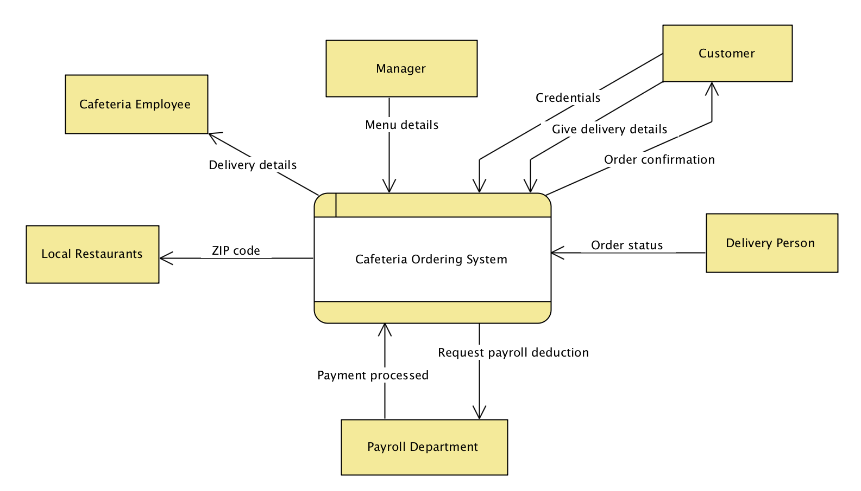

**Figure 8:** Level 0 Data flow diagram for COS

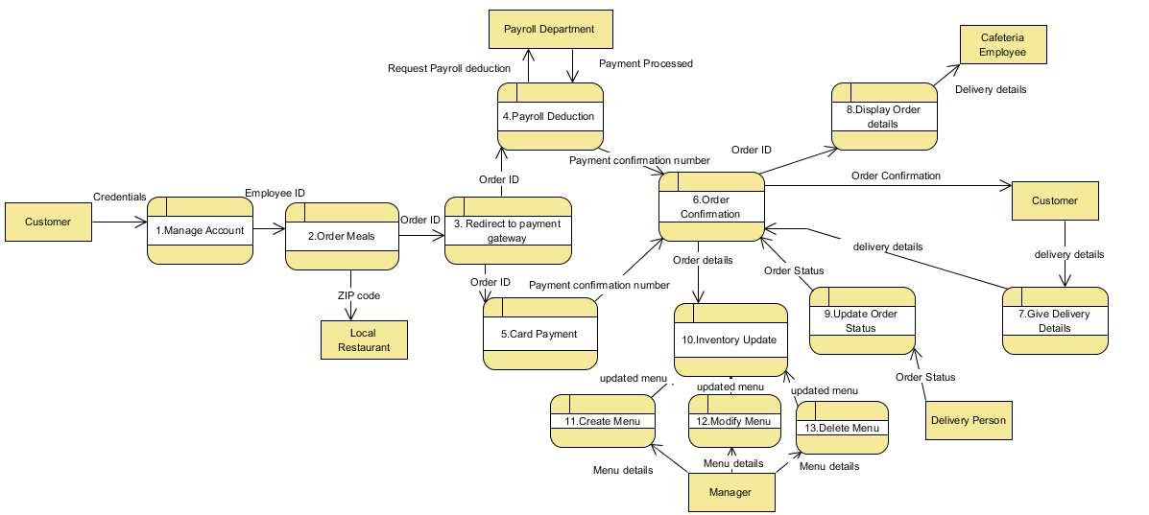**Figure 9:** Level 1 Data flow diagram for COS

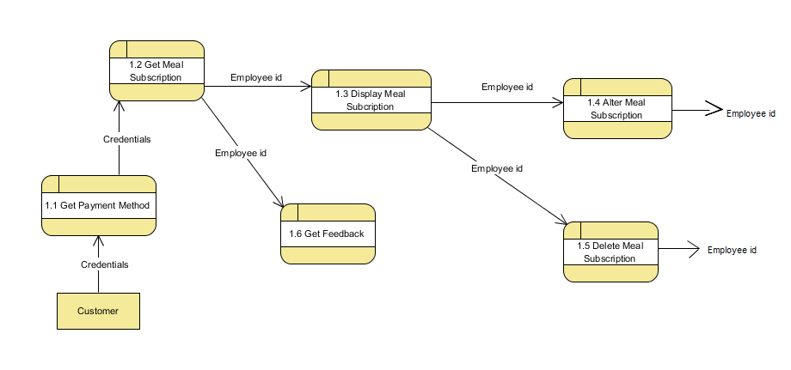

**Figure 10:** Level 2 data flow diagram for “Manage Account”

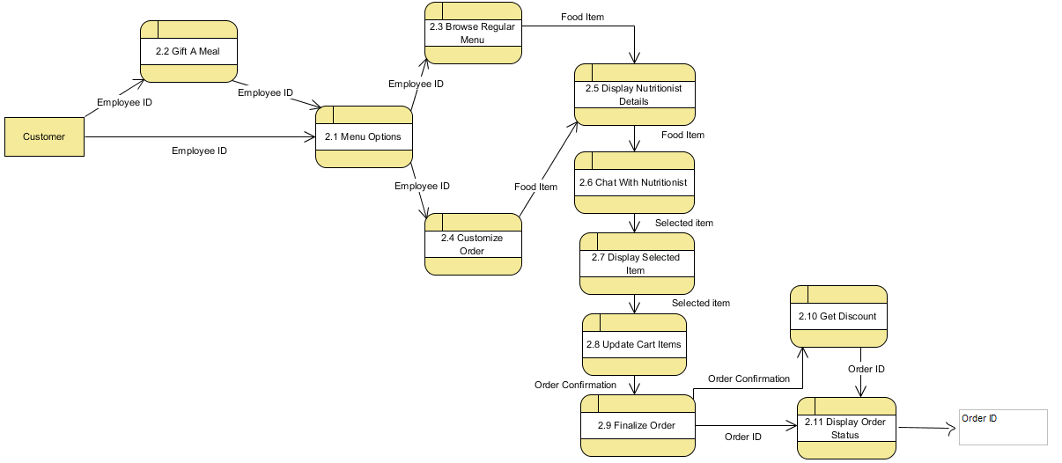

**Figure 11:** Level 2 data flow diagram for "Order Meals"

# 

# Functional Requirements (FRs)

* 1. **FR 1 – Manage Account** 
     1. **Introduction**

The COS shall allow the patron to create an account in the COS.

* + 1. **Inputs**

1. Customer’s first and last name
2. Customer’s Employee id
3. Email id and contact mobile number
4. Date of birth
5. Gender
6. Payment method (payroll deduction or credit/debit card)
7. Home address
8. Building and cubicle number
9. User id
10. Password

* + 1. **Processing**

The customer shall select create account option on COS. The COS shall display the create account form and prompt the customer to enter the mandatory details. The customer shall enter those details. The customer shall verify and submit the form and COS shall send success message notification on customer’s e-mail id.

* + 1. **Outputs**

1. Success message
2. Email notification to customer
   * 1. **Error Handling**

1. COS shall display error message if customer missed any mandatory field.
   1. **FR 2- Get Payment Method**
      1. **Introduction**

The COS shall allow the customer to select the payment method of his/her choice during account creation.

* + 1. **Inputs**

1. Employee id

2. Credit/Debit Card Number

3. Employee name

4. Card Expiration Date

5. Card CVS Code

* + 1. **Processing**

COS shall display the payment method and prompt the customer to select from the displayed options. If the customer selects payroll deduction option and the COS shall verify for employee id credentials and register the customer for payroll deduction. If customer selects credit/debit card option then the COS shall ask the customer to enter the card credentials such as Credit/Debit Card Number, Employee name, Card Expiration Date, Card CVS Code. Customer these details and COS records the inputs and register customer for card payment method.

* + 1. **Outputs**

1. Customer registered for payroll deduction/card payment option.
2. COS shall record the details and display success message for account creation
   * 1. **Error Handling**

1. If customer inputs invalid employee id then the COS shall display error message and prompt the customer to enter the correct employee id.
   1. **FR 3 - Get Meal Subscriptions** 
      1. **Introduction**

The COS shall allow the patron to create meal subscriptions and the system shall display the meal subscriptions.

* + 1. **Inputs**

1. Valid date
2. Time Duration of meal subscriptions that can be mentioned either in days, weeks or months.

* + 1. **Processing**

The customer shall select manage meal subscription option on COS. The COS shall prompt the customer to select any of the various options such as create, modify, view and delete options. The customer shall selects the create meal subscriptions and system displays the meal creation form. Customer provides all the mandatory fields such as starting date and duration of meal subscriptions. The COS shall validate those details and displays the total price for the subscriptions and registers the meal subscribed.

* + 1. **Outputs**

1. Total Price of meal
2. Meal subscription confirmation message on screen
   * 1. **Error Handling**

1. COS shall display error message if customer entered past date as starting date for meal creation.
2. COS shall prompt to enter the correct date

* 1. **FR4- Display Meal Subscriptions** 
     1. **Introduction**

The COS shall allow the patron to view meal subscriptions for the selected date.

* + 1. **Inputs**

1. Valid date

* + 1. **Processing**

The customer shall select manage meal subscription option on COS. The COS shall prompt the customer to select any of the various options such as create, modify, view and delete options. The customer shall selects the view meal subscriptions and system shall prompt the customer to enter the date for viewing the subscription. Customer provides date details and the COS shall validate those details and displays selected meal subscriptions.

* + 1. **Outputs**

1. Selected meal subscription displayed

* + 1. **Error Handling**

None

* 1. **FR 5 - Alter Meal Subscriptions** 
     1. **Introduction**

The COS shall allow the patron to alter meal subscriptions for the selected date.

* + 1. **Inputs**

1. Valid date

* + 1. **Processing**

The customer shall select manage meal subscription option on COS. The COS shall prompt the customer to select any of the various options such as create, modify, view and delete options. The customer shall selects the modify meal subscriptions and system shall prompt the customer to enter the date for modifying the subscription. Customer provides date details and the system shall validate those details and displays selected meal subscriptions and prompt the customer to modify it. Customer modifies and saves the updated subscription. COS shall record and display the updated subscription.

* + 1. **Outputs**

1. Updated meal subscription is displayed and record is updated.

* + 1. **Error Handling**

None

* 1. **FR 6- Delete Meal Subscriptions** 
     1. **Introduction**

The COS shall allow the patron to delete meal subscriptions for the selected date.

* + 1. **Inputs**

1. Valid date

* + 1. **Processing**

The customer shall select manage meal subscription option on COS. The COS shall prompt the customer to select any of the various options such as create, modify, view and delete options. The customer shall selects the delete meal subscriptions and system shall prompt the customer to enter the date for deleting the subscription. Customer provides date details and the system shall validate those details and deletes selected meal subscriptions.

COS shall record and display the updated subscription.

* + 1. **Outputs**

1. Selected meal subscription is deleted and record is updated.

* + 1. **Error Handling**

None

* 1. **FR 7**- **Menu Options**
     1. **Introduction**

The COS shall allow the customer to browse cafeteria menu or redirect the customer to local restaurant.

* + 1. **Inputs**

1. Zip code

2. Valid date

* + 1. **Processing**

The customer shall selects browse menu option on COS. The COS shall prompt the customer to browse either cafeteria menu or Local Restaurant. If customer selects COS menu option, the system shall prompt the customer to enter valid date. Customer enters the date and system shall display the available menu for the selected date. If customer selects local restaurant option, COS shall prompt customer to enter zip code. Customer enters the zip code and COS shall display list of available restaurants.

* + 1. **Outputs**

1. Cos display Cafeteria menu
2. Cos display local restaurant list
   * 1. **Error Handling**

None

* 1. **FR 8**- **Display selected item**
     1. **Introduction**

The COS shall display the selected item details such as price, ingredients, images, nutrition values.

* + 1. **Inputs**

1. Valid date
2. Menu item

* + 1. **Processing**

The customer selects COS menu option from the browse menu, the COS shall prompt the customer to enter valid date. Customer enters the date and system shall display the available menu for the selected date. Customer shall selects an item form the available menu to view details. The COS shall display the price, ingredients, images, nutrition values for the selected item.

* + 1. **Outputs**

1. COS displays the menu
2. COS display the details of selected item
   * 1. **Error Handling**

None

* 1. **FR 9**- **Update Cart Items**
     1. **Introduction**

The COS shall allow the customer to select the order and update the cart item of the customer.

* + 1. **Inputs**

1. Select order valid date

2. Menu item

* + 1. **Processing**

The COS shall prompt the customer to select the date and customer provides the date. COS shall display the list of available menu items of that particular date. COS shall prompt customer to select meal form regular meal or customized meal, if customer selects the regular meal then COS shall record and display the order. The COS shall add the order to the customer’s cart. If customer selects customized option then the COS shall prompt the customer to select the ingredients of this choice and build his own meal, then COS shall record and display the order. The COS shall add the order to the customer’s cart.

* + 1. **Outputs**

1. Order is displayed to the customer
2. Cart is updated
   * 1. **Error Handling**

None

* 1. **FR 10- Give delivery details** 
     1. **Introduction**

The COS shall allow the customer to enter the delivery details for the order placed

* + 1. **Inputs**

1. Street Name
2. Street Number
3. Building Number
4. Cubicle Number
5. Delivery Time
6. Mobile Number

* + 1. **Processing**

The customer has added items to his cart and selects the checkout option. The COS shall prompt the customer to enter the delivery address, delivery time, mobile number. Customer shall enter the details and COS shall record the details and redirects to the payment gateway.

* + 1. **Outputs**

1. Customer redirected to payment gateway
   * 1. **Error Handling**

1. If customer enters delivery time after cuts off timing the COS shall display error and prompt the customer to either enter new delivery time or to select meal pick-up option.
2. Customer selects the desired option and COS directs the customer to payment gateway.
   1. **FR 11**- **Redirect to payment gateway**
      1. **Introduction**

The COS shall redirect the customer to make payment once the order is selected and confirmed

* + 1. **Inputs**

1. Items present in the cart

2. Employee id

3. Select from the registered Credit/Debit card

* + 1. **Processing**

The customer has added items to his cart, selects the checkout option and provides the all the delivery details. The COS shall then redirect the customer to the payment gateway and display the payment method options. If the customer selects payroll deduction option and the COS shall confirm the order and display the order id and sends the notification to cafeteria employee. If customer selects credit/debit card option then the COS shall ask the customer to select the card from the registered cards. Customer selects the card and COS confirm the order and display the order id and sends the notification to cafeteria employee.

* + 1. **Outputs**

1. Order id
2. Email notification to cafeteria employee
   * 1. **Error Handling**

None

* 1. **FR 12- Display order details**
     1. **Introduction**

The COS shall allow the cafeteria employee to view the details of the orders.

* + 1. **Inputs**

1. Order id

* + 1. **Processing**

The COS shall allow cafeteria employee to view the order details. The COS shall prompt the cafeteria employee to select the order id to view its details. The employee selects the desired order and COS shall display the details such as the items in the order, name of the customer and delivery address and time.

* + 1. **Outputs** 
       1. Order details such as items in order, name of customer and delivery address and time
    2. **Error Handling**

None

* 1. **FR 13- Inventory Update**
     1. **Introduction**

The COS shall update the inventory once the order is delivered

* + 1. **Inputs**

1. Meal items
2. Order Status

* + 1. **Processing**

The customer placed the order and meal item is delivered to the customer, then the COS update the order status. Once the order status got updated as delivered then the COS shall update the inventory

* + 1. **Outputs** 
       1. Order Inventory Updated
    2. **Error Handling**

None

* 1. **FR 14- Get Feedback**
     1. **Introduction**

The COS shall allow the customer to provide the feedback

* + 1. **Inputs**

1. Customer Clicks on Feedback button

* + 1. **Processing**

    The customer clicks on the Feedback button in the COS. The COS shall display the

Feedback form and customer enters the feedback. Once customer clicks on the enter button, the COS shall display the feedback in the screen.

* + 1. **Outputs** 
       1. Feedback displayed in the screen
    2. **Error Handling**

None

* 1. **FR 15- Update Order Status**
     1. **Introduction**

The COS shall allow the delivery person to update the order status of the meal.

* + 1. **Inputs**

1. Delivery person user id
2. Delivery person password
3. Order id

* + 1. **Processing**

The COS shall prompt the delivery person to enter the user id and password. Once the delivery person provided the credentials, the COS shall prompt to enter the order id. The delivery person enters the order id. COS shall display the order details and prompt to update the order status. The delivery person provides the status of the order id and clicks on enter, the COS displays the entered order status for that order id.

* + 1. **Outputs** 
       1. Order Status updated
       2. Error Message if entered invalid credentials
       3. Error Message if entered invalid order id
    2. **Error Handling**

1. If the delivery person enters invalid credentials then the COS shall display the error message and prompt to enter the correct credentials.
2. If the delivery person enter the invalid order id, then the COS shall display the error message and prompt to enter the valid order id.
   1. **FR 16- Display Order Status**
      1. **Introduction**

The COS shall display the order status to the customer

* + 1. **Inputs**

1. Order id

* + 1. **Processing**

Customer clicks on the view order status button, then the COS shall display the view order status page. The COS shall prompt the customer to enter the order id. The customer enters the order id, then the COS shall display the order status of that order id.

* + 1. **Outputs** 
       1. Display Order Status
       2. Error Message if entered invalid order id
    2. **Error Handling**

If the customer enters the invalid order id, then the COS shall display the error message and prompt to enter the valid order id.

* 1. **FR 17- Gift a meal**
     1. **Introduction**

The COS shall allow the customer to gift a meal to his friend, either by ordering a meal or by adding credit to the friends account and include the message note.

* + 1. **Inputs**

1. Date
2. Delivery time
3. Friend’s Name
4. Friend’s Street Number
5. Friend’s Cubicle Number
6. Friend’s Mobile Number
7. Message Note

* + 1. **Processing**

  When the customer selects the gift a meal button, COS shall redirect the customer to the menu option. Once the customer selects the regular meal or customized meal, provides the friend’s delivery details, mobile number, and delivery time and confirms the meal, then the COS shall prompt to enter the message note to friend. The customer provides the message and the COS shall record the message and display the message in the screen

* + 1. **Outputs** 
       1. Order confirmed
       2. Message recorded
    2. **Error Handling**

If customer enters delivery time after cuts off timing the COS shall display error and prompt the customer to either enter new delivery time or to select meal pick-up option, then the customer selects the desired option and COS directs the customer to payment gateway.

If customer enter invalid date, the COS shall display error and prompt the customer the valid date

* 1. **FR 18- Display nutritionist details**
     1. **Introduction**

The COS shall allow the customer to view the available nutritionist details.

* + 1. **Inputs**

1. Chat option is selected.

* + 1. **Processing**

The customer selects the chat option available on his account page. The COS shall display the list of all nutritionist available online at that time.

* + 1. **Outputs**

1. List of online nutritionist
2. Email id of offline nutritionist
   * 1. **Error Handling**

1. If no nutritionist is available online at the current time, then COS shall display the email id of the offline nutritionist.
   1. **FR 19- Chat with nutritionist** 
      1. **Introduction**

The COS shall allow the customer to chat with the nutritionists available online.

* + 1. **Inputs**

Chat option is selected.

Nutritionist from available list is selected

* + 1. **Processing**

The customer selects the specific nutritionist from all the online nutritionist list displayed by the COS. The COS shall then open a chat window to allow the customer to chat with that nutritionist and allow both customer and nutritionist to send text and images via the chat window.

* + 1. **Outputs**

1. Chat window opened
   * 1. **Error Handling**

None

* 1. **FR 20- Create Menu** 
     1. **Introduction**

The COS shall allow the Cafeteria Manager to create the menu.

* + 1. **Inputs**

1. Menu name
2. Ingredients
3. Calorie Value
4. Price
5. Date
6. Time
7. Menu Images

* + 1. **Processing**

The manager shall select manage meal menu option on COS. The COS shall prompt the manager to select any of the various options such as create, modify, view and delete menu options. The manager shall selects the create menu and COS displays the menu creation form. Manager provides all the mandatory fields such as Menu name, Ingredients, Calorie value, price, menu availability date and time. Manager can also upload image of the menu (optional). The COS shall validate those details, record and display these details and also display confirmation message for successful menu creation.

* + 1. **Outputs**

1. Record and display details of created menu
2. Confirmation message for successful creation of menu
3. Menu Id
   * 1. **Error Handling**

1. If the manager enters the past date as the available date for the menu, the COS shall display error message and prompt manager to enter valid date.
2. Manager enters a valid date and COS records the details.
   1. **FR 21- Modify Menu** 
      1. **Introduction**

The COS shall allow the Cafeteria Manager to modify the menu.

* + 1. **Inputs**

1. Menu id
2. Menu name
3. Ingredients
4. Calorie Value
5. Price
6. Date
7. Time
8. Menu Images

* + 1. **Processing**

The manager shall select manage meal menu option on COS. The COS shall prompt the manager to select any of the various options such as create, modify, view and delete menu options. The manager shall selects the modify menu option and COS shall prompt the manager to enter the menu id of the menu. Manager provides the menu id and COS shall display the available details such as date, time images, ingredients, calorie values and prices of the meal for the selected menu. Manager modifies these details and selects save option The COS shall validate those details and display the modified menu and prompt the manager to provide confirmation on the changes. Manager confirms the changes and COS shall record and update the menu details in the list.

* + 1. **Outputs**

1. Confirmation message for changes in the menu
2. Record and display updated details of modified menu
   * 1. **Error Handling**

None

* 1. **FR 22- Delete Menu** 
     1. **Introduction**

The COS shall allow the Cafeteria Manager to delete the menu.

* + 1. **Inputs**

1. Menu id

* + 1. **Processing**

The manager shall select manage meal menu option on COS. The COS shall prompt the manager to select any of the various options such as create, modify, view and delete menu options. The manager shall selects the delete menu option and COS shall prompt the manager to enter the menu id of the menu. Manager provides the menu id and COS shall display the available details such as date, time images, ingredients, calorie values and prices of the meal for the selected menu. Manager selects the delete option for the selected menu. The COS shall prompt the manager to provide confirmation on the deletion. Manager confirms the deletion and COS shall delete the selected menu and updated menu’s in the list.

* + 1. **Outputs**

1. Confirmation message for deletion of the menu
2. Record the menu deletion and remove that menu from menu list
3. Display updated menu list
   * 1. **Error Handling**

None

* 1. **. FR 23- Get Discount**
     1. **Introduction**

The COS shall allow the customer to select single discount offer or group discount offer.

* + 1. **Inputs**

1. Order id
2. Employee id
3. Credit/Debit card details

* + 1. **Processing**

  When the customer selects the food items to order, COS shall prompt the customer to select the discount offer that customer wants to use. Once the customer selects the single discount offer or group discount offer, the COS shall display the discounted price of the selected food items and prompts the customer to proceed for payment. Customer makes the payment and order is placed.

* + 1. **Outputs** 
       1. Discount is offered
    2. **Error Handling**

None

# Initial and modified class diagram

Below are the initial and modified class diagram for the COS. In the initial class diagram, we have identified 16 boundary classes for each actor and use case pair interaction. We identified total 22 control classes for all the use cases identified for COS. For entity class, we identified 5 classes based on the nouns available in use case descriptions.

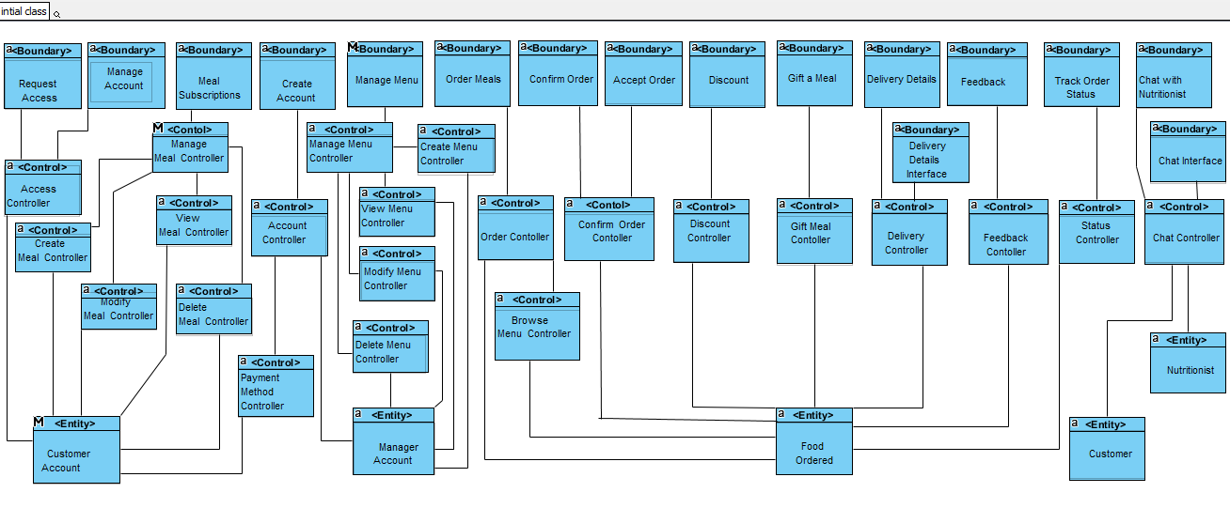

**Figure 12:** Initial class diagram of COS

Below is the modified class diagram for COS, in which we have identified the attributes of all the classes.

**Figure 13:** Modified Class Diagram for COS

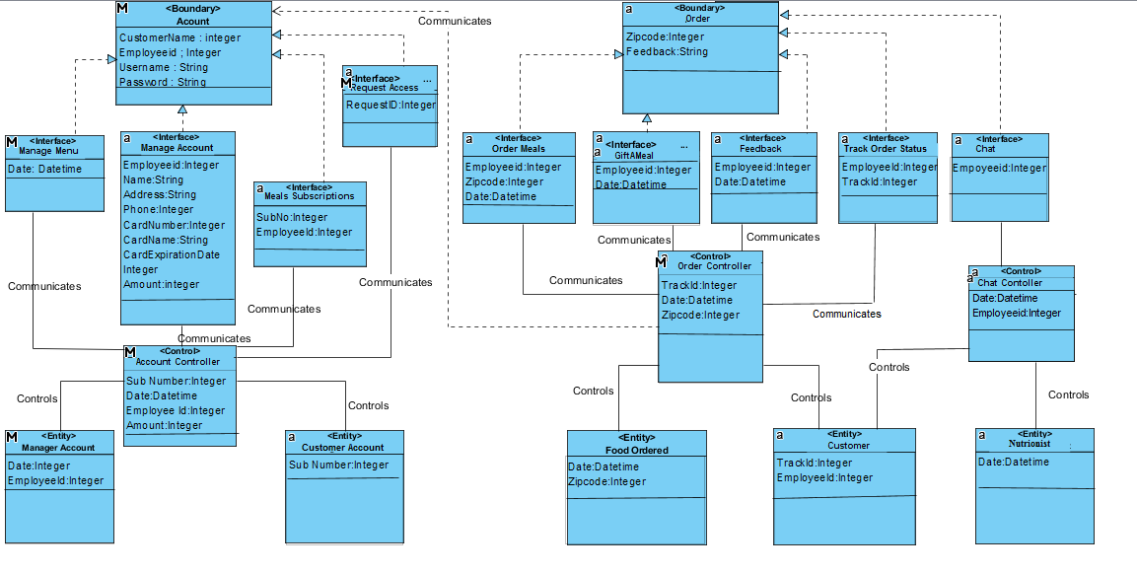

# Sequence Diagram

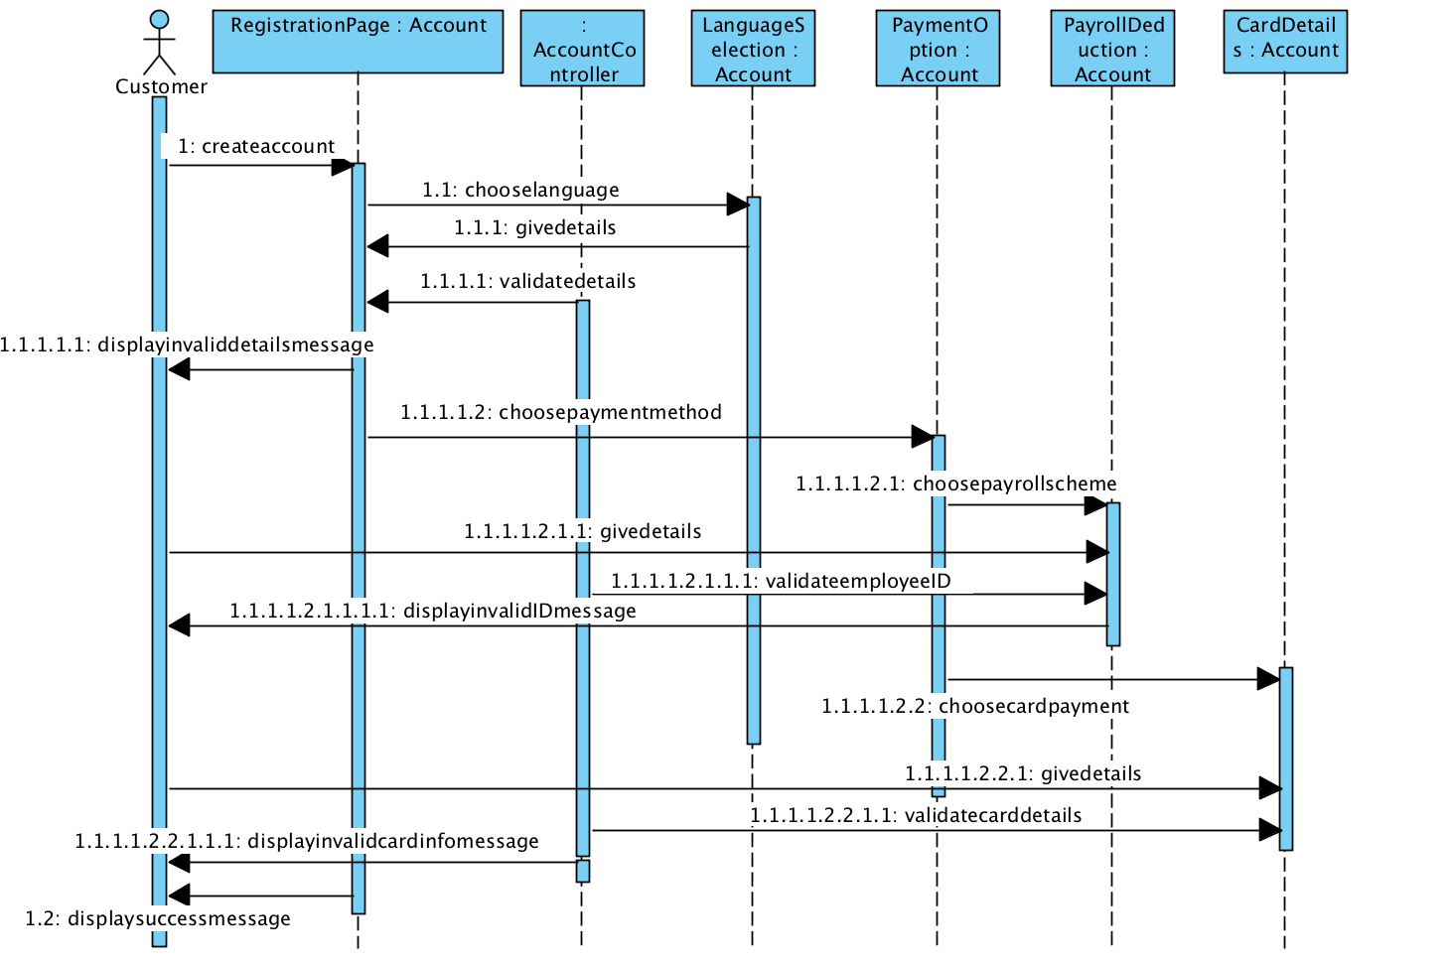Below are the sequence diagrams for the Cafeteria Ordering System.

**Figure 14:** Sequence diagram for Create account and accept payment method

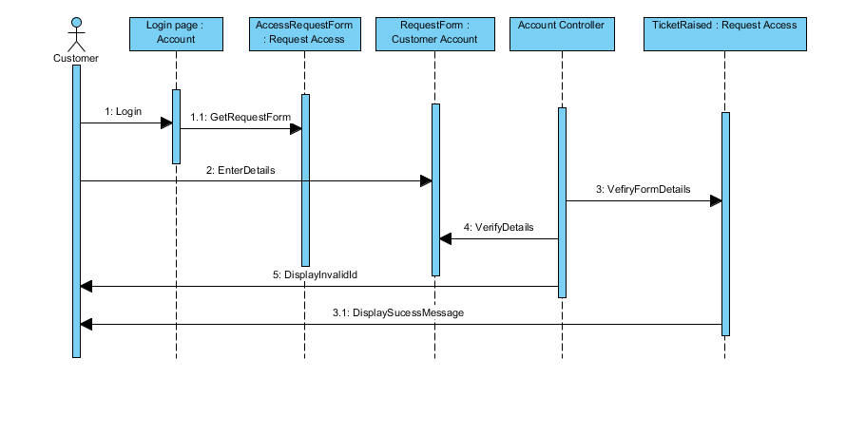

**Figure 15:** Sequence diagram for Request Internet Access

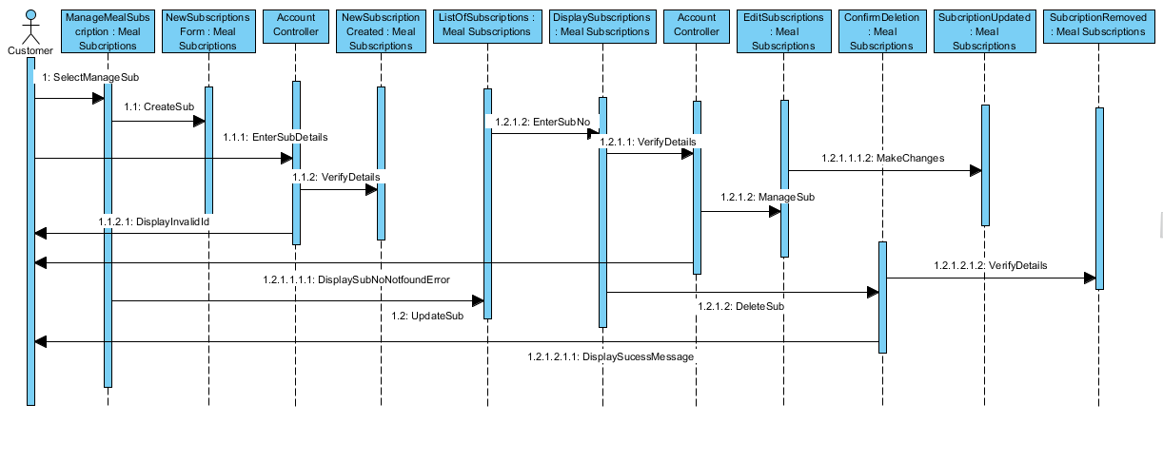

**Figure 16:** Sequence diagram for Manage Meal Subscription

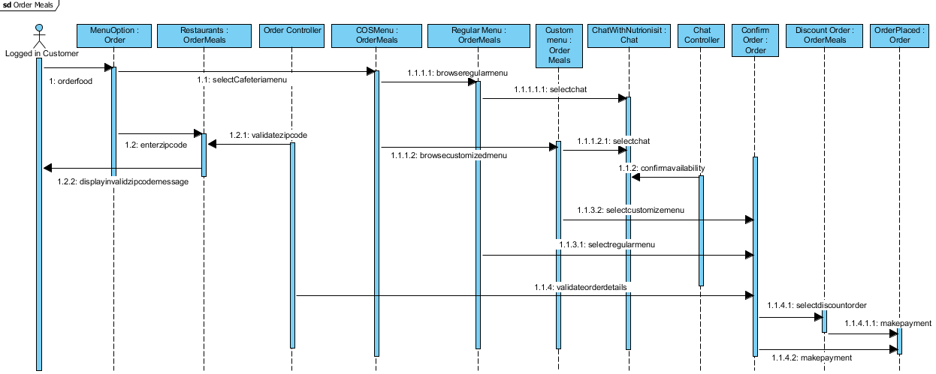

**Figure 17:** Sequence diagram for Order meals, offer discount and chat with nutritionist

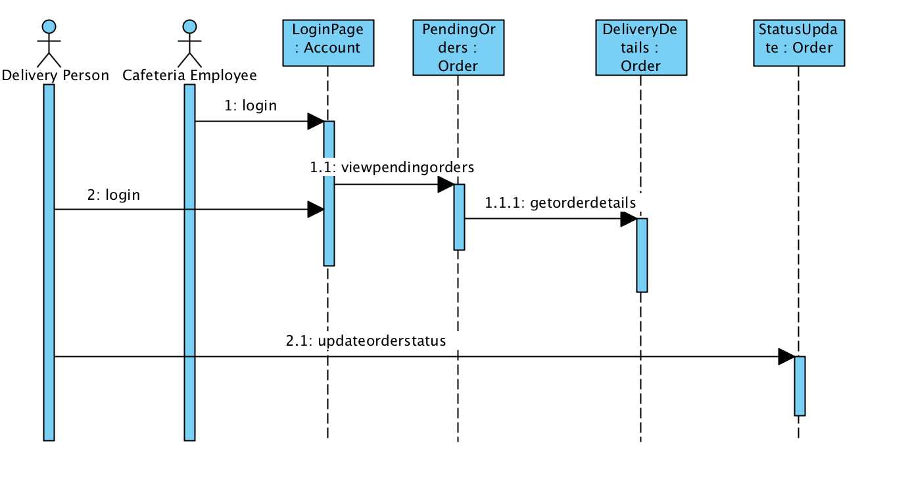

**Figure 18:** Sequence diagram for Get Order details and update order status

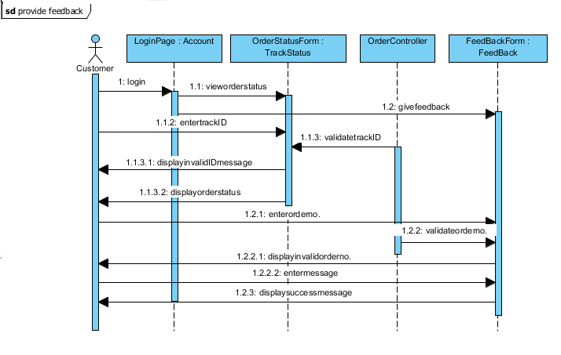

**Figure 19:** Sequence diagram for Check order status and provide feedback

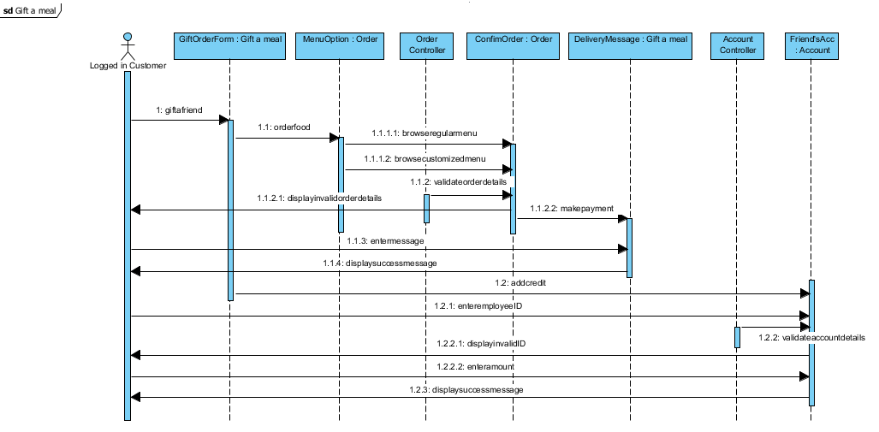

**Figure 20:** Sequence diagram for Gift a meal or add credit to friend’s account

# Class Diagram

Below is detailed class diagram for the COS. In the detailed class diagram, all the methods identified in the sequence diagrams have been included in the corresponding class.

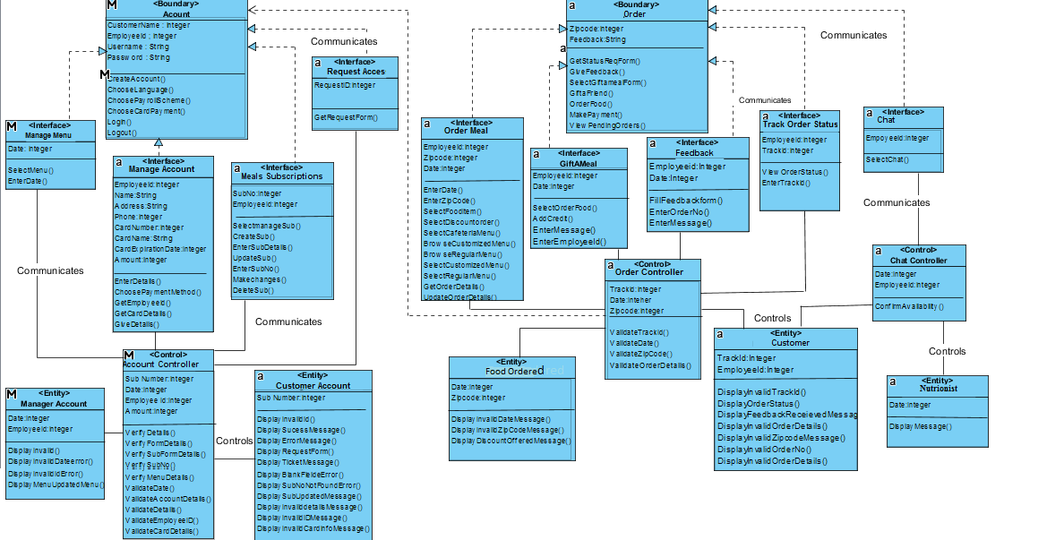

**Figure 21:** Detailed Class diagram of COS