1. Introduction

Company lockers file management system is an application which helps to manage files.

FMS makes easy handling of files, it has four options, file creation, file deletion, file viewing and file searching.

2. Requirement Gathering and Analysis

Requirement gathering is an essential part of project and project management. Understanding fully what a project will deliver is critical to its success. Requirement gathering involves producing a statement of requirements. This document is a guide to the main requirement of the project. The main requirement in fms is that it helps in easy handling of file in a single window. The goal of system analysis is determined where the problem is in an attempt to fix the system. This step involves breaking down the system in different pieces and drawing diagrams to analyse the system.

3.1 SRS (Software Requirement Specification Document)

3.1. Environmental characteristics

Hardware

Operating System : Windows or mac

Network Interface : Wi-Fi

Software

Java Development Kit (JDK 1.8)

Java Runtime Environment (JRE 1.8)

Eclipse ide

3.2 Developing Tools

Features of Platform and IDE

Core Java

The java programming language is a general-purpose, concurrent, class-based, object-oriented language. It is designed to be simple enough that many programmers can achieve fluency in the language. The java programming language is related to C and C++ but it is organized rather differently, with a number of aspects of C and C++ omitted and a few ideas from other languages included. It is intended to be a production language, not a research language, and so, as C.A.R.Hoare suggested in his class paper on language design, the design has avoided including new and untested features.

The java programming language is strongly typed. This specification clearly distinguishes between the compile-time errors that can and must be detected at compile time, and those that occur at run time. Compile time normally consists of translating programs into machine-independent byte code representation. Runtime activities include loading and linking of the classes needed to execute a program, optional machine code generation and dynamic optimization of the program, and actual program execution.

The java programming language is a relatively high level language, in that details of the machine representation are not available through the language. It includes automatic storage management, typically using a garbage collector, to avoid the safety problems of explicit de-allocation (as in C’s free or C++’s delete).High-performance garbage-collected implementations can have bounded pauses to support systems programming and real -time applications. The language does not include any unsafe constructs, such as array accesses without index checking, since such unsafe constructs would cause a program to behave in an unspecified way.

The java programming language is normally compiled to the byte code instruction set and binary format defined in the Java Virtual Machine Specification. The java virtual machine specification provides the hardware platform specifications to which we compile all java technology codes. This software enables the java software to be platform-independent because the compilation is done for a generic machine, known as JVM. Java is developed by the Sun Microsystems. Though it is associated with the World Wide Web, it is older than the origin of Web. It was only developed keeping in mind the consumer electronics and communication equipments. It came into existence as a part of web application, web services and a platform independent programming language in the 1990s. Java provides a “firewall” between a networked application and the computer.

Reasons for Using Java

It is required to explore systems running different Operating systems. In order to do so, there should be some way to connect or bridge those Operating systems so that all the differences between them are solved and the functionalities are achieved. Also the functions performed in one system should be able to transfer to another and the result should be able to reflect their property. Java serves as a bridge between these Operating systems. Also Java is widely considered to be the best in developing network applications.

The communication happens between java Virtual Machines running on the systems. When the client wants to perform the functionalities in another system and see the result, a method in the remote system are invoked from the client. The corresponding method in the remote system performs the job and sends the results to the client which is reflected in the interface.

Binary search method

In computer science, binary search, also known as half-interval search,[[1]](https://en.wikipedia.org/wiki/Binary_search_algorithm#cite_note-Williams1976-1) logarithmic

search,[[2]](https://en.wikipedia.org/wiki/Binary_search_algorithm#cite_note-FOOTNOTEKnuth1998%C2%A76.2.1_(%22Searching_an_ordered_table%22),_subsection_%22Binary_search%22-2) or binary chop,[[3]](https://en.wikipedia.org/wiki/Binary_search_algorithm#cite_note-FOOTNOTEButterfieldNgondi201646-3) is a search algorithm that finds the position of a target value within a sorted array.[[4]](https://en.wikipedia.org/wiki/Binary_search_algorithm#cite_note-FOOTNOTECormenLeisersonRivestStein200939-4)[[5]](https://en.wikipedia.org/wiki/Binary_search_algorithm#cite_note-5) Binary search compares the target value to the middle element of the array. If they are not equal, the half in which the target cannot lie is eliminated and the search continues on the remaining half, again taking the middle element to compare to the target value, and repeating this until the target value is found. If the search ends with the remaining half being empty, the target is not in the array.

Eclipse IDE

Eclipse IDE provide a web services Manger that supports Software as a Service (SaaS) applications. SaaS refers to a software application delivery model where a software vendor develops a web-native software application and hosts and operates the application for use by its customer over the internet. SaaS is a n increasingly popular model for providing software functionality as it is economical in terms of both cost and customer hardware resources. The IDE now makes it easy for java developers to access all the popular SaaS services on the web. eclipse refers to both a platform framework for java desktop applications, and an integrated development environment for developing with Java,Python, Ruby, Groovy, C, C++, Scala and Clojure.

The Eclipse IDE is written in Java and runs everywhere were a JVM is installed including Windows, Mac OS, Linux, and Solaris JDK is required for Java development functionality, but is not required for development in other programming languages.

The Eclipse Platform allows applications to be developed from a set of modular software components called modules. Applications based on the Eclipse platform (including the Eclipse IDE)can be extended by third party developers.

The Eclipse Platform is a reusable framework for simplifying the development of Java Swing desktop applications. The Eclipse IDE bundle for Java SE contains what is needed to start developing Eclipse plug-ins and eclipse platform based applications; no additional SDK is required.

Applications can install modules dynamically. Any application can include the Update Center module to allow users \of the application to download digitally-signed upgrades and new features directly into the running application. Reinstalling an upgrade or a new release does not force users to download the entire application again.

The platform offers reusable services common to desktop applications, allowing developers to focus on the logic specific to their application. Among the features of the platform are:

i. User interface management (eg.menus and toolbars)

ii. User settings management.

iii. Storage management (saving and loading any kind of data)

iv. Window management

v. Wizard framework (supports step-by-step dialogs)

vi. Eclipse visual library.

4. System Design and Development

System design is the process of developing specifications for a candidate system that meets the criteria established in the system analysis. The major steps in system design are the preparation of the input and the output reports in a form applicable to the user. The main objective of the system design is to use the package easily by any computer operator. System design is the creative act of invention, developing new inputs, a database, offline files, methods, procedures and output for processing business to meet an organization objective. System design builds information gathered during the system analysis.

4.1 Input Design

Input design plays a vital role in the life cycle of software development. It requires very careful attention of developers. It specifies the manner in which the data enters the system for

processing. Input design can ensure the reliability of the system and produces results from accurate data or it may result in output of enormous data. According to Software Engineering Concepts, the input forms of screens are designed to provide to have a validation control over the input limit, range and other related validations.

This system has input screens in almost all the modules. Error messages have been developed to alert the user whenever he commits some mistakes and guides him in the right way. Input design determines whether the user interacts with the system efficiently. It is the link that ties the information system into the user world. It consists of developing specifications and procedures for data preparation. So, structured steps are necessary to put transaction data into usable form for processing.

Input design is the process of converting the user-originated inputs to a computer-based format. It also includes the method of input and entry into the system. There can be many factors that can be taken into account.

* Flexibility of format
* Speed
* Accuracy
* Type of input
* Verification methods
* Offline contact facility
* Automatic features
* Ease of use

Keyboard is the most commonly used input media.Inacccurate input data are the most common cause of errors in data processing. Errors entered by the user can be controlled by the input design.

The design for handling input specifies how the data are accepted for computer processing. Input design is a part of overall system design that needs careful attention and it includes specifying the means by which action are taken.

A system user interacting through a workstation must be able to tell the system whether to accept the input produce a report or end the processing. The collection of input data is considered to be the most extensive part of system design. Since the inputs have to be planned in such a manner so as to get the relevant information, extreme care has to be taken to obtain the information. If the data going into the system is incorrect, then the processing and the outputs will magnify these errors.

The major activities carried out are

>Collection of needed data from the source.

>Conversion of data into computer accepted form.

>Verification of converted data.

>Checking the data for accuracy.

4.9. Flow Chart

Level 0

User

Figure 4.1 Level 0

Level 2

User

5. System Testing

Testing is vital to the success of the system. Testing makes a logical assumption that all the parts of the system are correct; the goal will be successfully achieved. The user tests the developed system and changes according to the need. Inadequate testing leads to errors that may not appear until months later.

This helps in the prevention of errors in a system and builds confidence that the system will work without error after testing. It is the process of executing a program with the intent of finding an error. Testing adds value to the product by conforming to the user requirements. Testing involves a series of operation of a system or application under controlled conditions and subsequently evaluating the results. The controlled condition should include both normal and abnormal conditions. The philosophy behind testing was to find errors. A set of sample data is processed in this system as a normal input. However data created the express internet of determining whether the system will process correctly. The software was tested for 2 strategies, code testing and specification testing.

Code testing strategy examined the logic of the program. Executing every path though the program is tested. Running each program separately did specification testing and verifies how it performed under various conditions. They were developed for each condition or combination of condition seemed satisfactory.

Testing objectives

The objectives of testing are:

1. Testing is the process of finding error in existing program.

2. A good test can is the one that has high probability of finding as yet undiscovered error.

3. A successful set of error is one that uncovers an as yet undiscovered error.

System testing is the implementation, which ensures that the system works accurately and efficiently before live operations commence. During the development of a software project, errors of various types can occur at any stage. System testing makes logical assumption that the system is correct and that the goals are successfully achieved.

The first major hurdle in the process of implementation is the period of testing the system. The debugging part is the most unpredictable part of the testing procedure. To make the system reliable and accepted, various testing methods were used, the most basic of them being the three mentioned below:

a) Running the program to identify any error(whether syntactic or semantic)that might have occurred while feeding the programs into the system.

B} Applying the screen formats to regulate users to gauge the extend to which the screen was comprehensible to the user.

c) Presenting the format to the administrator for the purpose of obtaining approval and checking if any modifications have to be done or whether the proposed serves their purpose.

Testing is carried out in order to ensure that the system does not fail, that it meets the specification and it satisfies the user. The system testing was carried out in a systematic manner with the test data containing all the possible combinations of data to check the feature of the system. A test data was prepared for each module ,which took care of all possible branches and sub procedures in the programs. During the first round of testing each module is tested individually because the fixing and rectification of the errors in this state would be easier.

6. System Implementation

An important aspect of system analyst’s job is to make sure that the new design implemented to establish standards. Implementation involves all these activities that take place to convert from the old system to new.

A proper implementation is essential to provide reliable system to meet the requirements of a new computerized system will improve the efficiency of the entire system and reduce the labors involved.

There are 3 types of implementation

* Implementation of computer system to replace manual system.
* Implementation of a new computer system to reduce existing.
* Implementation of a new modified application to replace an existing one using the same computer.

In this project a purely manual system is computerized.

Implementation is the process of converting a new or received system design into an operational one. It is the key stage in achieving a successful new system because usually it involves a lot of upheaval in the user department. It must therefore be carefully planned and controlled. Apart from planning the two major tasks of preparing implementation are education and training of users and testing of the system. Education of the users should really take place much earlier in the project. Training has to be given to the users regarding the new system. Once the system has been trained, the system can be tested.

Implementation is the stage in the project where the theoretical design is turned into a working system and is giving confidence on the new system for the users that it will work efficiently and effectively. It involves careful planning, investigation of the current system and its constraints on implementation, design of methods to achieve the change over, an evaluation, of change over methods. Apart from planning major task of preparing the implementation are education and training of users.

An implementation co-ordination committee based on policies of individual organization has been appointed. The implementation process begins with the preparation of a plan for the implementation of the system. According to this plan, the activities are to be carried out, discussions made regarding the equipment and resources to implement the new system. Implementation is the final and important phase. The most critical stage in achieving a successful new system is giving the users confidence. That the new system will work be effective. The system can be implemented only after thorough testing is done and if it found to working according to the specification. This method also offers the greatest security since the old system can take over if the errors are found or inability to handle certain type of transactions while using the new system. Implementation is the stage of project when theoretical designs turn into a working system. The design includes adequate procedures to allow user to produce a report and to retrieve necessary information.

The processing is initiated from menu form. By selecting necessary topic, user involves the programmers to carry out the activities. This system provides user friendly screen.

6.1 Verification

Pre-implementation and post implementation verification is made. They are indented to find errors. Executing the program in a simulated environment made pre implementation verification. The error during this period was rectified during this method.

Using the software in line environment in order to find errors did, post implementation verification. At this level no errors occurred, the system work schedules are matching for user environment and is working properly.

7. Maintenance

Software maintenance is a set of software engineering activities that occur after software has been delivered for the customer and put into operation. The success of the software and the project relies on the maintenance procedure adopted.

As with the venture of human, not a single one is perfect. The further modifications are left to the followers. It is because of the opinion or vision of a thing differs from individual to individual. Development is a single activity. Maintenance is a continuous activity. Maintenance involves activities like inspections, corrections and enhancements. Once the system is delivered and deployed, it enters the maintenance phase. The system need to be maintained not because of some of its components wear out and need to be replaced, but they are discovered. This includes activities related to debugging the software after it goes live, changes required to address evolving software and enhancement to meet changing customer requirements. So maintenance phase involves:

* Understanding the effects of the change
* Testing the new parts
* Retesting the old parts that were not changed
* Making changes to both the code and the documents

These changes have to be signed by the user before the change can be carried out. Since requirement change request involves cost, user will be cautious while requesting the software changes. The software will require continuous support. The system maintenance means the maintenance activities after and during the system development processes. This include activities related to debugging the software after it goes live, changes required to meet changes in user requirement.

Maintenance phase identifies if there are any changes required in the current system. If the changes are identified, then an analysis is made to identify if the changes are really required. Cost benefit analysis is a way to find out if the change is really essential. The maintenance is performed at regular intervals to keep the project safe and reliable. Maintenance covers a wide range of activities including correcting codes, design errors, updating documentation and test data and updating user support. The software will change or modify with user requirements in future.

Future Enhancements

The future scope of AI-iSync software is beyond words. We can add so many helpful applications within FMS according to client needs.

The future plan about FMSincludes the following.

* Implementing FMS in all file extensions.
* Includes all user inputs to add more security.

Screenshots

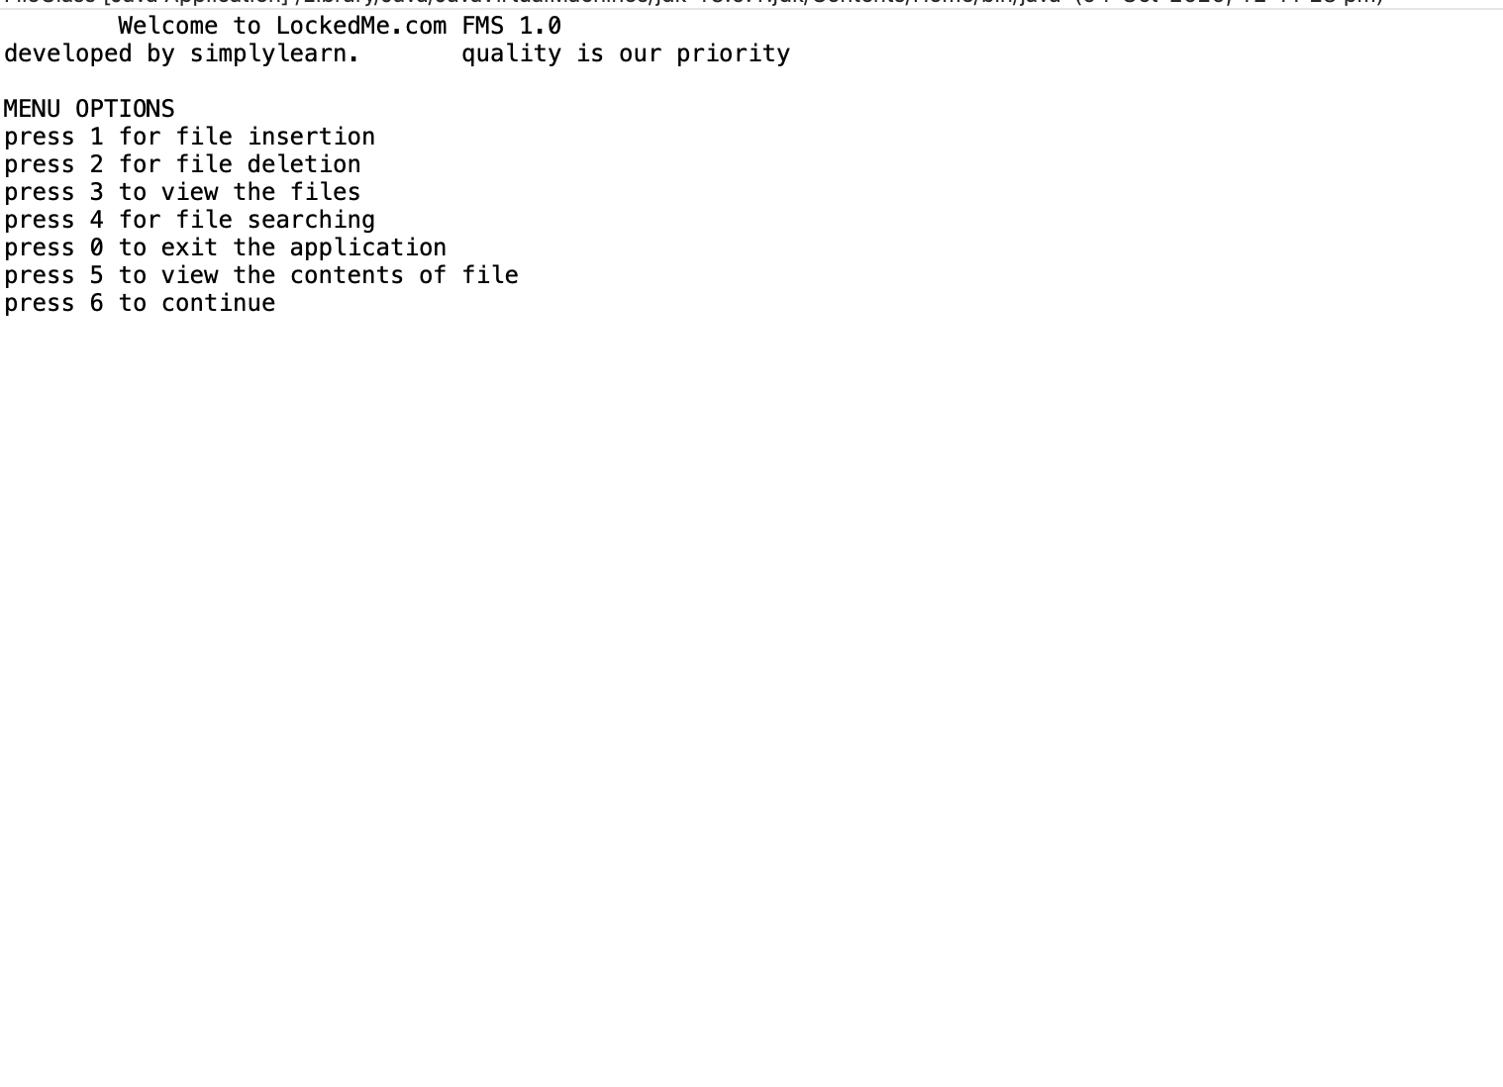

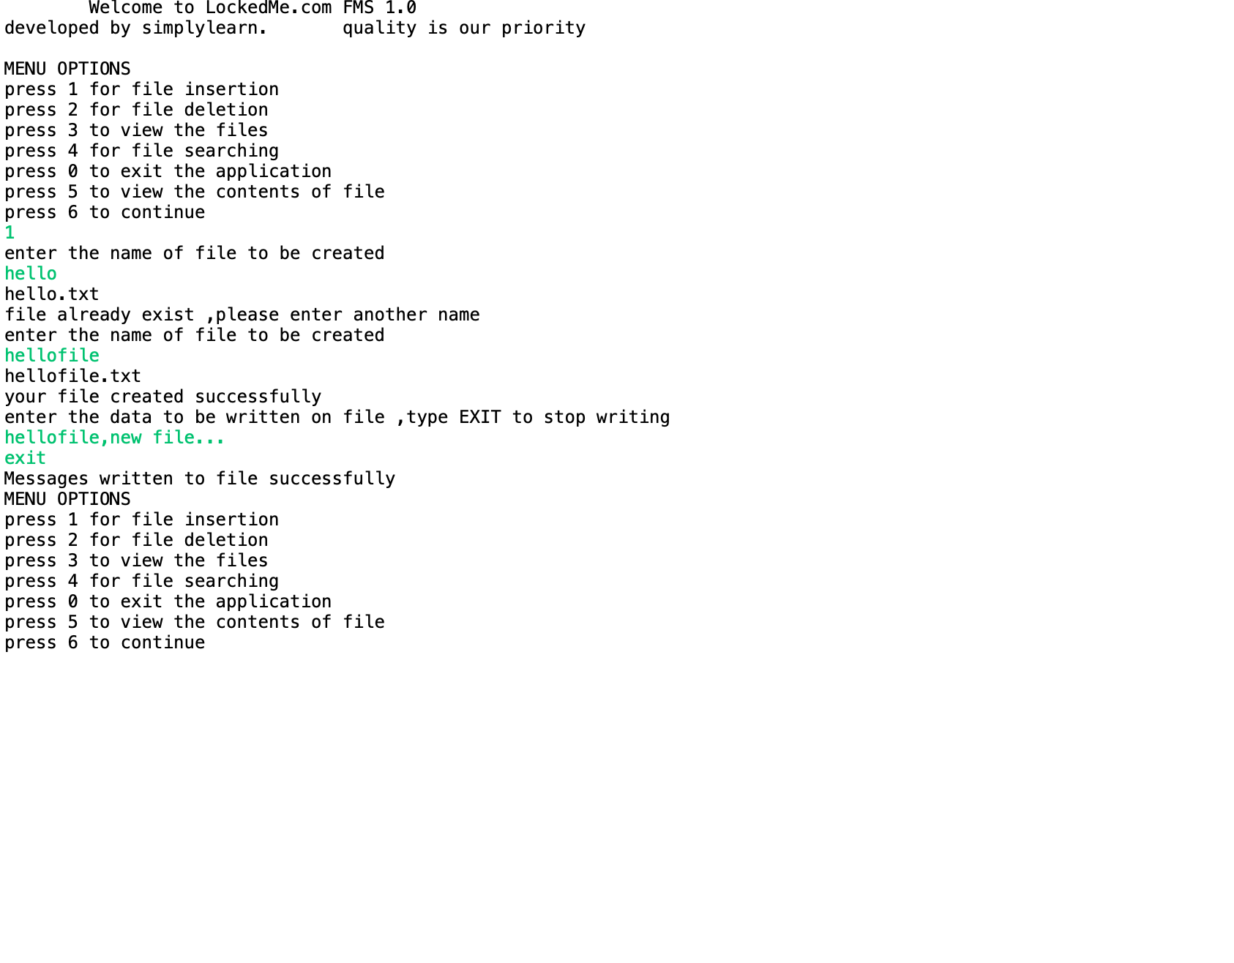

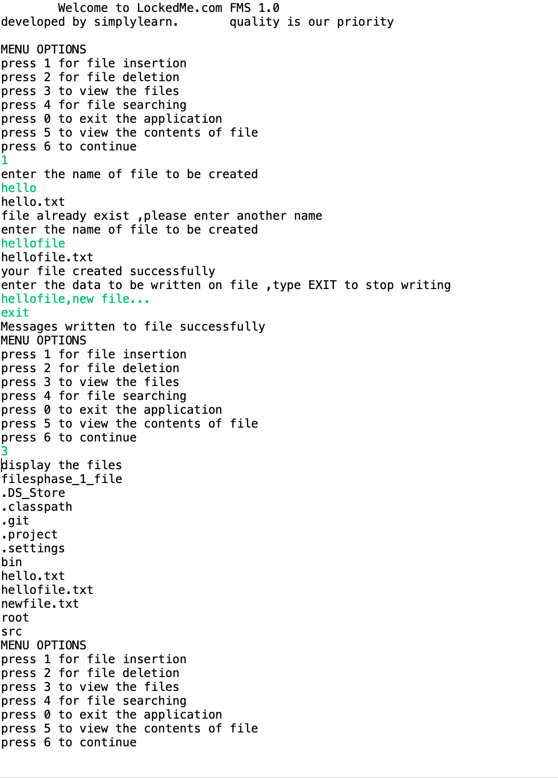

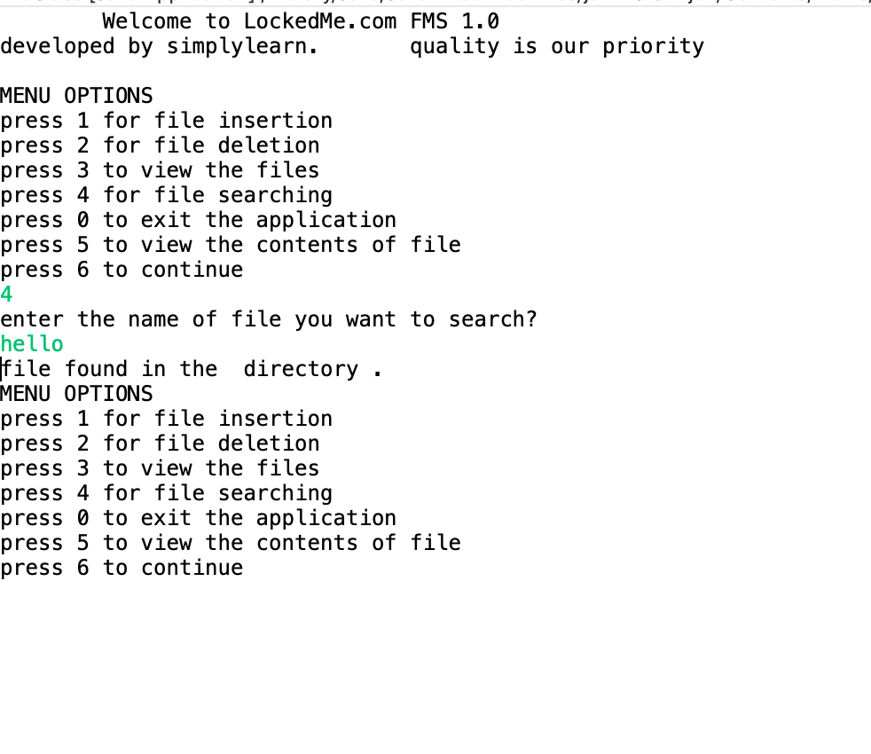

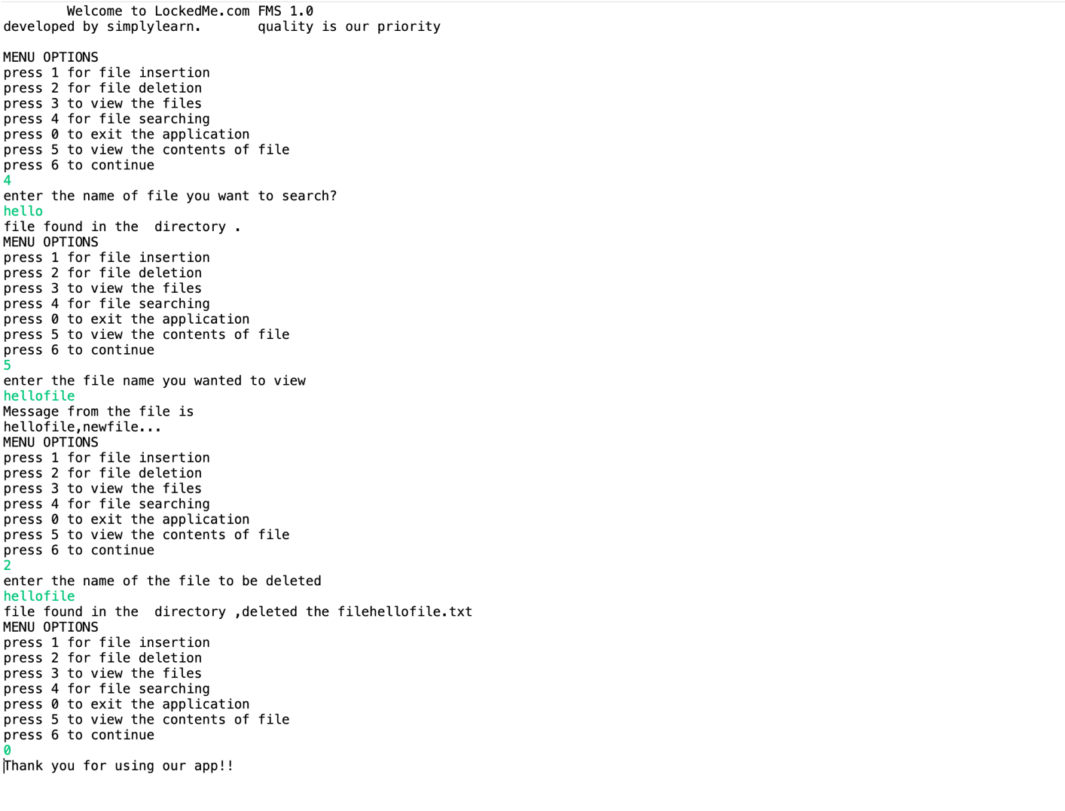

Bibliography

https://www.geeksforgeeks.org/

https //www.stackoverflow.com