**Practical Technical Assessment AI**

**Swathy s**

**AIM :**

Activity 1

Using a deep learning framework of your choice (TensorFlow, PyTorch, etc.), implement

a CNN to classify images from the CIFAR-10 dataset. Ensure your network includes

convolutional layers, pooling layers, and fully connected layers. Evaluate the

performance of your model and discuss any improvements you could make

**List of Hardware/Software used:**

* + - Windows OS
    - VS Code
    - PyTorch

**PROCEDURE:**

**Step 1**: Open VS code

**Step 2**: Create a new Python file .

**Step 3**: Rename the file and type the code to execute the program

**Step 4:** Save and run the code

**CODE :-**

1. Import libraries

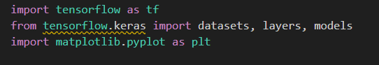

1. Load and Preprocess the CIFAR-10 Dataset



1. Define the CNN Model

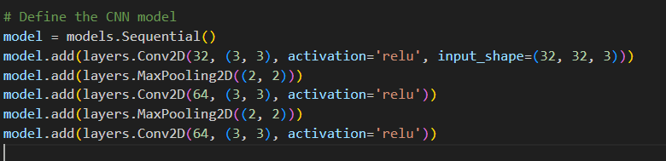

1. Define Loss Function and Optimizer

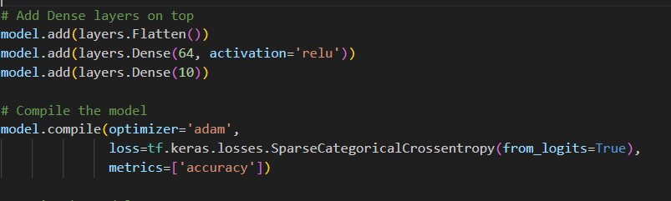

1. Train the Network

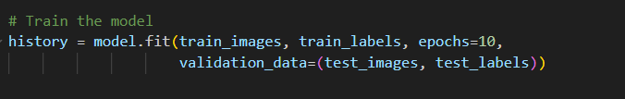

1. Evaluate the Network

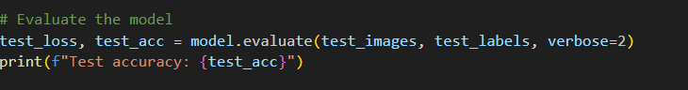

Output:



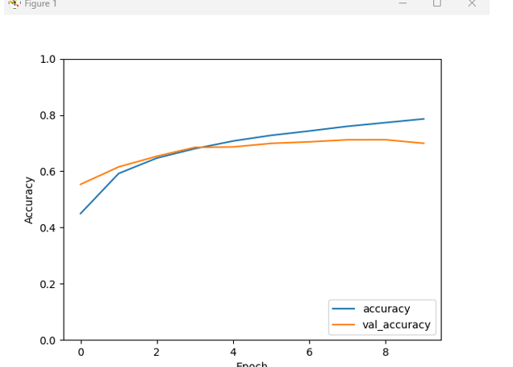

**Result:**

The program is successfully completed

Activity 2

**AIM:** Construct a feedforward neural network to predict housing prices based on the provided

dataset. Include input normalization, hidden layers with appropriate activation

functions, and an output layer. Train the network using backpropagation and evaluate its

performance using Mean Squared Error (MSE)

**List of Hardware/Software used:**

1. Windows OS
2. VS code

**PROCEDURE:**

**Step 1:** Open VS code

**Step 2:** Create a new Python file

**Step 3:** Rename the file and type the code to execute the program

**Step 4:** Save and run the code

**Code:**

#### Step 1: Open Visual Studio Code

* Launch Visual Studio Code.

**Step 2:** Create a new Python file

* Create a new Python file and name it housing_prices_prediction.py

**Step 3:** Install required libraries

* Install the necessary Python libraries by running the following commands in the terminal:

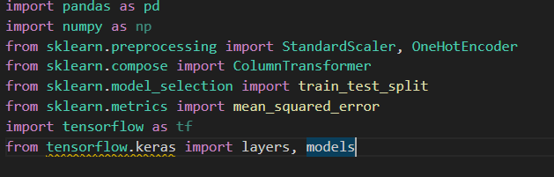

**Step 4:** Load the Dataset

* Use pandas to load the dataset from a CSV file.

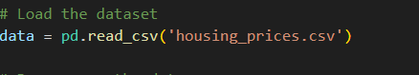

**Step 5:** Encode Categorical Variables

* Convert categorical variables into numerical values using one-hot encoding.

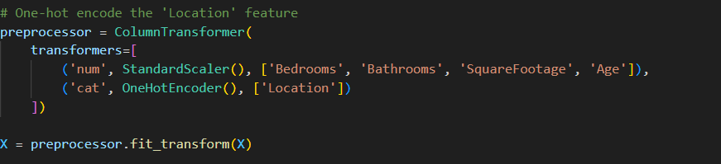

**Step 6:** Scale/Normalize Features

* Apply standardization to features using StandardScaler



**Step 7:** Define the Neural Network Model

* Build the neural network using Tensorflow.

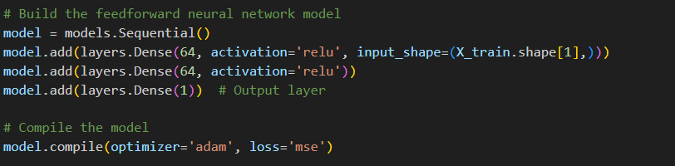

**Step 8:** Train the Model

* Train the model using backpropagation.



**Step 9:** Evaluate the Model\

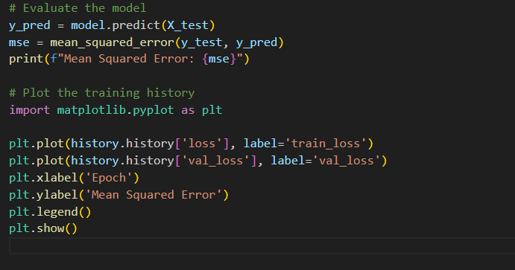

**Mean Squared Error (MSE):** The MSE of the model on the test dataset will be printed after training. This metric helps to understand the model's performance.

**OUTPUT:**



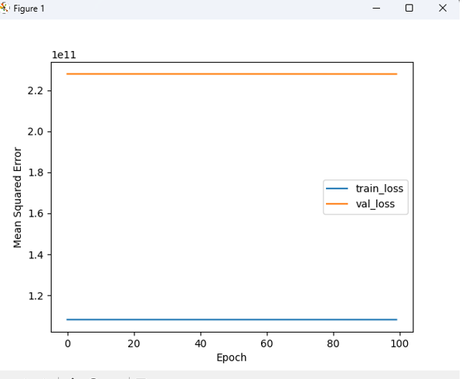

Result:

The program is successfully completed