AWS + GitHub Actions CI/CD Pipeline Project — Full Documentation
This document provides a complete step-by-step guide to building an automated CI/CD pipeline using GitHub Actions and AWS S3. It includes all commands, AWS Console steps, IAM configuration, GitHub setup, and troubleshooting.
This project is not about the website’s design, but about building a reliable automated deployment pipeline — one that moves my code from local → GitHub → AWS (S3) seamlessly and securely.

I implemented a CI/CD pipeline that automatically pushes changes from my local environment into production using:
🧠 Git, GitHub, GitHub Actions, and Amazon S3.

⚙️ Tools & Responsibilities (Technical) :
💻 Git (Local) → Version control & commit history.
🌐 GitHub (Remote) → Central repo & CI trigger.
⚡ GitHub Actions → Automates the build & deployment process (CI/CD).
🔐 IAM (AWS) → Secure role with least-privilege access for deployment.
🪣 Amazon S3 → Static website hosting for live deployment.
📊 CloudWatch / Logs → Monitoring & debugging pipeline activity.

Every time I push changes to the main branch →
the workflow triggers → authenticates with AWS → syncs files → deploys automatically 🚀.

💡 Result: Code updates appear on my live AWS-hosted site instantly, with no manual uploads needed.

🧠 What This Demonstrates
This project shows the end-to-end DevOps flow:
👉 Code → Repository → CI/CD Pipeline → Cloud Deploymentthis is someone else projectHelp me to achieve this step by step with each and every simple steps and a description to it

Architecture Overview:
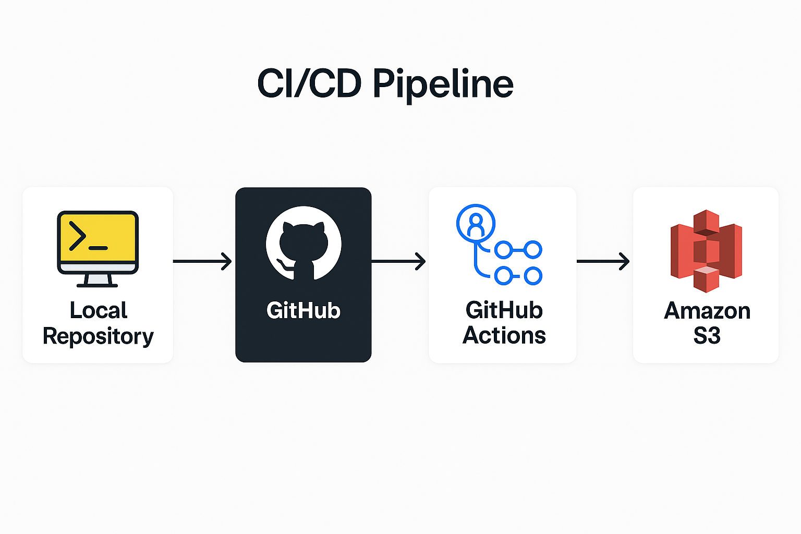

✅ Phase 1: Setup Your Local Project
Goal: Create a simple static website and push it to GitHub.
Steps:
- Create a folder for your project:
mkdir aws-portfolio
cd aws-portfolio
- Add basic files:
index.html
style.css
- Initialize Git and push to GitHub
git init
git add .
git commit -m "Initial commit"
git branch -M main
git remote add origin https://github.com/<your-username>/aws-portfolio.git
git push -u origin main
Checkpoint: Your code is now on GitHub.

✅ Phase 2: Create S3 Bucket for Static Website Hosting

Step 1: Log in to AWS Console

Go to https://aws.amazon.com/console/.
Navigate to S3 service.

Step 2: Create a New Bucket

Click Create bucket.
Enter:

Bucket name: aws-portfolio-bucket-01 (must be globally unique).
Region: Choose US East (N. Virginia) – us-east-1 (or your preferred region).

Uncheck “Block all public access” (because we need public access for website hosting).
Confirm the warning and click Create bucket.

Checkpoint: Bucket is created.

Step 3: Enable Static Website Hosting
Open your bucket → Properties tab.
Scroll to Static website hosting → Click Edit.
Select Enable.
Enter:

Index document: index.html
(Optional) Error document: index.html

Click Save changes.

Checkpoint: Website hosting is enabled.

Step 4: Make Bucket Public

Go to Permissions tab → Bucket policy → Click Edit.
Paste this policy (replace aws-portfolio-bucket with your bucket name):

{
"Version": "2012-10-17",
"Statement": [
{
"Sid": "PublicReadGetObject",
"Effect": "Allow",
"Principal": "*",
"Action": "s3:GetObject",
"Resource": "arn:aws:s3:::aws-portfolio-bucket01/*"
}
]
}
Click Save changes.

Checkpoint: Your bucket is now public.

Step 5: Note the Website URL

Go to Properties → Static website hosting.
Copy the Endpoint URL (e.g., http://aws-portfolio-bucket01.s3-website.ap-south-1.amazonaws.com).

✅ Phase 3: Create IAM User for GitHub Actions

This user will allow GitHub Actions to deploy files to your S3 bucket.

Step 1: Go to IAM

In AWS Console, search for IAM and open it.

Step 2: Create a New User

Click Users → Add users.
Name: github-actions-deploy.
Select Access key - Programmatic access.
Click Next.

Step 3: Attach Policy

Choose Attach existing policies directly.
Select AmazonS3FullAccess (or create a custom policy for least privilege).
Click Next → Create user.

Step 4: Save Credentials

Copy Access Key ID and Secret Access Key.
Important: Download the .csv file or note them securely. You’ll need these for GitHub Secrets.

Checkpoint: IAM user is ready.

Sometimes:
You’re in the IAM user creation screen for console access, but for GitHub Actions we need programmatic access (Access Key), not a console password.
Here’s why you don’t see it:
- AWS recently changed the flow: you create the user first, then create an access key separately.
- The old option “Access key – Programmatic access” is no longer shown during user creation.

✅ How to Create Access Key Now
- Finish creating the user with AmazonS3FullAccess.
- After the user is created:
  - Go to IAM → Users → github-actions-deploy → Security credentials.
  - Scroll to Access keys.
  - Click Create access key.
  - Choose Use case: Application running outside AWS.
  - Click Next → Create access key.
- Copy:
  - Access Key ID
  - Secret Access Key
  - Download the .csv file for backup.

✅ Phase 4: Add AWS Credentials to GitHub Secrets

- Go to your GitHub repo → Settings → Secrets and variables → Actions → New repository secret.
- Add:
- AWS_ACCESS_KEY_ID = <your access key>
- AWS_SECRET_ACCESS_KEY = <your secret key>
- AWS_REGION = us-east-1
- S3_BUCKET = aws-portfolio-bucket-01
Checkpoint: GitHub can now access AWS securely.

✅ Phase 5: Create GitHub Actions Workflow

Step 1: Create the Workflow Folder
In your project root (where index.html is):
mkdir -p .github/workflows

Step 2: Create the Workflow File
Inside .github/workflows, create a file named deploy.yml:
nano .github/workflows/deploy.yml

Step 3: Add the Workflow Code
Paste this YAML configuration:
name: Deploy to AWS S3

on:
push:
branches:
- main # Trigger only when pushing to main branch

jobs:
deploy:
runs-on: ubuntu-latest

steps:
# Step 1: Checkout the code from GitHub
- name: Checkout code
uses: actions/checkout@v3

# Step 2: Configure AWS credentials using GitHub Secrets
- name: Configure AWS credentials
uses: aws-actions/configure-aws-credentials@v2
with:
aws-access-key-id: ${{ secrets.AWS_ACCESS_KEY_ID }}
aws-secret-access-key: ${{ secrets.AWS_SECRET_ACCESS_KEY }}
aws-region: ${{ secrets.AWS_REGION }}

# Step 3: Sync files to S3 bucket
- name: Sync files to S3
run: aws s3 sync . s3://${{ secrets.S3_BUCKET }} --delete

Step 4: Save and Commit
git add .github/workflows/deploy.yml
git commit -m "Add GitHub Actions workflow for S3 deployment"
git push origin main

Step 5: Verify Workflow
- Go to your GitHub repo → Actions tab.
- You should see a workflow running after the push.
- If successful, your files will be deployed to S3.

✅ Important Notes:
- The aws-actions/configure-aws-credentials action uses the secrets you added earlier.
- The aws s3 sync command uploads all files from your repo to the S3 bucket and deletes old files not present locally.
✅Phase 6: Test Deployment

1. Modify index.html
2. Commit and push:
git add .
git commit -m 'Update site'
git push origin main
3. Check GitHub Actions → Visit S3 website URL:
http://aws-portfolio-bucket-01.s3-website-us-east-1.amazonaws.com

Troubleshooting Common Issues
- Permission errors: Ensure IAM user has AmazonS3FullAccess
- Workflow fails: Check GitHub Actions logs
- Website not loading: Verify bucket policy and static hosting settings

What happens in this project:
1. You create a simple static website on your local machine (HTML, CSS).
2. You push the code to GitHub. This acts as the central repository.
3. We create an S3 bucket in AWS and enable static website hosting.
4. We create an IAM user with permissions to access S3.
5. We store IAM credentials as GitHub Secrets for security.
6. We create a GitHub Actions workflow (deploy.yml) that runs automatically when you push code.
7. The workflow uses AWS CLI to sync your files from GitHub to the S3 bucket.
8. Result: Every time you push changes to GitHub, your live website on AWS updates automatically.

Why each step is needed:-
Local setup: To have your website files ready.
GitHub: To manage version control and trigger automation.
S3: To host your website.
IAM: To allow GitHub to deploy securely.
GitHub Secrets: To keep credentials safe.
Workflow: To automate deployment without manual uploads.

