**Student tax Form retrieval system**

The below document details my thought process & approach for designing the front- end & database components for Student tax Form retrieval system. After reviewing the provided documents 1098T form & sample data, I decided to use HTML & PHP for designing the front end & MySQL for the backend.

Back-End Process: Looking closely at the sample data, I decided to choose “SSN” as the primary key. I went about by creating a database (student) & table (student_1098T) to hold the sample data. The steps I followed are in the attached document below.

Sample Data Screenshot from Database:

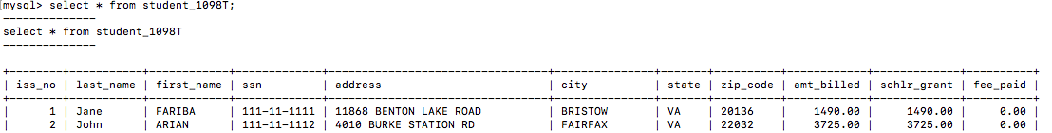

Front-End Process: For the front-end part of the application I designed 2 pages. 1st being “Login Page” & “Tax Form 1098T”.

i) Login Page: This page was designed with the purpose of validating the user & requires them to provide “Last Name” & SSN (SSN being a sensitive data is in hidden password format). The code I designed also handles for basic data check on this page by ensuring that the user inputs both the data fields. I utilized HTML to design this form. The code for the same (first_page.php) is attached for reference.

Sample screenshot of error handling on landing page:

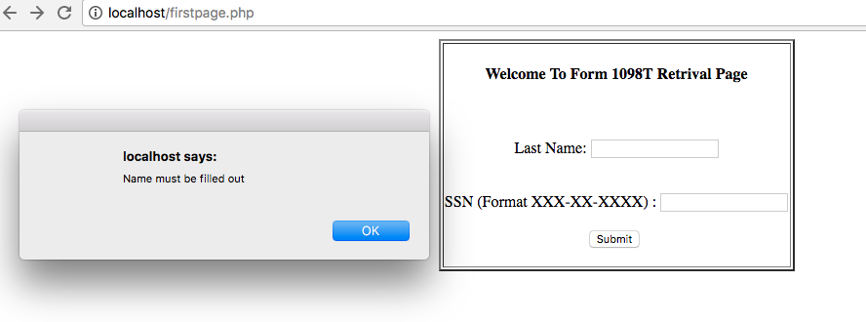

ii) Form 1098T (form3.php): Once the data is validated on the Login Page, the user information is passed to this form that is designed in HTML & utilizes PHP to establish a database connection. Using the last name & SSN information Students details (First Name, Last Name, Address, Fees & Scholarship) are retrieved to populate the Tax Form.

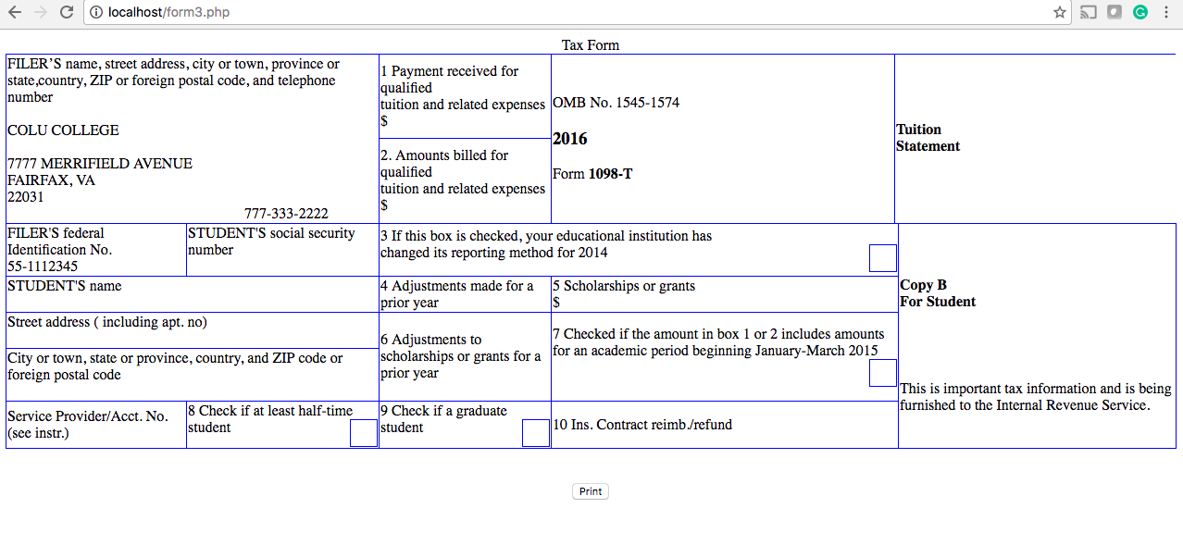

I used HTML table design to build the 1098T form. I optimized the process by establishing only one database read during the whole process and used PHP to format the Student information using the Array functions into the HTML code for the fields to be populated in the Tax form.

I also utilized the built in print function via the Print Button on “form3.php” to provide user ability to print the generated form.

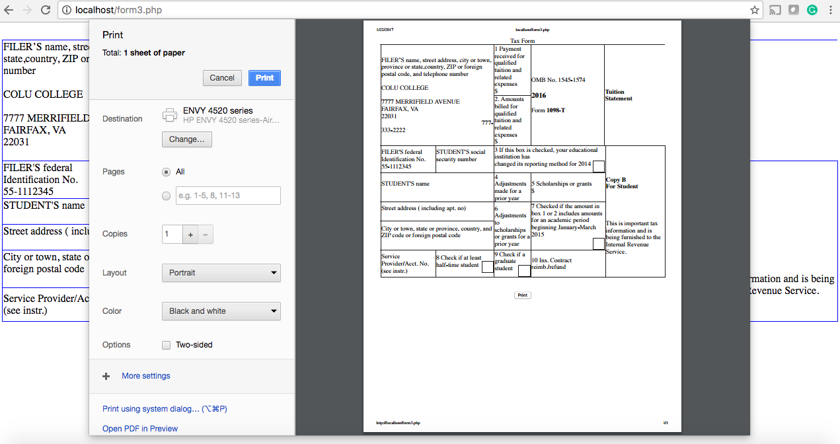

While working on this exercise my focus was on delivering functionality & application design. I would have loved to devote more time formatting the forms using CSS.