1. We used the Porter Stemmer Algorithm and tried to test if is working

The below Test file was created.

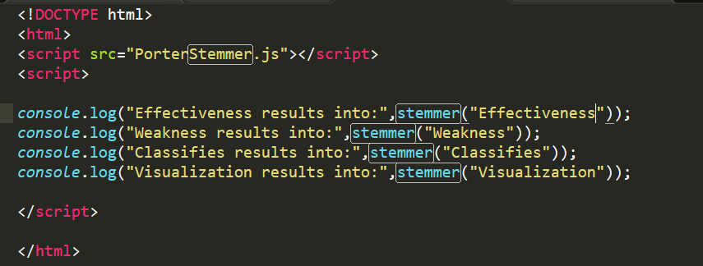

The algorithm was able to find out the root word. Below is the output:

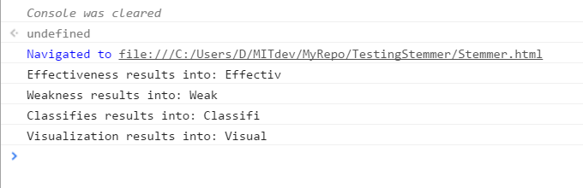

1. Connecting to the APIs:

Screen Shot of results obtained from NYT API:

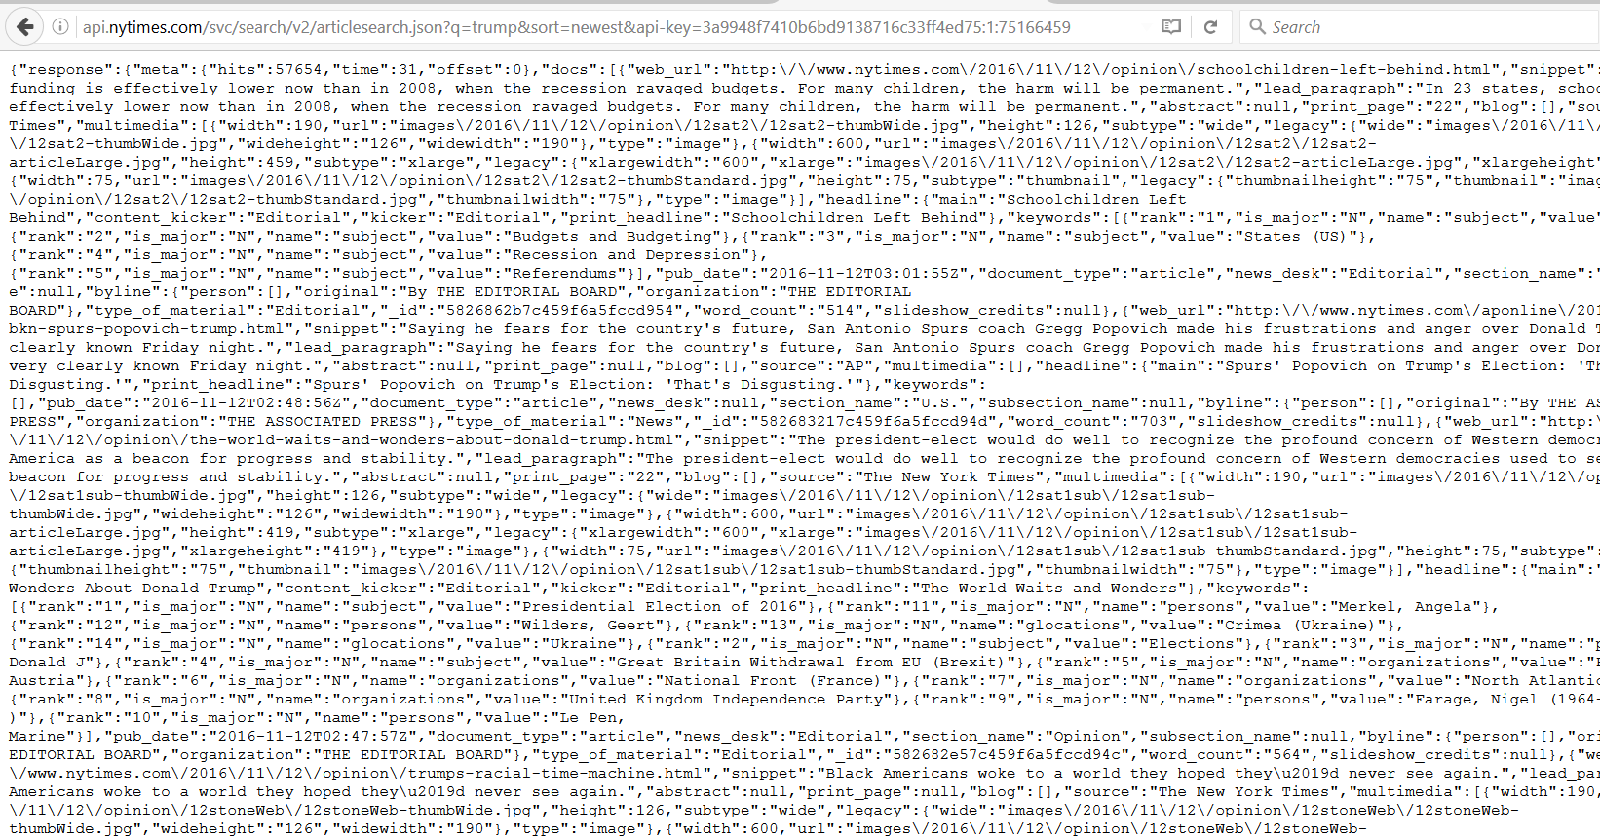

**Screen Shot of results obtained from Guardian:**

