1. Creating a Repo and pushing a file in repo-:

* curl -u admin:password -X PUT “<http://35.164.106.34:8081/artifactory/Maven-Reop-Test/Plotgraph.txt>”

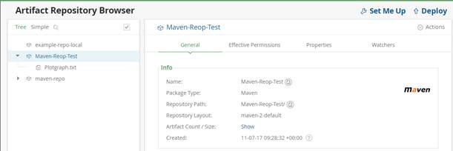

1. To set/update the properties in Repository level or artifacts-:

* curl -u admin:password -X PUT  <http://35.164.106.34:8081/artifactory/api/storage/maven-repo?properties=status=Dev_Passed,QA_passed;buid_url=http://10.242.135.72:8085/job/maven-test;version=1.1>;history=released

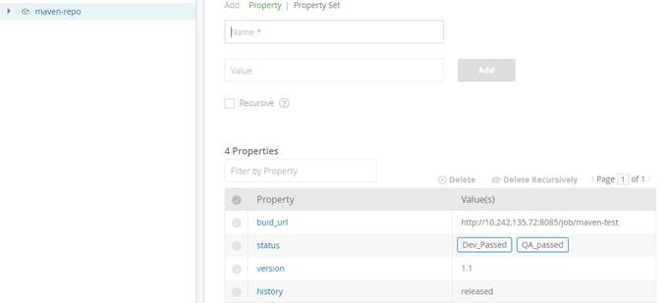

1. To delete the properties from artifacts-:

curl -u admin:password -X DELETE <http://35.164.106.34:8081/artifactory/api/storage/maven-repo/file.xlsx?properties=Build>