**PAPERLESS HOSPITAL SERVICE**

SOFTWARE REQUIREMENTS SPECIFICATION

SWATI GHOSH- 12BCE0007

MUSHEED KHAN-12BCE0002

KRISHNA PANDEY-12BCE0027

**TABLE OF CONTENT**

1. Problem Statement

2. Background

2.1 Background information

2.2 Domain

2.3 Targeted users

2.4 Existing System

2.5 Details about existing software

2.6 Limitations and solutions

3. Stakeholders

4. Requirements

4.1 Functional Requirements

4.1.1-Usecase: Patient/Relative

4.1.2-Usecase: Admitting Clerk

4.1.3-Usecase: Department Administrator

4.1.4-Usecase: Doctors/Nurse

4.1.5-Usecase: Billing Department

4.1.6-Usecase: Healthcare Insurance Provider

4.2 Non-functional Requirements

5.0 Use Case Diagram

**1-Problem Statement**

Objective of this project is to leverage paperless hospital service where patient need not do any paper-work while getting admitted to the hospital by providing seamless application that will handle the thousands of patient information and provide efficient healthcare service. Through this application, the main aim is to digitize every operation of hospital and reducing the unnecessary burden of maintain physical records on paper which are not only cumbersome to manage but also do not provide a secure means to safe confidential data.

**2-Background**

**2.1-Background information**

Paperless Hospital service includes registration of patients, storing their details into the system, and also computerized billing in the pharmacy, and labs. The system has the facility to give a unique id for every patient and stores the details of every patient and the staff automatically. User can search availability of a doctor and the details of a patient using the id. **Depending on their specific rights and roles,** **each employee will be able to log-in and update the database. Depending on** the type of data, it can be retrieved easily by all the employees, patients and other external parties by using an attractive and simple user interface.

**2.2-Domain**

Healthcare/Medicine

**2.3-Targeted Users**

* Patient/Relative
* Admitting Clerk
* Department Admin
* Doctor/Nurse
* Billing Department
* Healthcare Insurance Providers (External Actor)

**2.4-Details about existing software**

Traditional "HOSPITAL MANAGEMENT SYSTEM" is used to only computerize the Front Office Management of Hospital .It deals with the collection of patient’s information, diagnosis details, etc. The main function of these traditional systems is to register and store patient details and doctor details and retrieve these details as and when required by the management, and also to manipulate these details meaningfully System input contains patient details, diagnosis details; while system output is to get these details on to the monitor.

**2.5 -Limitations and Solutions**

*1) Access Control*

This problem will be dealt by the software as user with certain rights and responsibility can access and update the database. For ex: the clerk will have access to only patient’s personal information and not any information about his ongoing treatment.

*2) Security*

Secure access of confidential data and for performing all transactions for which the software will be using SSL.

*3) Availability*

The system will be active 24*7 hence can be used at any time.

*4) Performance*

The system designed will be compatible with the machines being used in the hospital.

*5) Mutual exclusion of users, fairness*

The access rights of one user should not conflict with access right of any other user. Also the access granted will be in accordance the roles and responsibility he/she owns.

*6) Consistency*

The data in different databases should not be redundant or duplicate or conflicting of which care will be taken while back end coding.

**3. Stakeholders**

Patients

Doctors/Nurses

Staff

Policyholders

Pharmaceutical Companies

Insurance Companies

**4. Requirements**

**4.1 Functional requirements**

4.1.1- Usecase: Patient/Relative

Usecase-id: 01

As a Patient when I go to hospital I should get admitted by giving my information to the Admitting Clerk. If it is a case of emergency, then relative will help in giving information to the Admitting Clerk.

4.1.2- Usecase: Admitting Clerk

Usecase-id: 02

As an Admitting Clerk, I will expect the software to provide an easy to use interface to quickly record all the necessary information without any delay. If the incoming patient is new then I should be able to create a new record in Web Portal and will provide Patient ID which will be sent via sms to patient’s mobile number. If it is a returning patient then the system should intimate me about that. According to the need, I will direct the patient to meet the department administrator and inform him about the same as well.

4.1.3- Usecase: Department Admin

Usecase-id: 03

As Department Admin, I will expect to get the details like patient-ID, the type of emergency, details about availability of doctor and nurses so that I can direct the Patient to meet the doctors/nurses who will be responsible to treat the Patient.

4.1.4- Usecase: Doctor/Nurse

Usecase-id: 04

As a Doctor, I should get patient information by querying on Patient ID and should be able to update their test report along with comments in the Application.

4.1.5- Usecase: Billing Department admin

Usecase-id: 05

As Billing Department admin, I should be able to calculate the expense and should be to verify if Patient has Insurance Policy, if so then they then the software should open a secure session to charge the cost to Insurance providers. If Patient doesn’t have Insurance Policy, then the software must generate the message to pay either in cash or credit/debit cards.

4.1.6- Usecase: Healthcare Insurance Providers

Usecase-id: 06

As Insurance Providers, we will need to verify the claim and will confirm whether the Insurance ID and policy coverage is valid or not, hence the software should be able to give us the necessary details about the claim.

**4.2 Non-Functional Requirements**

* Secure access of confidential data (user’s details). SSL can be used.
* 24 X 7 availability
* Better component design to get better performance at peak time.
* Flexible service based architecture will be highly desirable for future extension.
* The user interface should have a Professional look and feel.
* Use of Graphical tool like JASPER to show any strategic data.
* Reports exportable in .XLS, .PDF or any other desirable platform independent format.
* Preferable use of XML and X forms for getting user data quickly and also to handle the changing requirements of hospital in a better and efficient way.

**5.0 Use Case Diagram**

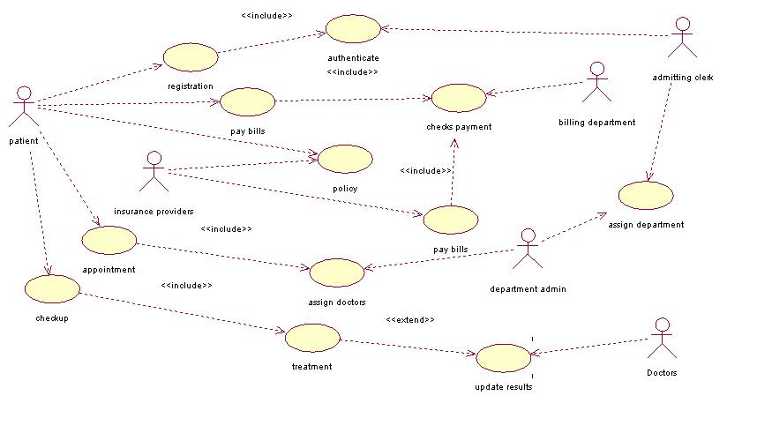

|  |  |
| --- | --- |
| **USE CASE** | **DESCRIPTION** |
| Registration | Admitting clerk will register the patient |
| Assign Department | Admitting clerk will assign department to patient |
| Assign doctors | Doctors are assigned to the patient by department admin |
| Update Results | Doctor will update the problems and prescription of patient |
| Pay | Patient will pay bills generated by billing department |
| Policy | Billing department checks whether patient has policy or not |
| Pay bills | Insurance provider will pay bills for the patient |