Q.1

JAVA CODE:

**import** java.io.*;

**import** org.apache.hadoop.io.Text;

**import** org.apache.hadoop.io.LongWritable;

**import** org.apache.hadoop.io.DoubleWritable;

**import** org.apache.hadoop.mapreduce.Job;

**import** org.apache.hadoop.mapreduce.Mapper;

**import** org.apache.hadoop.mapreduce.Reducer;

**import** org.apache.hadoop.conf.*;

**import** org.apache.hadoop.fs.*;

**import** org.apache.hadoop.mapreduce.lib.input.*;

**import** org.apache.hadoop.mapreduce.lib.output.*;

**public** **class** AllTimeHigh {

**public** **static** **class** MapClass **extends** Mapper<LongWritable,Text,Text,DoubleWritable>

{

**private** Text stock_id = **new** Text();

**private** DoubleWritable High = **new** DoubleWritable();

**public** **void** map(LongWritable key, Text value, Context context)

{

**try**{

String[] str = value.toString().split(",");

**double** high = Double.*parseDouble*(str[4]);

stock_id.set(str[1]);

High.set(high);

//context.write(new Text(str[1]),new LongWritable(vol));

context.write(stock_id, High);

}

**catch**(Exception e)

{

System.***out***.println(e.getMessage());

}

}

}

**public** **static** **class** ReduceClass **extends** Reducer<Text,DoubleWritable,Text,DoubleWritable>

{

**private** DoubleWritable result = **new** DoubleWritable();

**public** **void** reduce(Text key, Iterable<DoubleWritable> values,Context context) **throws** IOException, InterruptedException {

**double** maxValue=0;

**double** temp_val=0;

**for** (DoubleWritable value : values) {

temp_val = value.get();

**if** (temp_val > maxValue) {

maxValue = temp_val;

}

}

result.set(maxValue);

context.write(key, result);

//context.write(key, new LongWritable(sum));

}

}

**public** **static** **void** main(String[] args) **throws** Exception {

Configuration conf = **new** Configuration();

//conf.set("name", "value")

//conf.set("mapreduce.input.fileinputformat.split.minsize", "134217728");

Job job = Job.*getInstance*(conf, "Highest Price for each stock");

job.setJarByClass(AllTimeHigh.**class**);

job.setMapperClass(MapClass.**class**);

//job.setCombinerClass(ReduceClass.class);

job.setReducerClass(ReduceClass.**class**);

job.setNumReduceTasks(1);

job.setOutputKeyClass(Text.**class**);

job.setOutputValueClass(DoubleWritable.**class**);

FileInputFormat.*addInputPath*(job, **new** Path(args[0]));

FileOutputFormat.*setOutputPath*(job, **new** Path(args[1]));

System.*exit*(job.waitForCompletion(**true**) ? 0 : 1);

}

}

Upload jar and file on FTP

MAP-REDUCE

FTP

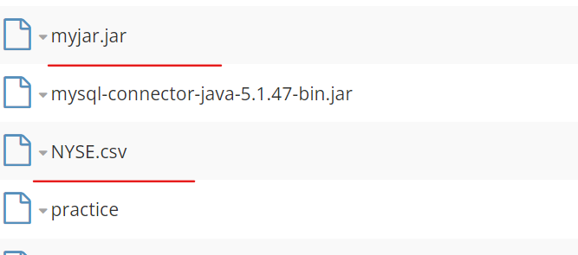

[bigdatamind43813@ip-10-1-1-204 ~]$hadoop fs -put NYSE.csv

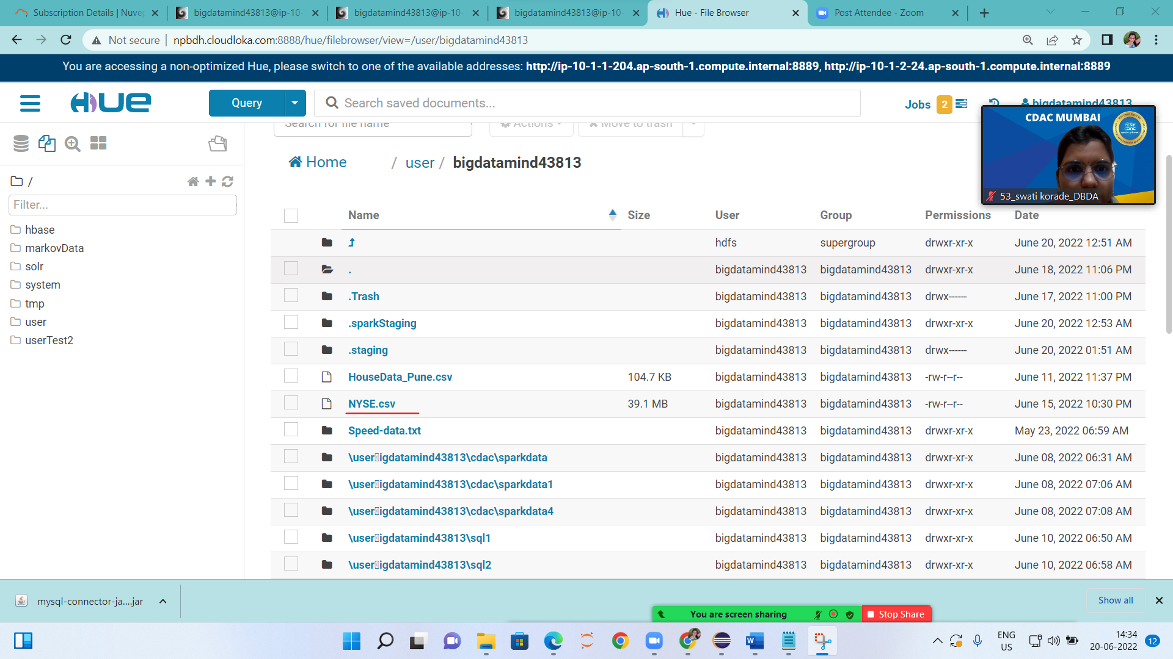

To check jar in hadoop



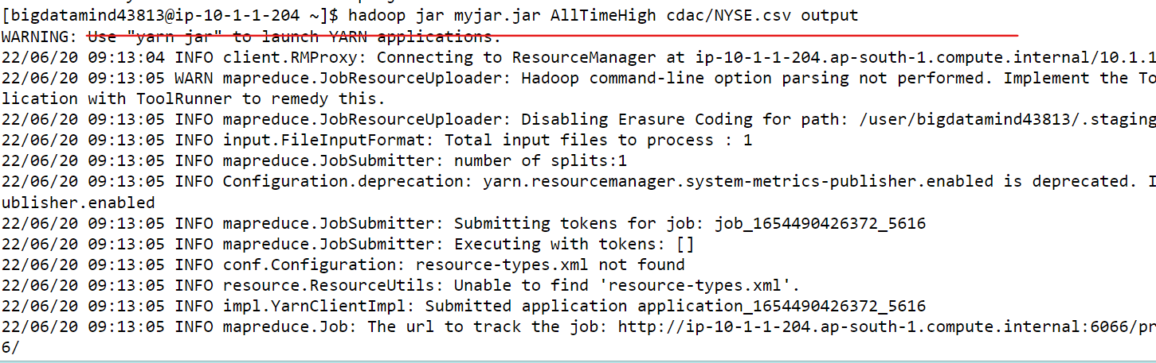

OUTPUT created on HUE

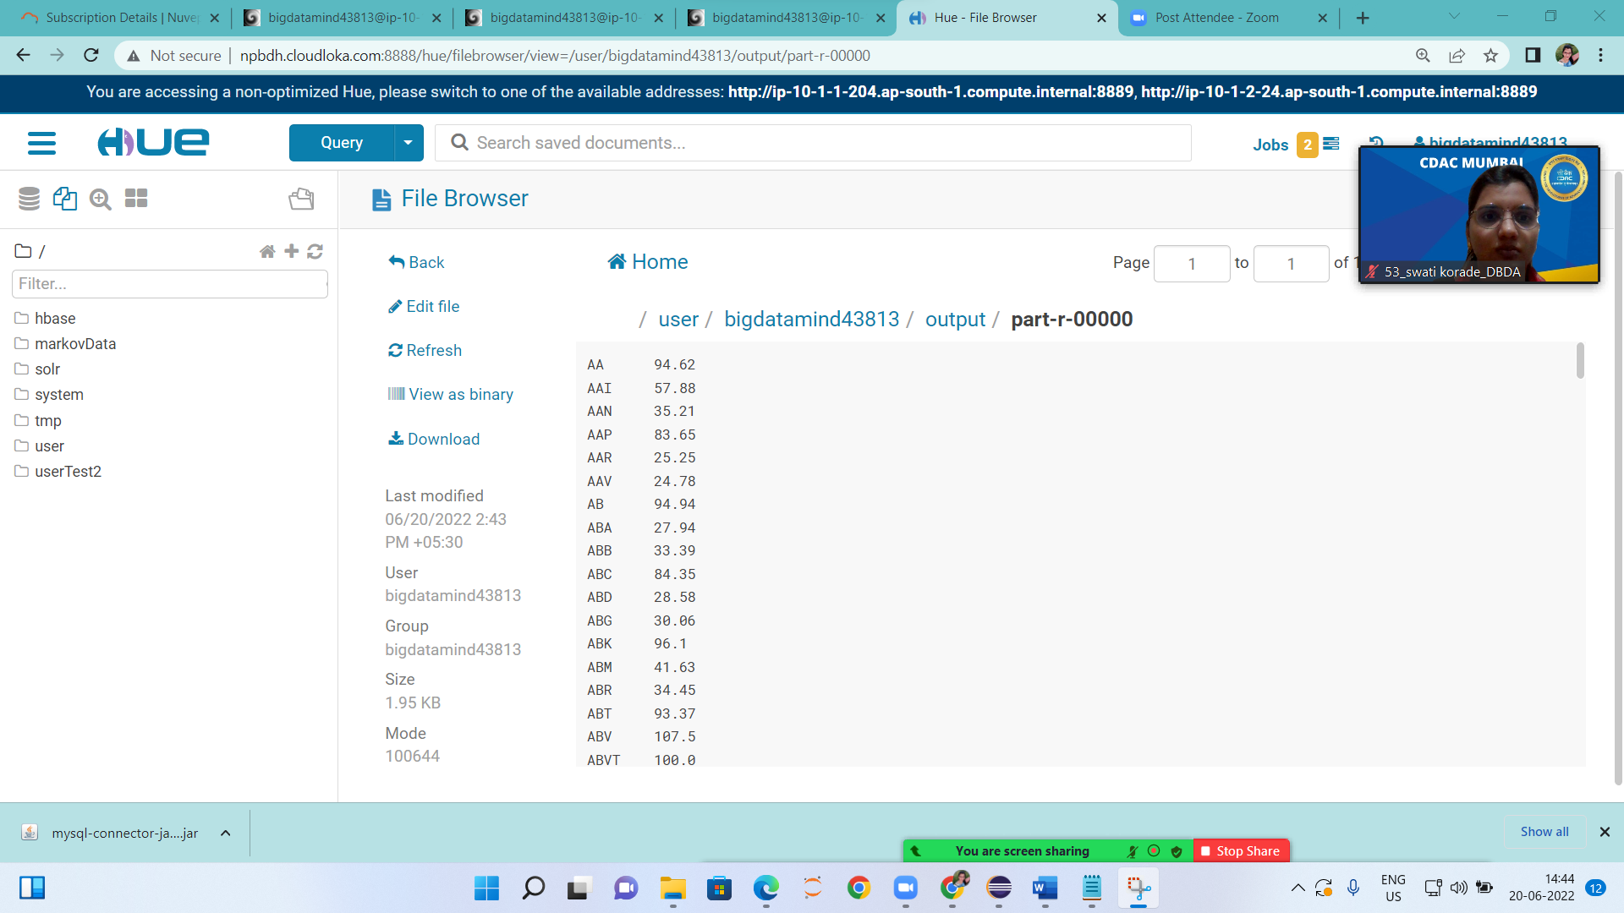

2.HIVE

1.Put data on FTP:

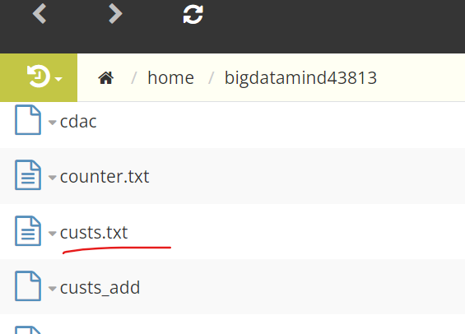

2. PUT data on hadoop:

hadoop fs -put cust.txt

3. create table,load data

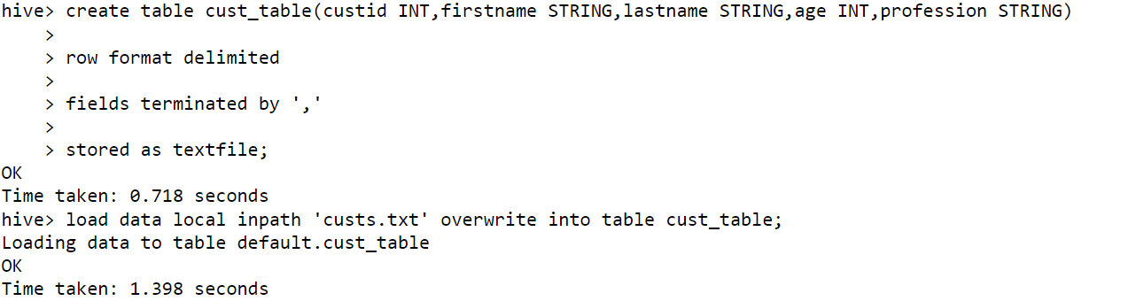

4. QUERY

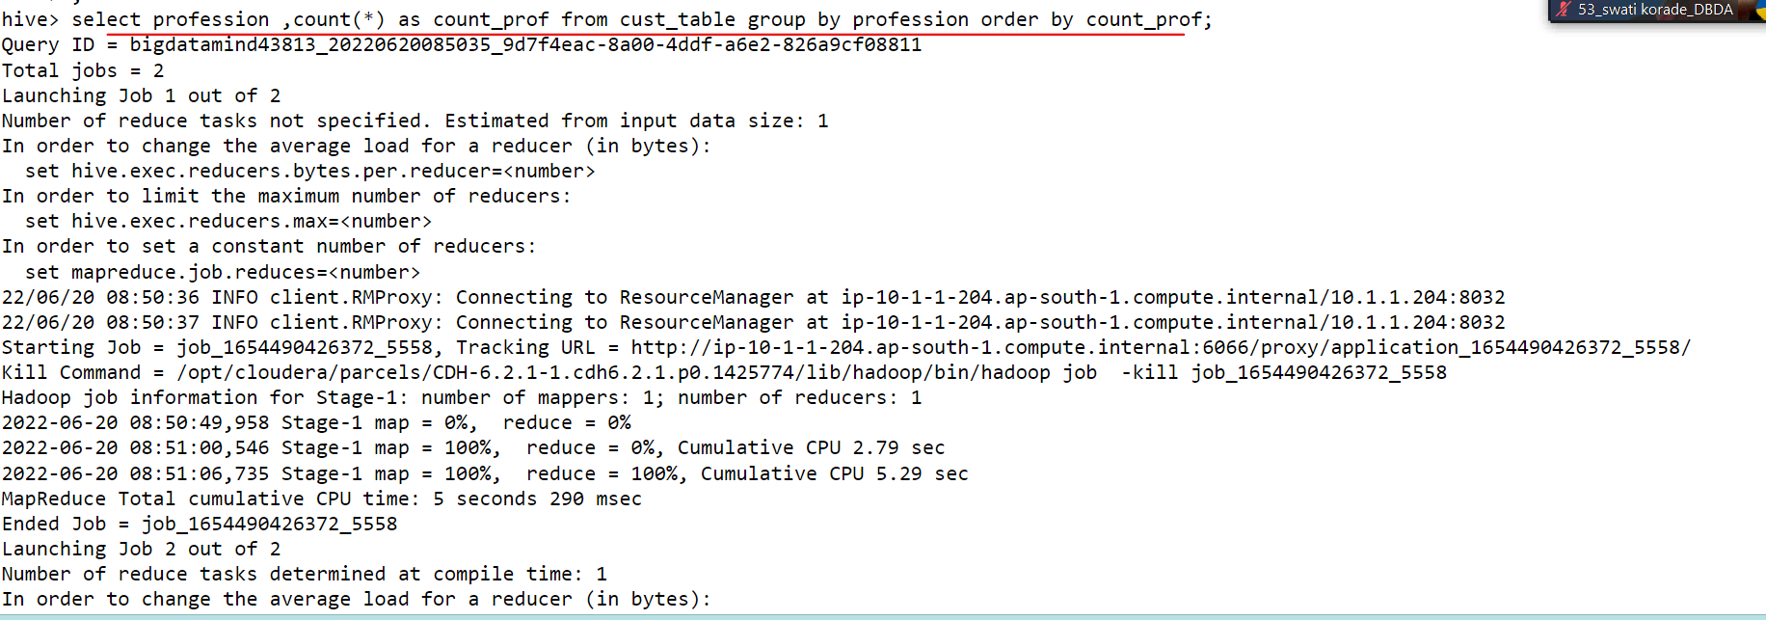

OUTPUT

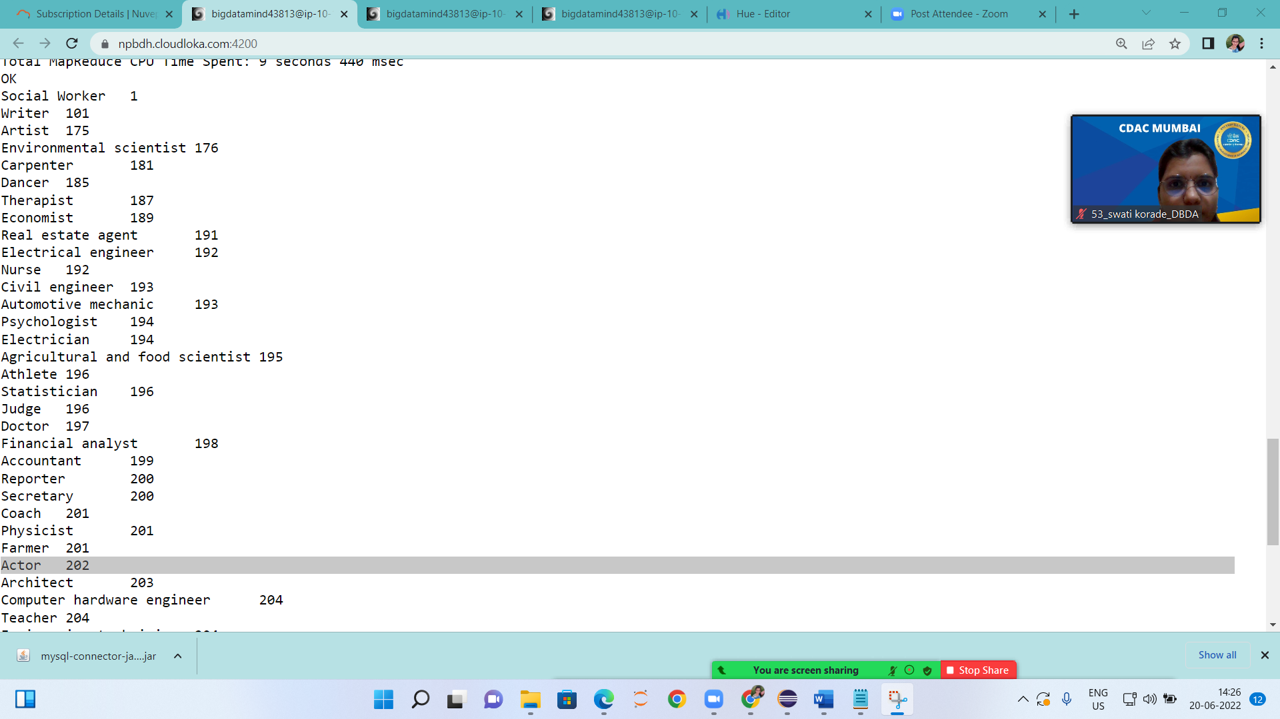

**Please find Sales data sets**

Put file on FTP

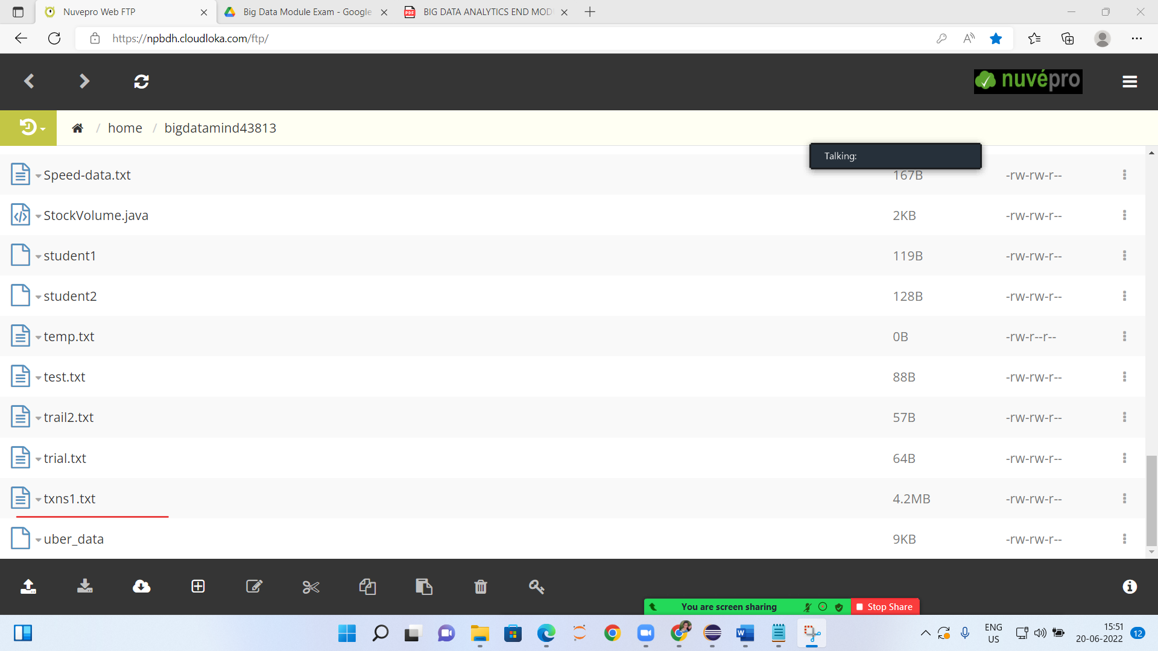

To put file on hadoop

hadoop fs -put txns1.txt

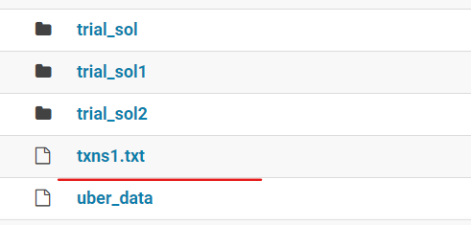

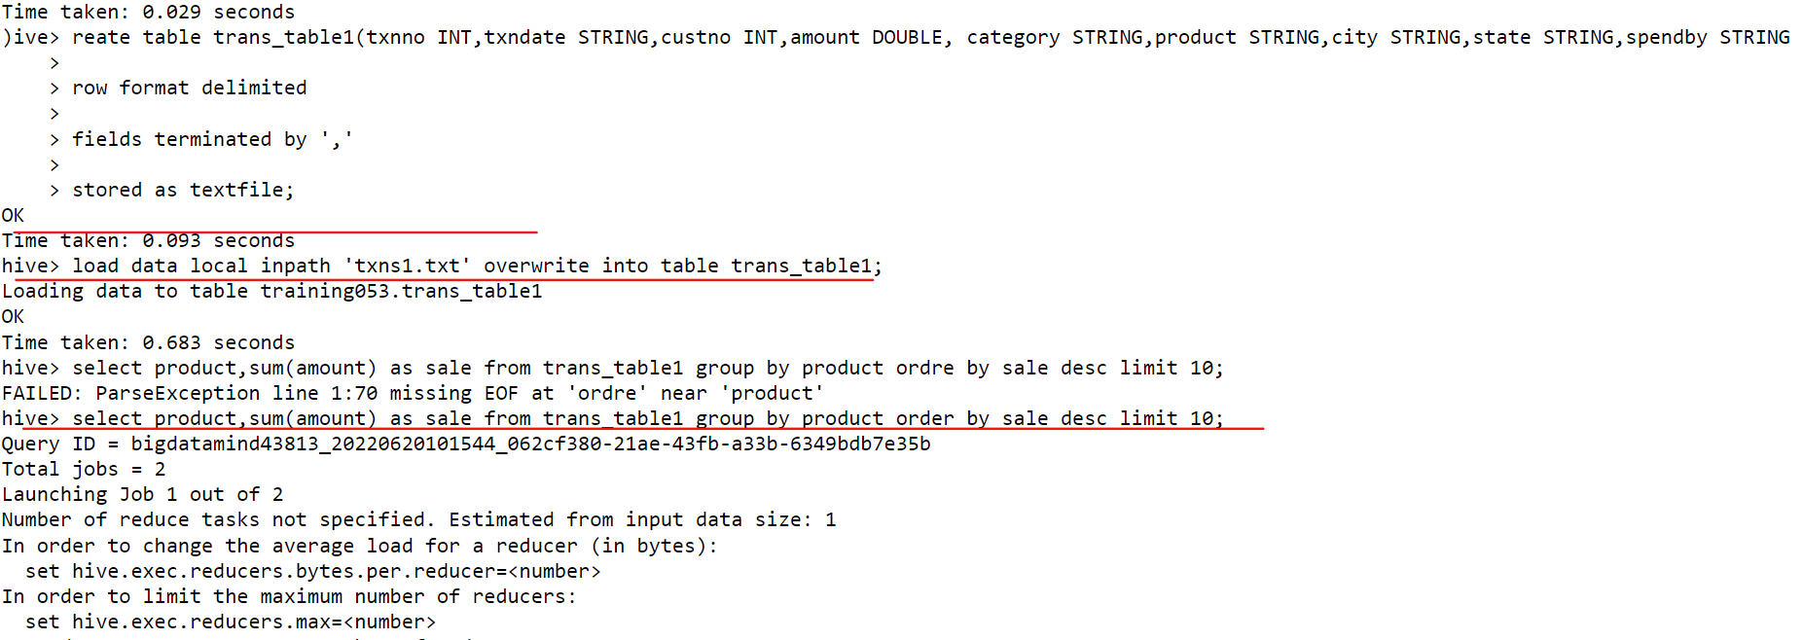

Table is created on hive warehouse:

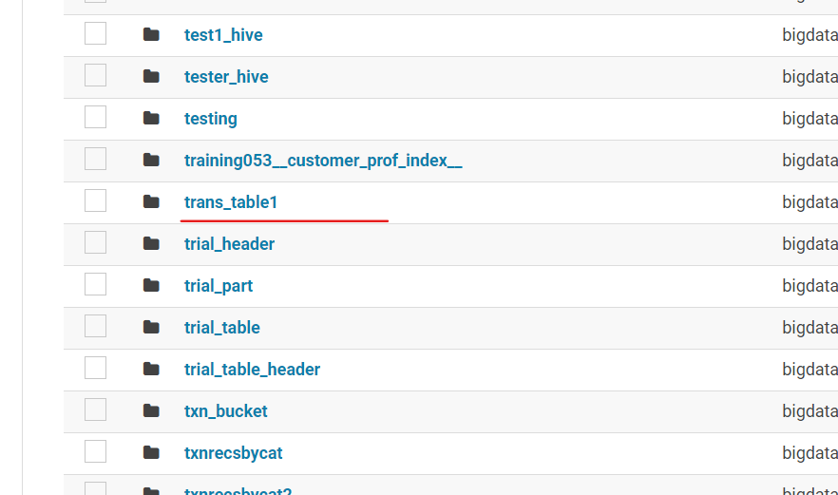

2) Write a program to find the top 10 products sales wise

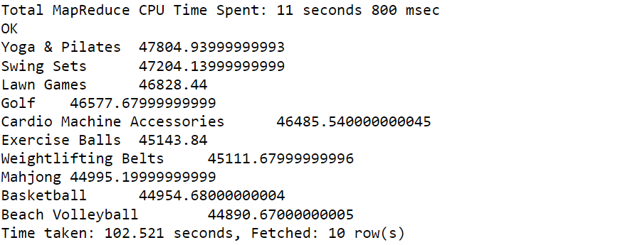

3) Write a program to create partioned table on category.

TABLE CRERATION WITH PARTITION ,LOAD DATA,

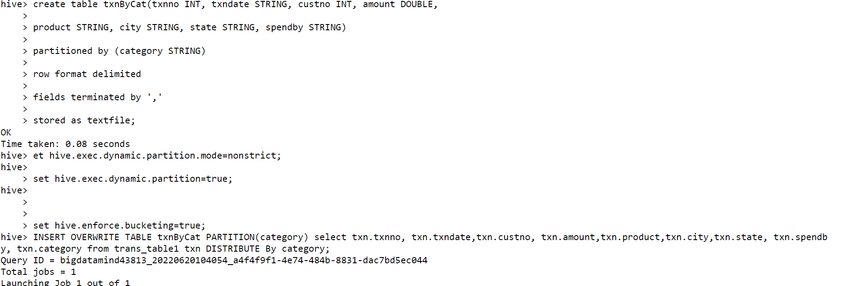

PARTION TABLE IN VIEW

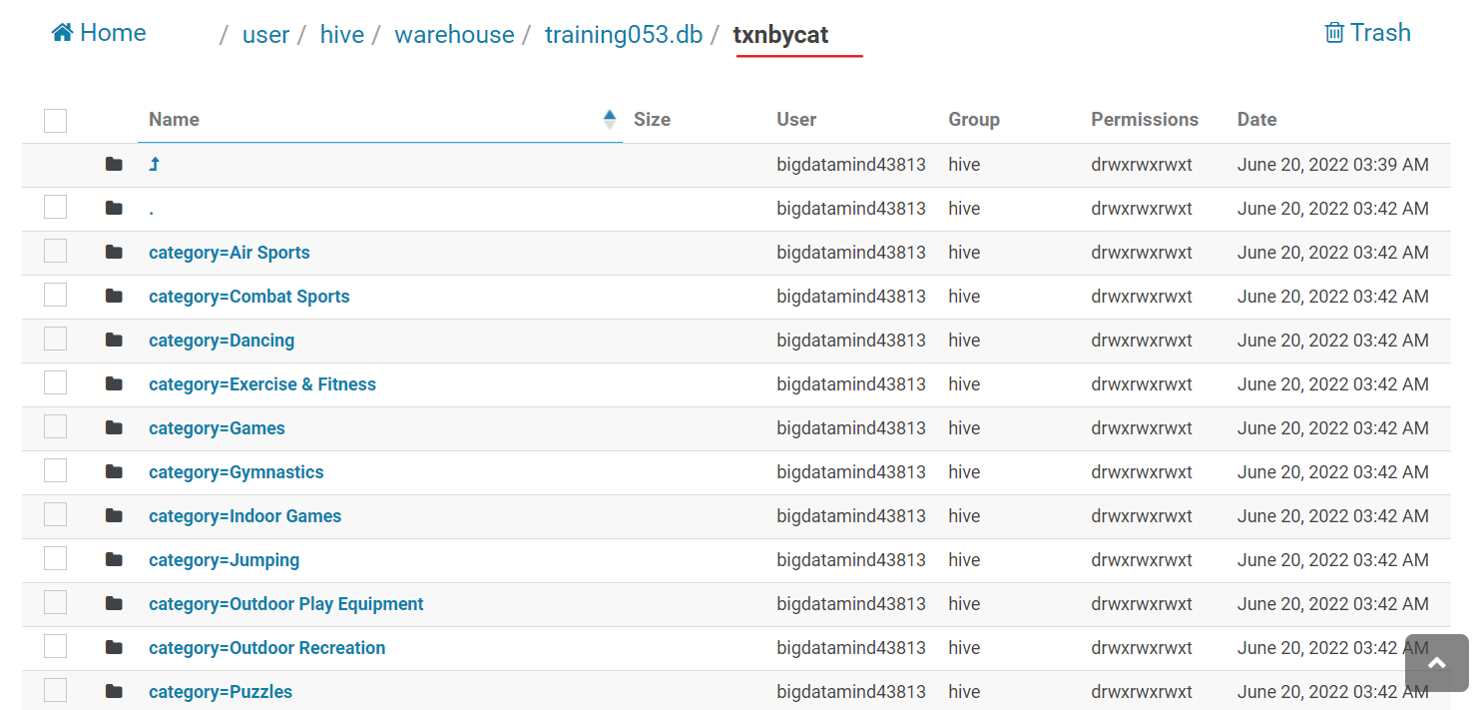

Q.3

.PYSPARK

PUT ON FTP

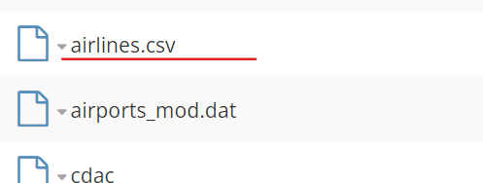

hadoop fs -put airlines.csv

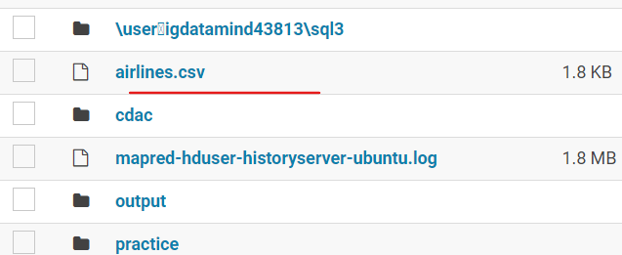

RDD creation

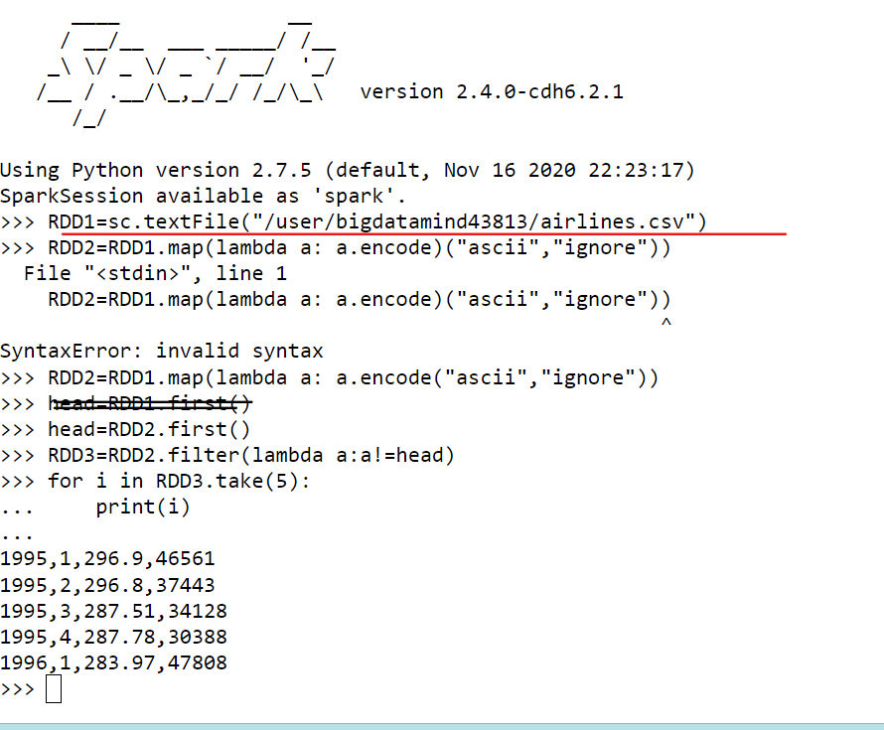

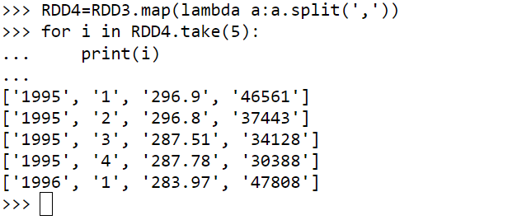

1. What was the highest number of people travelled in which year?

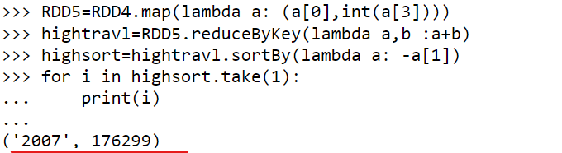

1. Identifying the highest revenue generation for which year

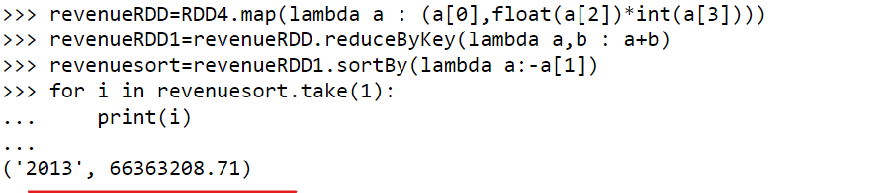

1. Identifying the highest revenue generation for which year and quarter (Common group)

