**NAME:SWATI RAJENDRA VISHWAKARMA**

**ROLL NO: 18**

**SUBJECT: FINAL PROJECT(MANUAL TESTING AND AUTOMATION TESTING)**

**COURSE: Full Stack Quality Engineering**

**MANUAL TESTING**

[**1**].Based on the acceptance criteria and mock-up write down the test scenario and test cases

TEST SCENARIO 1:USER SHOULD BE ABLE TO CLICK ON ABOUT US LINK

|  |  |  |  |  |
| --- | --- | --- | --- | --- |
| SR NO. | TEST CASES | EXPECTED RESULT | TEST DATA | STATUS |
| 1. | Launch the application as per given data | Application should be able to launch | https://test-nf.com/english.html | PASS |
| 2. | User should be able to click on About as link | User should ab able to click on About us link |  | FAIL |

TEST SCENARIO 2:USER SHOULD BE ABLE TO NAVIGATE ABOUT US LINK

|  |  |  |  |  |
| --- | --- | --- | --- | --- |
| SR  NO. | TEST CASES | EXPECTED RESULT | TEST DATA | STATUS |
| 1. | Launch the application as per given data | Application should be able to launch | https://test-nf.com/english.html | PASS |
| 2. | User should be able to click on About as link | User should ab able to click on About us link |  | FAIL |
| 3. | After clicking on About us link new information page should appear | User sholud be able to navigate the About us link page |  | FAIL |

TEST SCENARIO 3:VERIFY ABOUT US LINK IS AVAILABLE ON ALL THE TABS(HOME,FOOTBALL,BASKETBALL,CRICKET,CYBERSPORT)

|  |  |  |  |  |
| --- | --- | --- | --- | --- |
| SR  NO. | TEST CASES | EXPECTED RESULT | TEST DATA | STATUS |
| 1. | Launch the application as per given data | Application should be able to launch | https://test-nf.com/english.html | PASS |
| 2. | When user click on tab (i.e.home,football,cricket,  basketball,cybersport) it should navigate to that tab page | User should be able to  the navigate to tab which has been clicked |  | PASS |
| 3. | About us link should be displayed on every tab footer and User should able to click the link | User should ab able to click on About us link and navigate information page |  | FAIL |

[**2**]. Find out all the possible bugs and assign the priority and severity of the bug.

1.There are lots of spelling errors in an application (like-busketball,kriket,cibersport,etc)

->Priority- Medium Severity- Low

2.When user click on Michael Jordan photo or learn more option it does not display any information about him like others

->Priority- High Severity- Medium

3.When user click on close (X) for adverstisements it is not working or closing the ads.

->Priority- Urgent Severity- Urgent

4.When user click on any tab of sports game the paragraphs of sport information have blur last lines so it is not possible to read further.

->Priority- Urgent Severity- High

5. About us link is not working for any tabs it give 404 NOT FOUND error

->Priority- Urgent Severity- Urgent

6.Contact link is not working for any tabs it give 404 NOT FOUND error

->Priority- Urgent Severity- Urgent

7.Any Social media icons is not working

->Priority- Urgent Severity- High

8.In basketball tab one image is not displayed it gives image error

->Priority- Medium Severity- Low

9.When user scroll down the page ad display on tabs so user are unavailable to click on the tab when he is in footer part of the page

->Priority- Urgent Severity- Urgent

10.In home page first line has combine two words together(sportspeople)

->Priority- Low Severity- Low

11.In home page, on photo of Christano Ronaldo, Lionel Messi’s name is written

->Priority- High Severity- High

12.In football page,photo of other sport is displayed

->Priority- Urgent Severity- Urgent

13.When user move its curser on basketball tab it text become invisible

->Priority- High Severity- High

14.When user move its curser on football it’s highlight does not cover whole football text

->Priority- Medium Severity- Medium

**AUTOMATION TESTING**

**CODE –**

PAGEOBJECT-

import org.openqa.selenium.WebElement;

import org.openqa.selenium.support.FindBy;

public class PageObject {

// Created Page Object

*@FindBy*(xpath = "//a[@href='english.html']")

WebElement home;

*@FindBy*(xpath = "//a[text()='Football']")

WebElement football;

*@FindBy*(xpath = "//a[@href='busketball.html']")

WebElement basketball;

*@FindBy*(xpath = "//*[text()='Kriket")

WebElement cricket;

*@FindBy*(xpath = "//a[text()='Cibersport']")

WebElement cybersport;

}

**MAIN-**

package assignment_auto;

import java.io.FileOutputStream;

import org.openqa.selenium.By;

import org.openqa.selenium.WebDriver;

import org.openqa.selenium.chrome.ChromeDriver;

import org.openqa.selenium.support.PageFactory;

import org.testng.annotations.AfterMethod;

import org.testng.annotations.BeforeMethod;

import org.testng.annotations.Test;

import org.testng.asserts.SoftAssert;

import jxl.Workbook;

import jxl.write.WritableSheet;

import jxl.write.WritableWorkbook;

public class Swati_fynd {

public WebDriver driver;

@BeforeMethod

public void start() {

System.setProperty("webdriver.chrome.driver","D://chromedriver.exe");

driver = new ChromeDriver();

driver.get("https://test-nf.com/english.html");

driver.manage().window().maximize();

}

@Test

public void Execute() throws Exception {

// Imported the Page Object method by Page Factory property.

PageObject P = PageFactory.initElements(driver, PageObject.class);

//whether home is displayed,link contains it tab name

boolean a = P.home.isDisplayed();

System.out.println("Home is displayed:" +a);

String b = driver.getCurrentUrl();

boolean c = b.contains("english");

System.out.println("Home url contains english:" +c);

//whether football is displayed,link contains it tab name

SoftAssert s = new SoftAssert();

boolean d = P.football.isDisplayed();

s.assertEquals(d, true);

String e = driver.getCurrentUrl();

System.out.println("football url:" +e);

boolean f = e.contains("football");

s.assertEquals(f, true);

//whether basketball is displayed,link contains it tab name

boolean g = P.basketball.isDisplayed();

s.assertEquals(g, true);

String h = driver.getCurrentUrl();

System.out.println("basketball url:" +h);

boolean i = h.contains("busketball");

s.assertEquals(i, true);

//whether cricket is displayed,link contains it tab name

boolean j = P.cricket.isDisplayed();

s.assertEquals(j, true);

String k = driver.getCurrentUrl();

System.out.println("cricket url:" +k);

boolean o = k.contains("kriket");

s.assertEquals(o, true);

//whether cybersport is displayed,link contains it tab name

boolean m = P.cybersport.isDisplayed();

s.assertEquals(m, true);

String n = driver.getCurrentUrl();

System.out.println("cybersport url:" +n);

boolean r = n.contains("cibersport");

s.assertEquals(r, true);

//Saving the URL details in Excel

FileOutputStream z = new FileOutputStream("C:\\Users\\Swati\\OneDrive\\Desktop\\url.xls");

WritableWorkbook ws = Workbook.createWorkbook(z);

WritableSheet x = ws.createSheet("output", 3);

jxl.write.Label l = new jxl.write.Label(0, 0, b);

jxl.write.Label l1 = new jxl.write.Label(0, 1, e);

jxl.write.Label l2 = new jxl.write.Label(0, 2, h);

jxl.write.Label l3 = new jxl.write.Label(0, 3, k);

jxl.write.Label l4 = new jxl.write.Label(0, 4, n);

//Adding the Label value in the cell.

x.addCell(l);

x.addCell(l1);

x.addCell(l2);

x.addCell(l3);

x.addCell(l4);

//Saving and closing the workbook.

ws.write();

ws.close();

}

@AfterMethod

public void end() {

driver.close();

}

}

**TEST REPORT-**

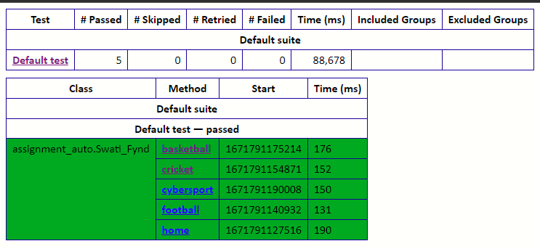

**OUTPUT-**

**CONSOLE-**

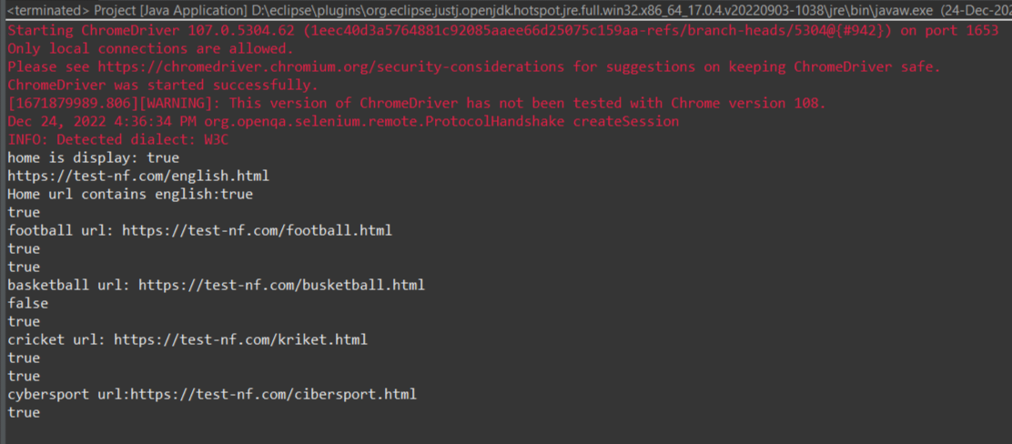

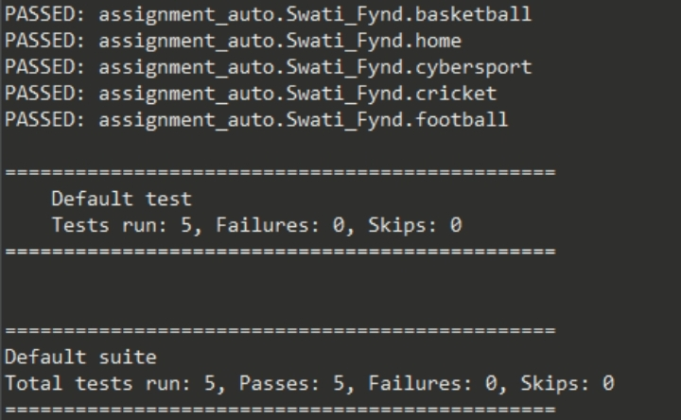

**EXCEL-**

