**STACKED**

**Case 1:**

**Training parameters:**

learning_rate = 0.01  
num_steps = 600  
batch_size = 256  
  
display_step = 1000  
examples_to_show = 10

**Loss:**



**Original image**

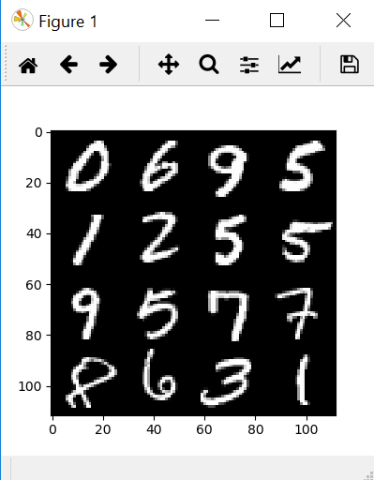

**Reconstructed Image**

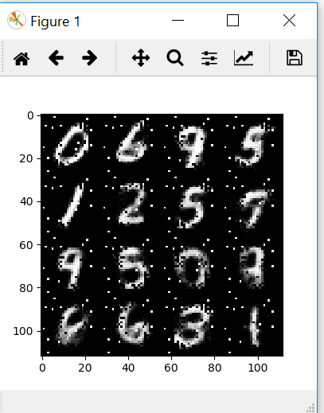

**STACKED**

**Case 2:**

**Training parameters:**

learning_rate = 0.01  
num_steps = 500  
batch_size = 256  
  
display_step = 100  
examples_to_show = 10

**LOSS:**

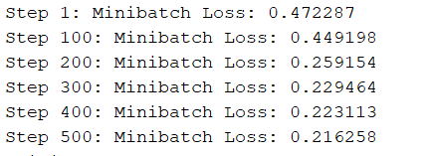

**ORIGINAL**

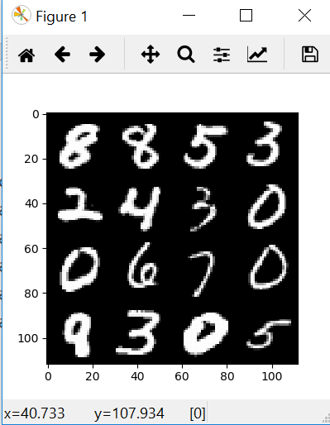

**RECONSTRUCTED**

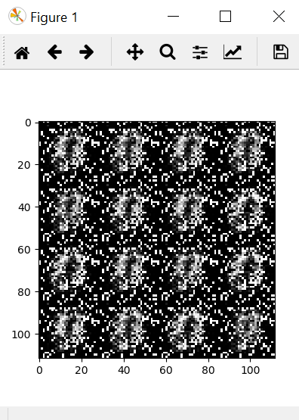

**TENSOR BOARD:**

