INTRODUCTION
VISUALIZATION-
Visualization is the process of representing data in graphical or visual form, such as charts, graphs, maps, and plots, to make information easier to understand, analyze, and interpret.
Example:
If you have students' marks in a table, displaying them as a bar chart or pie chart makes it easier to compare their performance.

Purpose of Data Visualization:
- Makes data easy to understand
- Identifies trends and patterns
- Compares different values
- Helps in decision-making
- Presents data in an attractive way

Visualization Library Documentation
Libraries: Matplotlib & Seaborn

1.Library Overview

Matplotlib
Matplotlib is an open-source Python library introduced by John D. Hunter in 2003. It is one of the most widely used libraries for creating static, animated, and interactive visualizations. It helps convert numerical data into graphs and charts, making it easier to understand trends, patterns, and comparisons.
Matplotlib is commonly used in data analysis, machine learning, scientific research, and business reporting. It works well with NumPy and Pandas.
Features:
- Easy to use
- Highly customizable
- Supports many chart types
- Suitable for scientific plotting

Use Cases:
- Data analysis
- Academic research
- Business reports

A Matplotlib figure contains:
- Figure
- Axes
- Axis
- Labels
- Legend

Figure :
A Figure is the main container that holds all the elements of a graph. It represents the entire chart or plotting area.
Axes :
Axes are the plotting regions where graphs such as line plots, bar charts, and scatter plots are drawn.
Axis :
An Axis represents the horizontal (X-axis) and vertical (Y-axis) directions used to display data values.
Labels :
Labels provide names for the X-axis and Y-axis, making the graph easier to understand.
Legend :
A Legend identifies different datasets or categories displayed in the graph.

INSTALL LIBRARIES-
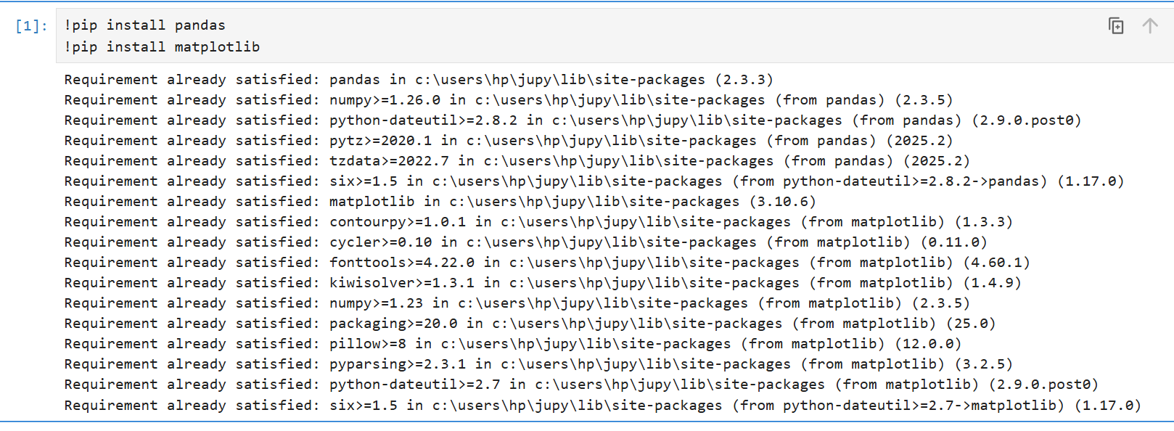

IMPORT LIBRARY-
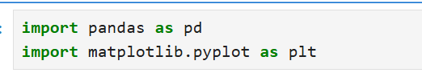

Graph Types in Matplotlib:
Line Plot
A Line Plot is used to show trends or changes in data over time by connecting data points with straight lines.
Use Cases:
- Sales growth over months
- Temperature changes
- Stock price trends
- Website traffic analysis

Code –
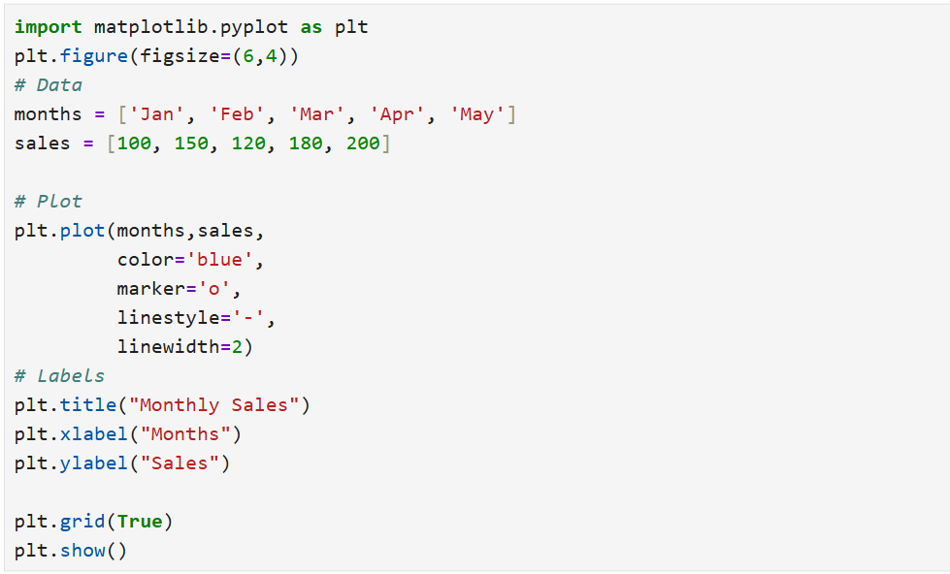
output-
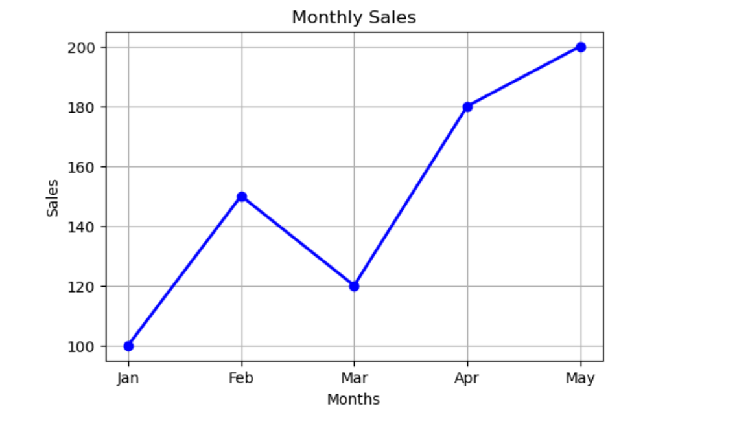

Bar Chart
Compares categories using attractive bars.
Use Cases:
- Sales comparison
- Student marks
CODE-
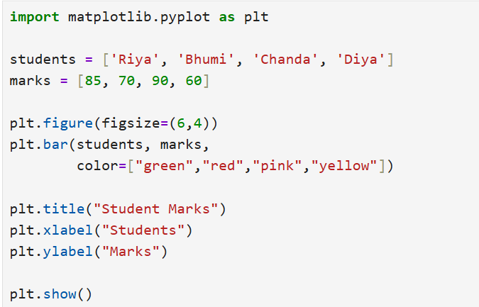
OUTPUT-
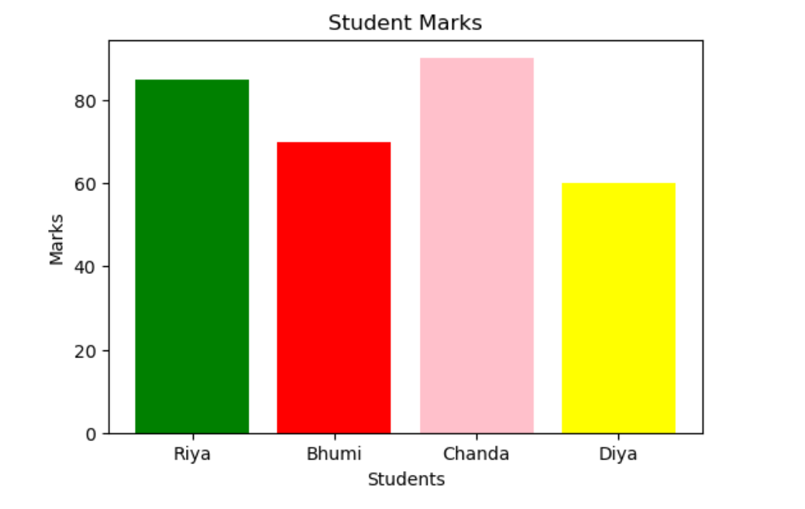
Scatter Plot
A Scatter Plot is a graph that displays individual data points to show the relationship between two numerical variables.
Each point represents one observation.
Use cases:
- Study Hours vs Marks
- Height vs Weight
- Age vs Salary
- Advertisement Cost vs Sales
- Temperature vs Ice Cream Sales
CODE-
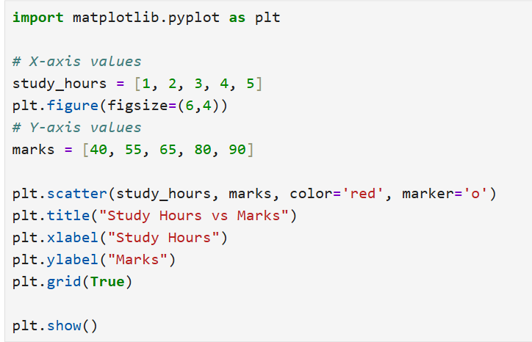
OUTPUT-
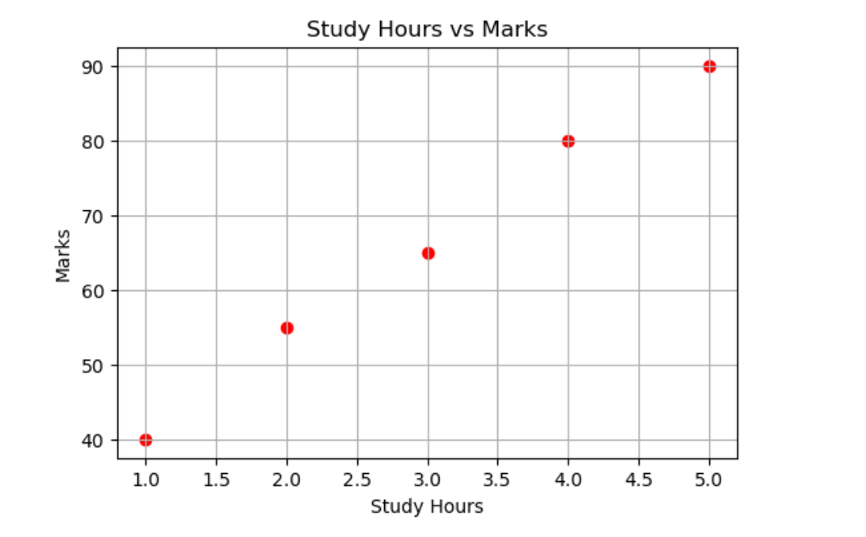
Histogram
A Histogram is a graph used to display the frequency distribution of numerical data. It groups data into intervals (bins) and shows how many values fall within each interval.
Use Cases:
- Marks distribution of students
- Age distribution of people
- Salary distribution of employees
- Customer purchase analysis
- Exam score analysis
CODE-
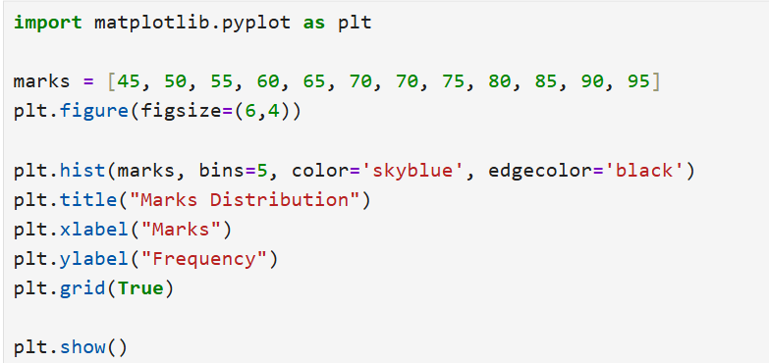
OUTPUT-
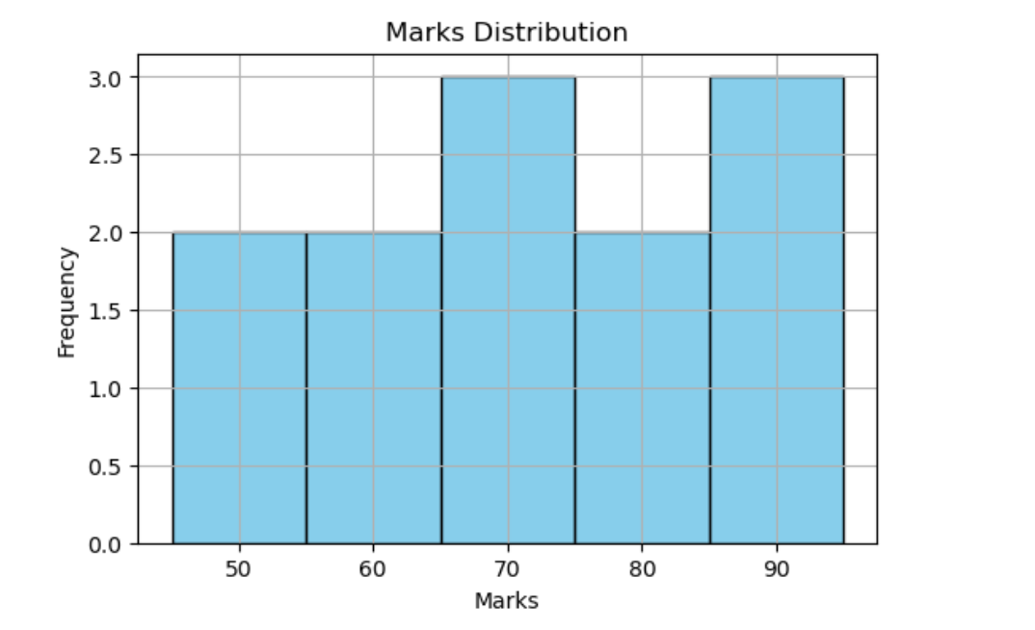
Pie Chart
A Pie Chart is a circular graph that represents data as parts of a whole. Each slice shows the proportion or percentage of a category relative to the total.
Use Cases:
- Market share of companies
- Budget allocation
- Survey results
- Population distribution
- Product sales percentage
CODE-
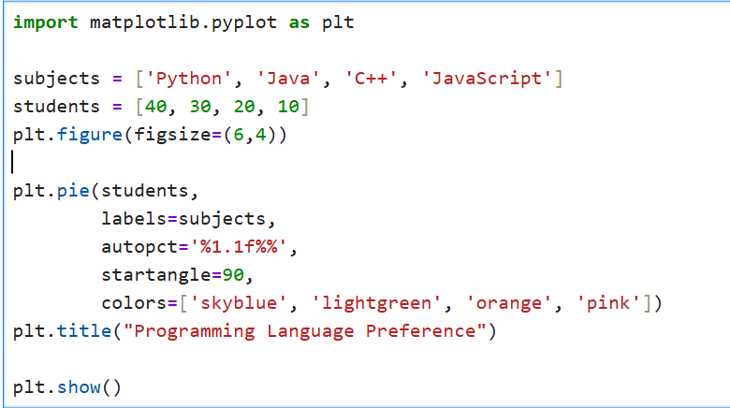
OUTPUT-
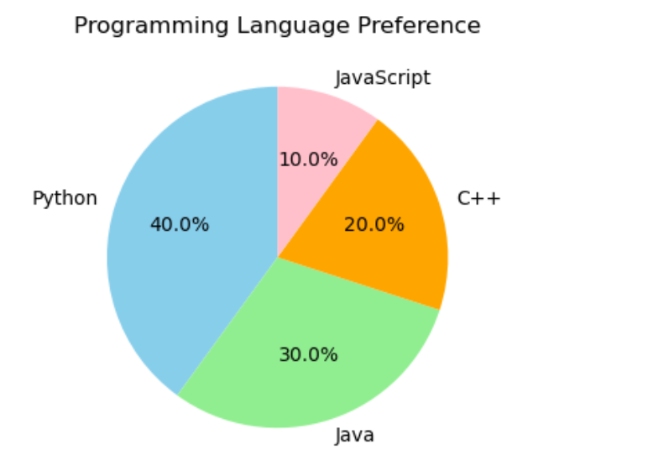
Box Plot
A Box Plot is a graph that displays the distribution of numerical data using five summary values: Minimum, First Quartile (Q1), Median (Q2), Third Quartile (Q3), and Maximum. It also helps identify outliers.
Use Cases:
- Salary distribution analysis
- Student marks analysis
- Detecting outliers
- Comparing data distribution between groups
- Exploratory Data Analysis (EDA)
CODE-
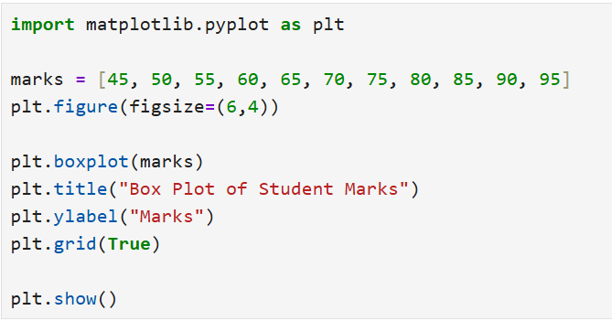
OUTPUT-
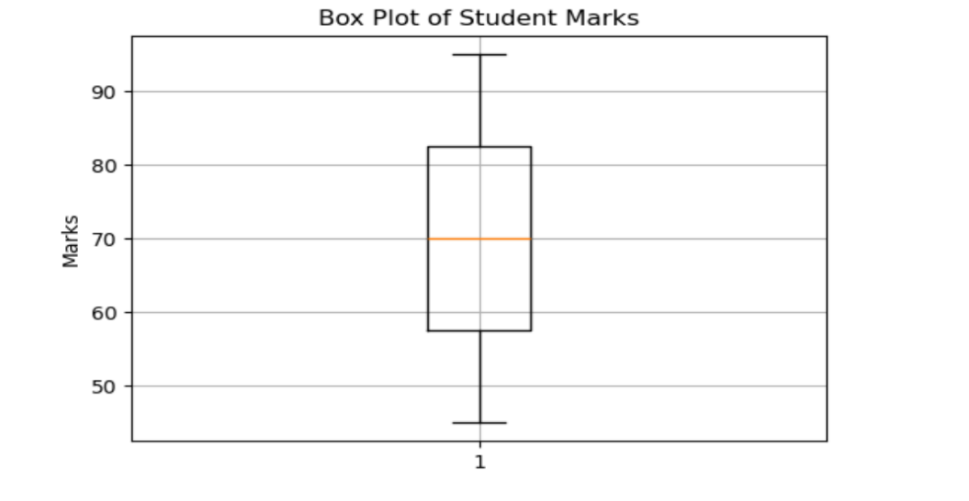
2.Library Overview

Seaborn
Seaborn is an open-source Python data visualization library built on top of Matplotlib. It is used to create attractive, informative, and statistical graphs with less code. Seaborn provides built-in themes, color palettes, and works directly with Pandas DataFrames, making data visualization simple and effective.
Features:
- Attractive default themes
- Statistical visualization
- Easy integration with Pandas
- Better color palettes
Use Cases:
- Data analysis
- Machine learning
- Statistical visualization

A Seaborn figure contains:
- Figure
- Axes
- Axis
- Title
- Labels
- Legend
- Grid
- Color
- Theme

Figure: Holds the complete graph.
Axes: Area where the plot is displayed.
Axis: Shows X-axis and Y-axis values.
Title: Gives the graph a heading.
Labels: Describe the X-axis and Y-axis.
Legend: Identifies different categories or datasets.
Grid: Makes the graph easier to read.
Color Palette: Enhances the graph with attractive colors.
Theme: Changes the overall appearance of the graph.

INSTALL LIBRARIES-
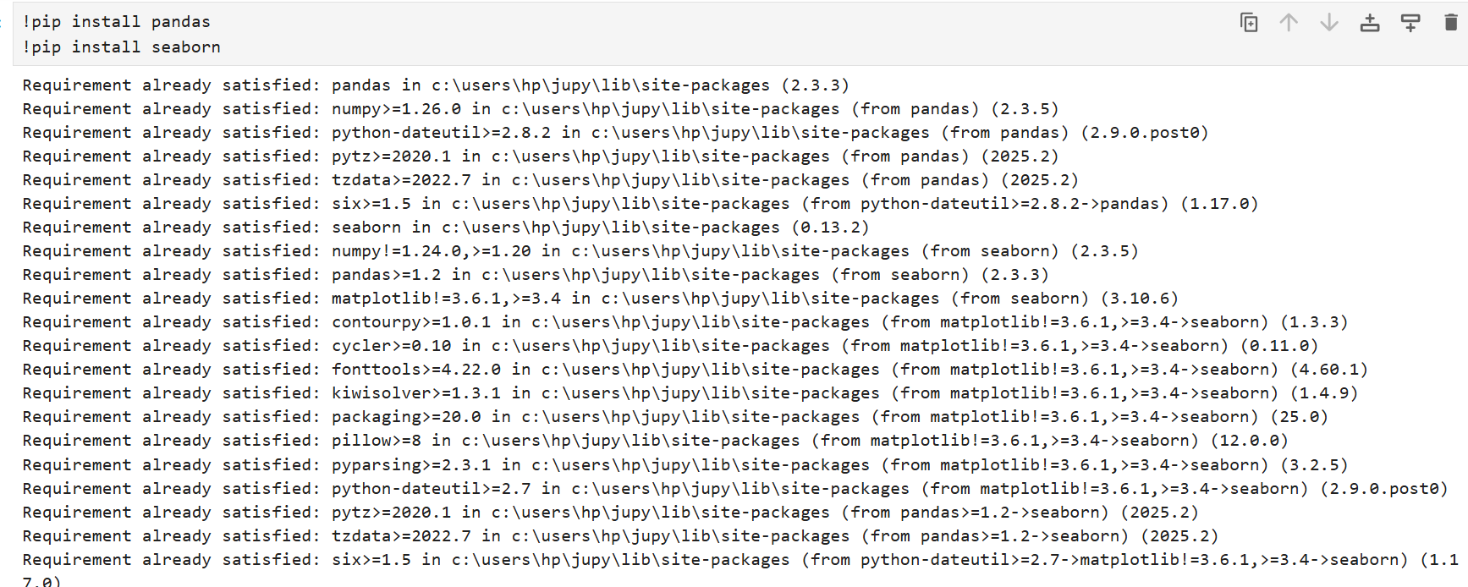
IMPORT LIBRARY-
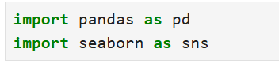
Graph Types in Seaborn:
Line Plot
A Line Plot is used to show trends or changes in data over time by connecting data points with straight lines.
Use Cases:
- Sales growth over months
- Temperature changes
- Stock price trends
- Website traffic analysis

CODE-
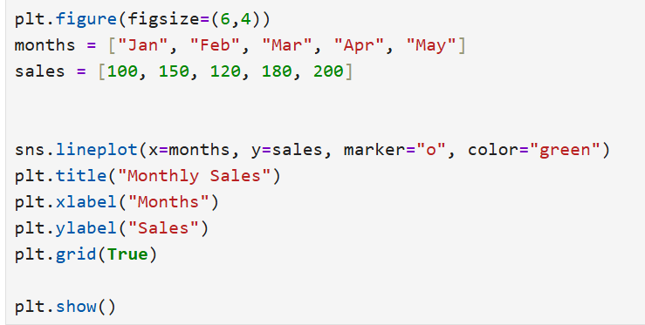
OUTPUT-
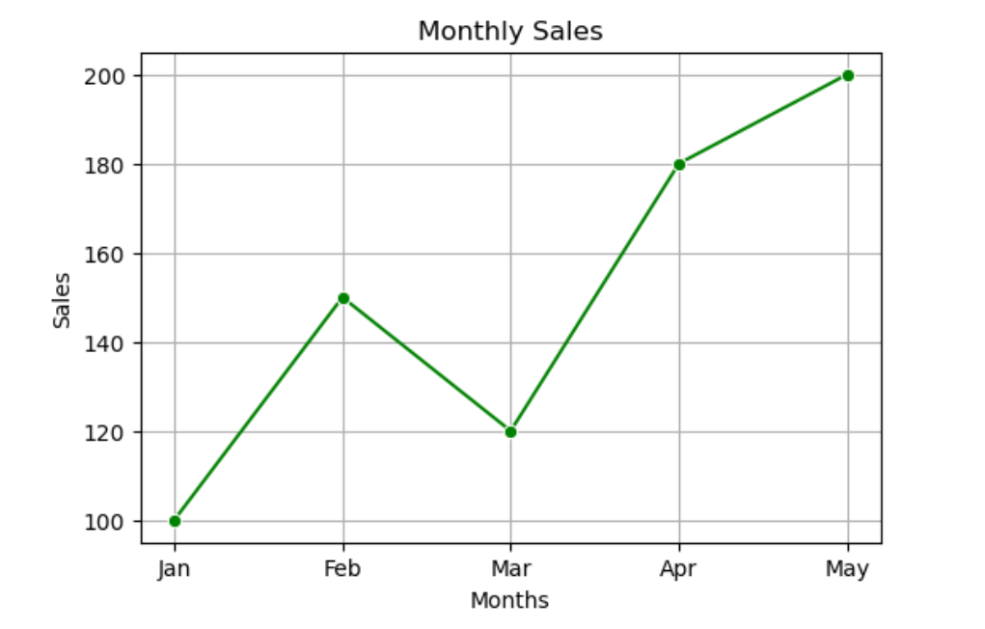

Bar Chart
A Bar Plot compares numerical values across different categories using rectangular bars.
Use Cases:
- Student marks
- Product sales
- Employee count
- Population comparison
CODE-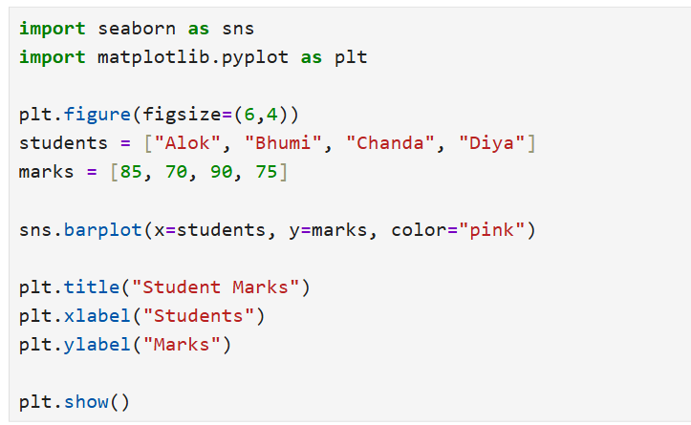
OUTPUT-
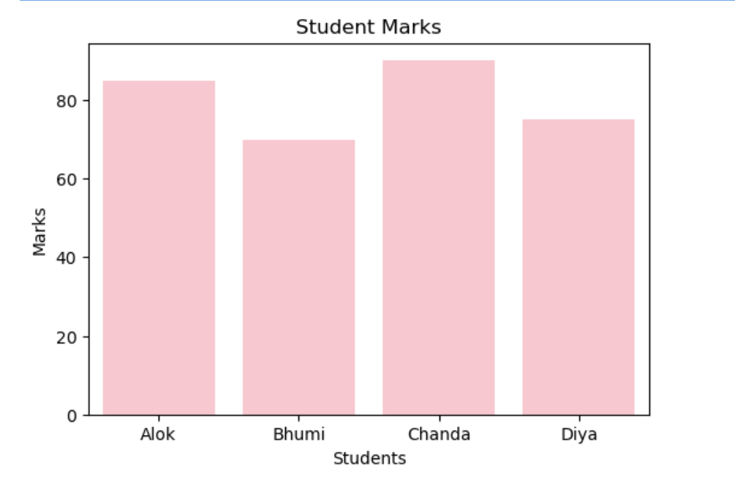
Scatter Plot
A Scatter Plot shows the relationship between two numerical variables using individual data points.
Use Cases:
- Height vs Weight
- Study Hours vs Marks
- Age vs Salary
- Sales vs Advertisement Cost
CODE-
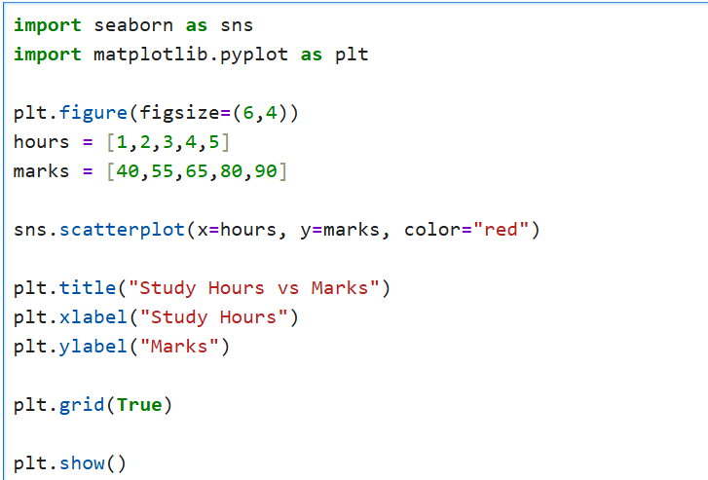
OUTPUT-
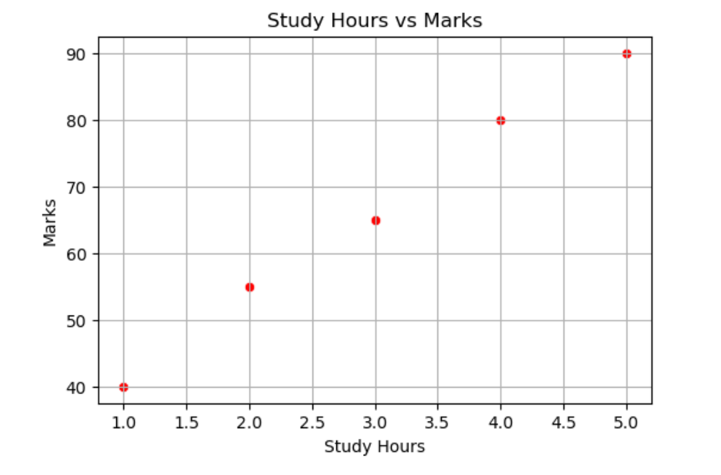
Histogram
A Histogram shows the frequency distribution of numerical data by dividing it into intervals (bins).
Use Cases:
- Marks distribution
- Salary distribution
- Age distribution
- Customer purchase analysis
CODE-
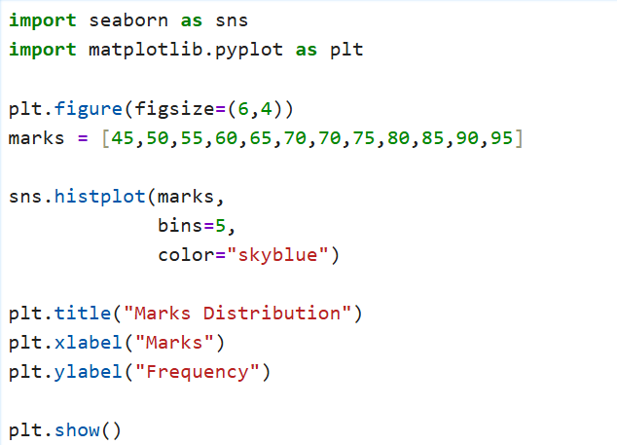
OUTPUT-
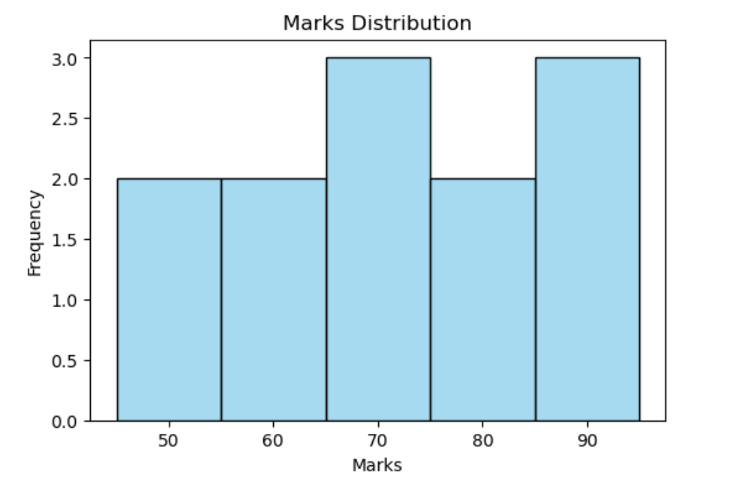
Box Plot
A Box Plot displays the distribution of numerical data and helps identify the median, quartiles, and outliers.
Use Cases:
- Salary analysis
- Marks analysis
- Outlier detection
- Data distribution comparison
CODE-
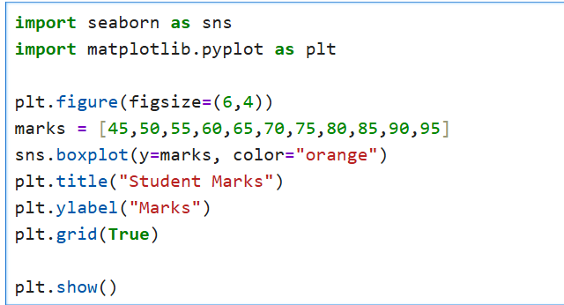
OUTPUT-
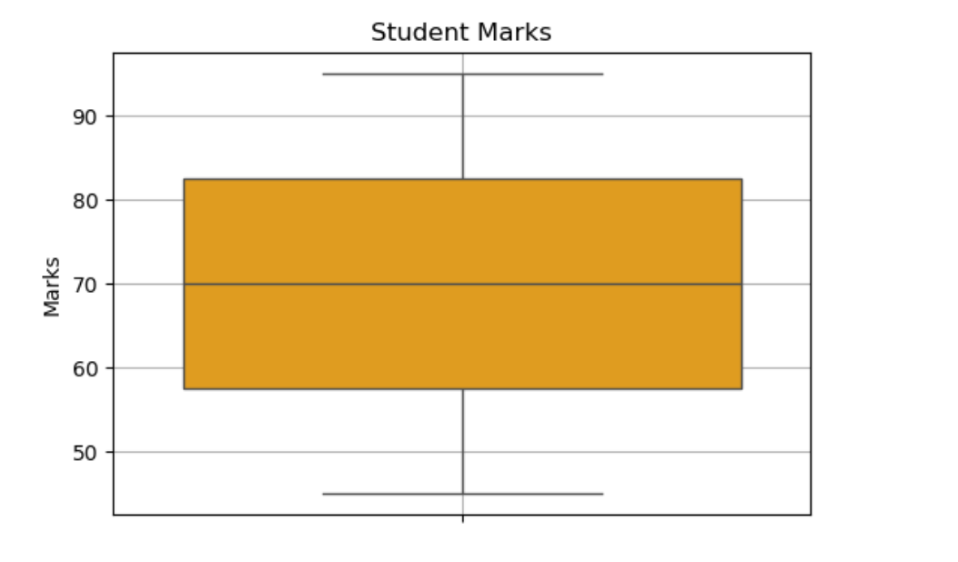
COMPARISON OF MATPLOTLIB AND SEABORN:
Matplotlib:
- Core Library:
Matplotlib is a popular open-source Python library used for creating 2D and basic 3D visualizations. It provides complete control over graph design and customization.
- Customization:
Matplotlib allows users to customize every part of a graph, including colors, fonts, markers, line styles, axes, legends, and figure size, making it suitable for professional-quality visualizations.
- Graph Types:
Matplotlib supports a wide variety of graphs such as Line Plot, Bar Chart, Scatter Plot, Histogram, Pie Chart, Box Plot, Area Chart, and Error Bar Chart.
- Integration:
Matplotlib works efficiently with NumPy, Pandas, and SciPy, making it a standard library for data analysis and scientific computing.

Advantages of Matplotlib-
- Provides complete control over graph appearance.
- Supports a wide variety of chart types.
- Produces high-quality publication-ready graphs.
- Well-documented with strong community support.
- Suitable for scientific research and data analysis.
- Supports both static and animated visualizations.

Seaborn:
- Statistical Visualization:
Seaborn is an open-source Python library built on Matplotlib for creating beautiful and statistical visualizations with minimal code.
- Ease of Use:
Seaborn provides attractive default themes and color palettes, making it easy to create professional-looking graphs quickly.
- Advanced Graph Types:
Seaborn supports Line Plot, Bar Plot, Scatter Plot, Histogram, Box Plot, Violin Plot, Heatmap, Pair Plot, Count Plot, Strip Plot, Swarm Plot, KDE Plot, Regression Plot, and Joint Plot.
- Integration:
Seaborn integrates seamlessly with Pandas DataFrames and Matplotlib, making it ideal for Exploratory Data Analysis (EDA) and machine learning.

Advantages of Seaborn-
- Creates attractive and informative statistical graphs.
- Requires less code than Matplotlib.
- Provides built-in themes and color palettes.
- Excellent for EDA and data analysis.
- Works directly with Pandas DataFrames.
- Supports advanced statistical visualizations such as Heatmaps, Pair Plots, and Violin Plots.

RESOURCES USED :
- Matplotlib Documentation
- Python Official Documentation
- GreeksforGreeks

