**Zumba Class Registration and Management System**

* **Epic Description**

Rohit is a Zumba Instructor. He takes multiple sessions during the day, dividing his participants into batches that run in the morning and evening. To manage his participants, he needs a software solution to record the details of his participants and batches. Luckily, his friend Mike runs a software company. Rohit has requested that he develop a backend solution to manage his participants and batches.

* **Developer Name** Swati Dubey
* **Course name** PG FSD: Backend and Database Development
* **High level Flow of the epic**

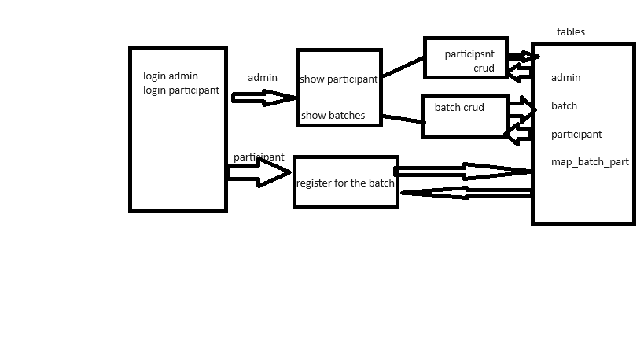

**GitHub Link**

https://github.com/swatidubey123/SwatiCourseProj