**Developer Name :Swati Dubey**

**Course :PG FSD: Backend and Database Development**

**Course 2 Final Project**

**Login option For Admin and Participants who wants to join the Zumba class**

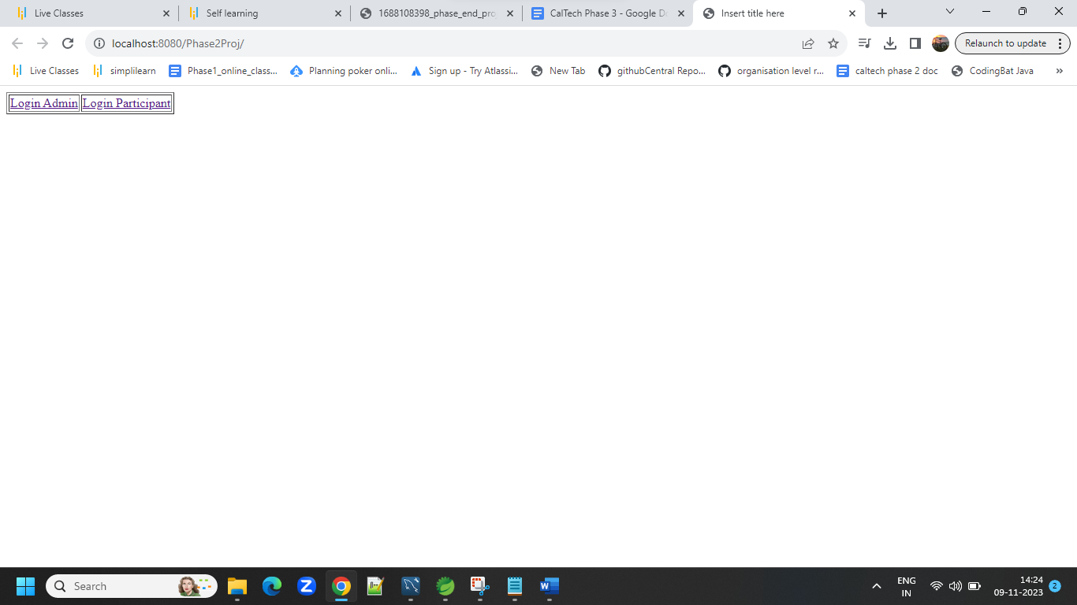

**Login Screen For Admin**

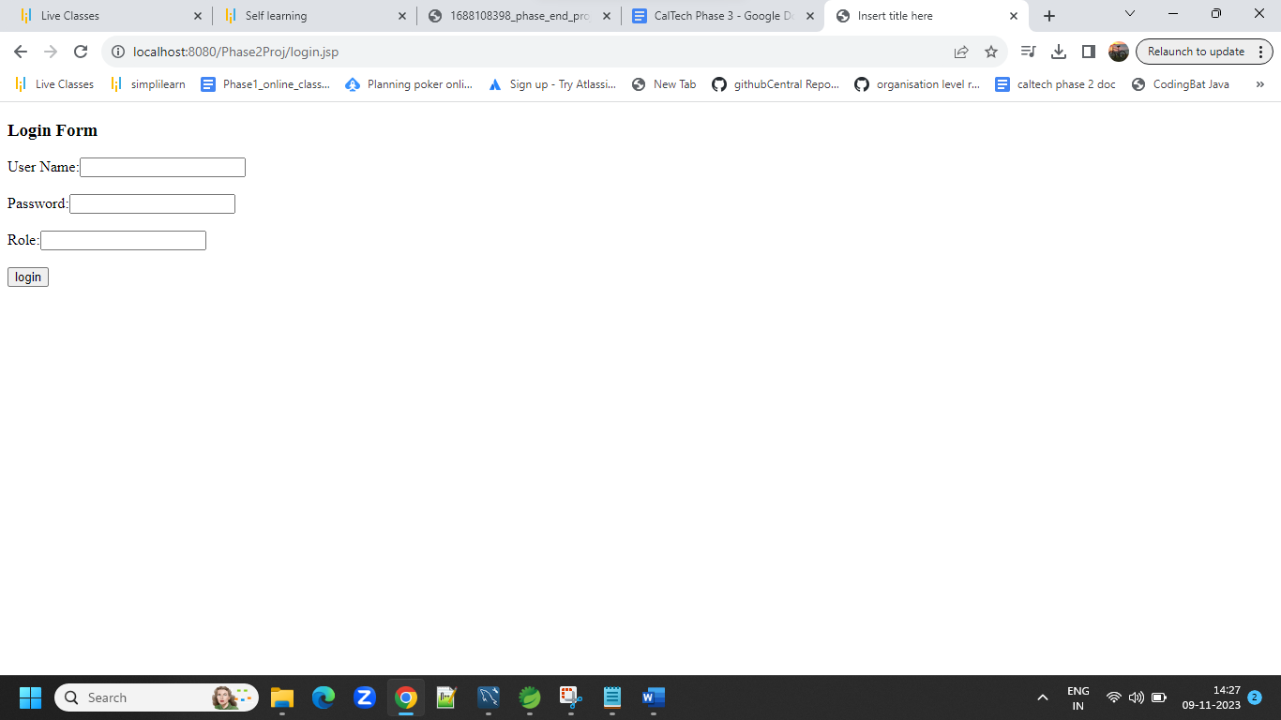

**Admin logins with the credentials ,if the admin is already in the admin table of the database the he/she would be able to login and will see the screen which only the user with admin role could see.**

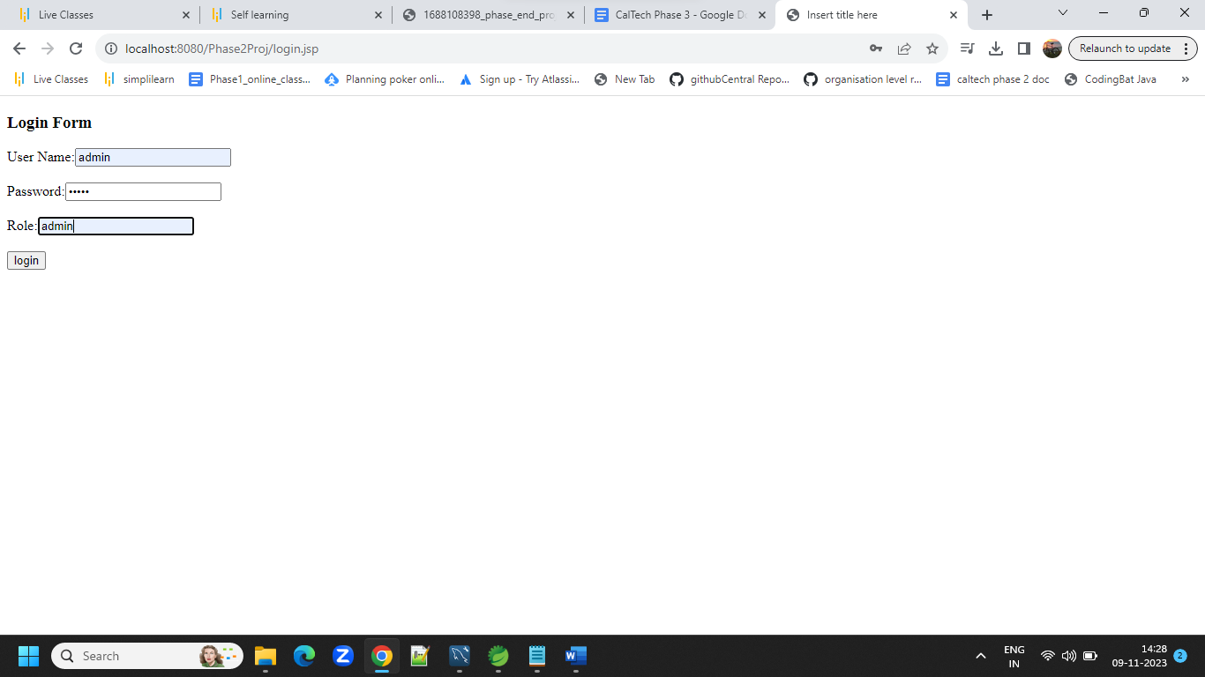

**After successful login the admin would see the following options..**

1. **Show batches**
2. **Show participants**

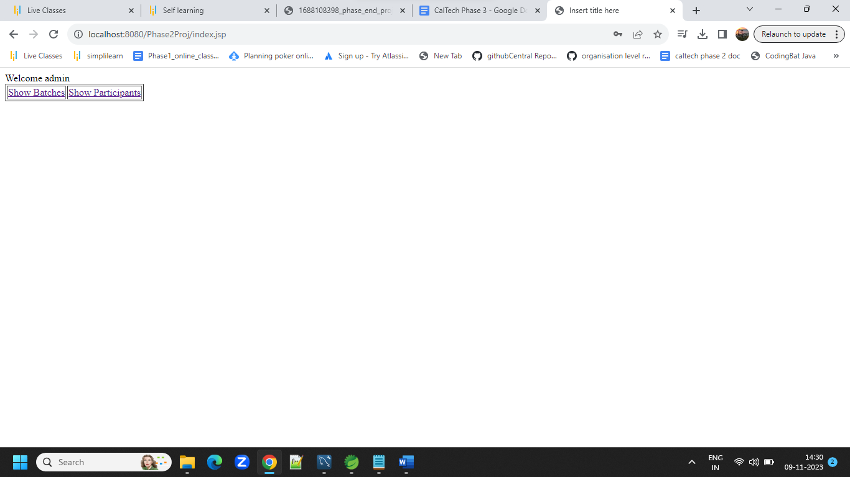

**If the login credentials not matches with the existing admin details in the database then following screen will appear**

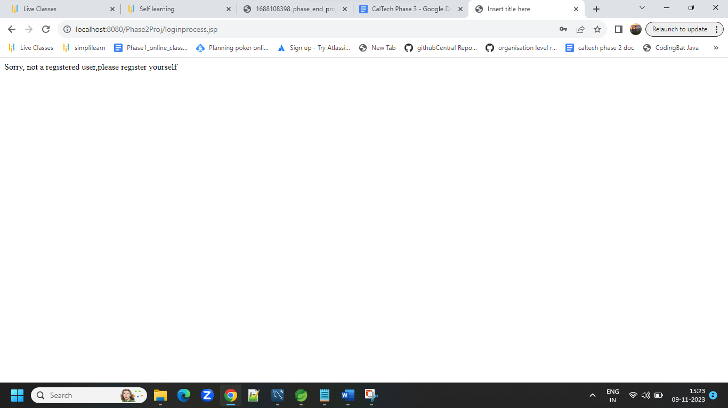

**If admin clicks on show batches ,he/she would see the following screen with add batch option also the option to see the list of batches and option to edit and delete the batches**

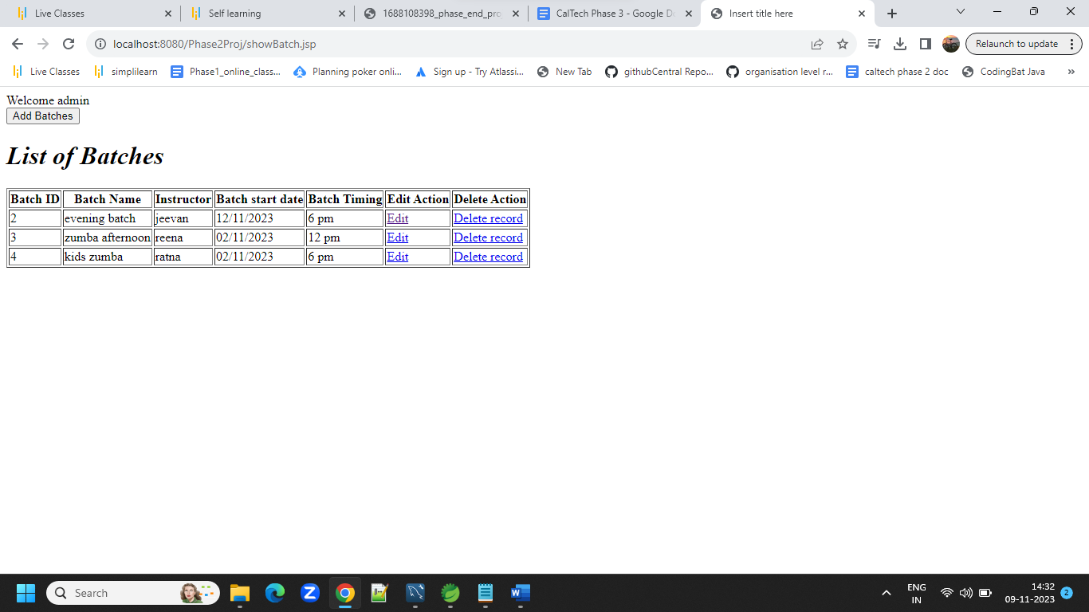

**The database entry before editing**

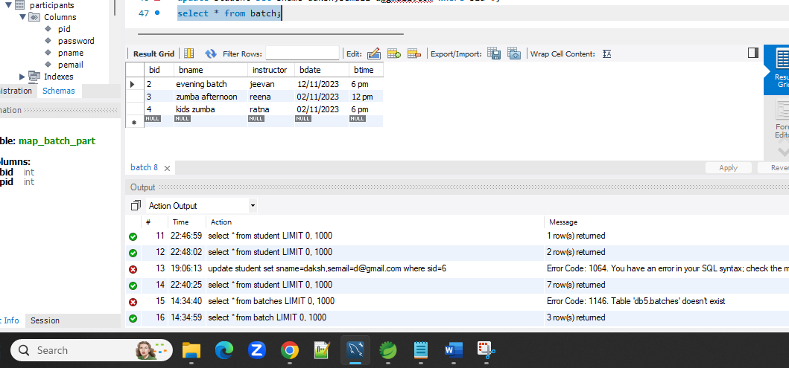

**Edit page after clicking edit link**

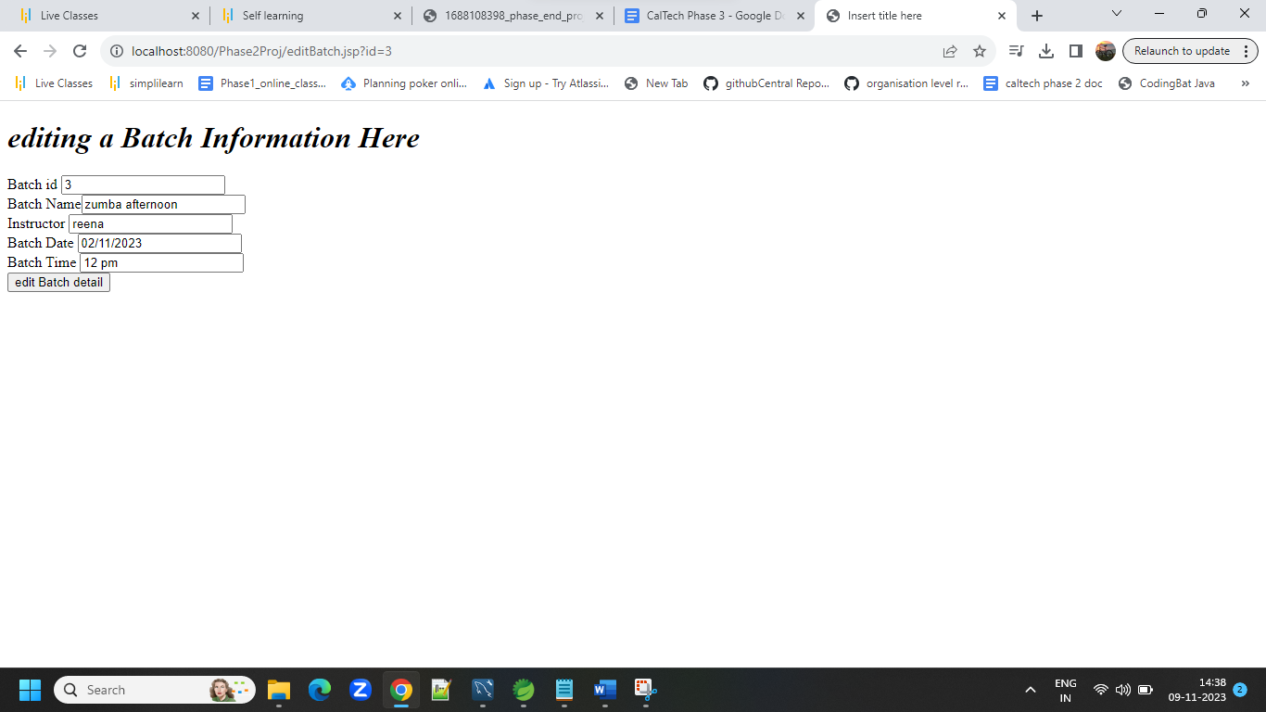

**Record edited with success message**

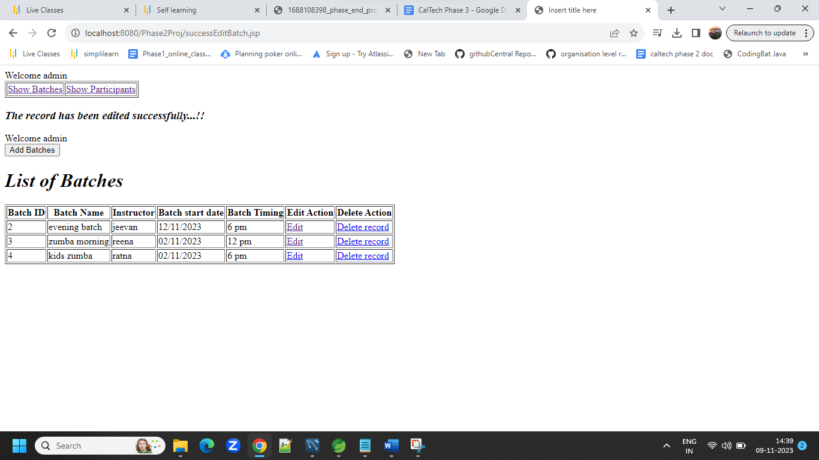

**To create a new batch by admin,he should click on “add batch “ button and he would see the screen below**

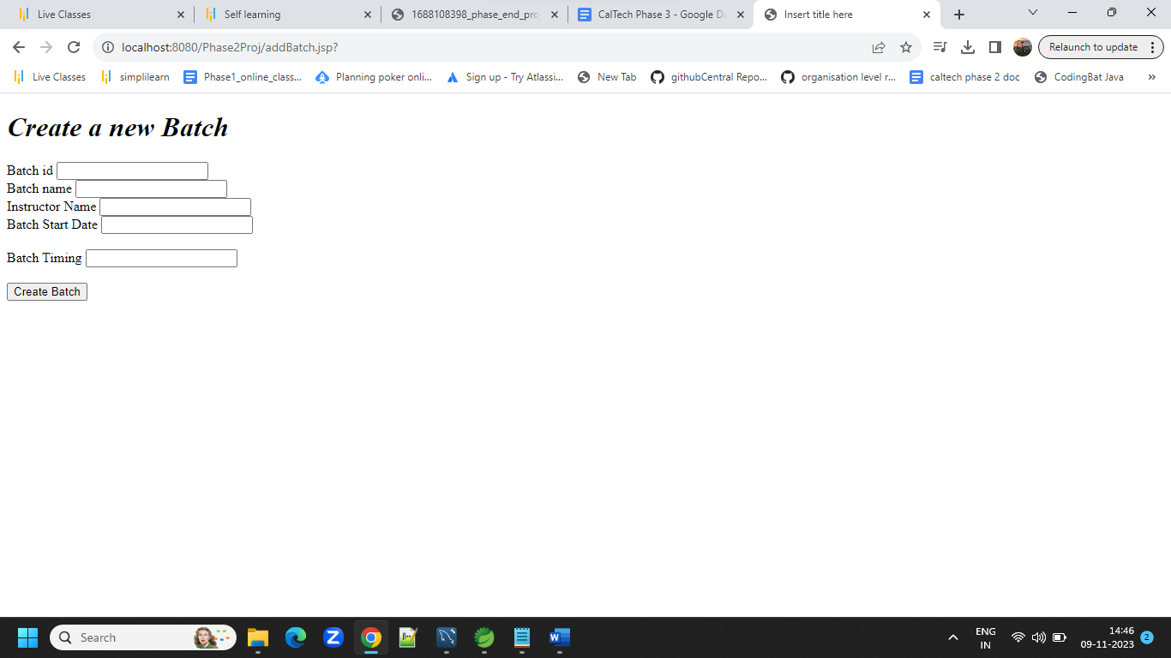

**Batch added successfully screen will come with the list of registred batches**

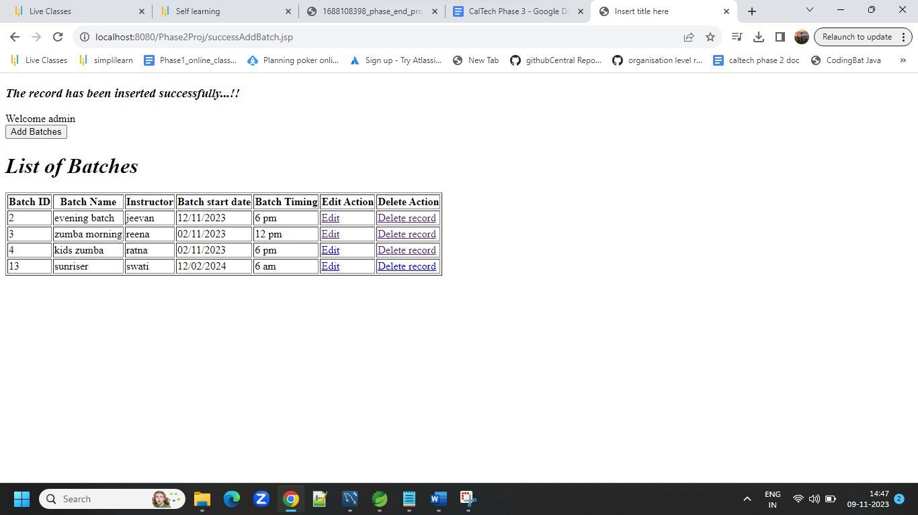

**The batches can be edited and deleted too by clicking the edit and delete link.**

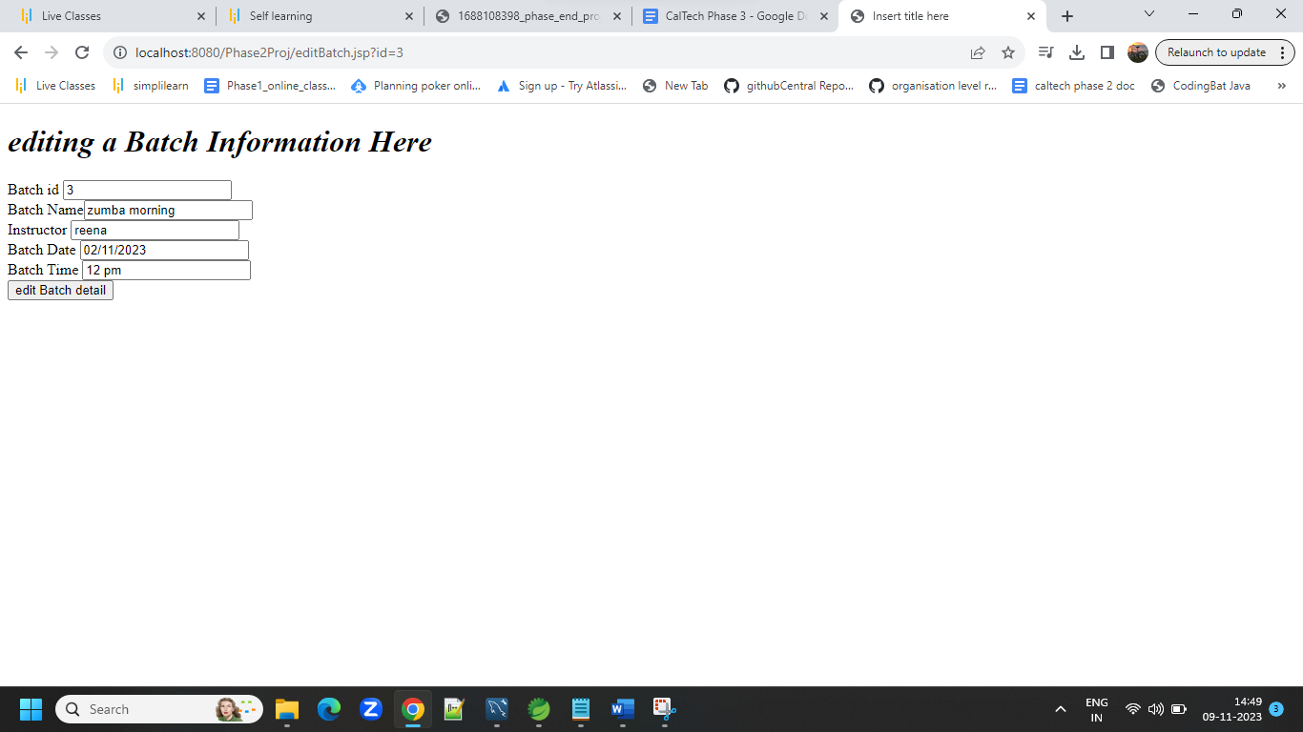

**Respective success screen will come**

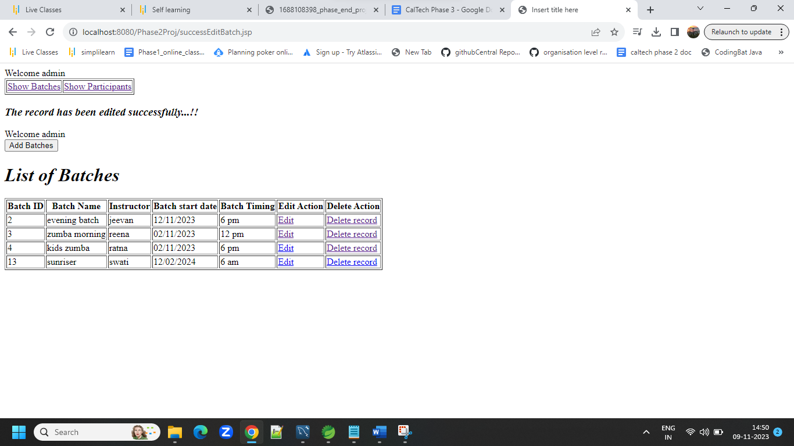

**By clicking on show participants option,following screen would come**

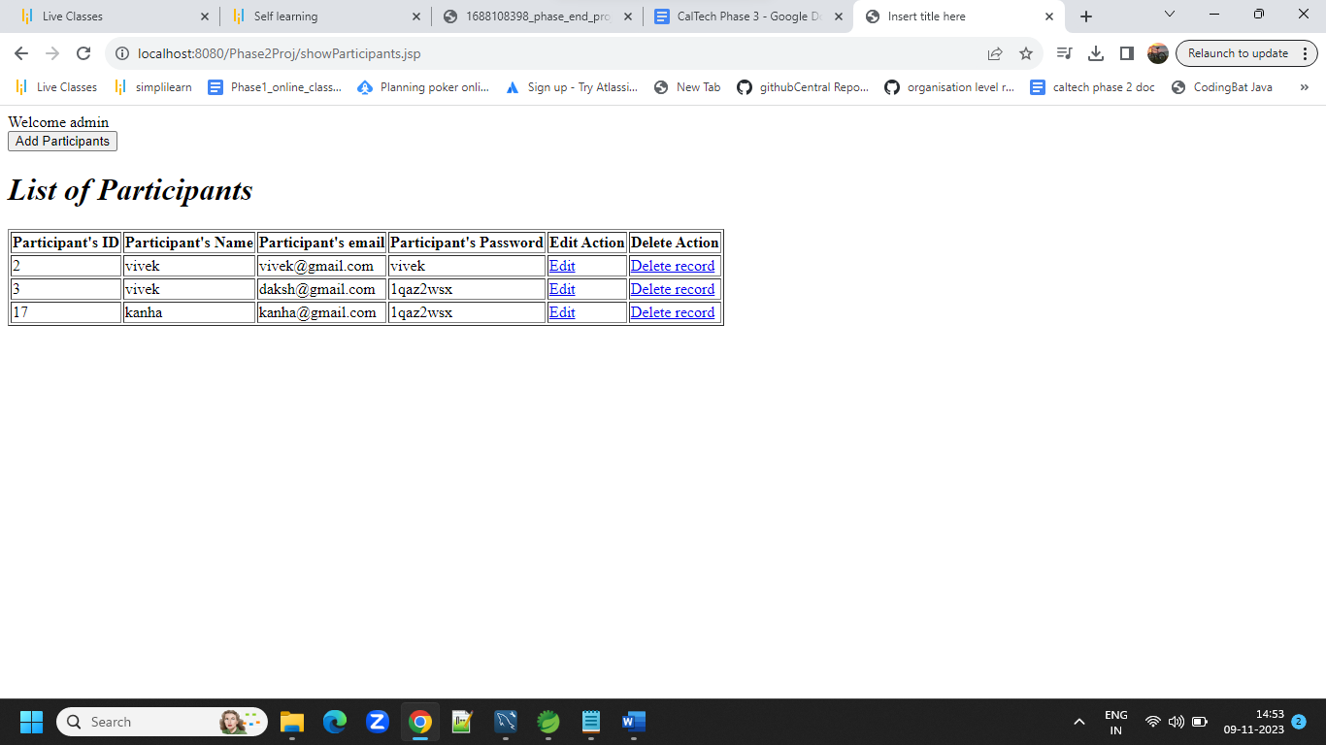

**By clicking on add participant screen the following screen will appear.Prticipant will be added by filling up the form and cling add participant button.**

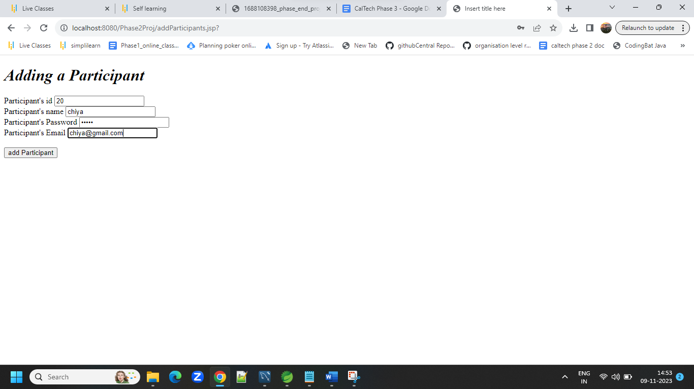

**Add success screen will come with the list of registered participants.**

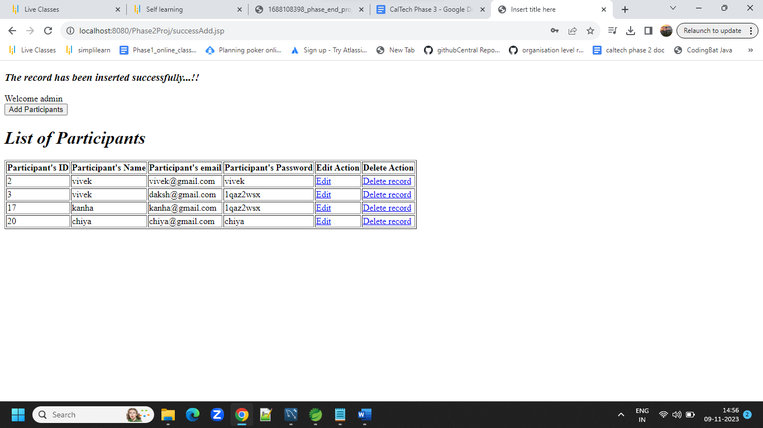

**Admin can edit or delete participant information by clicking on edit or delete link.**

**By clicking on edit, prefilled form will appear and admin can change the participant information and edit it in DB.**

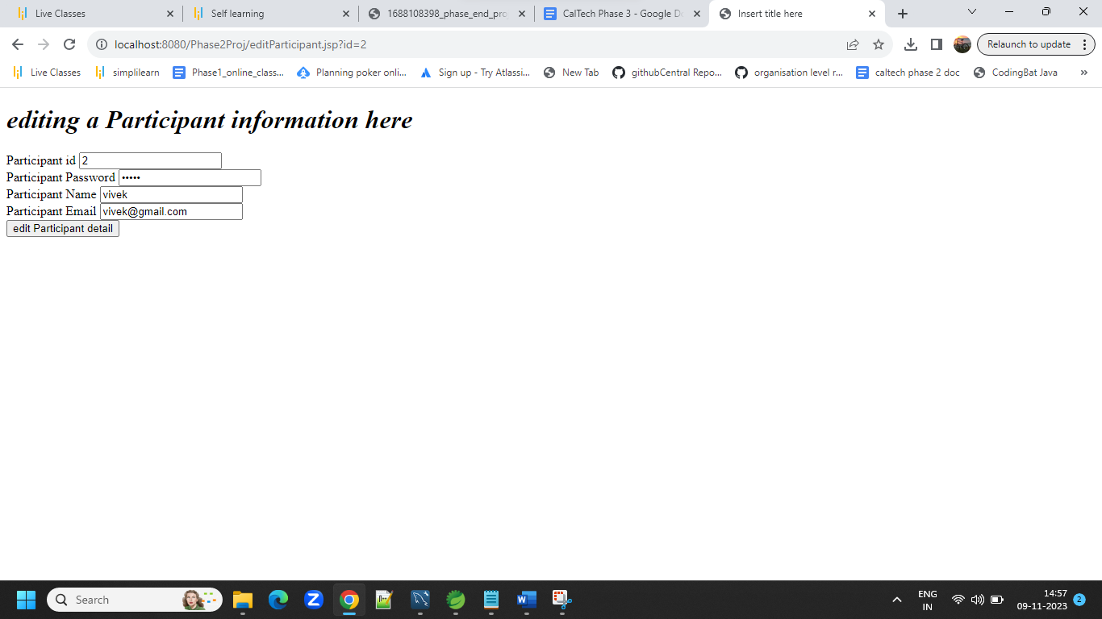

**After making the changes and clicking on edit participant button the list of participant along with the changes made would appear.**

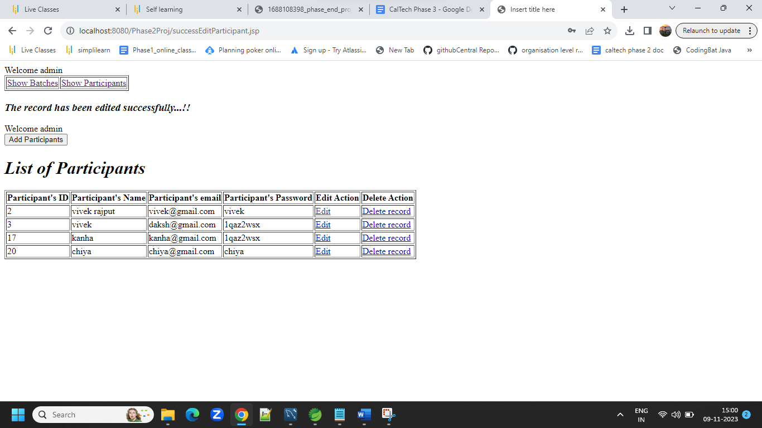

**By clicking on delete link the record will be deleted from the database and success screen will appear.**

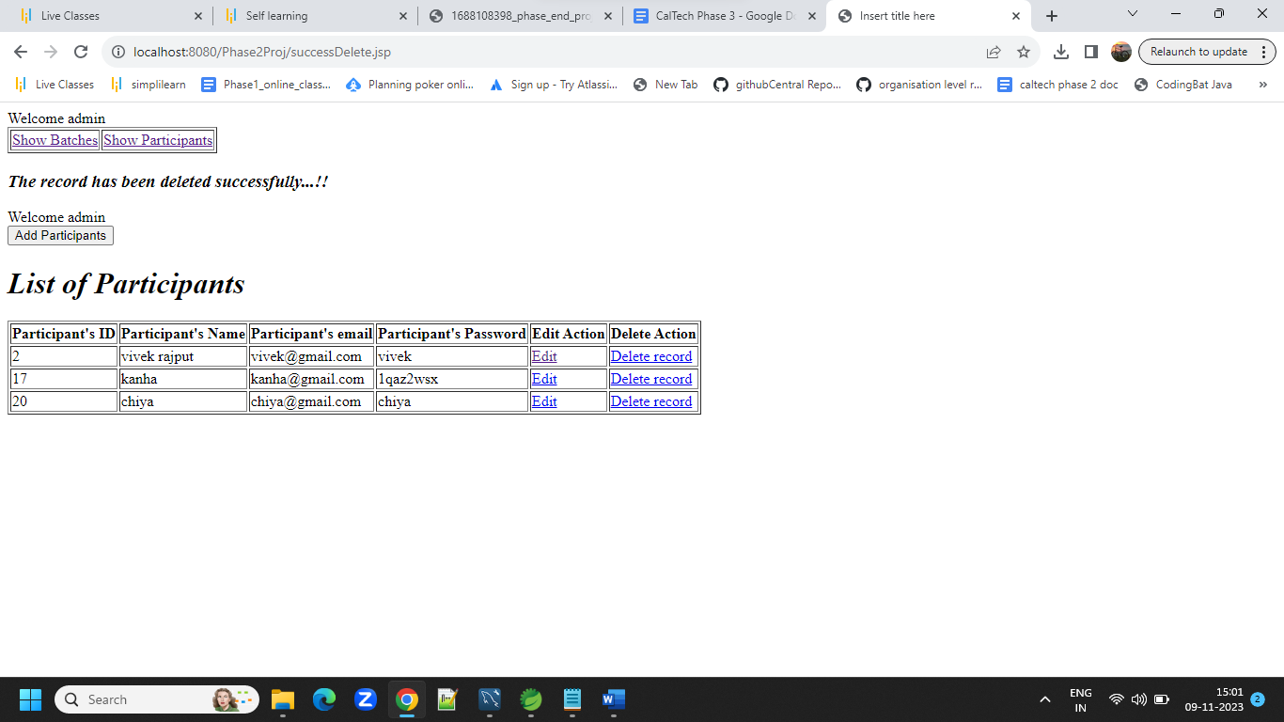

**If the user is participant then he/she would click on login participant link**

**The following login form will appear**

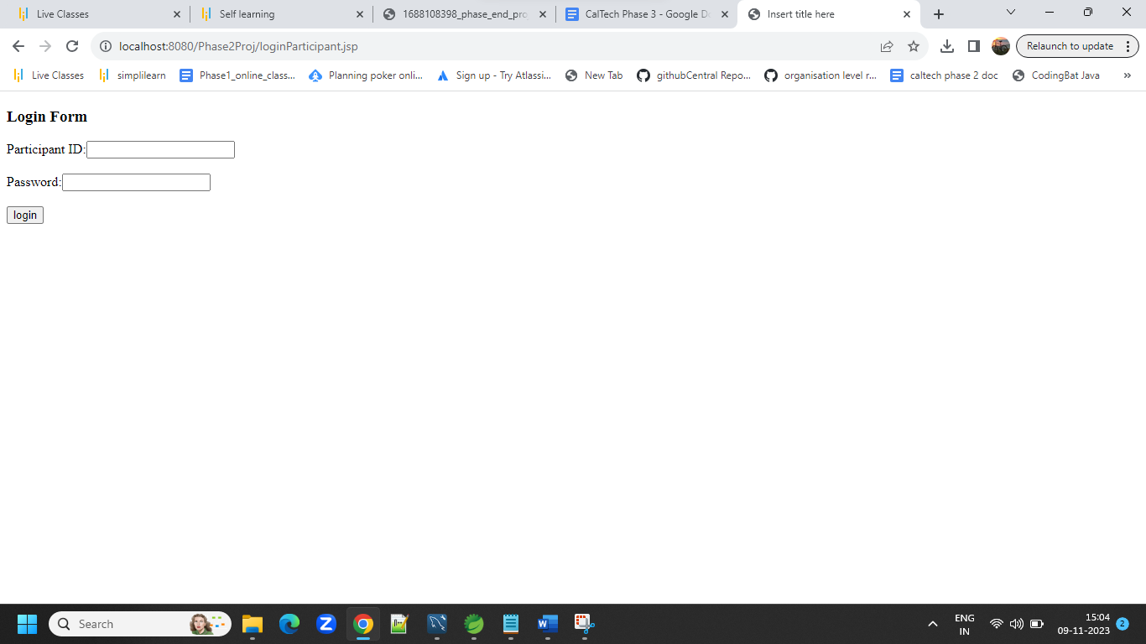

**If the participant is not registered by admin ,he will be notified to register**

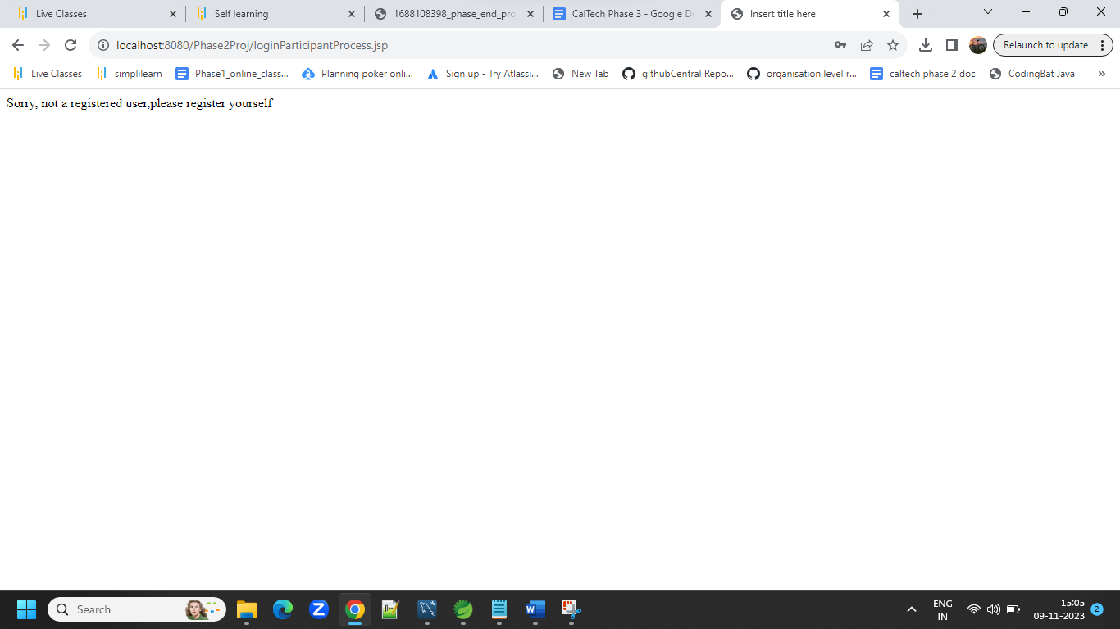

**If Participant is registered then he will see the screen below with the batch information and option to register himself for a particular batch.**

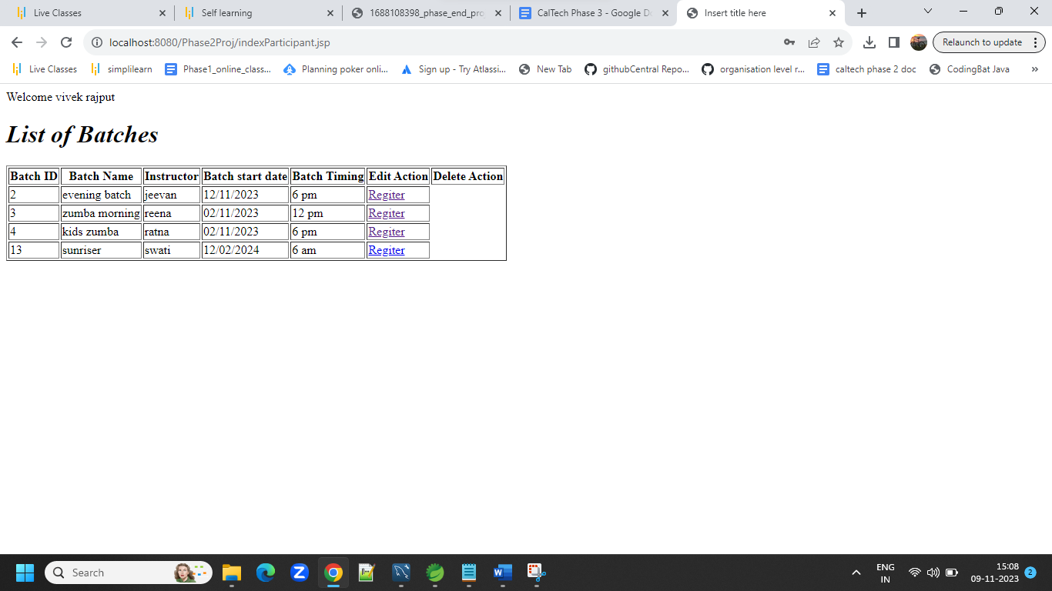

**Once the user is registered for the batch he will see the registered successfully screen.**

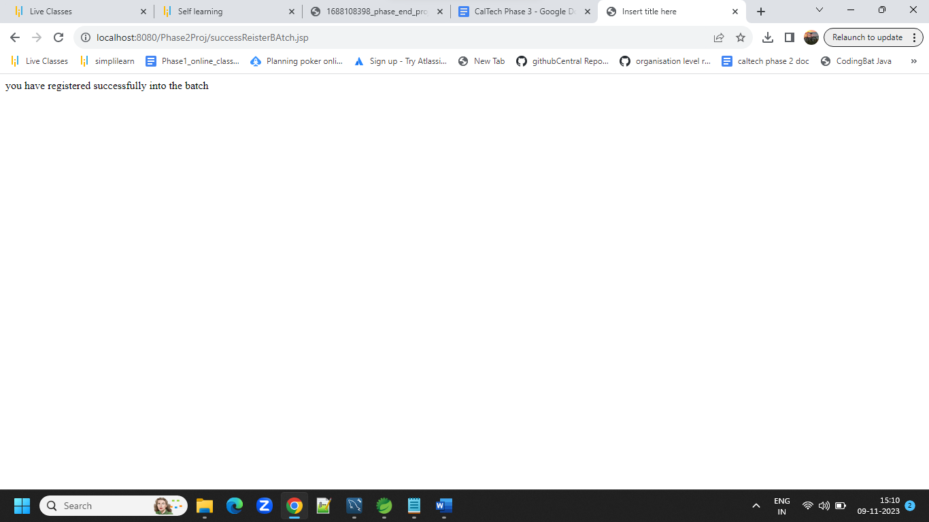

**Table screen**

1. **Participants**

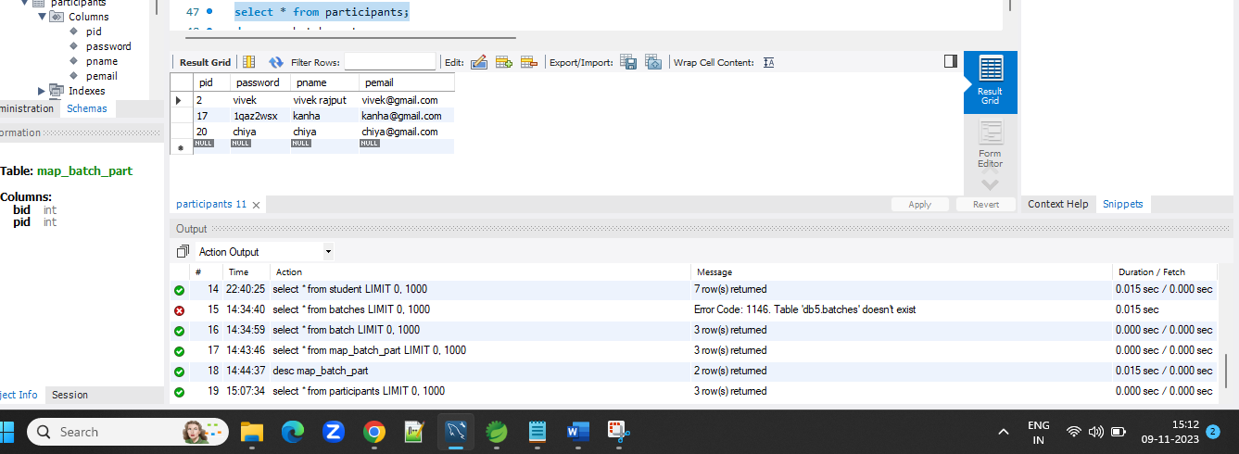

1. **Table map_batch_part**

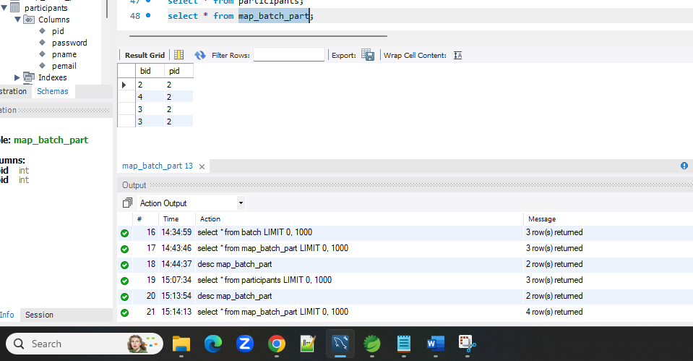

1. **Table batch**

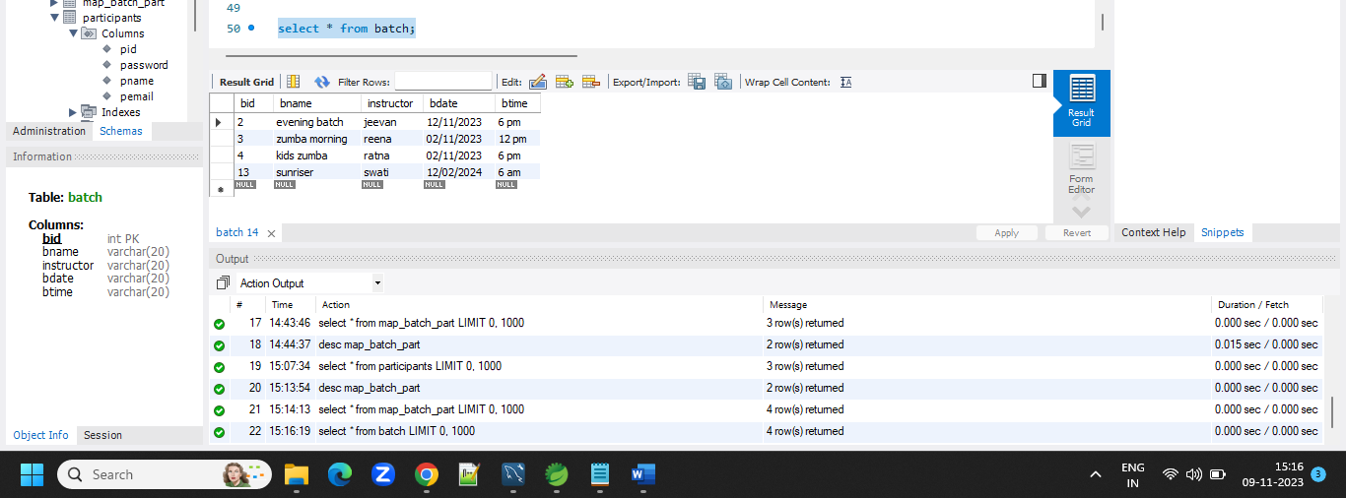

**Table admin**

