**Assignment 1 :- Draw your Home Network Topology and explain how you are accessing RPS Lab environment .**

Answer:-

First we will design a home network topology as follows:

1. Internet Connection: The network typically starts with an internet connection provided by an Internet Service Provider (ISP), such as cable, DSL, Fiber, or satellite.

2. Modem: The internet connection is usually received by a modem, which converts the ISP's signal into one that can be used by our devices.

3. Router: The modem is then connected to a router, which manages the local network and enables communication between devices within the home network and the internet. It assigns IP addresses to devices and directs traffic between them.

4. Wired Devices: Some devices, such as desktop computers, smart TVs, and gaming consoles, may be connected to the router via Ethernet cables for a more stable connection.

5. Wireless Devices: Other devices, like laptops, smartphones, tablets, and smart home devices, connect to the router wirelessly using Wi-Fi.

6. Firewall (Built into Router): The router typically includes a built-in firewall to protect the network from unauthorized access and malicious activity from the internet.

7. Printer and Other Peripherals: Printers, scanners, and other peripherals may also be connected to the network, either via Ethernet or Wi-Fi, making them accessible to all devices on the network.

Accessing the RPS lab from our home network topology involves the following steps :

8. VPN (Virtual Private Network): To access the RPS lab environment securely from home, we might use a VPN connection. A VPN creates a secure, encrypted tunnel over the internet between our device and the RPS lab's network, allowing us to access resources as if we were directly connected to the lab's network.

9. Internet Gateway: The VPN software on the device establishes a connection to the RPS lab's network through an internet gateway provided by the lab. This gateway acts as a bridge between the internet and the lab's internal network, allowing authorized users to access resources remotely.

10. Firewall and Security Measures: Both the home network and the RPS lab's network likely have firewalls and other security measures in place to protect against unauthorized access and ensure the security of data transmitted over the VPN connection.

11. Remote Desktop Protocol (RDP) or similar protocol: Once the VPN connection is established, we can use remote desktop software like Remote Desktop Protocol (RDP) to connect to a virtual desktop or server within the RPS lab's environment. This allows us to interact with applications and data hosted on lab servers as if we were sitting in front of them.

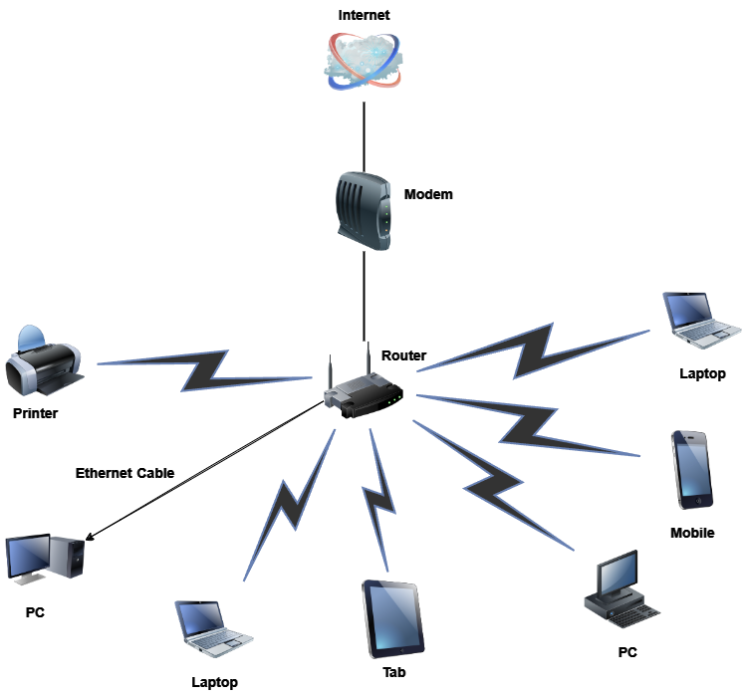

**Assignment 2 :- Identify a real-world application for both parallel computing and networked systems. Explain how these technologies are used and why they are important in that context.**

Answer:-

1. **Parallel Computing:**

Parallel computing refers to the process of breaking down larger problems into smaller, independent, often similar parts that can be executed simultaneously by multiple processors communicating via shared memory, the results of which are combined upon completion as part of an overall algorithm.

* To be run using multiple CPU’s.
* A problem is broken into discrete parts that can be solved concurrently.
* Each part is further broken down to a series of instruction.
* Instruction from each part execute simultaneously.
* Real-world Example :-

Consider a real-life example that people standing in a queue waiting for a movie ticket and there is only a cashier. The cashier is giving tickets one by one to the persons. The complexity of this situation increases when there are 2 queues and only one cashier. The complexity will decrease when there are 2 queues and 2 cashiers giving tickets to 2 persons simultaneously. This is an example of Parallel Computing.

1. **Networked System:-**

Networked systems are essentially interconnected devices or computers that communicate and share resources with each other over a network, like the internet or a local intranet. They enable data sharing, communication, and collaboration among users and devices across different locations.

* + Networked systems connect multiple devices, such as computers, servers, and other hardware, enabling them to communicate and share resources.
  + They utilize standardized communication protocols like TCP/IP to facilitate the exchange of data between connected devices.
  + They also include software components such as operating systems, network protocols, and applications that facilitate data exchange, resource sharing, and network management.
* Real-world Example :-

Just like we check the weather or news online, investors use websites and apps to get info about stocks, companies, and the economy. This helps them make smart decisions about their money.