**Assignment1: SDLC Overview - Create a one-page infographic that outlines the SDLC phases (Requirements, Design, Implementation, Testing, Deployment), highlighting the importance of each phase and how they interconnect.**

**Answer:**

Software Development Life Cycle (SDLC) :-

SDLC is a process that creates a structure of development of software. There are different phases within SDLC, and each phase has its various activities. It makes the development team able to design, create, and deliver a high-quality product.

SDLC describes various phases of software development and the order of execution of phases. Each phase requires deliverable from the previous phase in a life cycle of software development. Requirements are translated into design, design into development and development into testing; after testing, it is given to the client.

Different phases of the software development cycle:

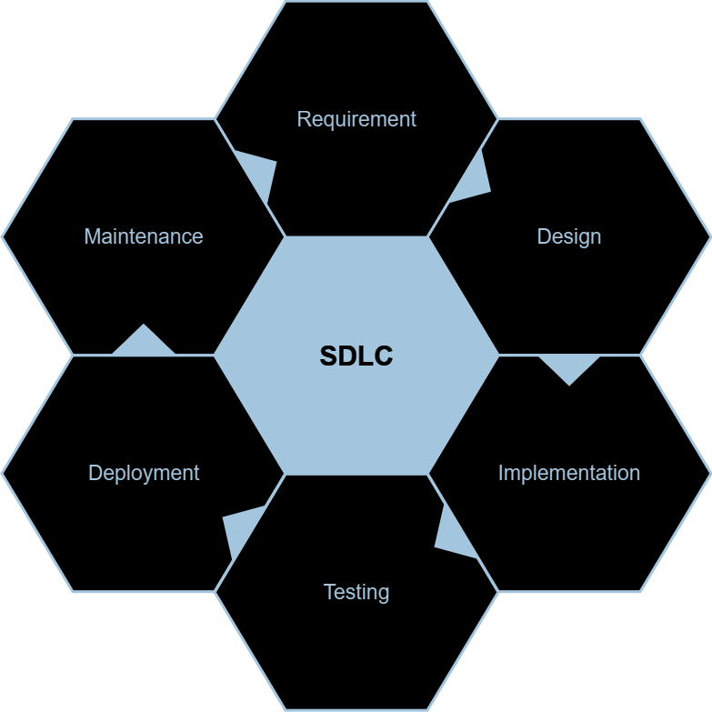

1. Requirement Phase

This is the most crucial phase of the software development life cycle. During this phase, the client states requirements, specifications, expectations, and any other special requirement related to the product or software. All these are gathered by the business manager or project manager or analyst of the service providing company.

1. Design Phase

The design phase includes a detailed analysis of new software according to the requirement phase. This is the high priority phase in the development life cycle of a system because the logical designing of the system is converted into physical designing. The output of the requirement phase is a collection of things that are required, and the design phase gives the way to accomplish these requirements .

1. Implementation Phase

The next phase is to implement the design into the development of a software system. In this phase, work is divided into small units, and coding starts by the team of developers according to the design discussed in the previous phase and according to the requirements of the client discussed in requirement phase to produce the desired result.

1. Testing Phase

Testing is the last step of completing a software system. In this phase, after getting the developed GUI and back-end combination, it is tested against the requirements stated in the requirement phase. Testing determines whether the software is actually giving the result as per the requirements addressed in the requirement phase or not.

1. Deployment Phase

When software testing is completed with a satisfying result, and there are no remaining issues in the working of the software, it is delivered to the customer for their use.

1. Maintenance

The maintenance phase is the last and long-lasting phase of SDLC because it is the process which continues until the software's life cycle comes to an end. When a customer starts using software, then actual problems start to occur, and at that time there's a need to solve these problems. This process to take care of product time to time is called maintenance.

**Assignment 2: Develop a case study analyzing the implementation of SDLC phases in a real-world engineering project. Evaluate how Requirement Gathering, Design, Implementation, Testing, Deployment, and Maintenance contribute to project outcomes.**

**Answer:**

Let's consider a real-world example of a software development project for a new e-commerce platform. We'll analyze how the various phases of the Software Development Life Cycle (SDLC) were implemented and their impact on project outcomes.

1. Introduction to the Project: The project involves developing a new e-commerce platform for a retail company to expand its online presence, improve customer experience, and increase sales.

2. Requirement Gathering Phase: Requirements were collected through stakeholder interviews, market research, and analysis of competitor platforms. Key features identified include user registration, product browsing, shopping cart functionality, secure payment processing, order tracking, and customer support.

3. Design Phase: The requirements were translated into a design for the e-commerce platform, including database schema, user interface wireframes, and system architecture.

4. Implementation Phase: The development team utilized Agile methodologies, to iteratively build the e-commerce platform. Features were developed in short sprints, with continuous integration and deployment practices to ensure rapid delivery of working software.

5. Testing Phase: Testing was performed throughout the development process, with a focus on automated unit tests, integration tests, and user acceptance testing.

6. Deployment Phase: The e-commerce platform was deployed to a cloud-based hosting environment. Continuous deployment pipelines were established to automate the deployment process and ensure consistency across environments. User training sessions were conducted to familiarize stakeholders with the new platform.

7. Maintenance Phase: Post-deployment, the development team continues to monitor and maintain the e-commerce platform. Regular updates are deployed to address user feedback, fix bugs, and improve performance. Customer support channels are established to provide assistance to users and resolve any issues that arise.

8. Outcome and Lessons Learned: The e-commerce platform was successfully launched, resulting in increased online sales and improved customer satisfaction. The Agile approach allowed for flexibility and adaptability to changing requirements, while continuous testing and deployment practices ensured a high-quality product.

By analyzing this real-world example, we can see how the implementation of SDLC phases contributed to the successful delivery of the e-commerce platform and its impact on project outcomes.

**Assignment 3: Research and compare SDLC models suitable for engineering projects. Present findings on Waterfall, Agile, Spiral, and V-Model approaches, emphasizing their advantages, disadvantages, and applicability in different engineering contexts.**

**Answer:-**

Here's a brief analysis of each SDLC model - Waterfall, Agile, Spiral, and V-Model - along with their advantages, disadvantages, and applicability in various engineering contexts:

1. Waterfall Model:

Advantages:

* Clear and structured approach with well-defined phases.
* Easy to understand and manage, making it suitable for small, straightforward projects with stable requirements.
* Emphasizes thorough documentation, which can aid in project traceability and compliance.

Disadvantages:

* Lack of flexibility to accommodate changes in requirements during development.
* High risk of project failure if requirements are not properly understood or change over time.
* Limited stakeholder involvement until the later stages of development.

Applicability:

Suitable for projects with clearly defined and stable requirements, such as building infrastructure systems or hardware projects with fixed specifications.

2. Agile Methodology:

Advantages:

* Iterative and incremental approach allows for flexibility and adaptability to changing requirements.
* Emphasizes customer collaboration and feedback, resulting in a product that better meets user needs.
* Quick delivery of working software in short development cycles (sprints).

Disadvantages:

* Requires active and continuous involvement of stakeholders, which may be challenging in some environments.
* May not be suitable for projects with strict regulatory or compliance requirements.
* Dependency on team cohesion and communication for success.

Applicability:

Ideal for software development projects where requirements are expected to evolve, such as web and mobile applications, and projects requiring rapid prototyping or frequent updates.

3. Spiral Model:

Advantages:

* Emphasizes risk management by addressing potential risks early in the development process.
* Allows for iterative development with opportunities for feedback and refinement.
* Suitable for large, complex projects with high levels of uncertainty or evolving requirements.

Disadvantages:

* Can be resource-intensive due to the need for multiple iterations and risk assessments.
* Complexity in planning and managing the iterative cycles.
* May not be suitable for small or straightforward projects with stable requirements.

Applicability:

Well-suited for projects where risk management is a priority, such as developing safety-critical systems, large-scale software projects, or projects involving cutting-edge technology.

4. V-Model:

Advantages:

* Provides a systematic approach to testing, ensuring thorough validation of each development phase.
* Enhances traceability between requirements and test cases, making it easier to verify compliance.
* Well-suited for projects with strict regulatory or quality requirements.

Disadvantages:

* Can be rigid and inflexible, making it challenging to accommodate changes in requirements.
* Requires detailed planning and documentation, which may increase project overhead.
* Limited stakeholder involvement until the testing phase, which can lead to misunderstandings or misalignments.

Applicability:

Suitable for projects where quality assurance and validation are critical, such as developing medical devices, aerospace systems, or projects with stringent regulatory requirements.

In summary, each SDLC model offers unique advantages and disadvantages, making them suitable for different engineering contexts depending on project requirements, complexity, and risk tolerance. Choosing the right SDLC model involves careful consideration of these factors to ensure successful project outcomes.