**Assignment 1: Create an infographic illustrating the Test-Driven Development (TDD) process. Highlight steps like writing tests before code, benefits such as bug reduction, and how it fosters software reliability.**

Test-driven development(TDD), is a software development process. As the name implies, involves utilizing tests to guide application development, resulting in simple, iterative implementation with good test coverage right from the start.

Test-driven development (TDD) follows a simple, iterative process:

1. Write a Test: Start by writing a test that defines the behavior you want to implement. This test should fail initially since the corresponding code hasn't been written yet.

2. Run the Test: Execute all the tests, including the new one. Since the new test is designed to fail (as there's no corresponding code yet), it should indeed fail.

3. Write the Code: Implement the functionality needed to make the test pass. Focus only on writing the code that's necessary to satisfy the test.

4. Run the Tests Again: Once the code is written, rerun all the tests, including the new one. If the test you just wrote passes, it means the new code behaves as expected.

5. Refactor: With the new functionality in place and passing the test, you can refactor the code to improve its design, readability, or performance. The tests act as a safety net, ensuring that any changes made during refactoring don't break the existing functionality.

6. Repeat: Repeat this process for each new feature or piece of functionality you want to add. Write a failing test, implement the code to make it pass, and then refactor as necessary.

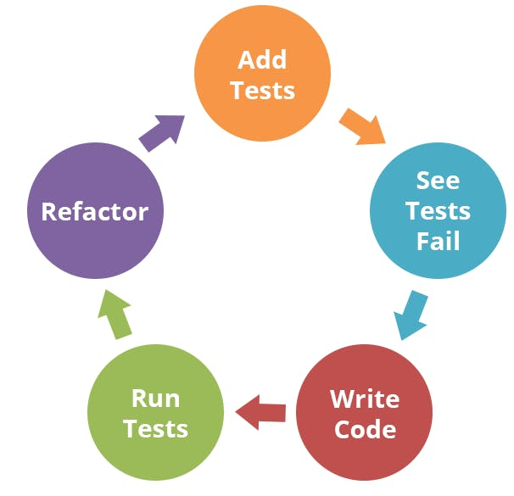

Benefits:

1. Improved Code Quality

By writing tests before the code, developers can focus on the requirements and desired behaviour of the system. This results in cleaner, more robust code with fewer defects, as the tests act as a safety net that catches errors early in the development process.

1. Easier Debugging and Maintenance

When a test fails, it’s much easier to pinpoint the cause of the issue, as the scope of the changes is limited to the most recent iteration. TDD also encourages modular code, which makes it easier to understand, debug, and maintain.

1. Faster Development

Although it might seem counterintuitive, writing tests before the code can lead to faster development in the long run. As bugs are caught and fixed early, less time is spent on debugging and fixing issues later in the development cycle.

1. Better Collaboration and Communication

TDD fosters a shared understanding of the requirements and desired behaviour among team members. Developers, testers, and stakeholders can use the tests as a common language to discuss and refine the system’s behaviour, making collaboration more effective.

1. Easier Refactoring and Code Evolution

With a comprehensive suite of tests, developers can refactor code confidently, knowing that the tests will catch any issues introduced. This encourages a more iterative approach to development, allowing the codebase to evolve and improve over time.

1. Improved Project Estimation and Risk Management

By breaking the development process into small, testable increments, estimating the effort and time required for each feature is more effortless. This allows for better project management and helps mitigate risks associated with scope creep or unexpected complications.

By following this cycle of writing tests, implementing code, and refactoring, developers can iteratively build and improve software while ensuring its correctness and maintainability. This process encourages a focus on small, incremental changes and helps catch bugs early in the development process.

**Assignment 2: Produce a comparative infographic of TDD, BDD, and FDD methodologies. Illustrate their unique approaches, benefits, and suitability for different building a software development contexts. Use visuals to enhance understanding.**

1. Test-Driven Development (TDD):

* Approach:

Write tests before writing code, aiming for minimal code to pass tests.

* Benefits:

Promotes code quality, ensures test coverage, encourages modular design.

* Suitability:

Well-suited for iterative development, agile environments, and projects with changing requirements.

2. Behavior-Driven Development (BDD):

* Approach:

Focuses on behavior rather than implementation details, involves stakeholders in defining behavior through scenarios.

* Benefits:

Enhances communication between stakeholders and development teams, fosters collaboration, ensures alignment with business goals.

* Suitability:

Ideal for projects with complex business logic, customer-facing applications, and teams with diverse skill sets.

3. Feature-Driven Development (FDD):

* Approach:

Divides development into short iterations, focuses on building features incrementally.

* Benefits:

Provides clear guidelines for development, emphasizes feature delivery, enables rapid progress.

* Suitability:

Suitable for large-scale projects, teams with established processes, and projects with well-defined requirements.

Comparison Table:

|  |  |  |  |
| --- | --- | --- | --- |
| Aspect | TDD | BDD | FDD |
| Focus | Test | Behavior | Features |
| Purpose | Validates functionality | Clarifies requirements | Delivers features |
| Workflow | Write test, code,  refactor | Define behavior, implement | Feature list, design, implement |
| Collaboration | Developers, testers | Developers, testers, stakeholders | Cross-functional teams |