IBM AML
TRANSACTION AND FRAUD ANALYSIS
USING POWER BI
STUDENT NAME
SWATI S
REGISTER NUMBER
E25FA046
COURSE
B.COM FINTECH WITH AI
PROJECT REPORT

IBM AML – Transaction and Fraud Analysis Dashboard Using Power BI

1. Introduction
Power BI is a business intelligence platform that helps users organise, analyse and present data through interactive reports and dashboards. In this project, the IBM Anti-Money Laundering (AML) dataset is used to examine banking transactions, account information and fraud alerts.
The key aim is to recognise potentially fraudulent activity, study how transaction values change over time, review account-related information and present useful findings that can support monitoring and financial decision-making.

2. Dataset Overview
Three CSV datasets were imported into a single Power BI project file named IBM AML.pbix. Each dataset provides a different view of the AML activity.
Table | Number of rows | Number of columns | Main fields / information
Accounts | 10,000 | 7 | ACCOUNT_ID, CUSTOMER_ID, INIT_BALANCE, COUNTRY, ACCOUNT_TYPE, IS_FRAUD, TX_BEHAVIOR_ID
Transactions | 1,323,234 | 8 | TX_ID, SENDER_ACCOUNT_ID, RECEIVER_ACCOUNT_ID, TX_TYPE, TX_AMOUNT, TIMESTAMP, IS_FRAUD, ALERT_ID
Alerts | 1,719 | 9 | ALERT_ID, ALERT_TYPE, IS_FRAUD, TX_ID, SENDER_ACCOUNT_ID, RECEIVER_ACCOUNT_ID, TX_TYPE, TX_AMOUNT, TIMESTAMP

3. Steps Involved

Step 1: Importing the Dataset
- Launch Power BI Desktop and import the Accounts, Transactions and Alerts CSV files.
- Save the report as IBM AML.pbix.
- Review the imported tables in Data View and Model View to confirm that the data has loaded correctly.
- Identify key fields: identifier columns such as ACCOUNT_ID, TX_ID and ALERT_ID; category columns such as ALERT_TYPE, TX_TYPE and IS_FRAUD; numeric columns such as TX_AMOUNT and INIT_BALANCE; and the TIMESTAMP field.

Step 2: Data Inspection and Cleaning
- Open Power Query Editor and check the structure and quality of each table.
- Promote the first row to column headers and assign suitable data types, including whole number, text, decimal number and True/False.
- Standardise the ALERT_TYPE values in the Alerts table by replacing 'cycle' with 'CYCLE' and 'fan_in' with 'FAN_IN'.
- Run validation checks to identify missing values, duplicate identifiers, unusual amounts and inconsistent data types.
Validation check | Observation / action
Blank or null Accounts[ACCOUNT_ID] | No missing values; all 10,000 account IDs are populated and unique.
Duplicate Transactions[TX_ID] | No duplicate transaction IDs were found.
Transactions[ALERT_ID] = -1 | 1,321,515 rows contain -1. This represents transactions for which no alert was raised, so the value was retained.
Repeated ALERT_ID values in Alerts | Repeated values are acceptable. The 1,719 alert rows contain 391 distinct ALERT_IDs because a single alert may relate to multiple transactions.
Negative amounts or balances | No negative values were identified. INIT_BALANCE ranges from 100 to 599.60.
Unusually high transaction amounts | 15,911 transactions exceed 1 million. Of these, 3,053 equal 21,474,836.47, which may represent a system-imposed maximum value.
IS_FRAUD data type | The field is stored as True/False in all three tables.
TIMESTAMP field | Retained as a numeric field, with values ranging from 0 to 199.

The COUNTRY field (US), ACCOUNT_TYPE field (I) and TX_TYPE field (TRANSFER) each contain only one distinct value. Therefore, they provide limited value for comparing categories within this particular dataset.

Step 3: Establishing Table Relationships
The following relationships were configured through the Manage Relationships option:
From | To | Relationship | Cross-filter direction
Accounts[ACCOUNT_ID] | Transactions[SENDER_ACCOUNT_ID] | One-to-many (Active) | Single
Accounts[ACCOUNT_ID] | Transactions[RECEIVER_ACCOUNT_ID] | One-to-many (Inactive) | Single
Transactions[TX_ID] | Alerts[TX_ID] | One-to-many (Active) | Both

The sender-account relationship is active, while the receiver-account relationship is inactive because Power BI allows only one active relationship between the same pair of tables in this model. The Transactions-to-Alerts relationship uses bidirectional filtering so that the Alert Type slicer from the Alerts table can filter the related transaction visuals.

Step 4: Creating DAX Measures
DAX (Data Analysis Expressions) measures were created to calculate the main indicators required for the dashboard.
Measure | DAX expression | Calculated result
TOTAL TRANSACTION AMOUNT | SUM(Transactions[TX_AMOUNT]) | 153,479,506,204.98 (153.48bn)
Total Transactions | COUNT(Transactions[TX_ID]) | 1,323,234
Total Accounts | DISTINCTCOUNT(Accounts[ACCOUNT_ID]) | 10,000
Average Transaction Amount | AVERAGE(Transactions[TX_AMOUNT]) | 115,988.18
Total Initial Balance | SUM(Accounts[INIT_BALANCE]) | 2,801,186.33
Fraudulent Transactions | CALCULATE(COUNT(Transactions[TX_ID]), Transactions[IS_FRAUD] = TRUE()) | 1,719

The measures were formatted according to their purpose. Transaction amounts were displayed as decimal or currency-style values, while transaction and account counts were formatted as whole numbers.

Step 5: Designing the Dashboard
A report page titled AML TRANSACTION AND FRAUD ANALYSIS was created. A bold heading was placed at the top, followed by KPI cards and charts.
Visualisation | Fields / configuration | Purpose
Four KPI cards | Fraudulent Transactions; Total Transactions; Total Transaction Amount; Total Accounts | Display the main indicators at a glance.
Transaction Volume upon Timestamp – line chart | X-axis: TIMESTAMP; Y-axis: TOTAL TRANSACTION AMOUNT | Shows how the overall transaction value changes across the timeline.
Transaction Distribution by Fraud Status – donut chart | Legend: IS_FRAUD; Values: Total Transactions | Compares the number of fraudulent and non-fraudulent transactions.
Fraudulent Transactions Volume upon Timestamp – line chart | Same axes as the transaction line chart; visual filter: IS_FRAUD = True | Highlights the transaction pattern for records marked as fraudulent.
Alert by Alert Type – clustered bar chart | Y-axis: ALERT_TYPE; X-axis: count of ALERT_ID | Compares alert records across CYCLE and FAN_IN categories.
Total Transaction Value by Fraud Status – column chart | X-axis: IS_FRAUD; Y-axis: TOTAL TRANSACTION AMOUNT | Compares the transaction value associated with each fraud status.

Dashboard Screenshot
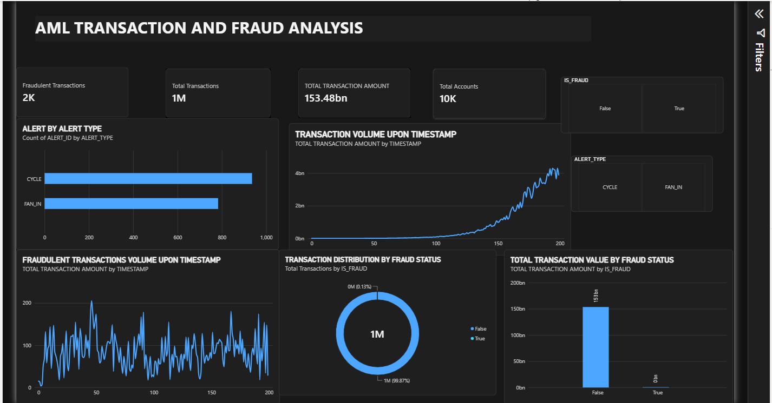
Figure 1: IBM AML Transaction and Fraud Analysis dashboard created in Power BI.

Step 6: Building an Interactive Dashboard
- Duplicate the original AML Transaction and Fraud Analysis report page.
- Rename the copied page as Interactive AML Dashboard.
- Keep the first dashboard unchanged as the main summary page.
- Arrange the KPI cards in a single row at the top, place the charts underneath and position the slicers on the right for easier navigation.

Step 7: Adding Slicers
Slicer | Field used | Function
Fraud Status | Transactions[IS_FRAUD] | Filters the report to show fraudulent or non-fraudulent transactions.
Alert Type | Alerts[ALERT_TYPE] | Filters the report by CYCLE or FAN_IN alert category.

The slicers make it possible to explore the dashboard by selecting a fraud status, an alert category or a combination of both.

Step 8: Reviewing Visual Interactions
- Select the Fraud Status slicer and open Edit Interactions from the Format options.
- Review the interaction setting for each visual.
- Use Filter where a visual should respond to the slicer and None where it should remain unaffected.
- Repeat the check for the other slicer to ensure that the report behaves as intended.

Step 9: Creating a Tooltip Page
- Add a new report page and name it AML Tooltip.
- In the page-format settings, set the page type to Tooltip and enable Allow use as tooltip.
- Place three card visuals on the page: Total Transactions, Total Transaction Amount and Fraudulent Transactions.
- Return to Interactive AML Dashboard and select the Transaction Volume upon Timestamp line chart.
- Enable the report-page tooltip option and select AML Tooltip.
After this setup, hovering over the transaction trend chart displays the tooltip page with the three additional measures, providing more context without leaving the dashboard.

Step 10: Applying a Power BI Theme
From the View ribbon, open the Themes menu and select the built-in Divergent theme. This theme applies a coordinated colour palette, Trebuchet MS typography and a light-grey background. Its contrasting red and green shades can help draw attention to differences and risk-related information.

4. Key Findings
Indicator | Fraudulent transactions | Non-fraudulent transactions
Number of transactions | 1,719 (0.13%) | 1,321,515 (99.87%)
Total transaction value | 16,783.13 | 153,479,489,421.85
Average transaction value | 9.76 | 116,139.04

- Fraud cases form a very small share of the dataset. Only 1,719 out of 1,323,234 transactions (approximately 0.13%) are marked as fraudulent. However, fraudulent records appear across all 200 timestamps, with between 1 and 17 such transactions at each timestamp.
- The value of each flagged fraudulent transaction is comparatively low. The recorded amounts range from 2.54 to 19.92. As a result, the fraudulent amount is barely visible beside the non-fraudulent amount in the total-value chart. This indicates why transaction counts and behavioural patterns should be reviewed alongside monetary value.
- A small number of very large transactions strongly influence the overall average. The mean transaction amount is approximately 115,988, while the median is 156.71. This difference is largely associated with the 3,053 transactions recorded at 21,474,836.47. The total transaction value reaches a peak near the end of the timeline, at timestamp 198, at approximately 4.31bn.
- The alert records are divided into two categories: 936 CYCLE records and 783 FAN_IN records. According to the dataset analysis, every transaction marked as fraudulent is associated with an alert.

5. Conclusion
This project provided practical experience in using Power BI to analyse anti-money laundering data. The work involved importing and checking datasets, cleaning selected fields, creating table relationships, writing DAX measures and presenting results through KPI cards, charts, slicers and report-page tooltips.
The dashboard makes it easier to examine transaction values, fraud classifications and alert categories. The analysis also demonstrates that fraudulent transactions are very limited in number and value compared with normal transactions. Therefore, effective monitoring should not depend only on total transaction value; transaction frequency, unusual patterns and alert information are also important. Overall, the project shows how data visualisation can support the identification of suspicious activity and improve the quality of financial monitoring and decision-making.

