**Project Report On: Data Visualization**

**Project Title: Promotional Strategy for a Bakery Industry**

**Contents:**

1. **Introduction**
2. **Abstract**
3. **Survey on Problem**
4. **Sample Input and Sample Output**

**Introduction**

In today’s world the bakery industry is a huge business. Bakery products are food items which generally includes biscuits ,cakes ,pastries ,muffin ,bread, tea, coffee. These products are rapidly gaining popularity due to its taste and health benefits as they are made up of grains such as rye,maize,wheat,oats some other ingredients which adds taste to it include baking soda,powder,nuts and additives.

**Abstract**

Our goal will be to increase the total quantity of items sold for customers already at our bakery location. We want to increase volume and revenue of our production that also will have fixed cost and stable working hours which means we will increase the sales of higher selling items to the existing customers which will results in profit as more cost will be covered with no additional labour, hours and space. For this we would require the revenue and profitable data so that we can analysis the impact on profitability of the strategy.

**Survey on problem**

1. Bakery products make 2.1% GDP and generates more than $30 billion in revenue every year which includes 6,000 retail bakeries and nearly 3,000 commercial bakeries. Retail bakeries generate around $3 billion in revenues, and commercial bakeries $31 billion.
2. After all this we found that the size of the market for baked goods is expected to grow around 1% per annum in the last decade which is very poor growth rate for the bakery industry .So we have concluded that this industry is not growing and facing loses
3. Due to rising prices of wheat and sugar and other raw materials such as oil, fat and eggs profits is less. These industries cannot raise price because this may lead to decrease in consumption of bakery products which may cause major loss to the industries and even wastage of raw material and this raw material cannot be kept in a stock for longer time.
4. Government also put some regulations on these industries heavy charges and taxes applied on these bakery products . The Environmental Protection Agency and the Food and Drug Administration are constantly issuing new regulations that increase the costs of production and thus the industries are not able to gain profits on their products.
5. Consumers are becoming more health conscious and they demand for sugar free products and zero carbohydrates,and diet products due to which more ingredients are included and cost of production got raised but they cant raise the cost of their products because this may leads to loss customers
6. Sixty-five percent of all bakeries have less than 10 employees and44 percent have one to four employees, and most small retailers only have one facility.
7. Consumption is affected by changes in disposable income, consumer preferences and economic conditions.
8. Large commercial bakeries will continue to dominate the competition in the market, because the other firms are small and the market is highly fragmented.

**Sample input and Sample Output**

* Our dataset of a bakery products

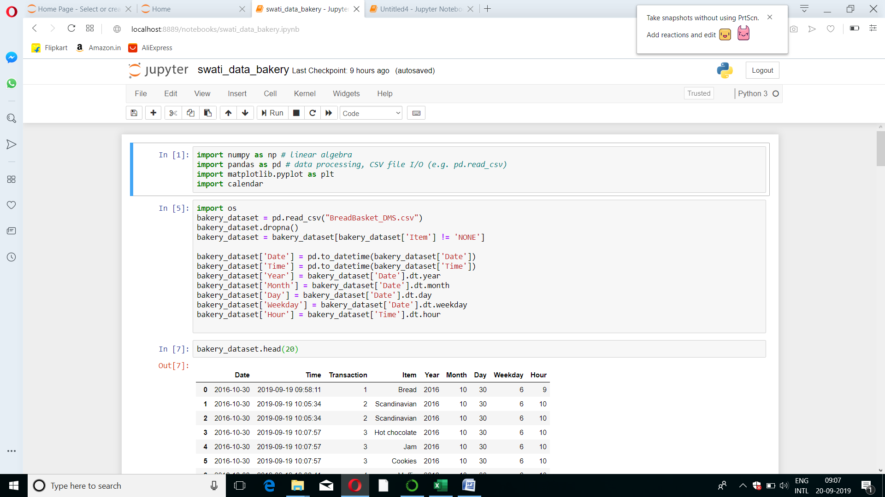

Context which we have on data is its transaction data from a bakery.It will have fields for Date,Timestamp and items purchased.

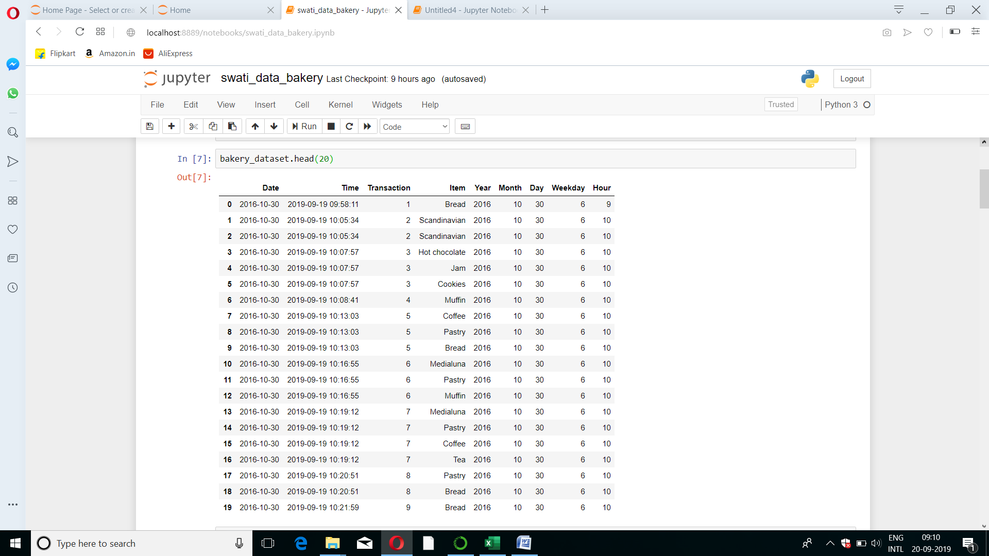

* Most popular items which is visualized

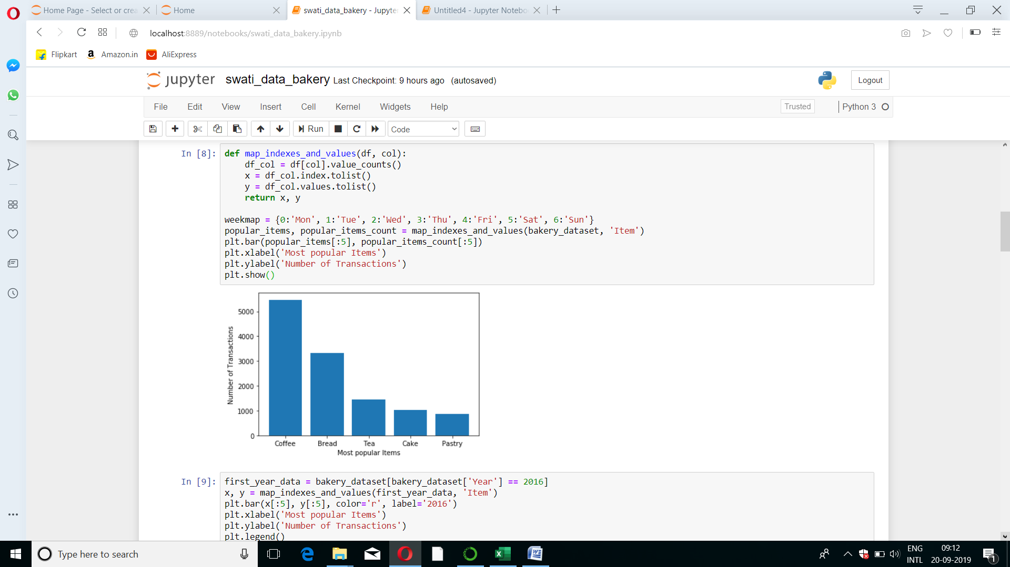

* The above helps inform analyses by giving us the knowledge of most popular items.
* In this graph we have analysed that there are five major items of bakery industry namely Coffee, which is most popular among others items.
* With this graph we have analysed that coffee is having maximum production in bakery .So we need to increase production of Coffee at most.

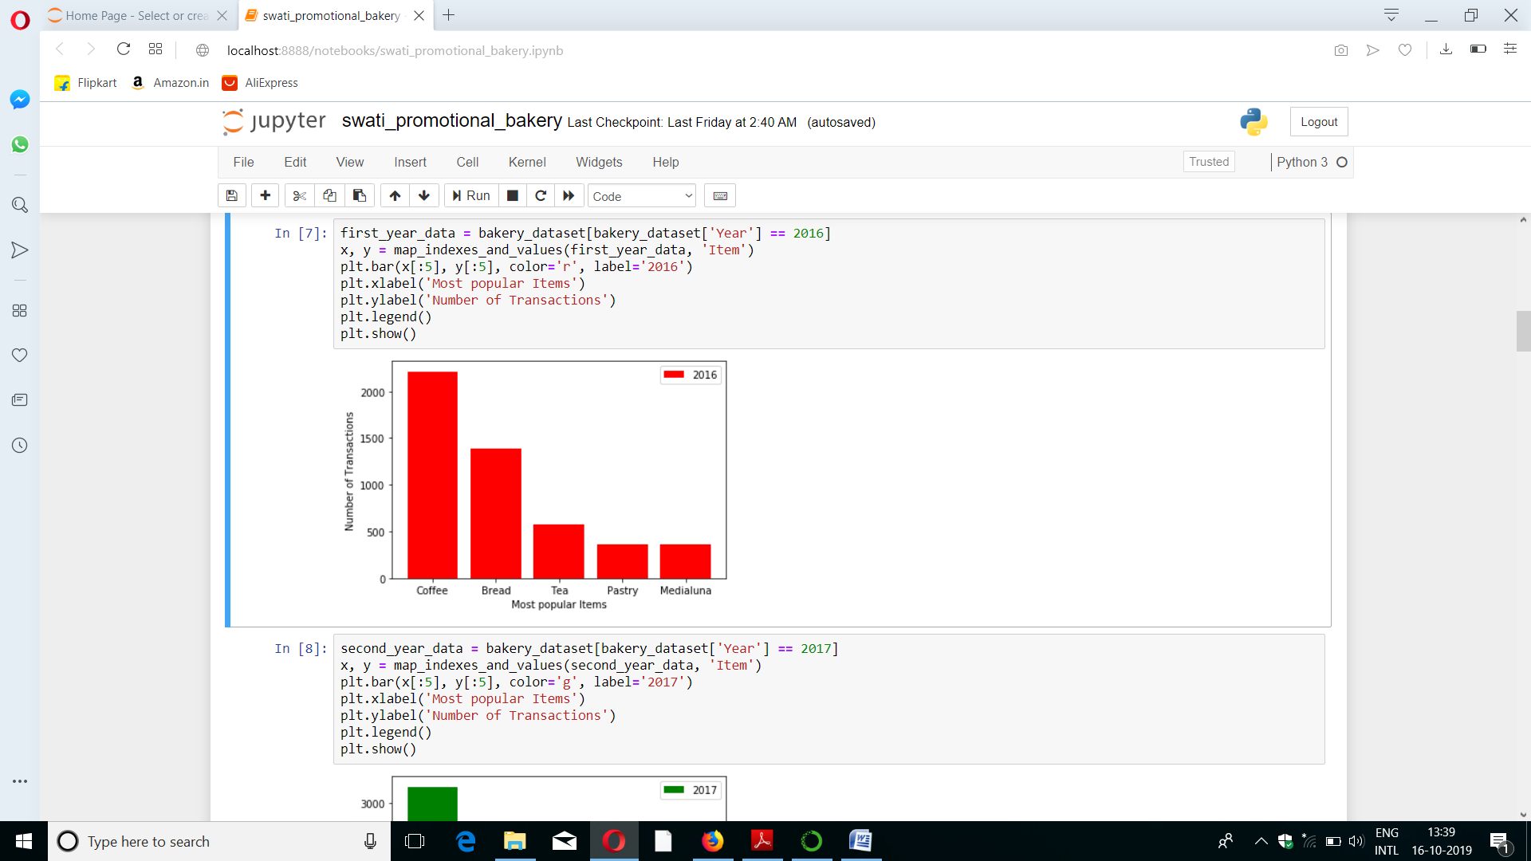 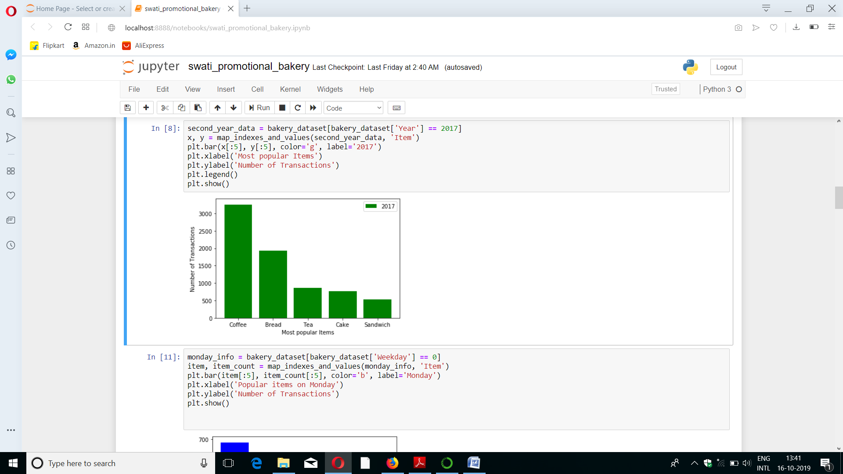

Now with this we will compare both the graph 2016 bakery data and 2017 bakery data. From both the graph we analysed that after 2016 in the year 2017 there is no change in bakery industry.

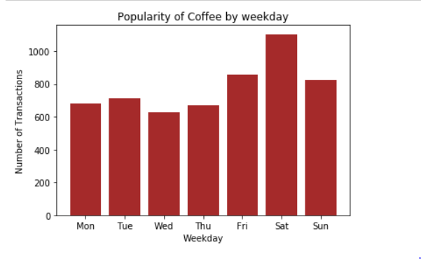

Weekly production of the coffee .

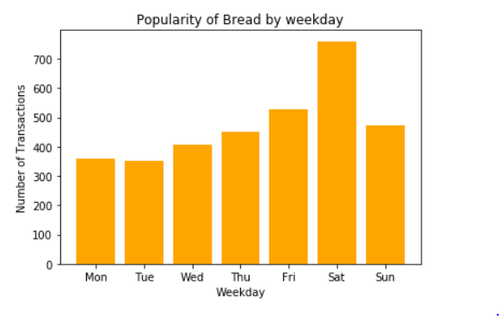

Weekly production of the Bread.

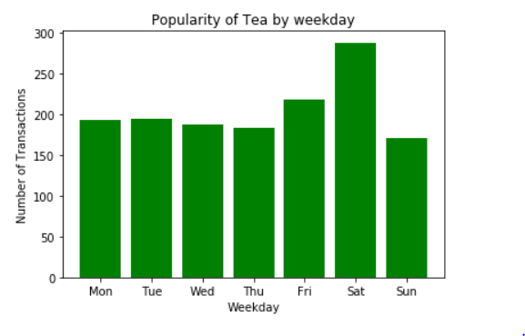

Weekly production of the Tea.

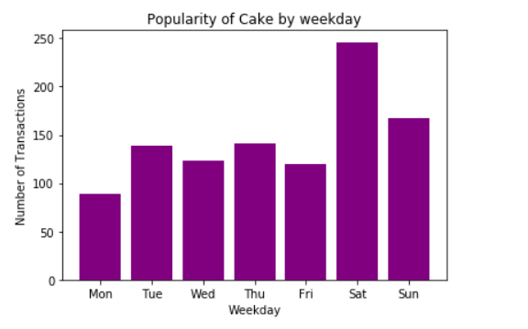

Weekly production of the Cake.

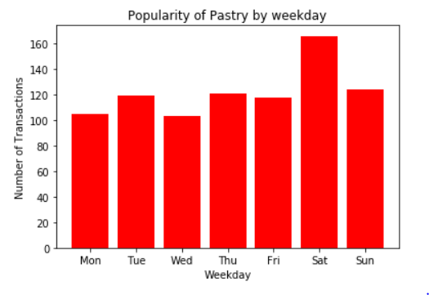

Weekly production of the Pastry.

**Conclusion:**

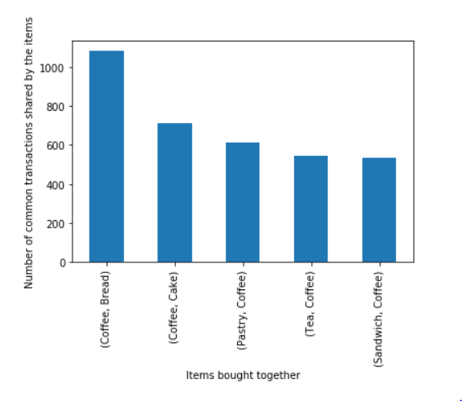

We have analysed all the products which are popular and customer usually preferred coffee with all other items. Such as coffee with bread and second priority coffee with cake, third is pastry with coffee and fourth tea with coffee and fifth preferred is sandwich with coffee.

From this we have concluded that bread is the highest sold item with coffee so with this conclusion we will increase the production of bread with the coffee.

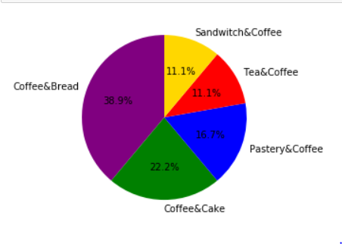

We have came to a conclusion through our analysis that we need to increase the above estimated percentage of production coffee with bread 38.9%, coffee with cake 22.2%,pastery with coffee 16.7%,tea with coffee 11.1 % and coffee with sandwich 11.1%to achieve the required GROWTH of the company.