**Swati Kadivar**

**Homework2**

**Q1-3 code is listed at address 0x000000000, 0x000000002, and 0x000000004**

**Q1-4 Keil snippet : after reset**

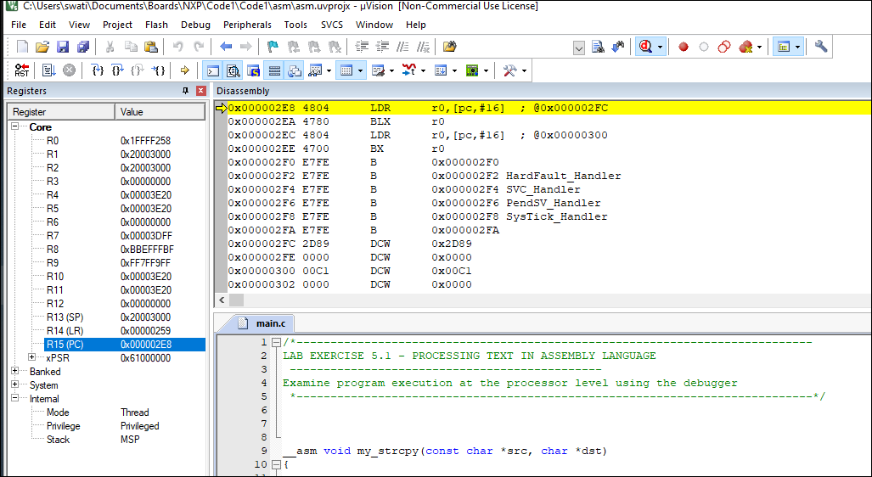

**Q1-5 Setup successful: HELLO WORLD – copied from a to b using given binary**

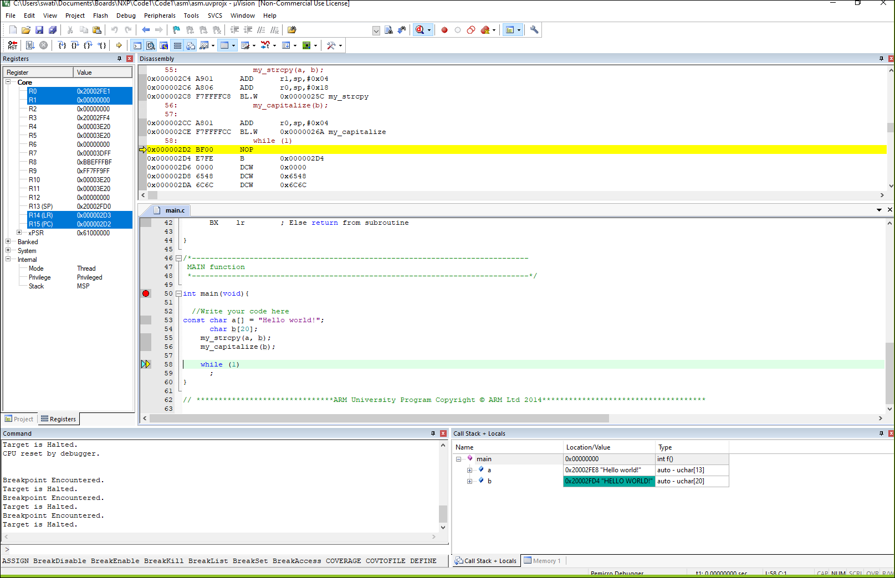

**Mbed : online compiler setup successful**

