**Swati Kadivar**

**Homework 3p**

**Q3**

**Address: 0x080002E8**

**This is the location to load the address of the first instruction to execute in PC.**

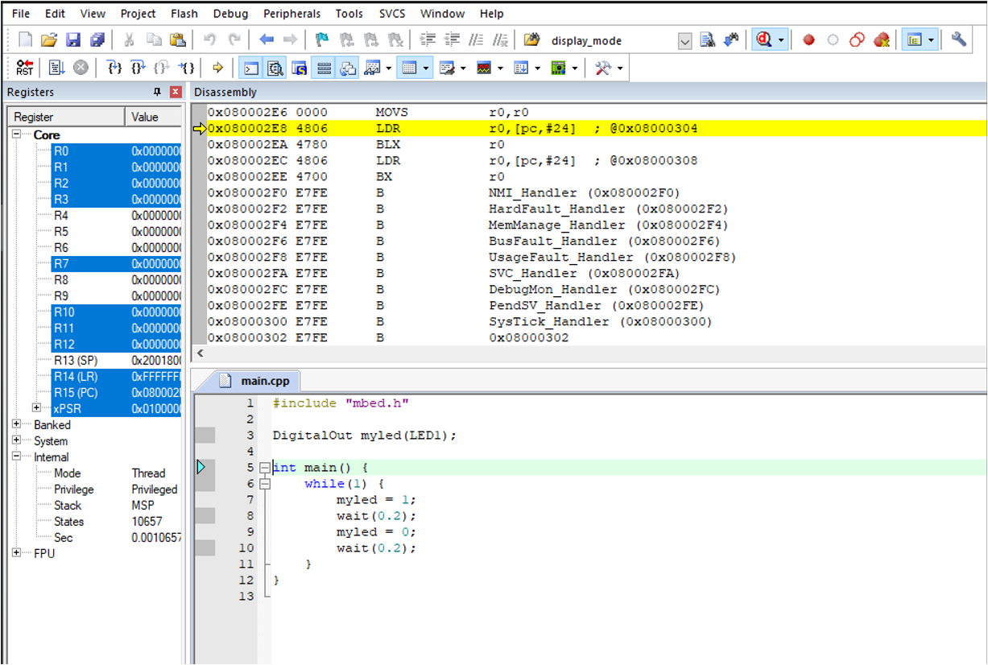

**Q4**

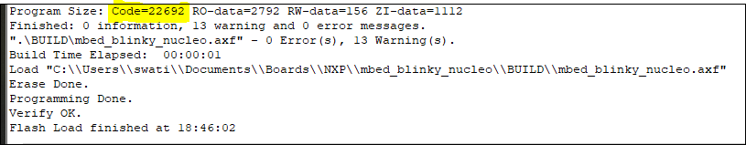

**Q5**

**CODE:**

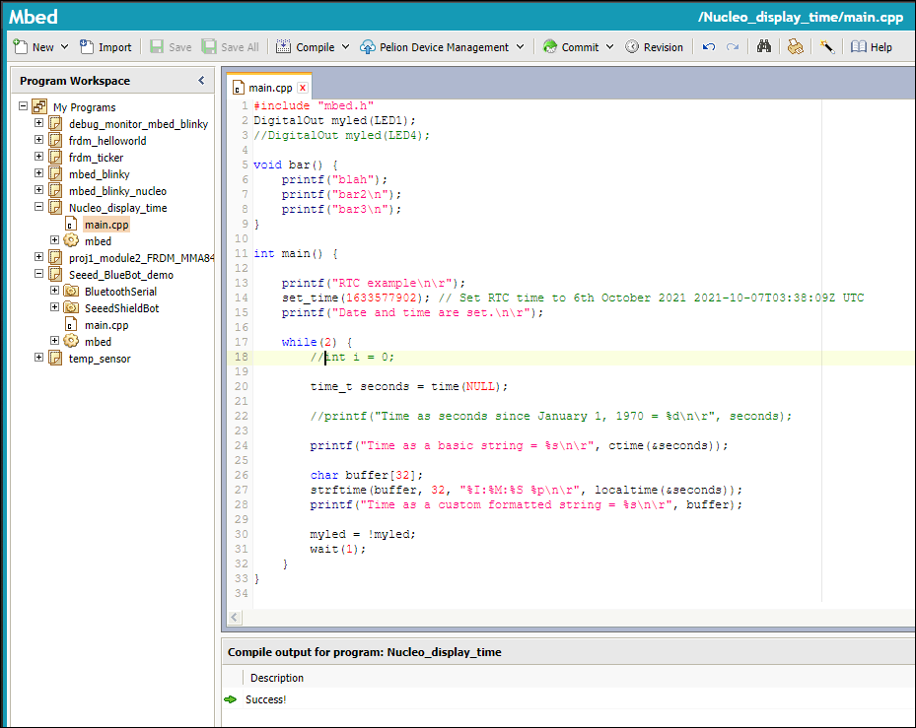

**OUTPUT:**

