**Homework 4p**

**Swati Kadivar**

=========================== Q1 ============================

1. Using the Getting Started instructions above, boot into Raspbian Linux.

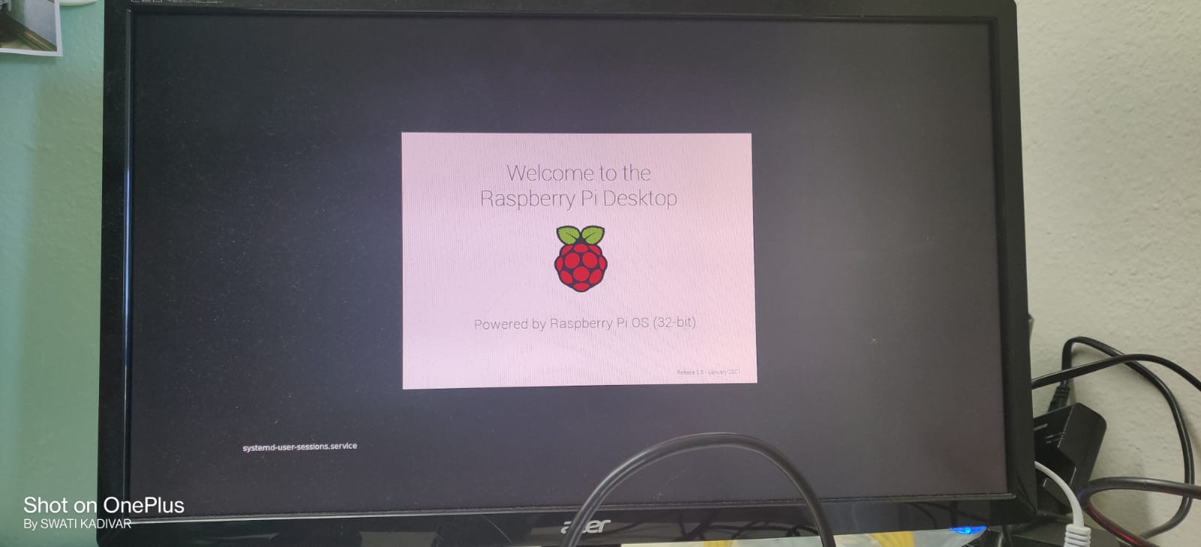

1. How much memory is used by the code? (What is the image size?) Think about how you might determine this.

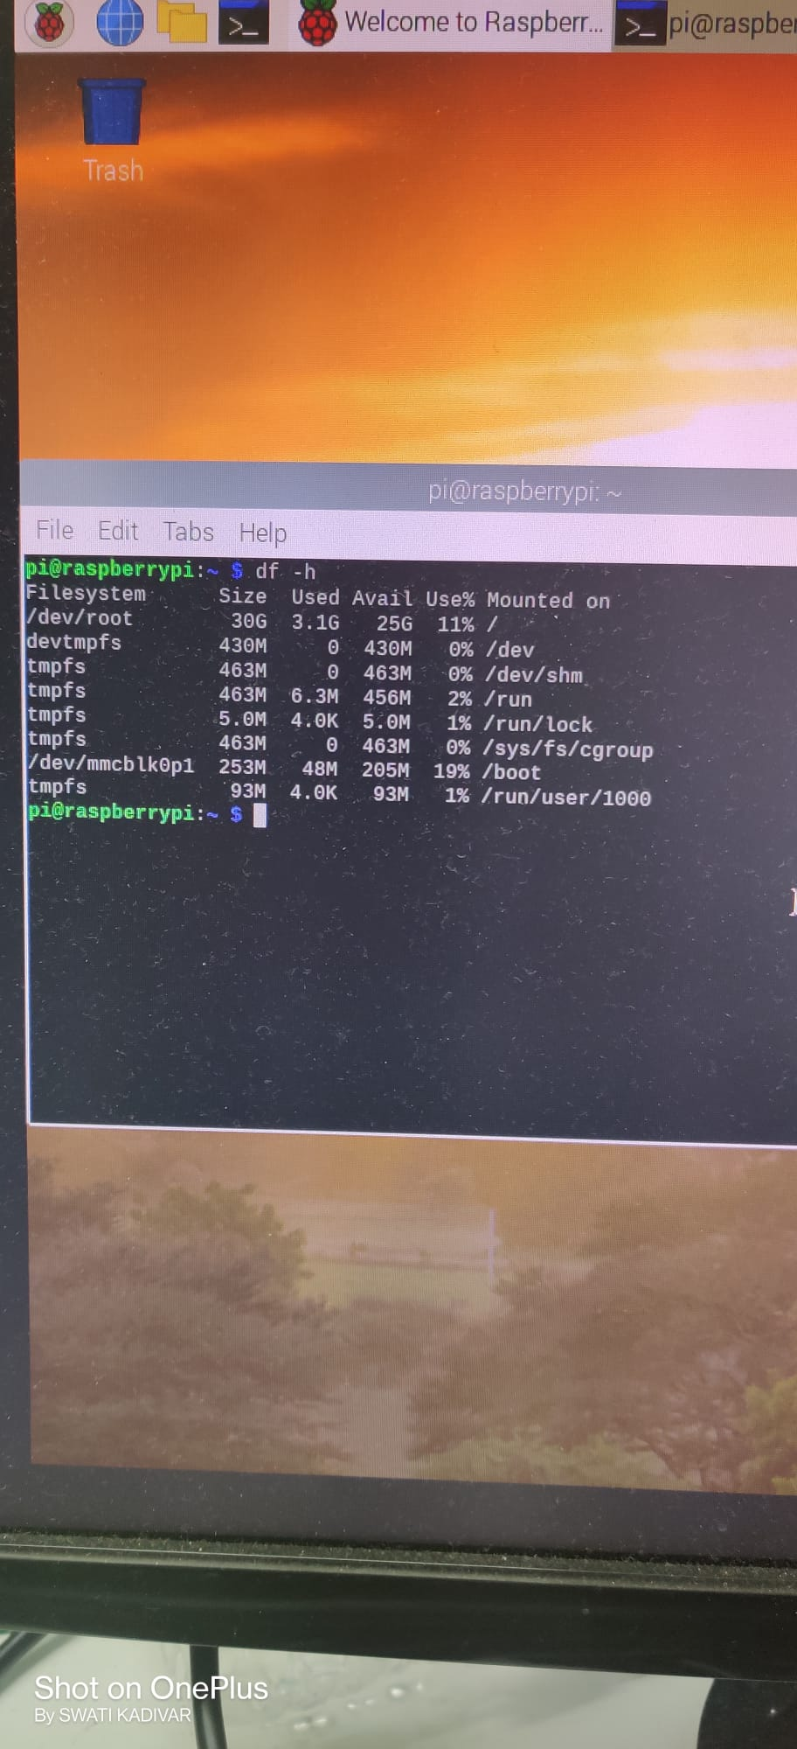

**Image size is 3.1GB**

1. Capture a screen shot of the Raspbian Desktop.

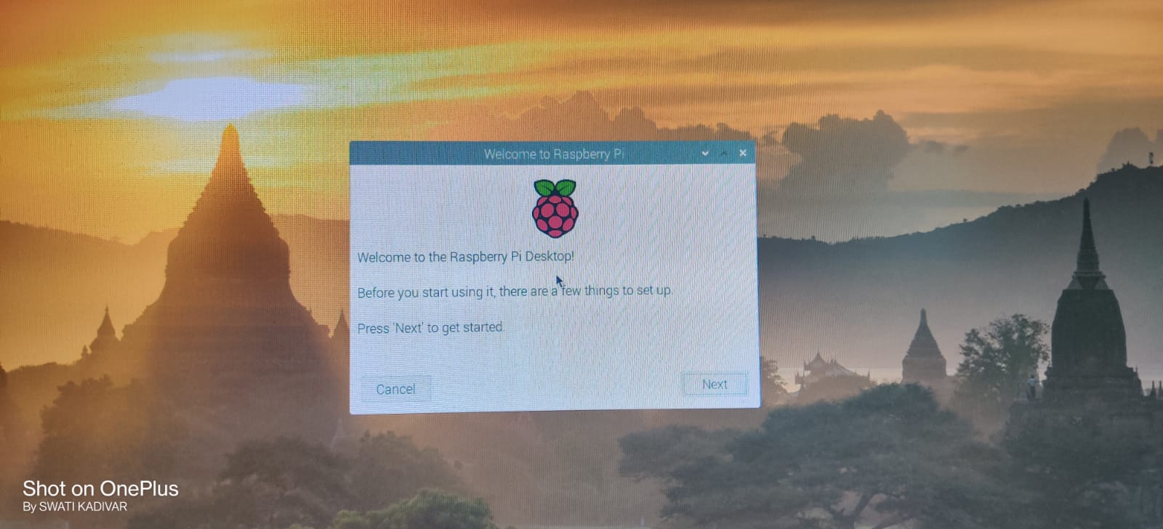

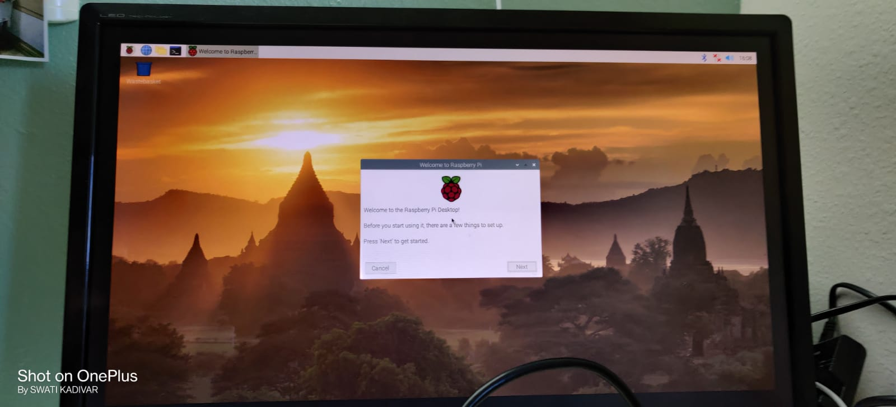

1. Capture a screen shot of a Linux terminal window.

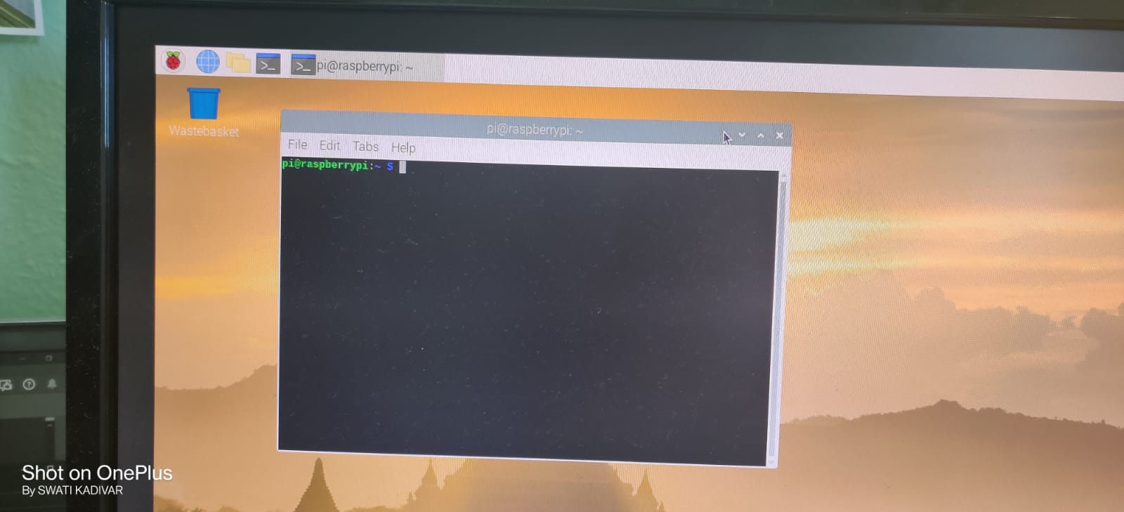

1. Blink the LEDs from the command shell.

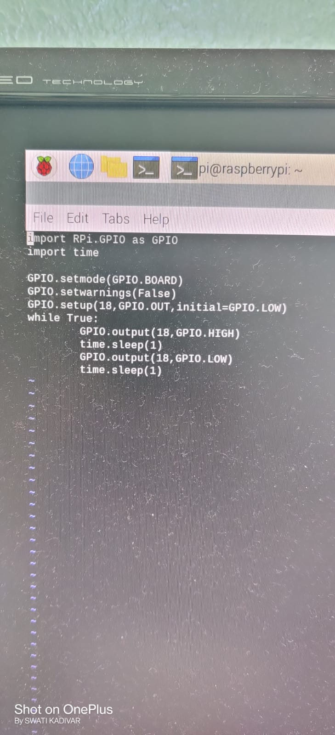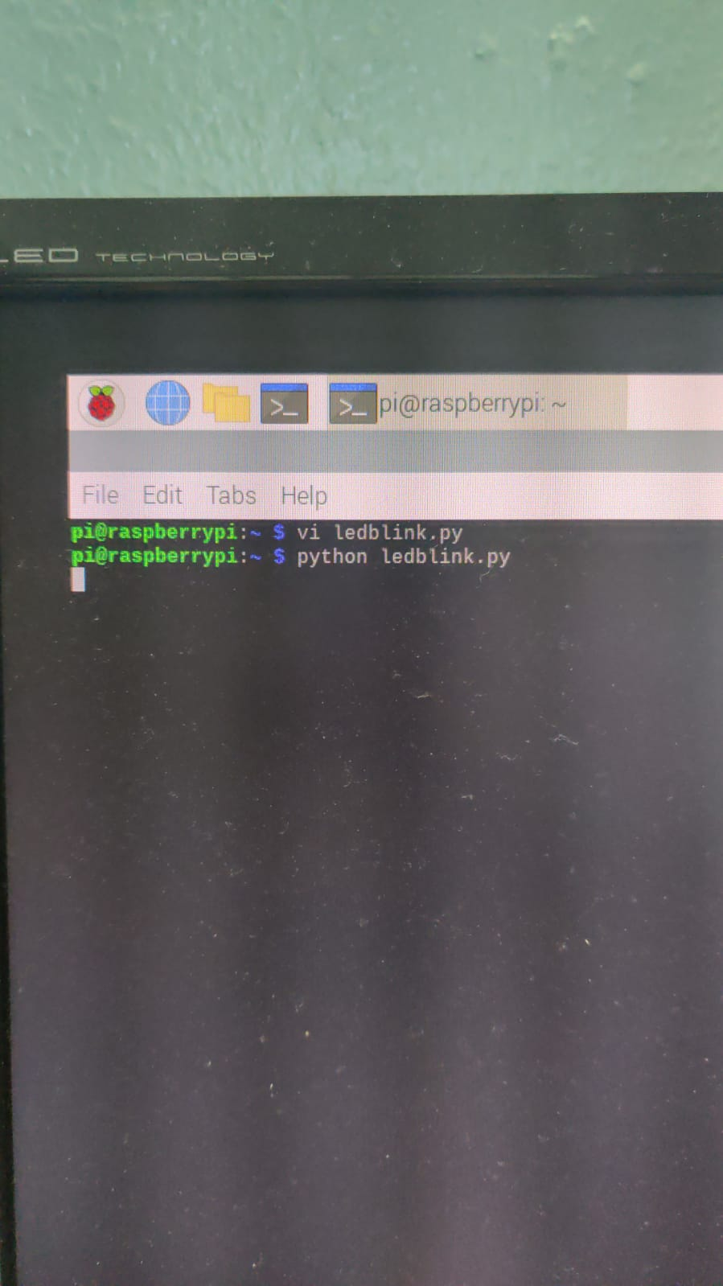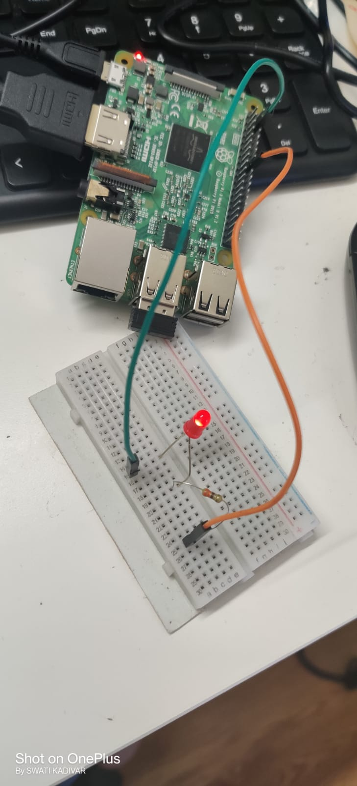

=========================== Q2 ============================

9 How much memory is used by the code? (What is the image size?)

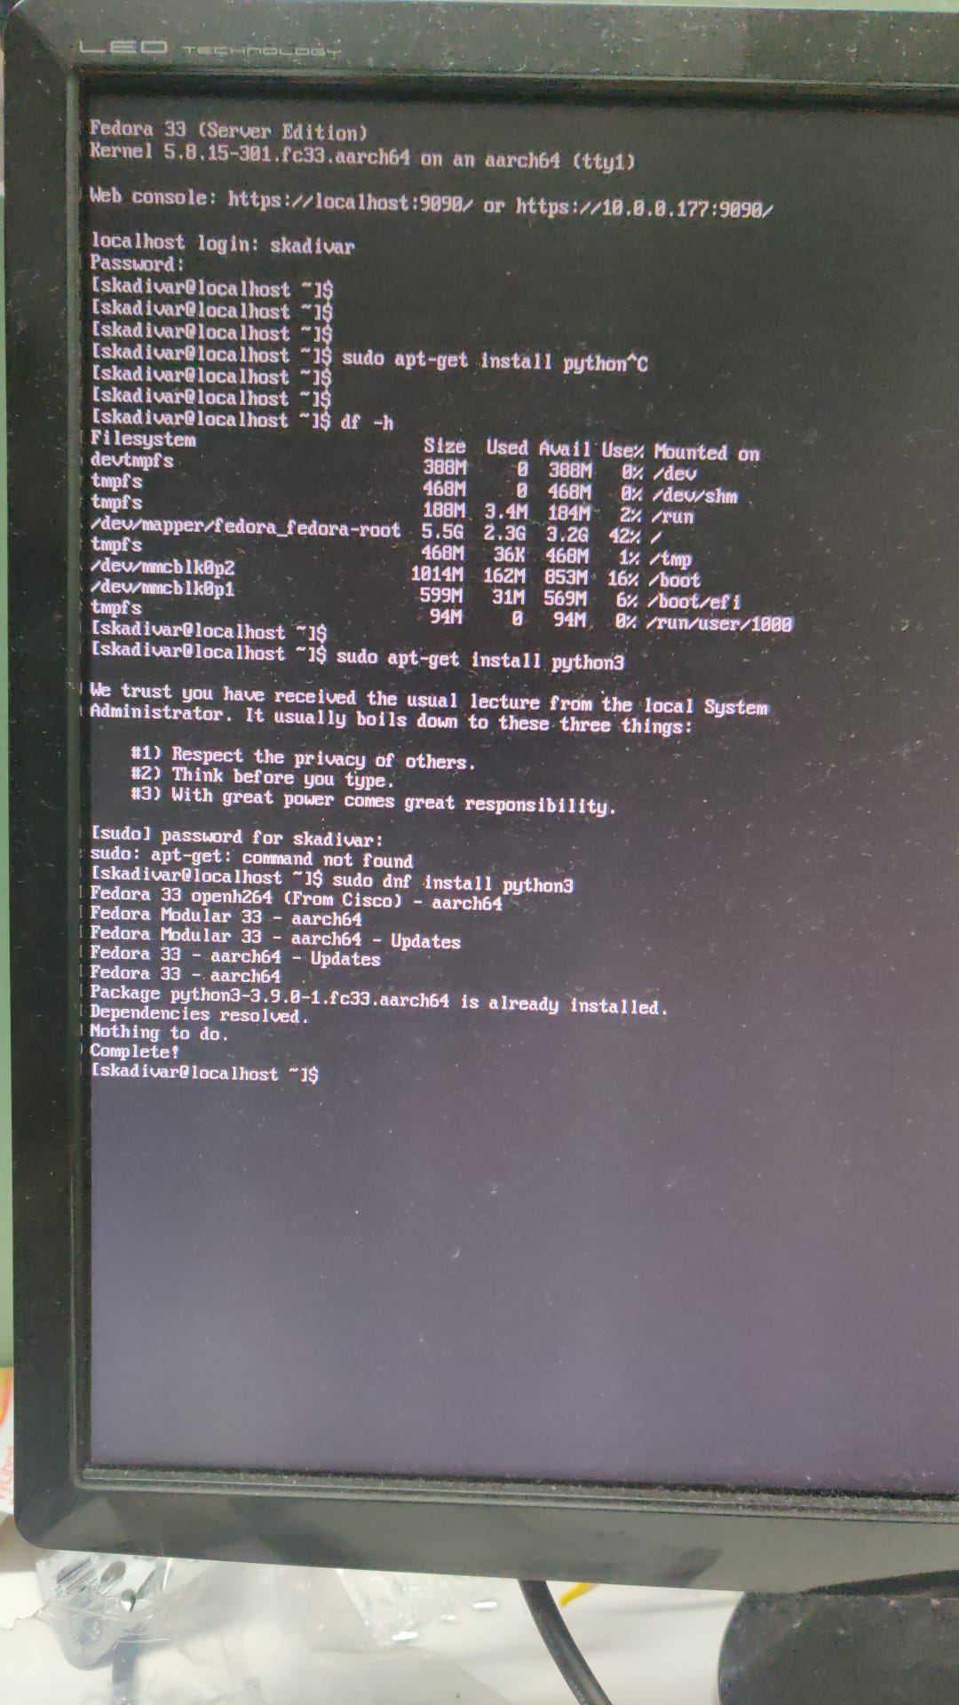

**2.3GB**

10. Capture a screen shot of a Linux terminal window.

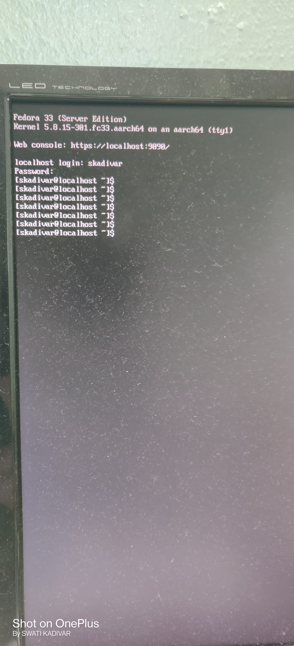

11. Blink an LED from the command shell. In order to control GPIO pins in Fedora, you may need to install the libgpiod library, which can be used from a Python script. See https://github.com/brgl/libgpiod

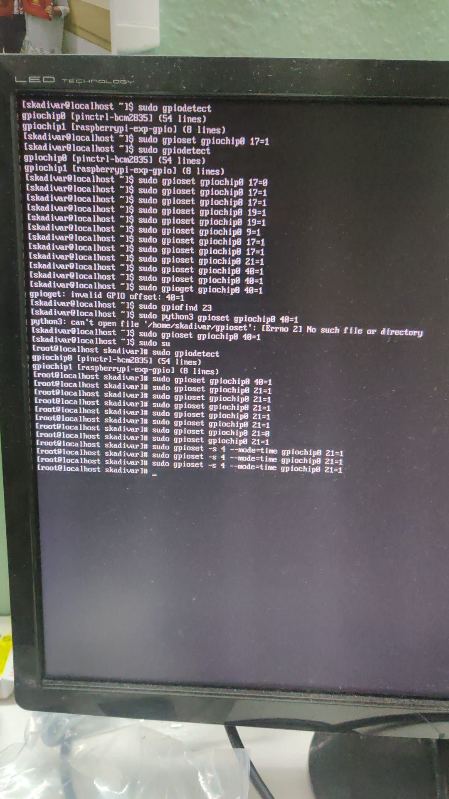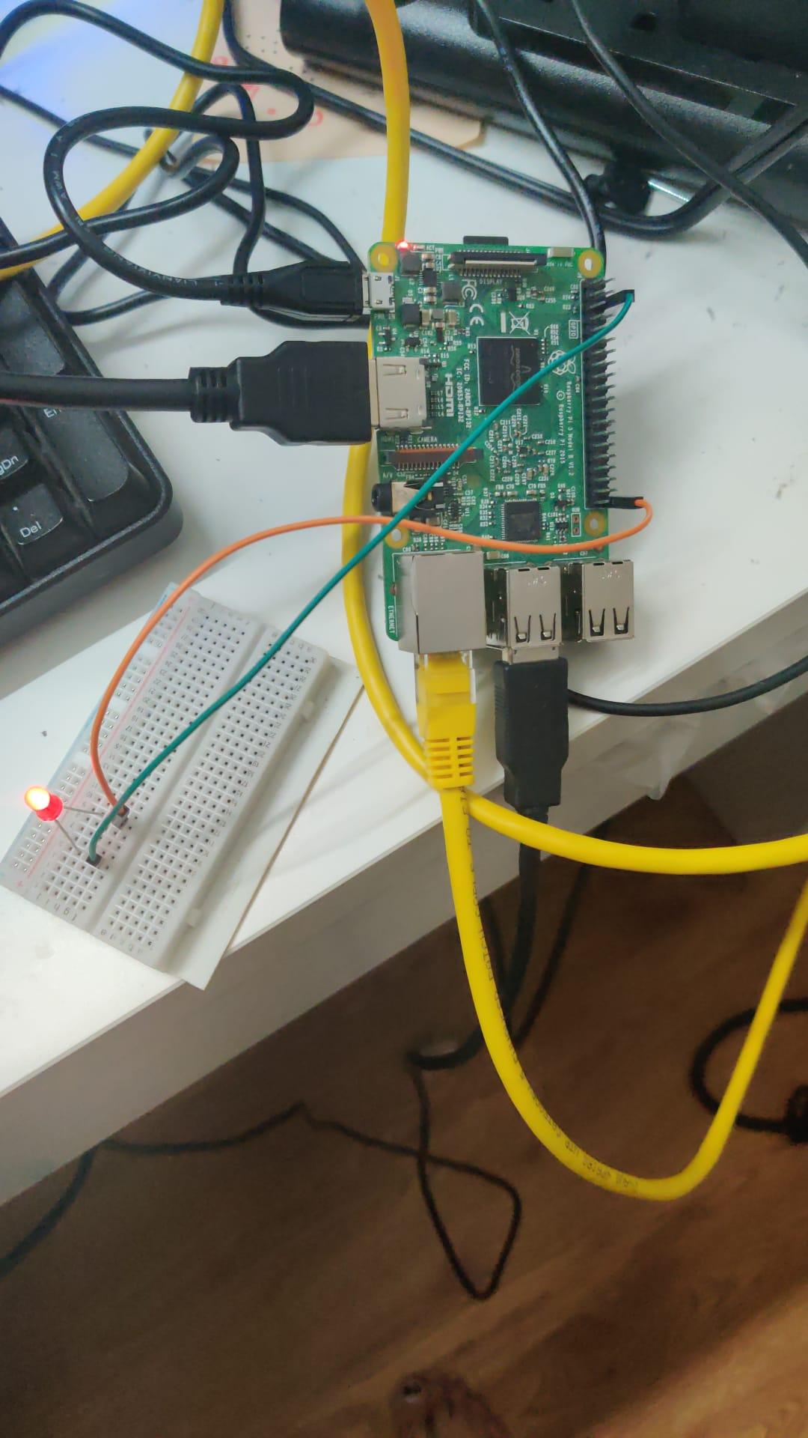

12. Connect the HDMI output to a monitor using an HDMI Cable and adapter if necessary. Reboot the system – what do you see?

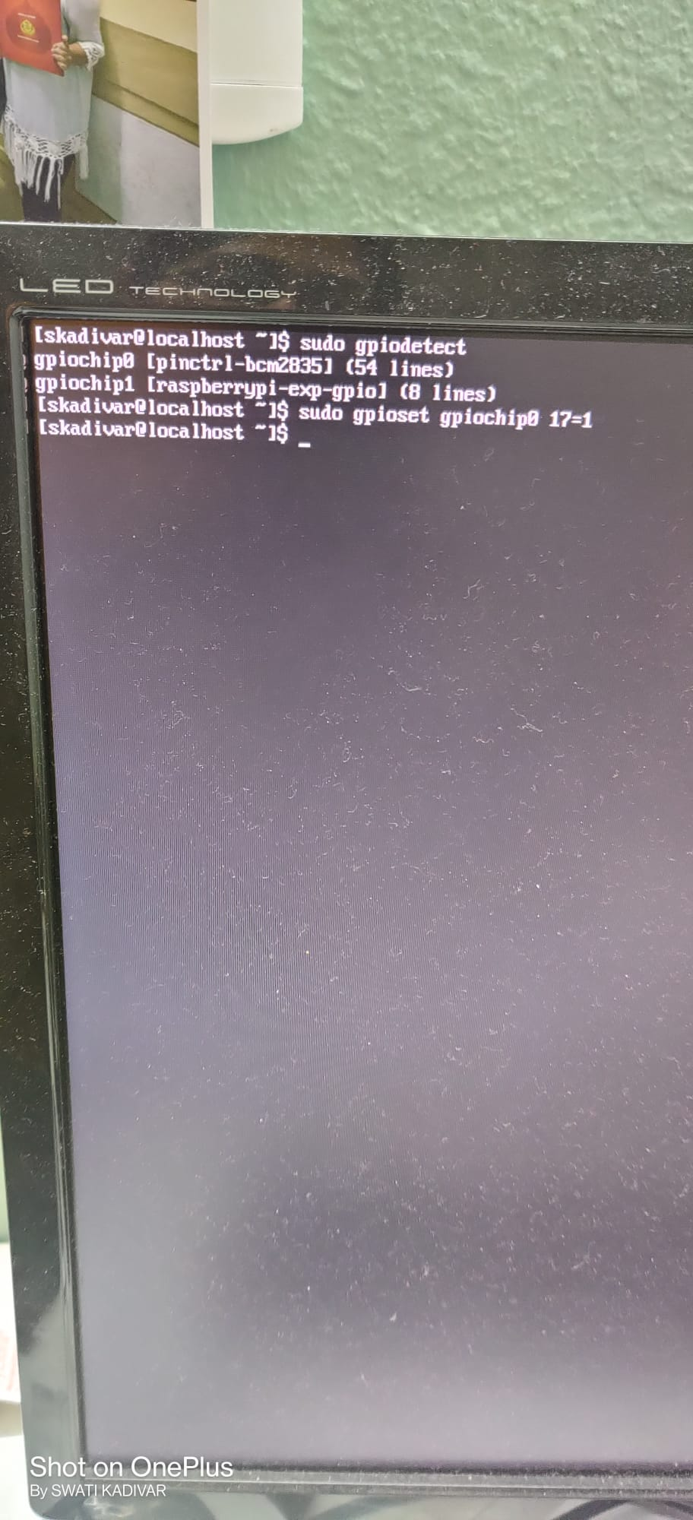

I was already using HDMI cable to connect to monitor and access the terminal.

13. Record your observations. How is the Fedora image different from the Raspbian image?

Ref : <https://www.stackshare.io/stackups/fedora-vs-raspbian>

Fedora: Operating system based on the Linux kernel, developed by the community-supported Fedora Project. Fedora is a Linux-based operating system that provides users with access to the latest free and open-source software, in a stable, secure and easy to manage form. Fedora is the largest of many free software creations of the Fedora Project. Because of its predominance, the word "Fedora" is often used interchangeably to mean both the Fedora Project and the Fedora operating system;

Raspbian: A free operating system based on Debian. It is optimized for the Raspberry Pi hardware. It provides more than a pure OS: it comes with over 35,000 packages, pre-compiled software bundled in a nice format for easy installation on your Raspberry Pi.