**[MCU on Eclipse](https://mcuoneclipse.com/)**

**Everything on Eclipse, Microcontrollers and Software**

[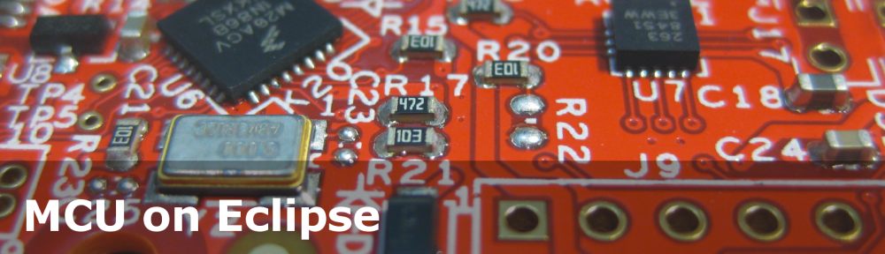](https://mcuoneclipse.com/)

Top of Form

Search 

Bottom of Form

**Main menu**

[Skip to primary content](https://mcuoneclipse.com/2014/11/01/illustrated-step-by-step-instructions-updating-the-freescale-freedom-board-firmware/#content)

* [Home](https://mcuoneclipse.wordpress.com)
* [Eclipse](https://mcuoneclipse.com/category/eclipse-2/)
* [PEx](https://mcuoneclipse.com/category/processor-expert/)
* [Compendium](https://mcuoneclipse.com/compendium/)
* [Pictures](https://mcuoneclipse.com/category/pictures/)
* [Q&A](https://mcuoneclipse.com/qa/)
* [Books!](https://mcuoneclipse.com/books/)
* [Bucket List](https://mcuoneclipse.com/the-bucket-list/)
* [Requests](https://mcuoneclipse.com/requests/)
* [About](https://mcuoneclipse.com/about/)

**Post navigation**

[← Previous](https://mcuoneclipse.com/2014/11/01/1000-days-of-blogging-numbers-and-tips-for-you/) [Next →](https://mcuoneclipse.com/2014/11/02/processor-expert-value-proposals/)

**Illustrated Step-by-Step Instructions: Updating the Freescale Freedom Board Firmware**

Posted on [November 1, 2014](https://mcuoneclipse.com/2014/11/01/illustrated-step-by-step-instructions-updating-the-freescale-freedom-board-firmware/) by [Erich Styger](https://mcuoneclipse.com/author/mcuoneclipse/)

7 Votes

I have received a bunch of Freescale FRDM boards to be used in an Embedded Systems programming crash course. There are multiple issues with the boards coming from the factory:

1. They come with an old bootloader which is not compatible with Windows 8.x
2. They have an old and outdated firmware on the board only supports a MSD bootloader

This post is a step-by-step instruction how to update Freescale FRDM boards (e.g. FRDM-KL25Z) to the latest firmware.

[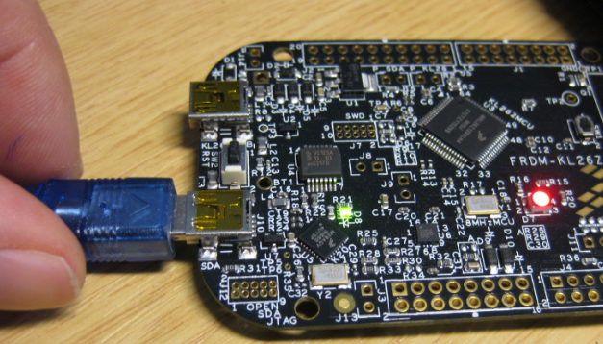](https://mcuoneclipse.files.wordpress.com/2014/11/frdm-board.png)

FRDM Board

**Preconditions**

Note that this instructions apply for the FRDM boards with the P&E OpenSDA bootloader (FRDM-KL03Z, FRDM-KL05Z, FRDM-KL25Z, FRDM-KL26Z, FRDM-KL46Z, FRDM-K20), but *NOT* to newer FRDM board like the FRDM-K64F and FRDM-K22F (which use a mbed bootloader which is different and does not allow to upate the bootloader). I need a SWD/JTAG programming device to update the bootloader on these boards, see <https://mcuoneclipse.com/2016/06/26/how-to-recover-the-opensda-v2-x-bootloader/>

You need

1. The board (of course )
2. A mini USB cable to connect the board to the host
3. A host machine (Windows 7 machine is needed, see note below)
4. P&E USB drivers
5. P&E [OpenSDA](https://mcuoneclipse.com/2012/09/20/opensda-on-the-freedom-kl25z-board/) Firmware files

There is a bug with the factory firmware on the board which prevents it working with Windows 8.x (see “[FRDM Board Bootloader fails with Windows 8.1 Preview](https://mcuoneclipse.com/2013/10/12/frdm-board-bootloader-fails-with-windows-8-1-preview/)” and “[New P&E OpenSDA Firmware v114](https://mcuoneclipse.com/2013/12/14/new-pe-opensda-firmware-v114/)“). Windows 8 tries to write the ‘virtual’ MSD (Mass Storage Device) of the board, confusing the bootloader. See <https://community.freescale.com/message/440982#440982> for the getting it working with Windows 8 (many thanks to Mark Butcher!).

Configure “**Do not allow locations on removable drives to be added to libraries**”  as discussed here: <http://answers.microsoft.com/en-us/windows/forum/windows8_1-hardware/how-do-i-prevent-system-volume-information-files/815b0046-d631-4419-a43e-44083a3733f5> Download and install the P&E drivers from <https://www.pemicro.com/opensda/> (you can skip this step if you have CodeWarrior or Kinetis Design Studio installed).

[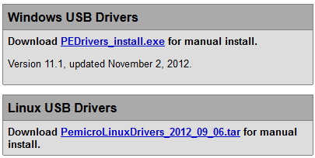](https://mcuoneclipse.files.wordpress.com/2014/11/pe-usb-drivers.png)

P&E USB Drivers

Download the OpenSDA Firmware Files from <https://www.pemicro.com/opensda/> (registration required). You can skip this step if you have Kinetis Design Studio V1.1.1 installed, as it comes with the files in C:\Freescale\KDS_1.1.1\pemicro\opensda).

[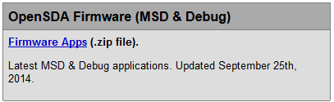](https://mcuoneclipse.files.wordpress.com/2014/11/pe-opensda-firmware-apps.png)

P&E OpenSDA Firmware Apps

Unzip that archive to your local machine. Inside the archive, there is as well **OpenSDA_Bootloader_Update_App_v111_2013_12_11.zip**: extract that file too:

You *have* to extract/unzip the files. You *cannot* copy/move the files from inside the zip file to the bootloader device.

[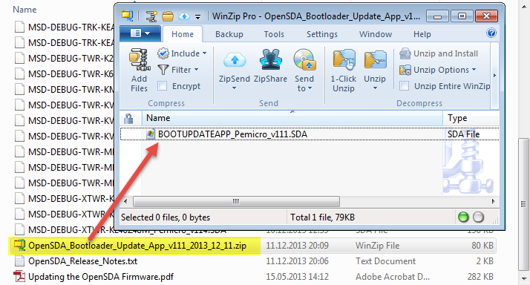](https://mcuoneclipse.files.wordpress.com/2014/11/bootupdateapp_pemicro_v111-sda.png)

BOOTUPDATEAPP_Pemicro_v111.SDA

There are two steps for the update required:

1. Update the bootloader. This makes it Windows 8 aware.
2. Update the board firmware. This gives you MSD bootloader, a USB CDC interface and the ability to debug the board as an OpenSDA board.

In the steps below you are asked to copy files to the ‘board’ drive. On Windows, you can use the ‘Send to’ context menu, or drag&drop the file to the drive. If this does not work, use the DOS/command Shell copy command. A common failure for this operation is using any kind of ‘File Commander’ or special File Manager. Another common failure point are any kind of virus scanner, so if things are still failing, temporarily disable your firewall/virus scanner.

**Updating the Bootloader**

1. Press first the Reset button (and keep it pressed) while power theboardwiththeOpenSDA USB connector:

[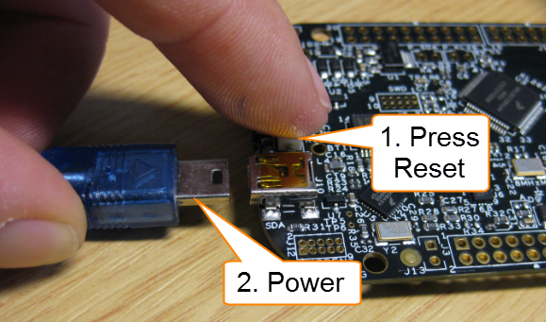](https://mcuoneclipse.files.wordpress.com/2014/11/power-on-with-reset-pressed.png)

Power-On with Reset Pressed

1. The green LED will blink with a frequency of 1 Hz:

[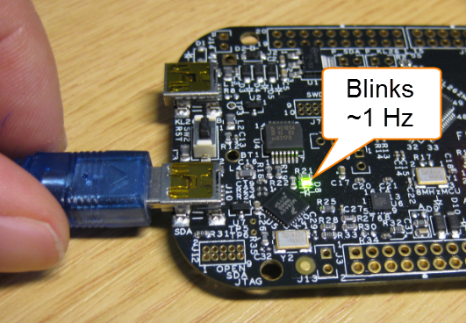](https://mcuoneclipse.files.wordpress.com/2014/11/blinks1hz.png)

Blinks with 1 Hz

1. The board willshowupasBOOTLOADER drive on your system:

[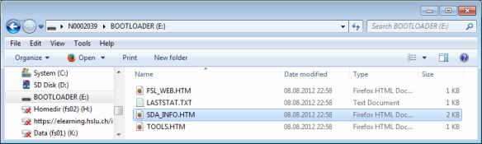](https://mcuoneclipse.files.wordpress.com/2014/11/bootloader.png)

BOOTLOADER

1. Copy **BOOTUPDATEAPP_Pemicro_v111.SDA** to the BOOTLOADER driver:

[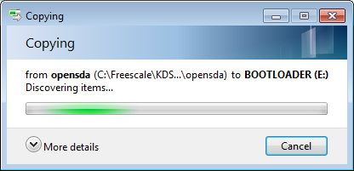](https://mcuoneclipse.files.wordpress.com/2014/11/copy-to-drive.png)

Copy to BOOTLOADER Drive

1. The copy operation takes about 2-3 seconds, and the green LED should still blink with a 1 Hz frequency. If it blinks faster, the copy operation failed.
2. Unpower the board:

[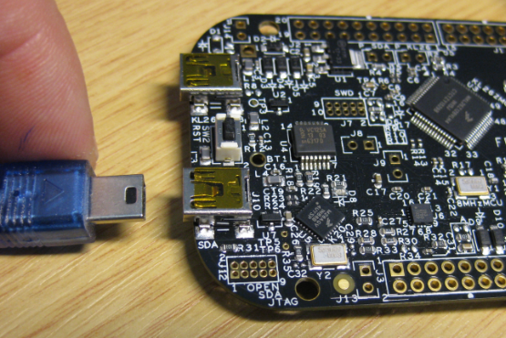](https://mcuoneclipse.files.wordpress.com/2014/11/unpowered-board.png)

Unpowered Board

1. Power the board again normally (do NOT press the reset button this time):

[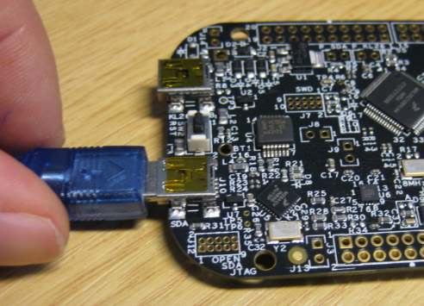](https://mcuoneclipse.files.wordpress.com/2014/11/powering-the-board-normally.png)

Powering the Board Normally

1. Wait a second so the bootloader gets reprogrammed. The board shall showupagainasBOOTLOADER, with the green LED blinking at 1 Hz.

[](https://mcuoneclipse.files.wordpress.com/2014/11/bootloader.png)

BOOTLOADER

1. You can check if the V1.11 bootloader has been correctly programmed if you open theBOOTLOADER\SDA_INFO.HTM file with your web browser:

[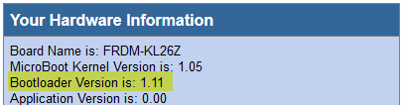](https://mcuoneclipse.files.wordpress.com/2014/11/bootloader-version-11-1.png)

Bootloader Version 11.1

If you have the V1.11 bootloader on your board, then everything is ready for the next step: loading the MSD+CDC+Debug board firmware.

**Updating Board Firmware**

The P&E OpenSDA firmware features three functions:

1. **USB MSD bootloader**: the board looks like a memory (MSD=Mass Storage Device), so you can copy .s19 files to it to get it programmed
2. **USB CDC serial bridge**: the OpenSDA debug firmware is like a USB-to-Serial Converter, so the microcontroller on the board can communicate with the host PC
3. **USB Multilink OpenSDA** **debug**: the board can be used for debugging e.g. with CodeWarrior or Kinetis Design Studio.

Because the firmware is board-specific, you need to copy the *correct* firmware file to your board. Carefully select and use the firmware *.SDA file matching your board:

[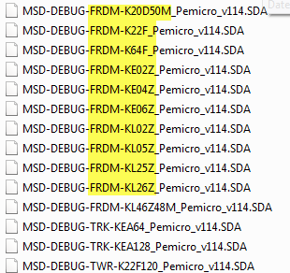](https://mcuoneclipse.files.wordpress.com/2014/11/different-firmware-for-each-board.png)

Different Firmware for each board

To program the board with the new firmware:

1. Press first the Reset button (and keep it pressed) while power theboardwiththeOpenSDA USB connector:

[](https://mcuoneclipse.files.wordpress.com/2014/11/power-on-with-reset-pressed.png)

Power-On with Reset Pressed

1. The green LED will blink with a frequency of 1 Hz:

[](https://mcuoneclipse.files.wordpress.com/2014/11/blinks1hz.png)

Blinks with 1 Hz

1. The board willshowupasBOOTLOADER drive on your system:

[](https://mcuoneclipse.files.wordpress.com/2014/11/bootloader.png)

BOOTLOADER

1. Copy **MSD-DEBUG-<boardname>_Pemicro_v*.SDA** (matching your board!) to the BOOTLOADER driver:

[](https://mcuoneclipse.files.wordpress.com/2014/11/copy-to-drive.png)

Copy to BOOTLOADER Drive

1. The copy operation takes about 2-3 seconds, and the green LED should still blink with a 1 Hz frequency. If it blinks faster, the copy operation failed.
2. Unpower the board:

[](https://mcuoneclipse.files.wordpress.com/2014/11/unpowered-board.png)

Unpowered Board

1. Power the board again normally (do NOT press the reset button this time):

[](https://mcuoneclipse.files.wordpress.com/2014/11/powering-the-board-normally.png)

Powering the Board Normally

1. If needed, your host system will install the device drivers. In your Windows Device Manager, you should see the **PEMicro OpenSDA Debug Driver**, the **WinDriver** and an **OpenSDA – CDC Serial Port**:

[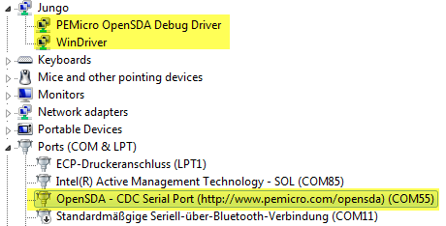](https://mcuoneclipse.files.wordpress.com/2014/11/pe-opensda-drivers-in-device-manager.png)

P&E OpenSDA Drivers in Device Manager

1. The green LED shall be permanently on:

[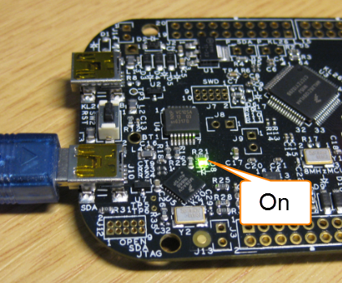](https://mcuoneclipse.files.wordpress.com/2014/11/green-led-on.png)

Green LED On

1. The board shows up with its name as device:

[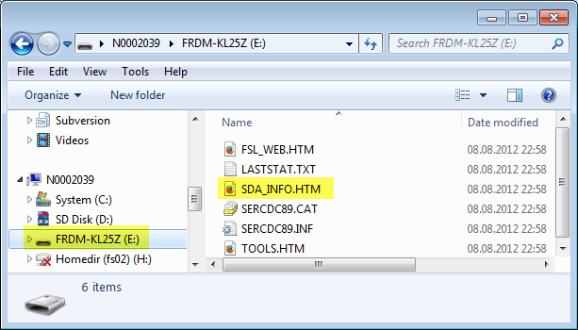](https://mcuoneclipse.files.wordpress.com/2014/11/board-device.png)

Board Device

1. You can check if the firmware has been correctly programmed if you open the SDA_INFO.HTM file with your web browser: It should show an installed application matching your board:

[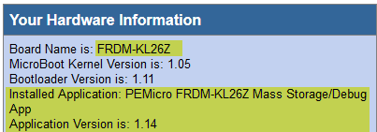](https://mcuoneclipse.files.wordpress.com/2014/11/debug-application-firmware-loaded.png)

Debug Application Firmware Loaded

Done! Now you can use the board to be programmed with an S19 file, or by the debugger, or it can communicate with the host using the USB CDC interface.

**Summary**

The factory boards come shipped with an outdated firmware and application (which only supports MSD bootloading). To make the board working with Windows 8 it requires a bootloader update. To really use the board, the latest firmware needs to be loaded on the board too. Happy Bootloading

[About these ads](https://wordpress.com/about-these-ads/)

**Share this:**

* [Print](https://mcuoneclipse.com/2014/11/01/illustrated-step-by-step-instructions-updating-the-freescale-freedom-board-firmware/#print)
* [Email](https://mcuoneclipse.com/2014/11/01/illustrated-step-by-step-instructions-updating-the-freescale-freedom-board-firmware/?share=email&nb=1)
* [Reddit](https://mcuoneclipse.com/2014/11/01/illustrated-step-by-step-instructions-updating-the-freescale-freedom-board-firmware/?share=reddit&nb=1)
* [Twitter](https://mcuoneclipse.com/2014/11/01/illustrated-step-by-step-instructions-updating-the-freescale-freedom-board-firmware/?share=twitter&nb=1)
* [Facebook2](https://mcuoneclipse.com/2014/11/01/illustrated-step-by-step-instructions-updating-the-freescale-freedom-board-firmware/?share=facebook&nb=1)
* [LinkedIn2](https://mcuoneclipse.com/2014/11/01/illustrated-step-by-step-instructions-updating-the-freescale-freedom-board-firmware/?share=linkedin&nb=1)
* [Tumblr](https://mcuoneclipse.com/2014/11/01/illustrated-step-by-step-instructions-updating-the-freescale-freedom-board-firmware/?share=tumblr&nb=1)
* [Pinterest](https://mcuoneclipse.com/2014/11/01/illustrated-step-by-step-instructions-updating-the-freescale-freedom-board-firmware/?share=pinterest&nb=1)
* [Google](https://mcuoneclipse.com/2014/11/01/illustrated-step-by-step-instructions-updating-the-freescale-freedom-board-firmware/?share=google-plus-1&nb=1)
* [Pocket](https://mcuoneclipse.com/2014/11/01/illustrated-step-by-step-instructions-updating-the-freescale-freedom-board-firmware/?share=pocket&nb=1)

***Related***

[FRDM Board Bootloader fails with Windows 8.1 Preview](https://mcuoneclipse.com/2013/10/12/frdm-board-bootloader-fails-with-windows-8-1-preview/)In "Boards"

[Using the Freedom Board as SWD Programmer](https://mcuoneclipse.com/2013/04/21/using-the-freedom-board-as-jtag-programmer/)In "Boards"

[The Freescale OpenSDA Trap: "No Device Available", or something like that....](https://mcuoneclipse.com/2013/09/02/the-freescale-opensda-trap-no-device-available-or-something-like-that/)In "FRDM-KE02Z"

This entry was posted in [ARM](https://mcuoneclipse.com/category/cpus/arm/), [Boards](https://mcuoneclipse.com/category/boards/), [CPU's](https://mcuoneclipse.com/category/cpus/), [FRDM-KE02Z](https://mcuoneclipse.com/category/boards/frdm-ke02z/), [FRDM-KL26Z](https://mcuoneclipse.com/category/boards/frdm-kl26z/), [Freescale](https://mcuoneclipse.com/category/freescale/), [K20D50M Freedom Board](https://mcuoneclipse.com/category/boards/k20d50m-freedom-board/), [KL05Z Freedom Board](https://mcuoneclipse.com/category/boards/kl05z-freedom-board/), [KL25Z Freedom Board](https://mcuoneclipse.com/category/boards/kl25z-freedom-board/), [KL46Z Freedom Board](https://mcuoneclipse.com/category/boards/kl46z-freedom-board/), [Tips & Tricks](https://mcuoneclipse.com/category/tips-tricks/) and tagged [Flashing](https://mcuoneclipse.com/tag/flashing/), [freedom board](https://mcuoneclipse.com/tag/freedom-board/), [Freescale](https://mcuoneclipse.com/tag/freescale/), [K20D50M Freedom Board](https://mcuoneclipse.com/category/boards/k20d50m-freedom-board/), [KL05Z Freedom Board](https://mcuoneclipse.com/category/boards/kl05z-freedom-board/), [KL25Z Freedom Board](https://mcuoneclipse.com/category/boards/kl25z-freedom-board/), [KL46Z Freedom Board](https://mcuoneclipse.com/category/boards/kl46z-freedom-board/), [OpenSDA](https://mcuoneclipse.com/tag/opensda/), [P&E](https://mcuoneclipse.com/tag/pe/), [Tips&Tricks](https://mcuoneclipse.com/tag/tipstricks/) by [Erich Styger](https://mcuoneclipse.com/author/mcuoneclipse/). Bookmark the [permalink](https://mcuoneclipse.com/2014/11/01/illustrated-step-by-step-instructions-updating-the-freescale-freedom-board-firmware/).



**About Erich Styger**

Embedded is my passion....

[View all posts by Erich Styger →](https://mcuoneclipse.com/author/mcuoneclipse/)

**32 thoughts on “Illustrated Step-by-Step Instructions: Updating the Freescale Freedom Board Firmware”**

1. [Mark Butcher](http://www.uTasker.com) on [November 1, 2014 at 17:25](https://mcuoneclipse.com/2014/11/01/illustrated-step-by-step-instructions-updating-the-freescale-freedom-board-firmware/#comment-38372) said:

Eric

The Windows 8.1 setting is described and linked to here:  
<https://community.freescale.com/message/440982#440982>

Regards

Mark

Like

[Reply ↓](https://mcuoneclipse.com/2014/11/01/illustrated-step-by-step-instructions-updating-the-freescale-freedom-board-firmware/?replytocom=38372#respond)

* + https://2.gravatar.com/avatar/5835d6072b696e2e76b088d6159eedea?s=39&d=https%3A%2F%2F2.gravatar.com%2Favatar%2Fad516503a11cd5ca435acc9bb6523536%3Fs%3D39&r=G[Erich Styger](https://mcuoneclipse.wordpress.com) on [November 1, 2014 at 18:10](https://mcuoneclipse.com/2014/11/01/illustrated-step-by-step-instructions-updating-the-freescale-freedom-board-firmware/#comment-38376) said:

Hi Mark,  
ah, that’s the place where I have seen it, but was not able to find it MANY, MANY thanks! I’ll update the post with that info.  
Erich

Like

[Reply ↓](https://mcuoneclipse.com/2014/11/01/illustrated-step-by-step-instructions-updating-the-freescale-freedom-board-firmware/?replytocom=38376#respond)

* + https://2.gravatar.com/avatar/58445ca0ff9e9c055837c77aa1f79878?s=39&d=https%3A%2F%2F2.gravatar.com%2Favatar%2Fad516503a11cd5ca435acc9bb6523536%3Fs%3D39&r=Gnena on [February 4, 2016 at 05:47](https://mcuoneclipse.com/2014/11/01/illustrated-step-by-step-instructions-updating-the-freescale-freedom-board-firmware/#comment-78041) said:

ive already upgraded to windows 10. to upgrade the firmware are there any similar steps from windows 10? or i will have to carry the procedure from 7 only? my project is stuck. help me asap!

Like

[Reply ↓](https://mcuoneclipse.com/2014/11/01/illustrated-step-by-step-instructions-updating-the-freescale-freedom-board-firmware/?replytocom=78041#respond)

* + - https://2.gravatar.com/avatar/5835d6072b696e2e76b088d6159eedea?s=39&d=https%3A%2F%2F2.gravatar.com%2Favatar%2Fad516503a11cd5ca435acc9bb6523536%3Fs%3D39&r=G[Erich Styger](https://mcuoneclipse.wordpress.com) on [February 4, 2016 at 07:04](https://mcuoneclipse.com/2014/11/01/illustrated-step-by-step-instructions-updating-the-freescale-freedom-board-firmware/#comment-78045) said:

Yes, Windows 10 is the same as Windows 8 from what I can tell. Try the following  
<http://answers.microsoft.com/en-us/windows/forum/windows8_1-hardware/how-do-i-prevent-system-volume-information-files/815b0046-d631-4419-a43e-44083a3733f5?auth=1>  
and you should be able to update the bootloader that way.

Like

1. [gasstationwithoutpumps](http://gasstationwithoutpumps.wordpress.com) on [November 2, 2014 at 02:54](https://mcuoneclipse.com/2014/11/01/illustrated-step-by-step-instructions-updating-the-freescale-freedom-board-firmware/#comment-38418) said:

Does this also allow the board to be programmed from Mac OS X?  
Does it allow switching back and forth from the MBED bootloader, or do you still need a WIndows 7 machine to do that?

Like

[Reply ↓](https://mcuoneclipse.com/2014/11/01/illustrated-step-by-step-instructions-updating-the-freescale-freedom-board-firmware/?replytocom=38418#respond)

* + https://2.gravatar.com/avatar/5835d6072b696e2e76b088d6159eedea?s=39&d=https%3A%2F%2F2.gravatar.com%2Favatar%2Fad516503a11cd5ca435acc9bb6523536%3Fs%3D39&r=G[Erich Styger](https://mcuoneclipse.wordpress.com) on [November 2, 2014 at 06:29](https://mcuoneclipse.com/2014/11/01/illustrated-step-by-step-instructions-updating-the-freescale-freedom-board-firmware/#comment-38434) said:

I do not have a Mac, so I cannot really tell. To my understanding with the bootloader on v1.11, it should not be vulnerable to host OS systems trying to write or index the MSD device.

Like

[Reply ↓](https://mcuoneclipse.com/2014/11/01/illustrated-step-by-step-instructions-updating-the-freescale-freedom-board-firmware/?replytocom=38434#respond)

1. Pingback: [Debugging Failure: Check List and Hints | MCU on Eclipse](https://mcuoneclipse.com/2014/11/03/debugging-failure-check-list-and-hints/)
2. Keith on [November 4, 2014 at 14:33](https://mcuoneclipse.com/2014/11/01/illustrated-step-by-step-instructions-updating-the-freescale-freedom-board-firmware/#comment-38705) said:

I am trying to figure this out for a Mac, and I get stuck where you are downloading the drivers from pemicro. There apparently are drivers for Windows and Linux, but not Mac. Is this correct? What do you recommend for Mac users?

Like

[Reply ↓](https://mcuoneclipse.com/2014/11/01/illustrated-step-by-step-instructions-updating-the-freescale-freedom-board-firmware/?replytocom=38705#respond)

* + https://2.gravatar.com/avatar/5835d6072b696e2e76b088d6159eedea?s=39&d=https%3A%2F%2F2.gravatar.com%2Favatar%2Fad516503a11cd5ca435acc9bb6523536%3Fs%3D39&r=G[Erich Styger](https://mcuoneclipse.wordpress.com) on [November 4, 2014 at 14:43](https://mcuoneclipse.com/2014/11/01/illustrated-step-by-step-instructions-updating-the-freescale-freedom-board-firmware/#comment-38706) said:

Yes, P&E does not have drivers for Mac. I recommend that you use Segger as Mac user (with the Segger firmware). But to upgrade the firmware, you need to find a Windows machine.

Like

[Reply ↓](https://mcuoneclipse.com/2014/11/01/illustrated-step-by-step-instructions-updating-the-freescale-freedom-board-firmware/?replytocom=38706#respond)

* + - https://2.gravatar.com/avatar/b99108c3228764ee04c379e9a5e578d6?s=39&d=https%3A%2F%2F2.gravatar.com%2Favatar%2Fad516503a11cd5ca435acc9bb6523536%3Fs%3D39&r=G[gasstationwithoutpumps](http://gasstationwithoutpumps.wordpress.com) on [November 5, 2014 at 20:33](https://mcuoneclipse.com/2014/11/01/illustrated-step-by-step-instructions-updating-the-freescale-freedom-board-firmware/#comment-38867) said:

The Mac does not usually need custom drivers for each new product the way that Windows does. OS X relies on the device class to set up generic drivers for most devices (only using the vendor ID for exceptions). OS X recognizes OpenSDA port as a flash drive (but because P&E didn’t follow the standards, the writing doesn’t work). The MBED software does work with Macs, but first you need a Windows machine to get rid of the P&E junk.

Like

1. Pingback: [OpenOCD/CMSIS-DAP Debugging with Eclipse and without an IDE | MCU on Eclipse](https://mcuoneclipse.com/2015/03/22/openocdcmsis-dap-debugging-with-eclipse-and-without-an-ide/)
2. [Karibe](http://karibe.co.ke) on [April 16, 2015 at 11:38](https://mcuoneclipse.com/2014/11/01/illustrated-step-by-step-instructions-updating-the-freescale-freedom-board-firmware/#comment-54878) said:

am trying this with the FRDM-KL05Z, debugging in KDS V2 and PNE option not working…

Like

[Reply ↓](https://mcuoneclipse.com/2014/11/01/illustrated-step-by-step-instructions-updating-the-freescale-freedom-board-firmware/?replytocom=54878#respond)

* + https://1.gravatar.com/avatar/448bf22bc89fa31e5146256cd0ce0270?s=39&d=https%3A%2F%2F1.gravatar.com%2Favatar%2Fad516503a11cd5ca435acc9bb6523536%3Fs%3D39&r=G[Karibe](http://karibe.co.ke) on [April 16, 2015 at 12:08](https://mcuoneclipse.com/2014/11/01/illustrated-step-by-step-instructions-updating-the-freescale-freedom-board-firmware/#comment-54883) said:

Sorry, works, my bad! P&E debugger pretty much hangs unexpectedly when using KDS in Linux and there is need to kill the process before attempting again, that was my problem, not the firmware.

Like

[Reply ↓](https://mcuoneclipse.com/2014/11/01/illustrated-step-by-step-instructions-updating-the-freescale-freedom-board-firmware/?replytocom=54883#respond)

* + https://2.gravatar.com/avatar/5835d6072b696e2e76b088d6159eedea?s=39&d=https%3A%2F%2F2.gravatar.com%2Favatar%2Fad516503a11cd5ca435acc9bb6523536%3Fs%3D39&r=G[Erich Styger](https://mcuoneclipse.wordpress.com) on [April 16, 2015 at 12:09](https://mcuoneclipse.com/2014/11/01/illustrated-step-by-step-instructions-updating-the-freescale-freedom-board-firmware/#comment-54884) said:

Hmm, it *does* work for me, but I’m using Windows. I think you are using Linux: does it work for other boards (FRDM-KL25Z)? What is the error/message?

Like

[Reply ↓](https://mcuoneclipse.com/2014/11/01/illustrated-step-by-step-instructions-updating-the-freescale-freedom-board-firmware/?replytocom=54884#respond)

* + - https://1.gravatar.com/avatar/448bf22bc89fa31e5146256cd0ce0270?s=39&d=https%3A%2F%2F1.gravatar.com%2Favatar%2Fad516503a11cd5ca435acc9bb6523536%3Fs%3D39&r=G[Karibe](http://karibe.co.ke) on [April 17, 2015 at 17:58](https://mcuoneclipse.com/2014/11/01/illustrated-step-by-step-instructions-updating-the-freescale-freedom-board-firmware/#comment-55013) said:

Have you ever tried working with the serial port via opensda with PE debug server with the kl05z board. It has some funny connection. from the k20 debug mcu to the uart of the kl05 onboard mcu to the arduino headers. IF i try using the opensda interface serial port doesnt send any data to computer, if i use the arduino headers with a usb-to-serial cable, the serial port works, yet they appear to be shorted, only seperated by 1k resistors according to the schematic. Whats going on?

Like

1. Pingback: [Primeiros passos – Como preparar seu computador e microcontrolador para códigos e projetos | void Hardwarizando( ) {](https://hardwarizando.wordpress.com/2015/05/11/primeiros-passos/)
2. Pingback: [Using the Freescale Freedom (FRDM-KL43Z) to Debug other Boards | MCU on Eclipse](https://mcuoneclipse.com/2015/08/19/using-the-freescale-freedom-frdm-kl43z-to-debug-other-boards/)
3. [camposecov](http://camposecov.wordpress.com) on [August 27, 2015 at 06:08](https://mcuoneclipse.com/2014/11/01/illustrated-step-by-step-instructions-updating-the-freescale-freedom-board-firmware/#comment-65793) said:

Have anyone tried on Windows 10? Is there any known issue?

Like

[Reply ↓](https://mcuoneclipse.com/2014/11/01/illustrated-step-by-step-instructions-updating-the-freescale-freedom-board-firmware/?replytocom=65793#respond)

* + https://2.gravatar.com/avatar/5835d6072b696e2e76b088d6159eedea?s=39&d=https%3A%2F%2F2.gravatar.com%2Favatar%2Fad516503a11cd5ca435acc9bb6523536%3Fs%3D39&r=G[Erich Styger](https://mcuoneclipse.wordpress.com) on [August 27, 2015 at 08:11](https://mcuoneclipse.com/2014/11/01/illustrated-step-by-step-instructions-updating-the-freescale-freedom-board-firmware/#comment-65795) said:

I have not tried with Windows 10, but my understanding is that it will be the same as with Windows 8.

Like

[Reply ↓](https://mcuoneclipse.com/2014/11/01/illustrated-step-by-step-instructions-updating-the-freescale-freedom-board-firmware/?replytocom=65795#respond)

* + - https://0.gravatar.com/avatar/f1c1de283816875c358733a82b725165?s=39&d=https%3A%2F%2F0.gravatar.com%2Favatar%2Fad516503a11cd5ca435acc9bb6523536%3Fs%3D39&r=G[camposecov](http://camposecov.wordpress.com) on [August 29, 2015 at 08:43](https://mcuoneclipse.com/2014/11/01/illustrated-step-by-step-instructions-updating-the-freescale-freedom-board-firmware/#comment-65906) said:

i have 1.09 but i cannot boot anymore, i´ve tried 11, 14 and 05 from start guide. is not booting. should advice is tied to win7.

Like

* + - https://2.gravatar.com/avatar/5835d6072b696e2e76b088d6159eedea?s=39&d=https%3A%2F%2F2.gravatar.com%2Favatar%2Fad516503a11cd5ca435acc9bb6523536%3Fs%3D39&r=G[Erich Styger](https://mcuoneclipse.wordpress.com) on [August 29, 2015 at 09:20](https://mcuoneclipse.com/2014/11/01/illustrated-step-by-step-instructions-updating-the-freescale-freedom-board-firmware/#comment-65909) said:

Not sure what you mean with ‘cannot boot anymore’? So 1.09 is your bootloader version, right?

Liked by [1 person](https://mcuoneclipse.com/2014/11/01/illustrated-step-by-step-instructions-updating-the-freescale-freedom-board-firmware/)

* + - https://0.gravatar.com/avatar/f1c1de283816875c358733a82b725165?s=39&d=https%3A%2F%2F0.gravatar.com%2Favatar%2Fad516503a11cd5ca435acc9bb6523536%3Fs%3D39&r=G[camposecov](http://camposecov.wordpress.com) on [August 29, 2015 at 09:25](https://mcuoneclipse.com/2014/11/01/illustrated-step-by-step-instructions-updating-the-freescale-freedom-board-firmware/#comment-65910) said:

i cannot boot in storage mode. only in bootloader.

Like

* + - https://2.gravatar.com/avatar/5835d6072b696e2e76b088d6159eedea?s=39&d=https%3A%2F%2F2.gravatar.com%2Favatar%2Fad516503a11cd5ca435acc9bb6523536%3Fs%3D39&r=G[Erich Styger](https://mcuoneclipse.wordpress.com) on [August 29, 2015 at 09:28](https://mcuoneclipse.com/2014/11/01/illustrated-step-by-step-instructions-updating-the-freescale-freedom-board-firmware/#comment-65911) said:

Once you are in BOOTLOADER mode, copy the MSD-DEBUG-FRDM-KL25Z_Pemicro_v114 (for FRDM-KL25Z board only!) to the BOOTLOADER drive.  
Do not drag&drop from the zip file. Use the DOS cmd/prompt to copy the file (just in case you have some explorer extensions).  
If this still fails: it might be your firewall/virus scanner causing problems: disable them if possible.  
I hope this helps.

Like

* + - https://0.gravatar.com/avatar/f1c1de283816875c358733a82b725165?s=39&d=https%3A%2F%2F0.gravatar.com%2Favatar%2Fad516503a11cd5ca435acc9bb6523536%3Fs%3D39&r=G[camposecov](http://camposecov.wordpress.com) on [August 29, 2015 at 10:04](https://mcuoneclipse.com/2014/11/01/illustrated-step-by-step-instructions-updating-the-freescale-freedom-board-firmware/#comment-65913) said:

i just tried that, any other idea? any dependency? i´m using win 8.1, downloaded latest drivers but, is there any way to get back to factory settings?

Like

* + - https://2.gravatar.com/avatar/5835d6072b696e2e76b088d6159eedea?s=39&d=https%3A%2F%2F2.gravatar.com%2Favatar%2Fad516503a11cd5ca435acc9bb6523536%3Fs%3D39&r=G[Erich Styger](https://mcuoneclipse.wordpress.com) on [August 29, 2015 at 10:09](https://mcuoneclipse.com/2014/11/01/illustrated-step-by-step-instructions-updating-the-freescale-freedom-board-firmware/#comment-65914) said:

To my knowledge it is not possible to downgrade the bootloader.  
Is your bootloader v1.14 or later (see <https://mcuoneclipse.com/2013/12/14/new-pe-opensda-firmware-v114/>)?  
If not, you need a Windows 7 (or XP) machine to upgrade the bootloader first.

Like

1. jasonhom@berkeley.edu on [September 15, 2015 at 01:07](https://mcuoneclipse.com/2014/11/01/illustrated-step-by-step-instructions-updating-the-freescale-freedom-board-firmware/#comment-67073) said:

After updating to the latest firmware and bootloader it shows up as an mbed device.

I can load a .bin program file on it from my windows 7 computer.

However when i try to do so with my windows 10 computer I get a swd fail file error.

Any advice?

Like

[Reply ↓](https://mcuoneclipse.com/2014/11/01/illustrated-step-by-step-instructions-updating-the-freescale-freedom-board-firmware/?replytocom=67073#respond)

* + https://2.gravatar.com/avatar/5835d6072b696e2e76b088d6159eedea?s=39&d=https%3A%2F%2F2.gravatar.com%2Favatar%2Fad516503a11cd5ca435acc9bb6523536%3Fs%3D39&r=G[Erich Styger](https://mcuoneclipse.wordpress.com) on [September 15, 2015 at 07:42](https://mcuoneclipse.com/2014/11/01/illustrated-step-by-step-instructions-updating-the-freescale-freedom-board-firmware/#comment-67081) said:

I don’t have Windows 10 (yet?), so cannot comment much. But could you try to copy the .bin file with the command prompt (cmd.exe)?

Like

[Reply ↓](https://mcuoneclipse.com/2014/11/01/illustrated-step-by-step-instructions-updating-the-freescale-freedom-board-firmware/?replytocom=67081#respond)

1. Joe Campbell on [September 16, 2015 at 00:02](https://mcuoneclipse.com/2014/11/01/illustrated-step-by-step-instructions-updating-the-freescale-freedom-board-firmware/#comment-67125) said:

Would also like to add that this issue persists on windows 10 (and bizarrely Ubuntu 15 as well) . Also the group policy setting is not available on home editions so there is no fix other than using a windows 7 machine

Like

[Reply ↓](https://mcuoneclipse.com/2014/11/01/illustrated-step-by-step-instructions-updating-the-freescale-freedom-board-firmware/?replytocom=67125#respond)

* + https://2.gravatar.com/avatar/5835d6072b696e2e76b088d6159eedea?s=39&d=https%3A%2F%2F2.gravatar.com%2Favatar%2Fad516503a11cd5ca435acc9bb6523536%3Fs%3D39&r=G[Erich Styger](https://mcuoneclipse.wordpress.com) on [September 16, 2015 at 07:49](https://mcuoneclipse.com/2014/11/01/illustrated-step-by-step-instructions-updating-the-freescale-freedom-board-firmware/#comment-67142) said:

Definitely, to use openSDA with Windows 8 or Windows 10, the bootloader has to be updated to under Windows 7 first. So you need to have someone with a windows 7 (or XP) machine to upgrade the board first.

Like

[Reply ↓](https://mcuoneclipse.com/2014/11/01/illustrated-step-by-step-instructions-updating-the-freescale-freedom-board-firmware/?replytocom=67142#respond)

1. Daniel Londoño on [May 26, 2016 at 08:08](https://mcuoneclipse.com/2014/11/01/illustrated-step-by-step-instructions-updating-the-freescale-freedom-board-firmware/#comment-83094) said:

although the firmware upgrade, always comes into bootloader mode, no matter what I always go that way, some solution?

I’m using windows 7

Like

[Reply ↓](https://mcuoneclipse.com/2014/11/01/illustrated-step-by-step-instructions-updating-the-freescale-freedom-board-firmware/?replytocom=83094#respond)

* + https://2.gravatar.com/avatar/5835d6072b696e2e76b088d6159eedea?s=39&d=https%3A%2F%2F2.gravatar.com%2Favatar%2Fad516503a11cd5ca435acc9bb6523536%3Fs%3D39&r=G[Erich Styger](https://mcuoneclipse.wordpress.com) on [May 26, 2016 at 08:18](https://mcuoneclipse.com/2014/11/01/illustrated-step-by-step-instructions-updating-the-freescale-freedom-board-firmware/#comment-83095) said:

Hi Daniel,  
try using the DOS prompt/shell for the copy to the bootloader drive. And disable any firewall/virusscanner.  
Erich

Like

[Reply ↓](https://mcuoneclipse.com/2014/11/01/illustrated-step-by-step-instructions-updating-the-freescale-freedom-board-firmware/?replytocom=83095#respond)

1. Pingback: [Bricking and Recovering OpenSDA Boards in Windows 8 and 10 | MCU on Eclipse](https://mcuoneclipse.com/2016/08/01/bricking_and_recovering_opensda_boards_in_windows_8_and_10/)

**What do you think?**

Top of Form



Bottom of Form

**Follow me on Twitter**

My Tweets

[Blog at WordPress.com.](https://wordpress.com/?ref=footer_blog)

:)

<https://mcuoneclipse.com/2016/08/01/bricking_and_recovering_opensda_boards_in_windows_8_and_10/>