Working Mbed Export

2020/09/21

ECEN 5803

To get the mBed export to Keil to work, here are the changes you need to make:

1. Change the mBed library version to 136
2. In Keil uVision, in the target options Target tab, change the ARM compiler to “Use default compiler version 5”
3. In Keil uVision, in the target options C/C++ tab, change the Misc control string to

--no_rtti --cpu=Cortex-M0plus -c --split_sections --no_depend_system_headers --md --gnu --apcs=interwork --preinclude=mbed_config.h

(you must cut and paste these 2 lines exactly)

Here are more details about each step:

Step 1: Change the mBed library version to 136

In the mBed compiler window, under your project directory select the mbed library, and then select revisions. The list of revisions should appear:

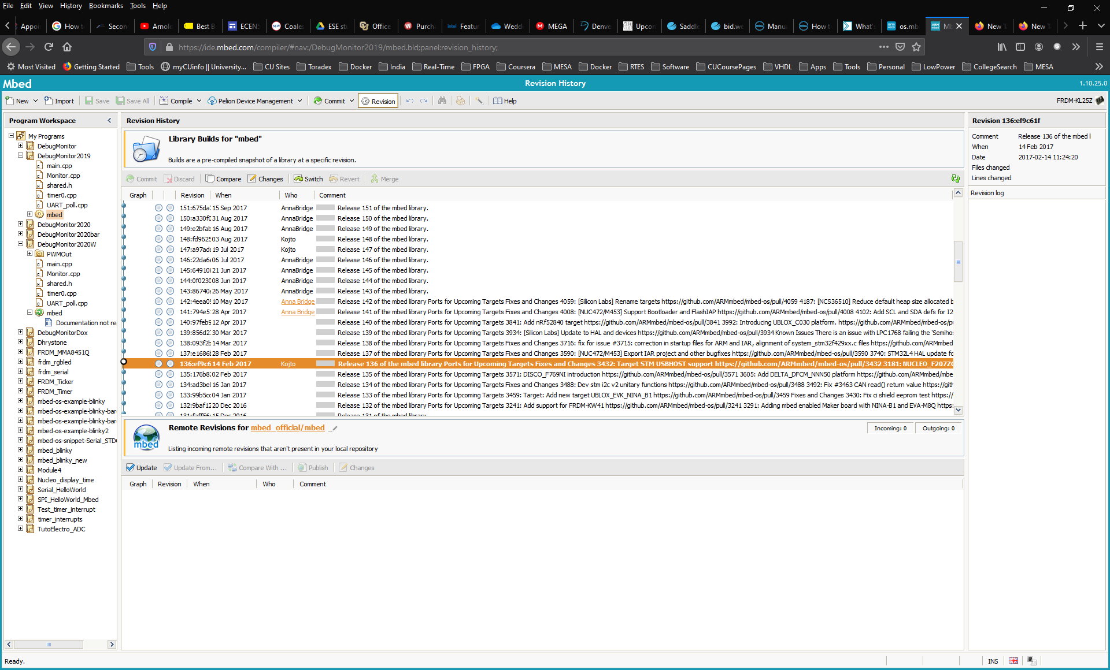

Click on the middle circle in the version 136 row, and then click switch above. This will change the mbed library version:

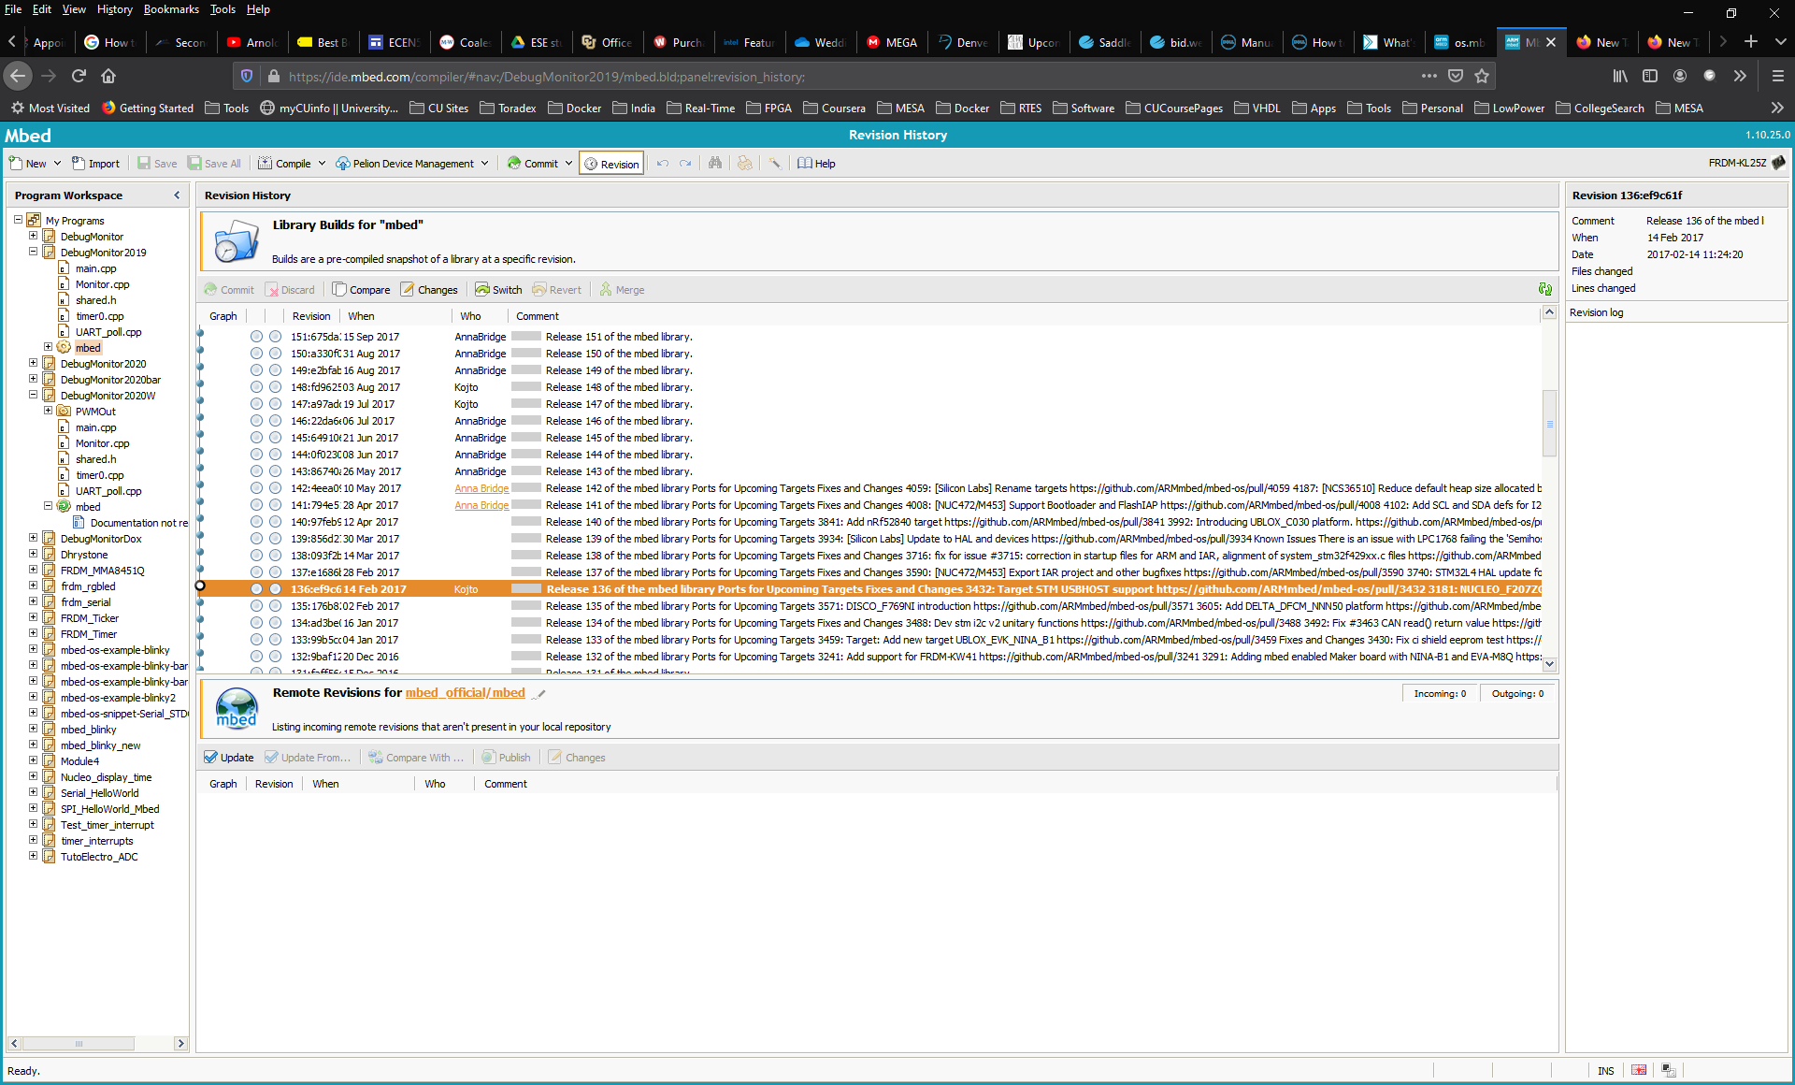

Now compile and commit your project. Right click on the project name and select export. Save the export file in your Keil uVision projects.

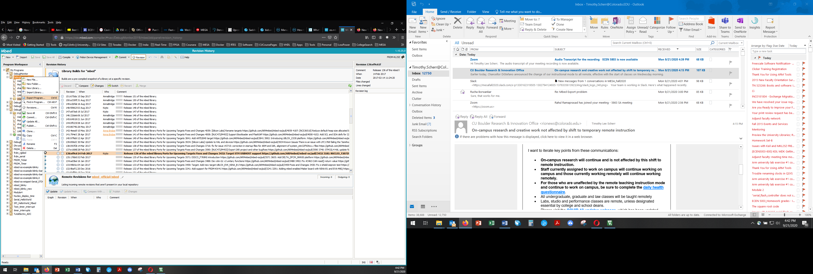

Step 2: After opening the exported mBed project in Keil uVision, in the target options Target tab, change the ARM compiler to “Use default compiler version 5”

Keil uVision Initial Screen:

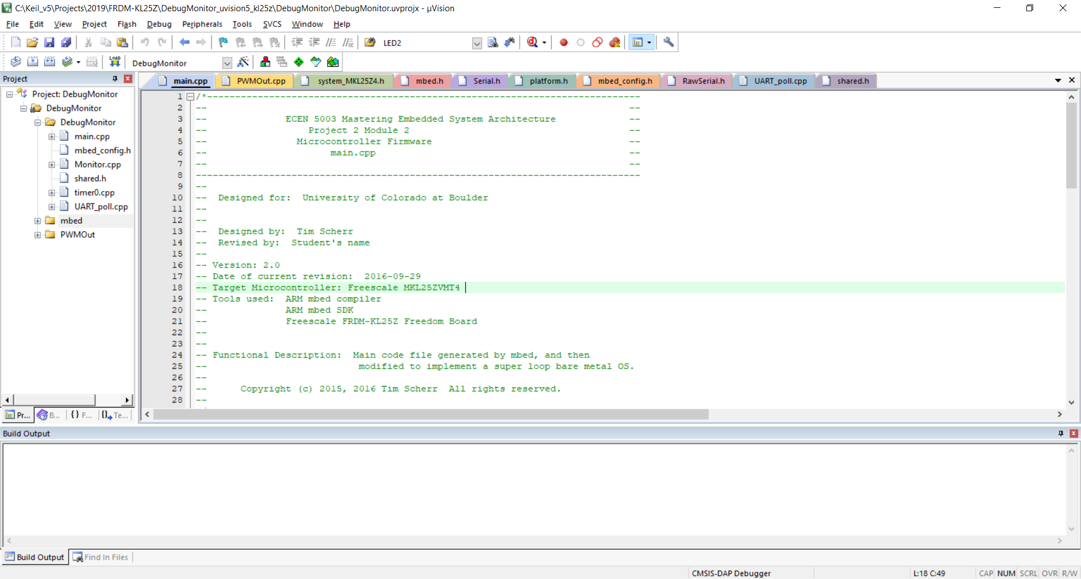

Right click on the Project name (DebugMonitor in this case) to view the Target Options:

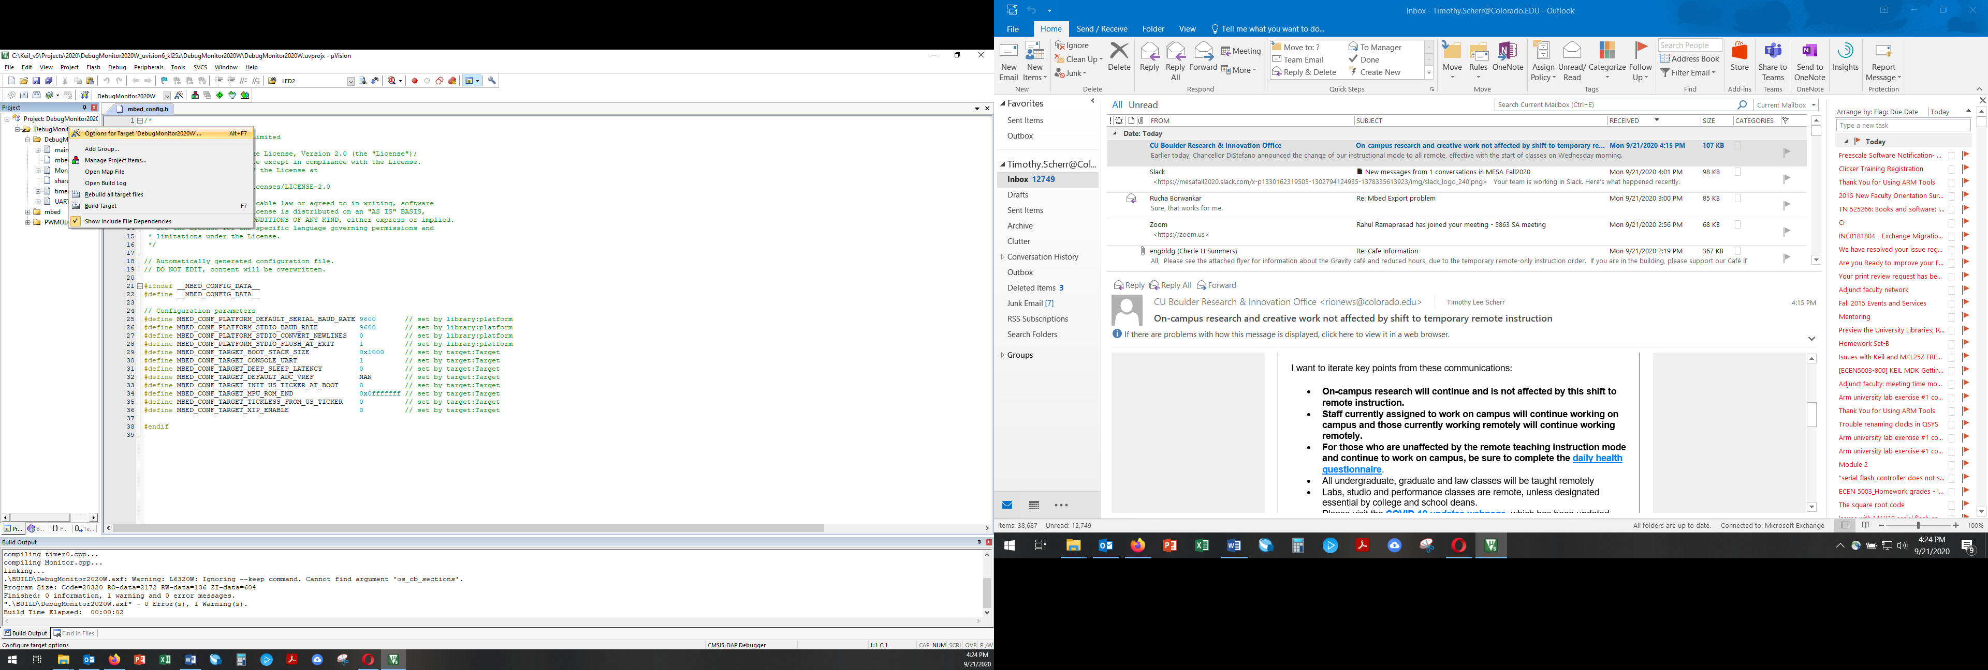

Change the ARM compiler setting to “Use default compiler version 5”

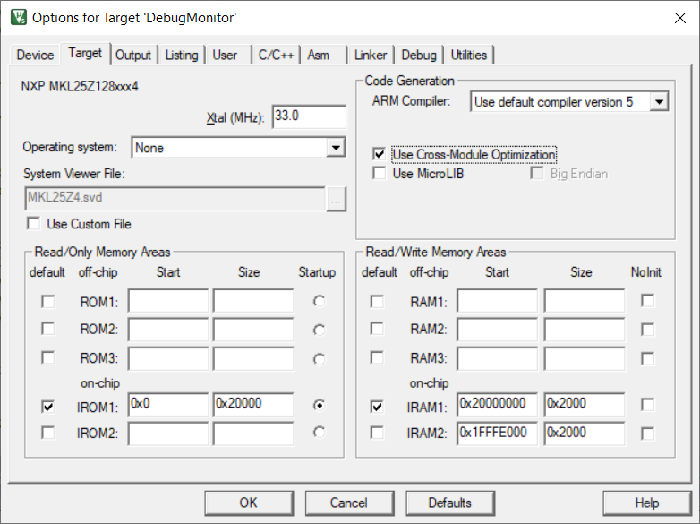

Step 3: In Keil uVision, in the target options C/C++ tab, change the Misc control string

C/C++ options:

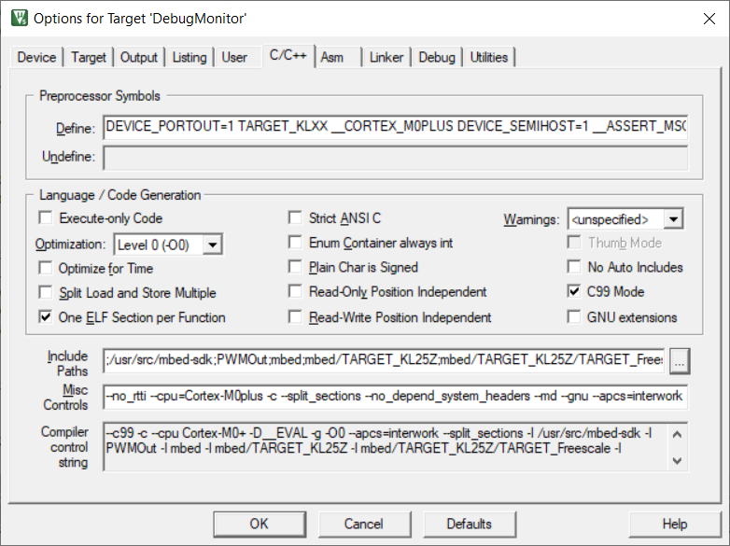

Misc Controls: --no_rtti --cpu=Cortex-M0plus -c --split_sections --no_depend_system_headers --md --gnu --apcs=interwork --preinclude=mbed_config.h