Lab Exercise:   
Serial communication

# Overview

In this lab, you will use three types of serial communication to interface with three peripherals:

* Use SPI to interface to an LCD display ( or a parallel port can be used as an alternative to SPI)
* Use I2C to interface to a temperature sensor
* Use UART to interface with a PC

After each peripheral is tested separately, you need to build an integrated application, in which the LCD displays the current temperature. High-level functions will be used in this lab.

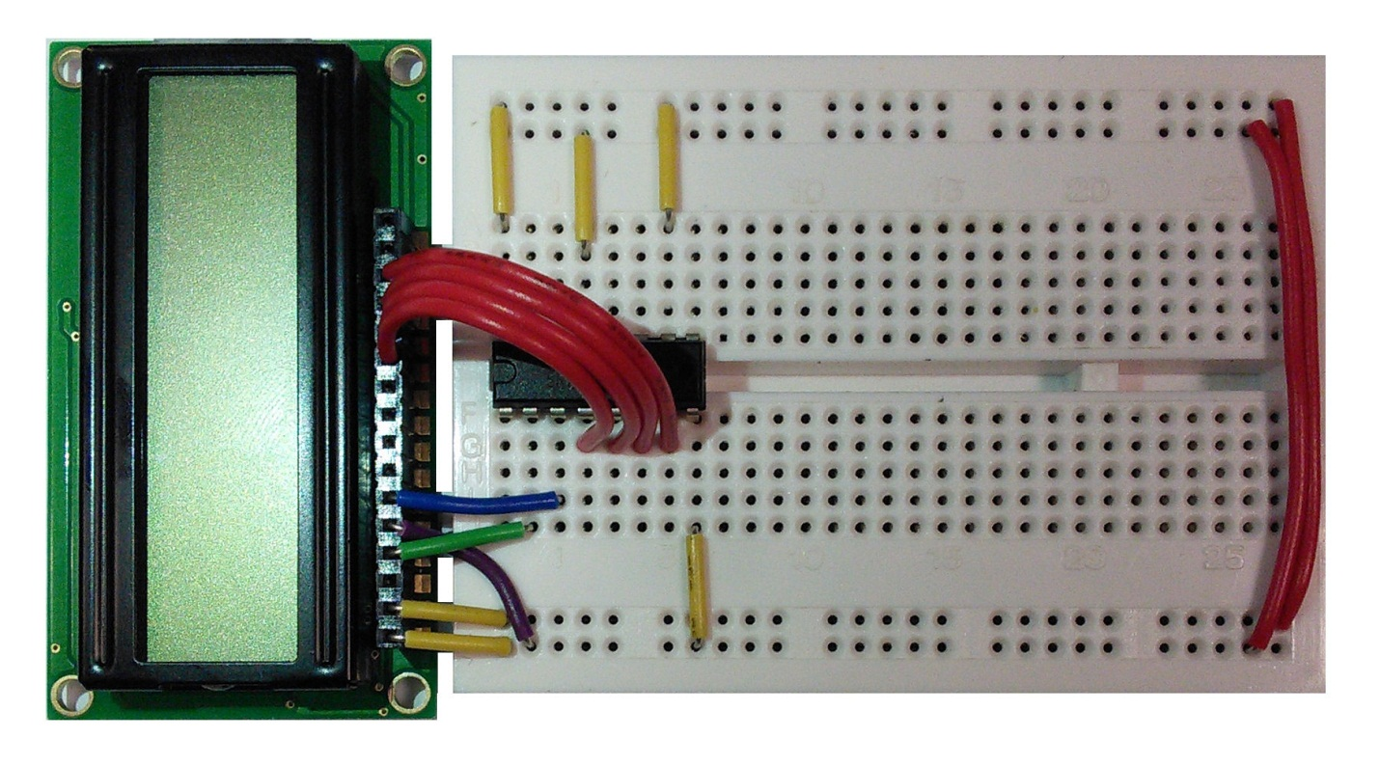

LCD screen

Vcc

74HC595N Shift Register

MOSI

SCK

CS

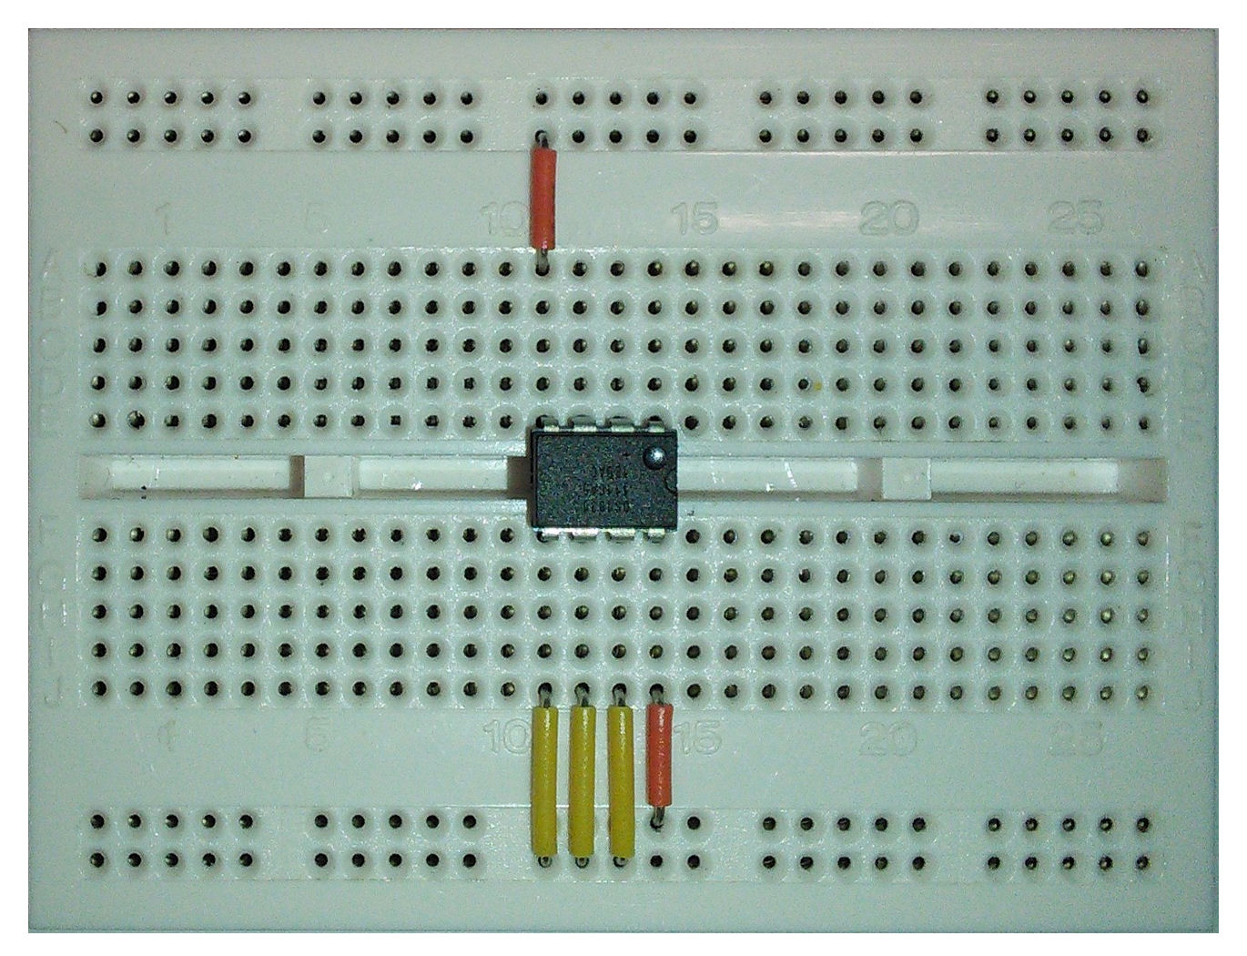

Vcc

SCL

SDA

DS1631 Temperature Sensor/Thermostat

1kΩ resistors

# implementation details

## hardware

### Nucleo F401RE board

The Nucleo F401RE board pin descriptions are shown below:

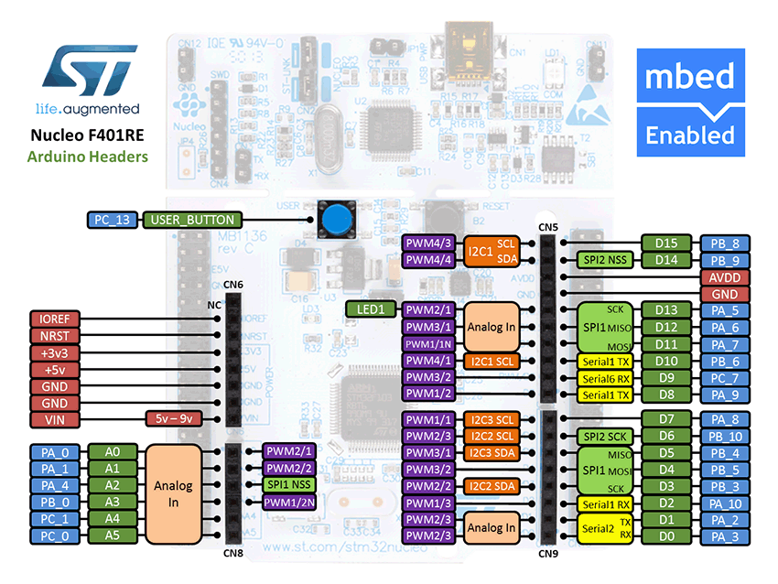

|  |  |
| --- | --- |
| **Pin** | **Pin name in mbed API** |
| LCD SPI MOSI | PA_7 |
| LCD SPI SCK (SCLK) | PA_5 |
| LCD SPI CS | PB_6 |
| Temperature sensor I2C SCL | PB_8 |
| Temperature sensor I2C SDA | PB_9 |
| USB UART TX | PA_2 |
| USB UART RX | PA_3 |

### LCD display

The LCD (NHD-0216HZ-FSW-FBW-33V3C) has a 2 line x 16 character display. It can be configured and the data can be written via SPI interface. To be able to use SPI with the LCD, you will have to use a 74HC595N shift register.

You can find out more about shift registers on Wikipedia: <http://en.wikipedia.org/wiki/Shift_register>

Detailed information about the 74HC595N can be found here:

<http://www.nxp.com/documents/data_sheet/74HC_HCT595.pdf>

You will be using the LCD in 4-bit mode. Detailed initialisation procedure can be found on page 25-26 of the ST7066U LCD driver datasheet:

[http://www.newhavendisplay.com/app_notes/ST7066U.pdf](http://www.newhavendisplay.com/app_notes/ST7066U.pdf%20)

If you have trouble with the SPI interface, as an alternative, you may wire up the LCD directly to GPIO in the 8-bit parallel mode. You will have to write your own code to drive the LCD in this case, as the provided code is the 4-bit mode through SPI only.

### temperature sensor

The temperature (DS1631) can be accessed by I2C interface.

General I2C information:

* All data is transmitted MSb first over the 2-wire bus
* One bit of data is transmitted on the 2-wire bus each SCL period
* Pull-up resistors are required on SDA and SCL lines, so that when the bus is idle both lines must remain in a logic-high state

To use it, you first need to setup the address for the temperature sensor. It is done by connecting pins 5, 6 and 7 to either Vcc or ground. In this case, we’ll connect pins 5, 6 and 7 to ground, which means that our temperature sensor address will be 0x90.

In this example, two 1kΩ pull-up resistors were used to keep the SDA and SCL lines in a logic-high while the bus is idle.

Each read or write command must start with a Control Byte:

|  |  |  |  |  |  |  |  |
| --- | --- | --- | --- | --- | --- | --- | --- |
| Bit 7 | Bit 6 | Bit 5 | Bit 4 | Bit 3 | Bit 2 | Bit 1 | Bit 0 |
| 1 | 0 | 0 | 1 | A2 | A1 | A0 | R/W |

The R/W bit is set by the API, so you don’t need to worry about it.

Command set for DS1631:

|  |  |  |
| --- | --- | --- |
| Command | Command in Hex | Description |
| Start Convert T | 0x51 | Initiates temperature conversions |
| Stop Convert T | 0x22 | Stops temperature conversions when the device is in continuous conversion mode |
| Read Temperature | 0xAA | Reads the last converted temperature value from the 2-byte temperature register |
| Access TH | 0xA1 | Reads or writes the 2-byte TH register |
| Access TL | 0xA2 | Reads or writes the 2-byte TL register |
| Access Config | 0xAC | Reads or writes the 1-byte configuration register |
| Software POR | 0x54 | Initiates a software power-on-reset (POR), which stops temperature conversions and resets all registers and logic to their power-up states. The software POR allows the user to simulate cycling the power without actually powering down the device |

The temperature register has 16 bits, divided into MSByte and LSByte, the data is aligned from MSByte to the 3 MSBs of the LSByte, as shown below:

|  |  |  |  |  |  |  |  |  |  |  |  |  |  |  |  |
| --- | --- | --- | --- | --- | --- | --- | --- | --- | --- | --- | --- | --- | --- | --- | --- |
| MSByte | | | | | | | | LSByte | | | | | | | |
| 7 | 6 | 5 | 4 | 3 | 2 | 1 | 0 | 7 | 6 | 5 | 4 | 3 | 2 | 1 | 0 |
| D10 | D9 | D8 | D7 | D6 | D5 | D4 | D3 | D2 | D1 | D0 | X | X | X | X | X |

The MSB is used to indicate the sign of the temperature, for example:

* If the Temp data MSByte bit D10 = 0, then the temperature is positive and Temp value (oC) = +(Temp data) x 0.125 oC.
* If the Temp data MSByte bit D10 = 1, then the temperature is negative and Temp value (oC) = o (two’s complement of Temp data) x 0.125 oC.

The detailed information can be found at the product datasheet:

<http://datasheets.maximintegrated.com/en/ds/DS1631-DS1731.pdf>

## Software functions

Functions maybe used in this section are listed below:

|  |  |
| --- | --- |
| **Function name** | **Description** |
| ***UART functions*** |  |
| Serial (PinName tx, PinName rx, const char *name=NULL) | Create a Serial port, connected to the specified transmit and receive pins |
| void baud (int baudrate) | Set the baud rate of the serial port |
| void format (int bits=8, Parity parity=SerialBase::None, int stop_bits=1) | Set the transmission format used by the serial port |
| int readable () | Determine if there is a character available to read |
| int writeable () | Determine if there is space available to write a character |
| void attach (void(*fptr)(void), IrqType type=RxIrq) | Attach a function to call whenever a serial interrupt is generated |
| void send_break () | Generate a break condition on the serial line |
| void set_flow_control (Flow type, PinName flow1=NC, PinName flow2=NC) | Set the flow control type on the serial port |
| int putc( int ch, FILE *stream ) | Writes the character ch to stream. Function returns the character written, or EOF if an error happens |
| int getc( FILE *stream ) | Read a character from the stream, an EOF indicates the end of file is reached |
| int printf( const char *format, ... ) | Prints output both text string and data, according to format and other arguments passed to printf() |
| ***SPI functions*** |  |
| SPI (PinName mosi, PinName miso, PinName sclk, PinName _unused=NC) | Create a SPI master connected to the specified pins |
| void format (int bits, int mode=0) | Configure the data transmission format |
| void frequency (int hz=1000000) | Set the spi bus clock frequency |
| virtual int write (int value) | Write to the SPI Slave and return the response |
| ***I2C functions*** |  |
| I2C (PinName sda, PinName scl) | Create an I2C Master interface, connected to the specified pins |
| void frequency (int hz) | Set the frequency of the I2C interface |
| int read (int address, char *data, int length, bool repeated=false) | Read from an I2C slave |
| int read (int ack) | Read a single byte from the I2C bus |
| int write (int address, const char *data, int length, bool repeated=false) | Write to an I2C slave |
| int write (int data) | Write single byte out on the I2C bus |
| void start (void) | Creates a start condition on the I2C bus |
| void stop (void) | Creates a stop condition on the I2C bus |

## your Application Code

### SPI

* Initialise the LCD (implement the init_lcd() function in the NHD_0216HZ.cpp using the initialisation sequence from the ST7066U LCD driver datasheet)
* Print something to the LCD

### uart

Send text to the PC

* Set the baudrate
* Print “Hello mbed” to the PC
* Open a terminal (e.g. putty) on the PC to view the message

### I2C

Display the temperature on the PC

* Write the Start Convert T command to the sensor, then write the Read Temperature command to the sensor
* Read the 16-bit temperature data
* Convert the temperature data into real temperature
* Print the temperature to the PC via UART

### iNTEGRATION USING HIGH-LEVEL API

Display the temperature on the LCD using high-level APIs, including:

|  |  |
| --- | --- |
| **Function name** | **Description** |
| NHD_0216HZ (PinName CS, PinName MOSI, PinName SCLK) | Create a NHD_0216HZ LCD interface |
| void init_lcd() | Initialise the NHD_0216HZ LCD |
| void clr_lcd() | Clear the screen |
| void set_cursor (int column, int row) | Set location of the starting text |
| int printf( const char *format, ... ) | Print to the LCD |
| DS1631 (PinName sda, PinName scl, int addr) | Create a DS1631 temperature sensor interface |
| int read() | Read the temperature register and convert to the real temperature presentation |