**Swati Kadivar**

**ECEN 5803 - Mastering Embedded System Architecture**

**Homework set 1**

1. Visit the https://os.mbed.com/handbook/Homepage website. Find the Freescale Freedom board KL25Z enable platform and answer the following questions

a. How many UARTs does this device have? **Three**

b. What is the part number of the on-board accelerometer? **MMA8451Q – 3-axis accelerometer**

2. Draw a UML, flowchart or similar sequence diagram that will find the smallest of 3 numbers, A, B, and C and list them in ascending order. Write a C program that implements this flowchart.

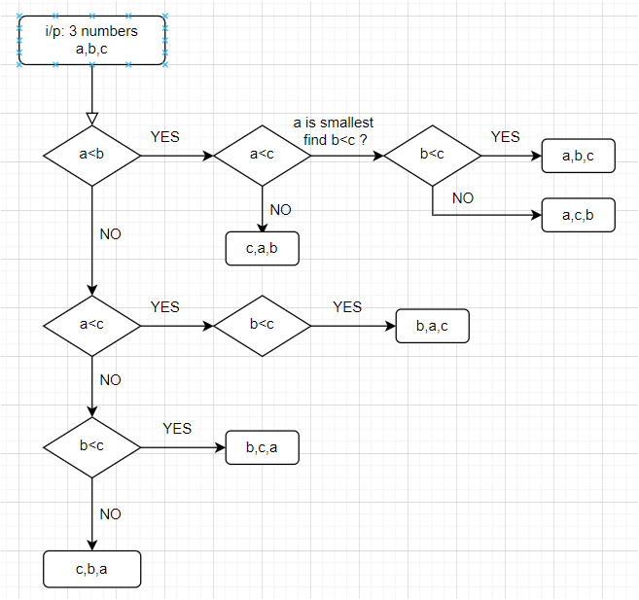

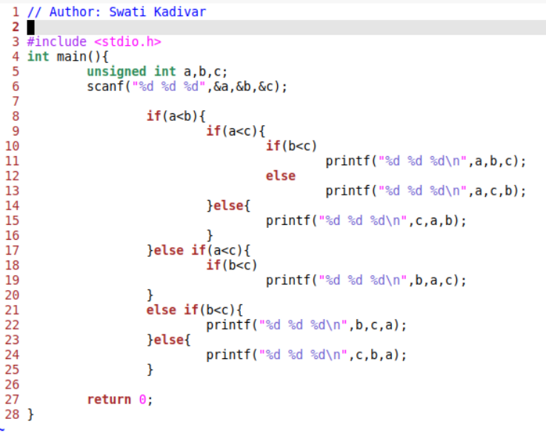

3. At what stage of the design methodology or development cycle should we determine what type of CPU to use (8-bit versus 16-bit versus 32-bit, memory size, etc.)?

**Requirements stage**

4. Given the State Diagram below, provide a state table with binary encoding and design a circuit to implement the corresponding state machine using

a. gates and D flip-flops

|  |  |  |  |  |
| --- | --- | --- | --- | --- |
| current state | | input | next state | |
| A | B | C | X | Y |
| 0 | 0 | 0 | 0 | 0 |
| 0 | 0 | 1 | 0 | 1 |
| 0 | 1 | 0 | 1 | 0 |
| 0 | 1 | 1 | 0 | 1 |
| 1 | 0 | 0 | 1 | 0 |
| 1 | 0 | 1 | 1 | 1 |
| 1 | 1 | 0 | 1 | 1 |
| 1 | 1 | 1 | 0 | 0 |
|  |  |  |  |  |
| X-map |  |  |  |  |
| C A B | 0 | 1 | 11 | 10 |
| 0 | 0 | 1 | 1 | 1 |
| 1 | 0 | 0 | 0 | 1 |
| X = BC̅+AB̅ | | | | |
|  |  |  |  |  |
| Y-map |  |  |  |  |
| C A B | 0 | 1 | 11 | 10 |
| 0 | 0 | 0 | 1 | 0 |
| 1 | 1 | 1 | 0 | 1 |
| Y = CĀ + ABC̅ + B̅C | | | | |

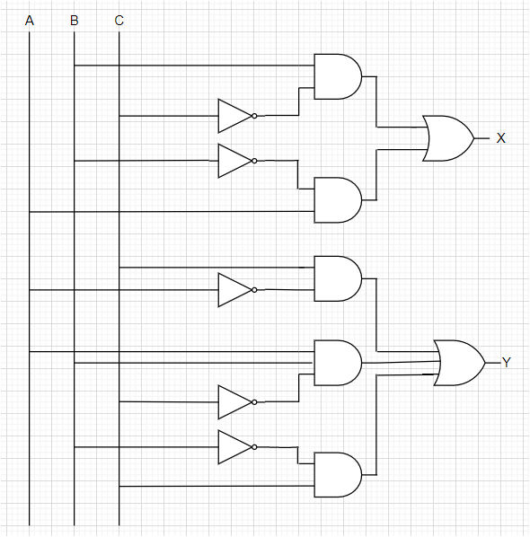

b. a control memory (FLASH or EPROM memory with added registered outputs)

5. What organization is most involved in creating standards to assure quality control in product development?

**ISO**

Look up this organization’s standard 8601 and explain how it impacts embedded systems design.

**The purpose of standard ISO 8601 is to provide a well-defined, unambiguous method of representing calendar dates and times in worldwide communications, especially to avoid misinterpreting numeric dates and times when such data is transferred between countries with different conventions for writing numeric dates and times.**

6. Given the GPS Navigator product requirements above, what would you base the Embedded System Architecture on, given the following options:.

Justify your answer using ARM’s Embedded System Options Criteria (see Lecture Notes) and be sure to include Time to Market.

a. ASIC - NO because of extremely high design cost ($500k/mask set)

b. MCU - **Yes - It has all the factors perfectly matching as we want – low design cost, mid to low Unit cost (~160$), easy to upgrade and bug fix, small in size, low weight, low-medium power consumption and last moderate performance.**

c. MPU - No. It will have low to mid design cost, size and weight while we want low design cost, size and weight

d. Discrete Circuits - NO. Very heavy in weight and size.

e. Programmable Logic (FPGA) - NO. Power issue.

f. Embedded PC – NO. Size issue.

7. a. What benefit is provided by the use of indirect addressing?

**This addressing mode allows executing the same set of instructions for the different memory location. This can be done by incrementing the content of register thereby pointing the new location each time. With the help of this quality the number of instructions decreases as a result of which performance increases. for a word length of N, an address space of 2N is now available. the content of the register containing the pointer to the operand can be modified at runtime.**

b. For each Processor Architecture Listed, answer the question: Does this processor use indirect addressing, and if so, what register or memory location is used to store the address?

1. ARM M0+**: yes, General purpose registers R0-R12**

2. PIC 16F**: yes, FSR0L, FSR0H, and INDF0 control channel 0, FSR1L, FSR1H, and INDF1 control channel 1**

3. TI C55x DSP**: yes, XAR0−XAR7 and AR0−AR7**

8. Answer the following questions about the ARM programming model:

a. How many general-purpose registers are there? **30**

b. What is the purpose of the CPSR? **By medium of CPSR register you can see the thumb, fast, interrupt, overflow, carry, zero, and negative flags’ status at any given point of time.**

c. What is the purpose of the Z bit? **If the result of an operation is zero then this bit gets set in CPSR.**

d. Where is the program counter kept? **General purpose register set: R15**

9. How would the ARM status word be set after these operations?

a. 2-3 : **N, V**

b. -232 + 1 –1 : **N,V,C**

c. -4+5 : **Nothing will change**

10. What is the meaning of these ARM condition codes?

**a. EQ: Equals to**

**b. NE: Not equals to**

**c. MI: Minus**

**d. VS: Signed overflow**

**e. GE: greater than**

**f. LT: Less than**

Questions out of the book:

F.3 What are the three kinds of computing engine that are utilized in embedded systems?

**Microprocessor, microcontroller, microcomputer**

F.6 What is an instruction cycle?

**The instruction cycle (also known as the fetch–decode–execute cycle, or simply the fetch-execute cycle) is the cycle that the central processing unit (CPU) follows from boot-up until the computer has shut down in order to process instructions.**

F.12 Briefly describe the major elements of the embedded system development life cycle.

The major elements of the Embedded systems development life cycle involves:

* Requirements Analysis
* System specification
* System Architecture
* Hardware/Software design
* Hardware/Software Implementation
* Hardware/Software Testing
* System Integration
* System Validation
* Operation and Maintenance

F.8 Today, in the typical embedded system development cycle, hardware design precedes software design. Discuss the advantages and disadvantages of developing the hardware and software components of the system at the same time

1.11 How do we distinguish a signed integer from one that is unsigned?

Unsigned number will have double the range of numbers available for a given number of bits than signed number. For example, for a 4 bit number, signed number will have –7 to 7 range while unsigned will have 0 to 16 range. Signed numbers have one bit (MSB) reserved for a sign. Unsigned numbers will give unpredictable behavior when being used to store a negative number.

1.12 What do the terms little endian and big endian mean? Why are they important?

Little endian and Big Endian indicates how a word is stored in a memory. If it stores lower byte at lower address then it’s little endian and if it stores lower byte at higher address then it is big endian as shown in below figure from a textbook. Different microprocessors, operating systems, and networks interpret such words in different ways. When executing a design, so it is absolutely essential to determine which format each of these components in the system uses.

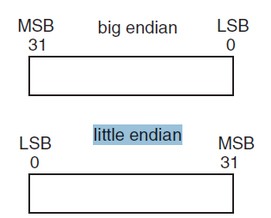

1.17 How are alphanumeric characters and symbols represented inside of a microprocessor?

Alphanumeric characters are represented by an internationally agreed code, the International Standards Organization (ISO) Code which was derived from the American Standard Code for Information Interchange (ASCII). The seven-bit ASCII code represents all the letters of the alphabet, both upper and lower case, as well as the numerals 0 to 9 and various punctuation marks and control codes.

Ref: <https://www.sciencedirect.com/topics/engineering/alphanumeric-character>

1.16 The essential components of an instruction are the opcode and operand(s) on which the operation is to be performed. Is it necessary that the opcode always contain the same number of bits? Why or Why not?

Opcode is calculated by taking log of instruction set size and instruction set size remains same irrespective of operand values so opcode always contain the same number of bits.

1.24 If one has an assembly code listing for an embedded program that has been running on a Motorola processor, will that program run on an AMD processor?

No. The program won’t run.

1.30 Explain why a register access is generally faster than a memory access.

Registers are stored on CPU itself while memory may or may not be on the same chip as CPU. So register access is faster.