1. **Project Structure: Page Object Model**

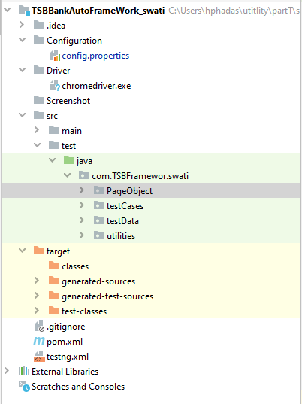

2.Components of framework:

* Configuration
* Driver
* Screenshot
* SRC\main\test\java – PageObject
* Testcases
* testData
* utilities

**Configuration**: This directory contains Config.properties file, which basically has all the prop = value pairings of important configuration , eg : URL , username, password

**Driver**: This Directory contains chrome driver executable file

**PageObject:**  As this is the page object based framework, this directory would include all pages (java files) persisted to AUT(application under test)

**TestCases**: As name suggest, all test cases would be returned under this segment

**TestData**: This would contain excel (data driven execution)

**Utilities**: This folder would contain all the common utilities classes needed for smooth running of framework. Eg – excel reading utilities, Config file reading utilities

**Testng**.xml: configurable xml for bulk and selective running of test cases

**Pom.Xml:** all dependency needed for our framework to continue working.

As this is a maven-based framework, we can have many more future extensions like rerun of failed test cases, extent report for proper reporting, integration with Jenkins and many more

Framework component and Process:

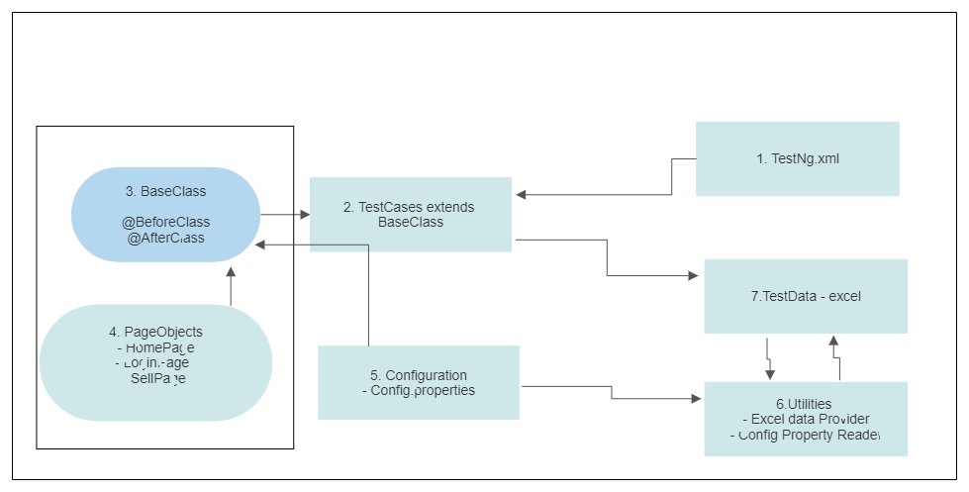

Test Cases: