PROJECT REPORT
Contact Book (CLI)
A Menu-Driven Command-Line Application for Managing Personal Contacts

Course: Python Essentials
Name: Swati Krishnani
Registration Number: 26BAI10937
Program: BTech CSE-AIML

Table of Contents
1. Introduction
2. Problem Statement
3. Functional Requirements
4. Non-Functional Requirements
5. System Architecture
6. Design Diagrams
7. Design Decisions & Rationale
8. Implementation Details
9. Sample Run / Results
10. Testing Approach
11. Challenges Faced
12. Learnings & Key Takeaways
13. Future Enhancements
14. References

1. Introduction
Keeping track of personal contacts — names, phone numbers, and email addresses — is one of the most common small tasks a personal computer is used for. In practice this information often ends up scattered across notes apps, saved chat messages, or a phone's built-in address book, none of which are easy to search, back up, or version-control.
This project, the Contact Book (CLI), is a simple command-line application for adding, viewing, searching, and deleting personal contacts, with the results persisted between runs in a local file. It is built entirely in Python 3 using only the standard library (json and os) — no external packages, no database server, and no GUI toolkit are required, which keeps setup effectively zero-friction for a first-year project.
The application follows a small two-layer design: a menu-driven command-line interface handles all user interaction, while a separate module holds the core logic (adding, searching, deleting, validating, and persisting contacts) as plain, independently testable functions.
This report documents the problem the application addresses, its requirements, architecture, design decisions, implementation, testing approach, and the challenges encountered while building it, along with reflections on what was learned and how the project could be extended further.

2. Problem Statement
Without a dedicated, lightweight tool, personal contact details tend to accumulate in an unstructured way — spread across notes, messages, and device-specific address books that are difficult to search consistently or move between systems.
There is a need for a simple, dependency-free command-line application that lets a user add, view, search, and delete contacts; validates entries at the point of entry so obviously malformed data (an empty name, a non-numeric phone number, a malformed email) is rejected immediately; and persists the contact list between sessions without requiring a database server or a graphical interface — making it approachable to build and run as an early Python project.

3. Functional Requirements
The system shall provide the following capabilities:
- Present an interactive, numbered menu accessible via a single command-line entry point (python main.py).
- Allow the user to add a new contact consisting of a name, phone number, and email address.
- Reject an empty name, a phone number that is not all digits or is under 7 digits, and an email address missing '@' or '.'.
- Reject a new contact whose name matches an existing contact's name (case-insensitive).
- Persist all contacts to a local JSON file (contacts.json) so data survives between runs.
- Automatically load any existing contacts from contacts.json when the program starts.
- Allow the user to view all saved contacts, sorted alphabetically by name.
- Allow the user to search contacts by a case-insensitive partial match on name.
- Allow the user to delete a contact by an exact (case-insensitive) name match.
- Display a clear message when a view or search returns no contacts, instead of an empty or confusing output.
- Handle an invalid menu selection gracefully, re-prompting the user instead of crashing.
- Allow the user to exit the program cleanly via a dedicated menu option.

4. Non-Functional Requirements

4.1 Performance
- For a personal-scale contact list (tens to a few hundred entries), every operation should feel instantaneous, since the full list is held in memory during the session and re-serialized to JSON only on add/delete.

4.2 Reliability
- A missing or corrupted contacts.json at startup should not crash the program — it should fall back to an empty contact list.
- Invalid user input (bad menu choice, malformed contact details) should produce a clear error message rather than an unhandled exception.

4.3 Usability
- The interface should be a numbered menu requiring no memorized command syntax, so it is approachable for a first-time user.

4.4 Maintainability
- Core contact logic and the command-line interface should live in separate modules, so either can be changed independently.
- Each function should have a single, clearly named responsibility (add, find, delete, sort, load, save).

4.5 Portability
- The application should run on any system with Python 3.8 or later, using only the standard library, with no installation step beyond having Python itself.

4.6 Testability
- Core logic should be verifiable with automated unit tests that operate on an in-memory list, independent of the menu loop or the filesystem.

5. System Architecture
The application follows a simple two-layer architecture. A logic-and-persistence layer (contacts.py) exposes plain functions for loading, saving, adding, searching, deleting, and sorting contacts. A presentation layer (main.py) owns the menu loop and all user interaction (input() and print() calls), delegating every actual operation on the contact list to contacts.py.
main.py never reads or writes contacts.json directly, and contacts.py never calls input() or print() — this keeps the core logic reusable and independently testable, and keeps the interface layer free of any storage or validation logic. On startup, main.py loads the contact list once and keeps it in memory for the session; every add or delete operation immediately saves the updated list back to contacts.json so the file always reflects what is shown on screen.
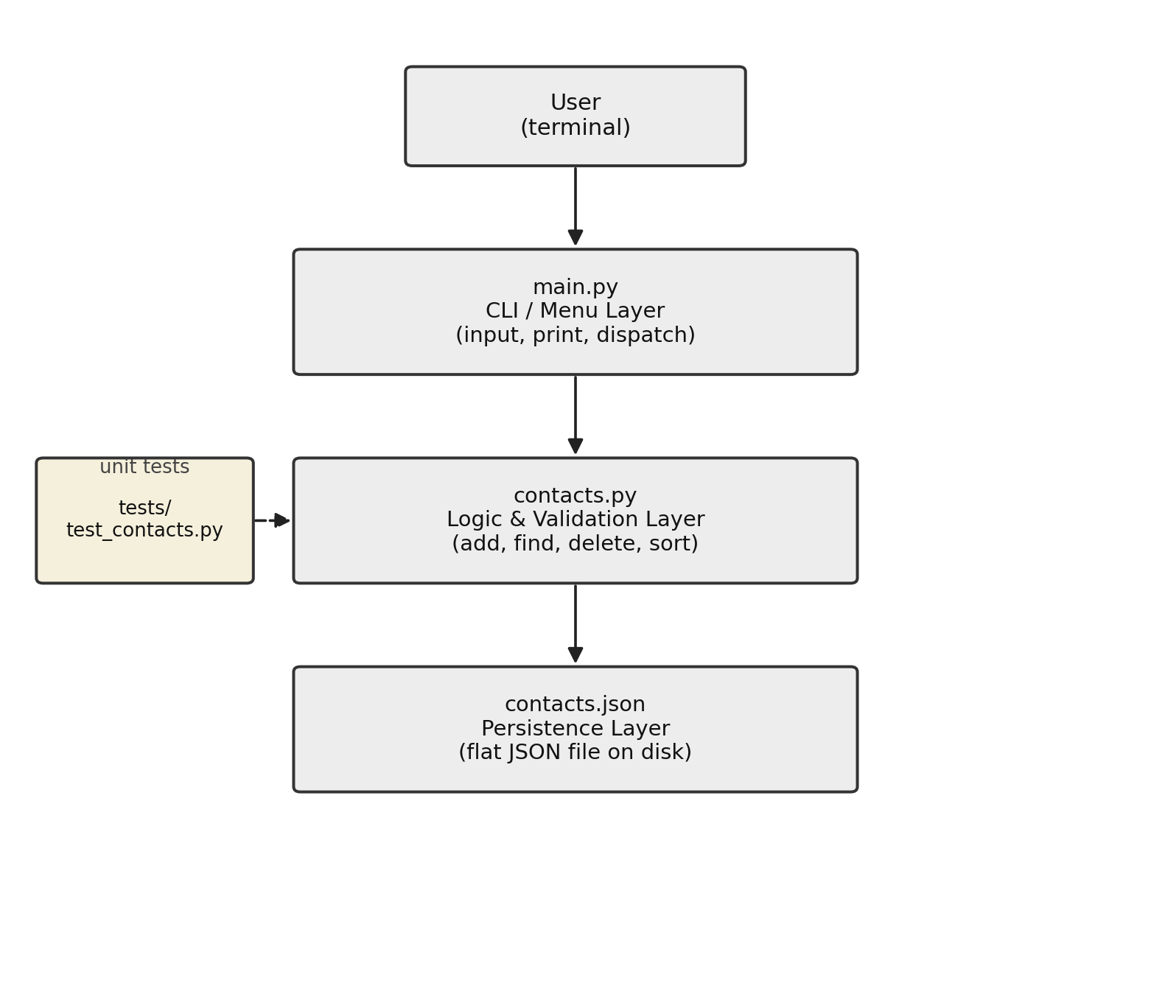
Figure 5.1 — Layered system architecture: CLI → logic → persistence, with tests exercising the logic layer directly.

6. Design Diagrams
This is a small, single-user command-line utility rather than a multi-component or multi-actor system, so several of the diagrams a larger project would include do not meaningfully apply here:

6.1 Use Case Diagram
A single actor — the user running the program from a terminal — interacts with the system through five menu-driven actions: Add Contact, View All, Search, Delete, and Exit.

6.2 Workflow Diagram
The diagram below traces the program's flow from start-up through the menu loop to exit: contacts are loaded once, the menu repeats until the user chooses to leave, and only the actions that change data (Add, Delete) write back to contacts.json before looping.
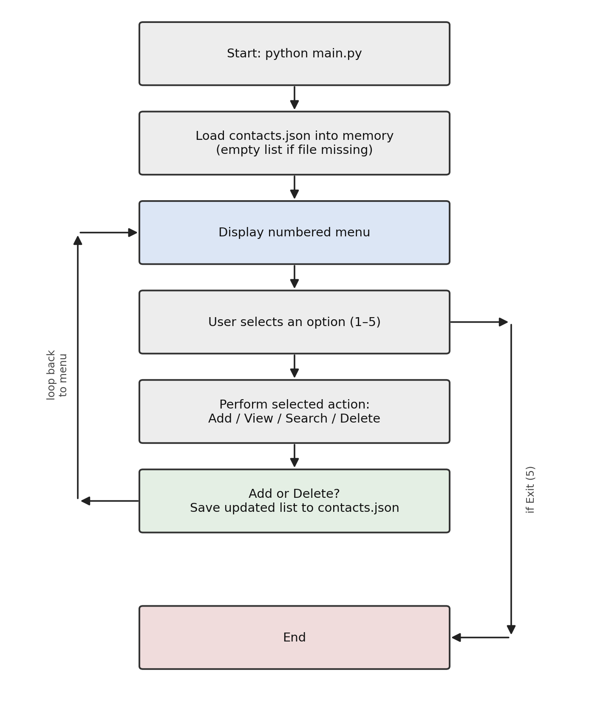
Figure 6.2 — Menu-driven workflow.

6.3 Sequence / Class Diagrams
Not applicable in any detailed sense: each menu choice triggers one synchronous call from main.py into a single function in contacts.py, followed by a print to the console. No classes are used in this project (see Section 7.2 for the rationale), so there is no class or component diagram to draw beyond the two-module structure already described in Section 5.

6.4 ER Diagram
Not applicable. This project does not use a relational or document database. Contacts are stored as a flat JSON array of objects in a single file, with exactly three fields per contact (name, phone, email), so there is no schema to model.

7. Design Decisions & Rationale

7.1 A JSON file over a database
The project deliberately avoids SQLite or any database engine in favor of a single JSON file. For a personal-scale contact list, this keeps the project dependency-free, makes the stored data human-readable and directly editable in a text editor, and keeps the storage layer simple enough to explain and reason about — an appropriate trade-off for a first project, at the cost of not scaling well to very large contact lists or concurrent access.

7.2 Plain functions over classes
Contact operations are implemented as plain functions that take and return an explicit list of dictionaries, rather than being wrapped in a class. This keeps the code approachable for an early stage in a Python course, while remaining fully testable — each function can be exercised directly in a unit test without needing to construct or manage an object's internal state.

7.3 A menu-driven loop over a flag-based CLI
The interface uses an input()-driven numbered menu rather than command-line flags (the style used in a separate, more advanced sibling project). This was chosen so a first-time user only has to read a menu and type a number, with nothing to memorize. The trade-off is that this style is less convenient to script or automate than a flag-based CLI would be.

7.4 Validation at the single point of entry
Name, phone, and email are all validated inside add_contact(), which raises a ValueError with a specific message the moment invalid data is given, rather than allowing bad data into contacts.json and discovering it later. Centralizing validation in one function also means the rules only need to be written, and tested, once.

7.5 Separating logic (contacts.py) from interface (main.py)
Keeping all storage and validation logic out of main.py means the interface file stays a thin, readable menu loop, and contacts.py can be unit-tested directly and reused by a different interface (a GUI or a web front end) later without any changes to its logic.

8. Implementation Details
The system is implemented in Python 3 using only the json and os modules from the standard library — no third-party packages are required.

8.1 Module Responsibilities
- contacts.py — load_contacts(), save_contacts(), add_contact(), find_contacts(), delete_contact(), sorted_by_name().
- main.py — the menu loop, all input()/print() calls, and dispatching each menu choice to the matching contacts.py function.
- tests/test_contacts.py — unit tests exercising contacts.py directly, independent of the menu.

8.2 Key Logic

Validation
add_contact() strips whitespace from all three fields, then checks: the name is non-empty and not already used by another contact (case-insensitive); the phone number consists only of digits and is at least 7 characters long; and the email contains both '@' and '.'. The first failing check raises a ValueError describing exactly what was wrong, which main.py catches and prints as a plain error message.

Search
find_contacts() performs a case-insensitive substring match between the search keyword and each contact's name, returning every contact whose name contains the keyword anywhere.

Persistence
save_contacts() serializes the in-memory list of contact dictionaries to contacts.json using json.dump(..., indent=2), keeping the file human-readable. load_contacts() returns an empty list if the file does not exist or fails to parse as JSON, rather than raising an exception at startup.

8.3 Example: Running the Program
$ python main.py
===== CONTACT BOOK =====
1. Add contact
2. View all contacts
3. Search contact
4. Delete contact
5. Exit

9. Sample Run / Results
The application was validated end-to-end with a manual smoke test: adding two contacts, viewing the list, searching by a partial name, deleting one contact, and viewing the list again. The actual console output from this run is reproduced below.

9.1 Adding and viewing contacts
Choose an option (1-5): 1
Name: Asha Patel
Phone (digits only): 9876543210
Email: asha@mail.com
Added 'Asha Patel' successfully.

9.2 Searching contacts
Choose an option (1-5): 3
Search by name: asha
Name : Asha Patel
Phone: 9876543210
Email: asha@mail.com

9.3 Deleting a contact and viewing the final list
Choose an option (1-5): 4
Name to delete: Ravi Kumar
Deleted 'Ravi Kumar'.
Choose an option (1-5): 2
1 contact(s):
Name : Asha Patel
Phone: 9876543210
Email: asha@mail.com

10. Testing Approach

10.1 Automated Unit Tests (unittest)
tests/test_contacts.py exercises the core logic in contacts.py directly, independent of the menu:
- add_contact() is tested for a successful add, an empty name, an invalid phone number, an invalid email, and a duplicate name — each invalid case verified to raise ValueError.
- find_contacts() is tested to confirm a partial, case-insensitive name match returns the right contact.
- delete_contact() is tested for both a successful delete and an attempt to delete a name that does not exist.
- sorted_by_name() is tested to confirm contacts come back in alphabetical order regardless of insertion order.
All nine tests operate on a plain in-memory list, so they run instantly and do not touch the filesystem.

10.2 Manual Smoke Test
The full menu flow — add two contacts, view, search, delete one, view again, exit — was run end-to-end via python main.py, with the output confirmed against expectations (see Section 9).

10.3 What Is Not Covered
The current test suite covers the in-memory logic only; it does not test load_contacts() and save_contacts() reading and writing an actual file on disk. A future addition would test this file round-trip using a temporary file, as noted in Section 13.

11. Challenges Faced

11.1 Deciding how strict validation should be
Choosing how strictly to validate a phone number and email address — without pulling in a full validation library — required a deliberate trade-off. The project settled on lightweight checks (digits-only and a minimum length for phone; presence of '@' and '.' for email) that catch obviously malformed input without rejecting valid real-world formats the checks weren't designed to anticipate.

11.2 Preventing duplicate names without over-restricting
Rejecting a new contact whose name matches an existing one prevents accidental duplicates, but also means two different people who happen to share a name cannot both be stored under that name. This is acknowledged as a known limitation rather than solved outright, since allowing duplicate names would make search-by-name and delete-by-name ambiguous.

11.3 Choosing JSON over a database
Weighing the simplicity of a JSON file against the greater capability of a real database (as used in a separate, more advanced project) required judging the actual scale this project needs to support. JSON was chosen as the right fit for a personal-scale, single-user contact list (see Section 7.1).

12. Learnings & Key Takeaways
- Separating pure logic functions from user-interaction code (input()/print()) makes a project properly unit-testable, since the logic can be exercised without simulating console input.
- Wrapping file loading in a try/except, and falling back to a sensible default, is a small addition that meaningfully improves reliability on first run or after manual edits to the data file.
- Centralizing all validation in a single entry-point function (add_contact()) keeps invalid data out of storage entirely, rather than needing to be checked again later.
- Small, single-purpose functions (one per menu action) made the main.py menu loop straightforward to read and easy to extend with a new option.
- A human-readable storage format (indented JSON) makes debugging and manual inspection of the data noticeably easier during development.

13. Future Enhancements
- Add an 'edit contact' option to update an existing contact's phone or email without deleting and re-adding it.
- Support multiple phone numbers or email addresses per contact.
- Add CSV export/import so contacts can be exchanged with other tools.
- Extend the test suite to cover load_contacts()/save_contacts() against a real temporary file (see Section 10.3).
- Migrate storage to SQLite if the contact list grows beyond a personal scale (mirroring the approach used in a separate, larger project).
- Add an optional notes or address field per contact.

14. References
- Python Documentation — json module. https://docs.python.org/3/library/json.html
- Python Documentation — os.path module. https://docs.python.org/3/library/os.path.html
- Python Documentation — unittest module. https://docs.python.org/3/library/unittest.html
- Python Documentation — argparse vs. simple input() loops (design reference). https://docs.python.org/3/library/argparse.html

