URL Shortener Service
API Documentation & System Flow
Version 1.0 • REST API Reference

1. System Architecture
The URL Shortener Service is built with Spring Boot and organized into the following layers:

Layer | Responsibility
api | REST endpoints — controllers that receive HTTP requests
service | Business logic — validation, expiry, click tracking
repository | Database operations — JDBC-based reads and writes
dto | Request/response models — CreateShortUrlRequest, ShortUrlResponse
model | Core domain object — ShortUrl with expiry and analytics
validation | URL safety checks — blocks private IPs, localhost, non-http
exception | Custom exceptions — ResourceNotFoundException, etc.
config | Spring Security and application configuration

2. API Endpoints Overview
All endpoints are served on port 8080. Management endpoints are prefixed with /api/v1/urls while public redirect is at root.

Method | Endpoint | Status | Description | Base
POST | /api/v1/urls | 201 | Create a short URL | localhost:8080
GET | /{code} | 302 | Redirect to original URL | localhost:8080
GET | /api/v1/urls/{code} | 200 | Fetch URL metadata | localhost:8080
GET | /api/v1/urls/{code}/analytics | 200 | Get click analytics | localhost:8080
DELETE | /api/v1/urls/{code} | 204 | Delete a short URL | localhost:8080

3. Create Short URL

3.1 Request
Endpoint:
POST /api/v1/urls

Request body (JSON):
{
"url": "https://example.com/path",
"customAlias": "test",
"expiresAt": null
}

3.2 Validation Rules
- url must not be blank and must use http or https scheme
- customAlias must match the allowed alphanumeric pattern (if provided)
- expiresAt must be a future timestamp (if provided)
- URL must not target localhost, .local domains, or private IP ranges

3.3 Processing Flow
- Client sends JSON body to UrlShortenerController#create
- Spring maps JSON to CreateShortUrlRequest; bean validation runs
- UrlSafetyValidator checks scheme, host, and IP safety
- If customAlias provided, it is used; otherwise ShortCodeGenerator creates a random code
- Repository checks for code conflict — returns 409 if already exists
- ShortUrl object is created and persisted in the database
- Controller returns 201 Created with the full response body

3.4 Success Response — 201 Created
When a URL is successfully created, the API returns the full short URL object:

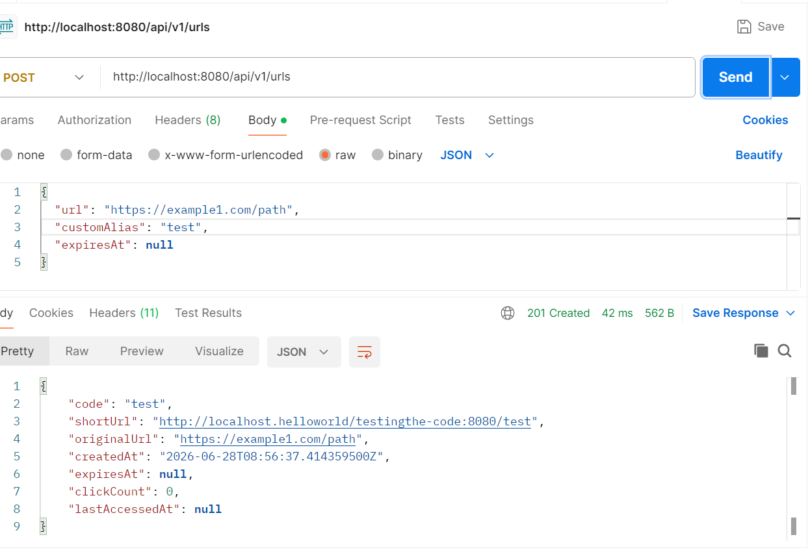
Figure 1 — POST /api/v1/urls — 201 Created response showing code, shortUrl, originalUrl, and timestamps

3.5 Conflict Response — 409 Conflict
If the requested customAlias already exists in the database, the service returns a 409 Conflict error with a descriptive message:

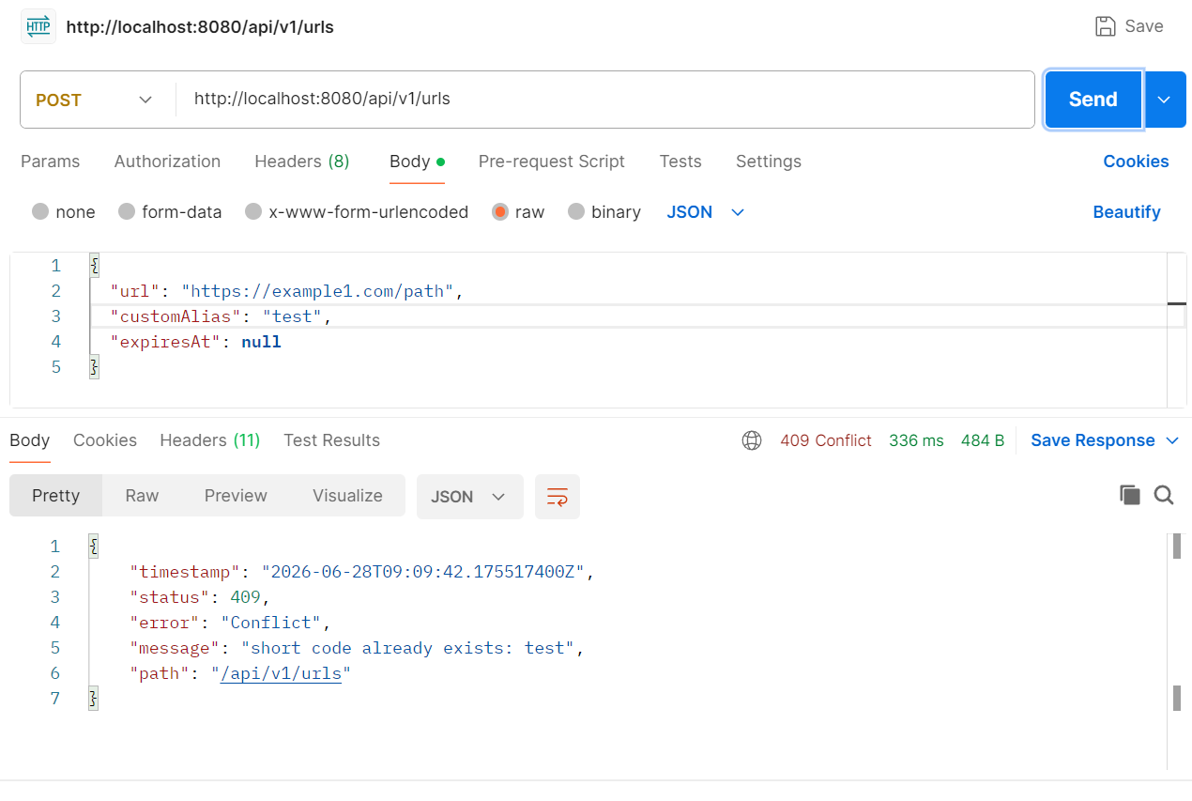
Figure 2 — POST /api/v1/urls — 409 Conflict when alias 'test' already exists

3.6 Invalid URL — 400 Bad Request
If the target URL targets a local network address (localhost, 127.x.x.x, 192.168.x.x, etc.), the UrlSafetyValidator rejects it with a 400 Bad Request:

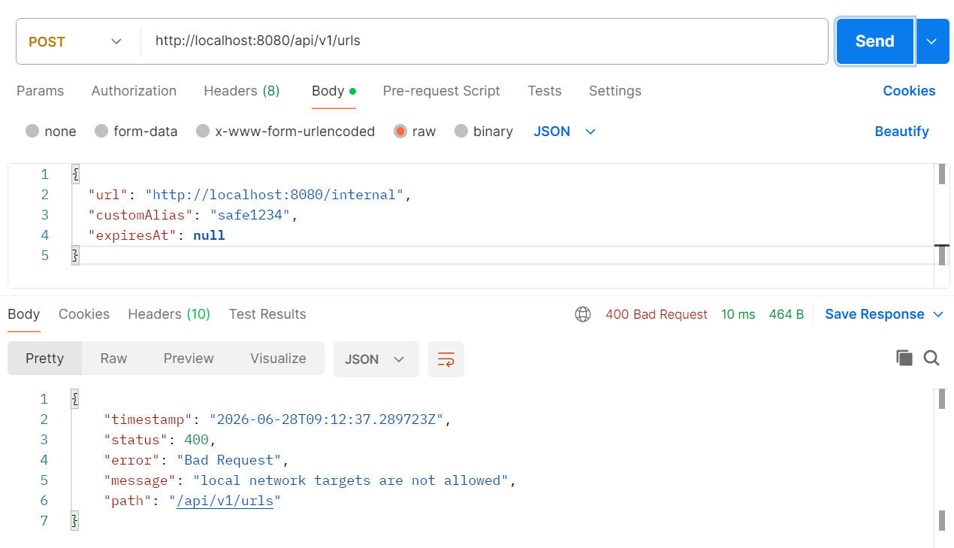
Figure 3 — POST /api/v1/urls — 400 Bad Request when URL targets a local network address

4. Database State After Creates
After successful create operations, entries are persisted in the short_urls table. The following screenshot shows the database state with two records — alpha1234 and test:

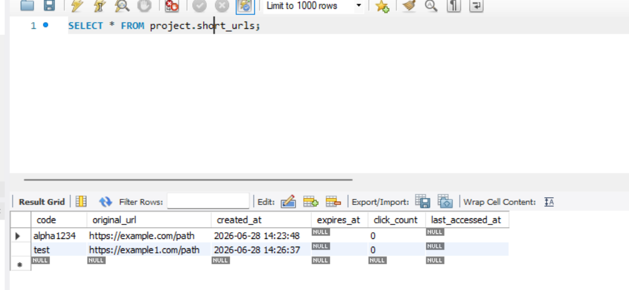
Figure 4 — MySQL Workbench: project.short_urls table showing alpha1234 and test records
Table columns:
- code — the short alias used in the URL
- original_url — the destination URL
- created_at — timestamp of creation
- expires_at — optional expiry (NULL = no expiry)
- click_count — total number of redirects
- last_accessed_at — timestamp of last redirect

5. Fetch URL Metadata

5.1 Endpoint
GET /api/v1/urls/{code}

Fetches metadata for a short URL without incrementing the click count. Useful for inspecting expiry and creation details.

5.2 Response
Returns 200 OK with the ShortUrlResponse object including shortUrl, originalUrl, createdAt, expiresAt, clickCount, and lastAccessedAt:

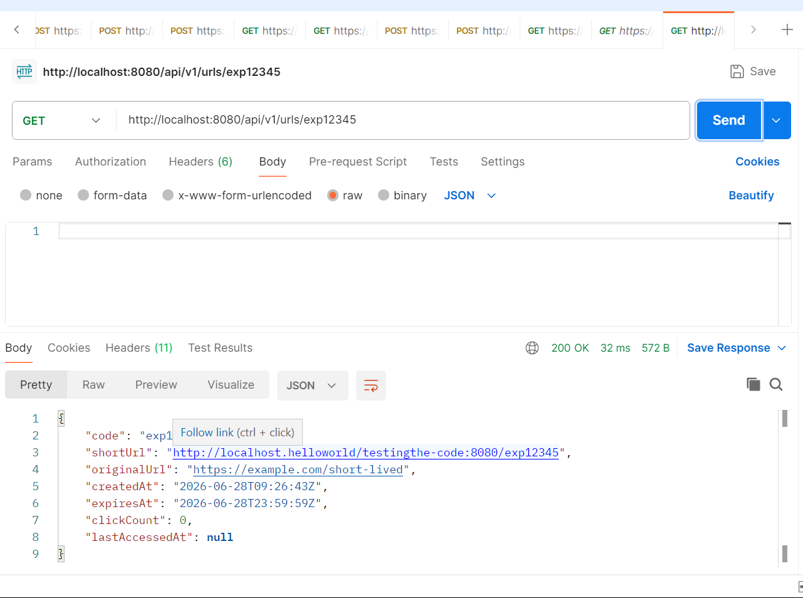
Figure 5 — GET /api/v1/urls/exp12345 — 200 OK showing metadata for a short URL with expiry set
Note: The shortUrl field uses the base URL configured in application.properties. The example above shows the misconfigured base URL (localhost.helloworld/testingthe-code:8080) which should be corrected in production.

6. Analytics

6.1 Endpoint
GET /api/v1/urls/{code}/analytics

Returns click statistics for a short URL. Unlike the metadata endpoint, this is optimized for usage analysis and includes daily click breakdown.

6.2 Response Fields
Field | Description
code | The short alias
originalUrl | The destination URL
totalClicks | Total redirect count
lastAccessedAt | Timestamp of the most recent redirect (null if never used)
dailyClicks | Map of date to click count for per-day breakdown

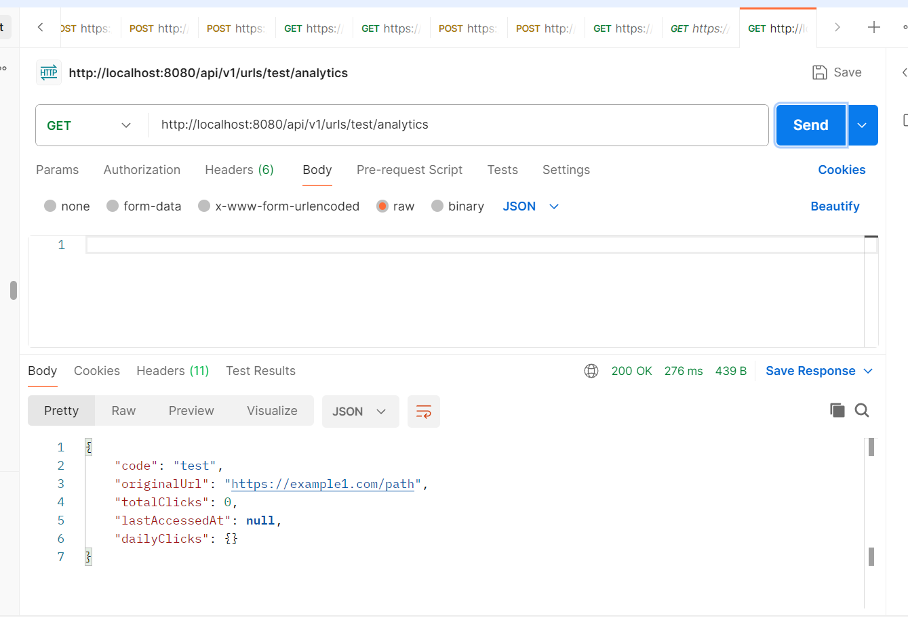
Figure 6 — GET /api/v1/urls/test/analytics — 200 OK with totalClicks, lastAccessedAt, and dailyClicks

7. Delete Short URL

7.1 Endpoint
DELETE /api/v1/urls/{code}

Permanently removes a short URL record from the database. Returns no body on success.

7.2 Flow
- Controller receives DELETE request for the given code
- Service checks whether the code exists in the repository
- If not found, returns 404 Not Found
- If found, record is deleted; controller returns 204 No Content

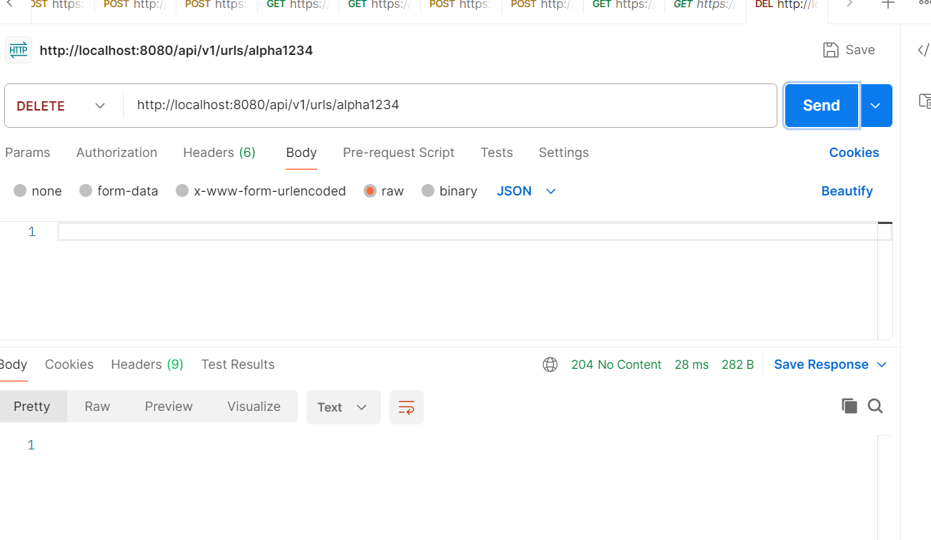
Figure 7 — DELETE /api/v1/urls/alpha1234 — 204 No Content on successful deletion

7.3 Database After Deletion
After deleting alpha1234, the short_urls table retains only the remaining record (test). The safe1234 entry visible in an earlier screenshot was also present during testing and later removed:

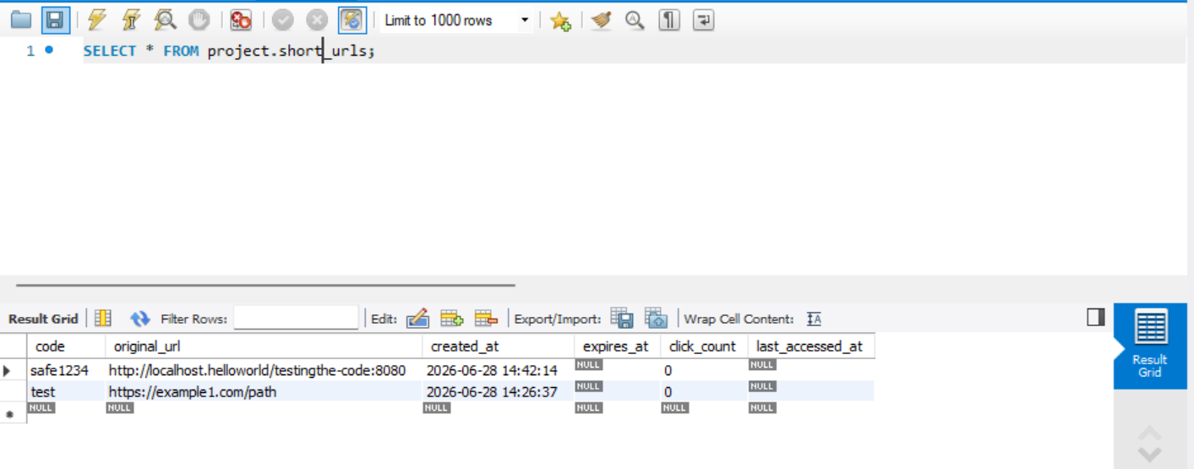
Figure 8 — Database state showing remaining records after deletion operations

8. Expiry Handling
Expiry is enforced in two ways:

8.1 On Access (Lazy Expiry)
When a user accesses an expired short URL (either via redirect or metadata fetch), the service:
- Detects that the current time is past the expiresAt timestamp
- Deletes the record from the database
- Throws ResourceExpiredException
- Client receives 410 Gone

8.2 Background Cleanup (Scheduled Job)
DefaultShortUrlService includes a scheduled task that periodically calls cleanupExpired(). The repository removes all rows where expires_at < NOW(). This ensures expired links are cleaned up even if they are never accessed again.

9. Error Handling
ApiExceptionHandler converts all exceptions into a consistent JSON error body with timestamp, status, error name, message, and path.

Status | Error | Exception | Cause
400 | Bad Request | InvalidUrlException | URL fails safety validation (private IP, localhost, bad scheme)
400 | Bad Request | Validation failure | Request body fails bean validation (blank URL, bad alias pattern)
404 | Not Found | ResourceNotFoundException | Short code does not exist in the database
409 | Conflict | ResourceConflictException | Requested customAlias is already in use
410 | Gone | ResourceExpiredException | Short URL has passed its expiresAt timestamp

10. Key Classes and Roles
Class | Role
UrlShortenerController | Handles create, lookup, analytics, and delete HTTP endpoints
RedirectController | Handles public redirect and updates click count on access
DefaultShortUrlService | Contains all business logic including expiry and cleanup scheduler
JdbcShortUrlRepository | Reads and writes ShortUrl records and analytics to the database
ShortCodeGenerator | Generates random alphanumeric short codes when no alias is provided
UrlSafetyValidator | Rejects URLs targeting localhost, private IPs, or non-http schemes
ApiExceptionHandler | Converts exceptions to structured JSON error responses
ShortUrl | Core domain object holding code, URL, expiry, and analytics data

11. Configuration Note
The application.properties currently contains an invalid base URL:
url-shortener.base-url=http://localhost.helloworld/testingthe-code:8080

This value is used to build the shortUrl field in all responses. For a local development setup it should be:
url-shortener.base-url=http://localhost:8080

The incorrect base URL is visible in several API screenshots in this document (e.g. Figure 1 and Figure 5). Update this before deploying to any environment.

