**Title:** EEG correlates of driving directions of vehicle particularly Left, Right and Straight

Few papers which use *mind control strategies for steering control* already exist. Paper 1 uses EEG signals for *steering intention* in order to judge “To steer or not!”, which needs binary classification of brain signals. Further they use camera signals to identify the actual *steering direction*. Paper 2 uses SSVEP based classification of brain signals which need the subject to pay attention to different SSVEP stimuli to steer the vehicle in Left, Right and Straight direction. Paper 3 uses a combination of EEG and EMG to determine the *steering direction*.

**Method:**

In our case, we are using three class classification of EEG signals Left, Right and Straight. In order to classify the signals, we propose the below method.

* Subjects ride an *automated vehicle* which presents few left and right turns to the subjects. The subject has to follow the Left and Right turns *visually* as they will be presented to him/her (We have chosen Automated Driving because, while performing the experiments the subjects should not do body movements)
* We gather the EEG of each subject while riding the vehicle. We used 64 channel ANT-Neuro EEG device with a sampling frequency of 512 Hz
* We save the EEG recordings with the following events of marked in **.mat** format. **How to mark the events in the simulator**?
  + Start
  + Left Turn
  + Right Turn
  + Straight - ignore
  + End
* We then extract the EEG potential for about 3 to 4 sec after each event
* We thus have following number of labelled data points
  + Number of Subjects x Number of Left Turns - These points will be labelled as 1
  + Number of Subjects x Number of Right Turns - These points will be labelled as 2
  + Number of Subjects x Number of Straight Segments - These points will be labelled as 0
* We will feed this data to CNN model
* CNN model will classify the signals for Left, Right and Straight turns

Below we have attached a diagram which demonstrates our current and future work:

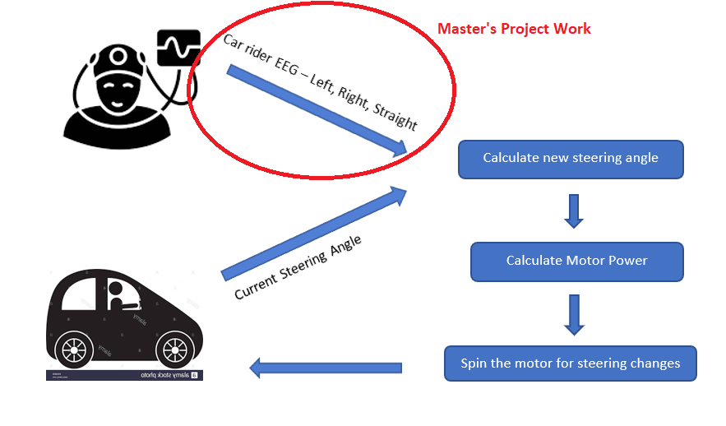

**Additional Information:**

A typical flow of events for steering will look like below:

* Maintain/Calibrate steering angle around 0, as the base position for “straight drive”
* Reduce the steering angle by 10 for each LEFT TURN and calculate new steering angle
* Increase the steering angle by 10 degrees for each RIGHT TURN and calculate new steering angle
* Based on the new steering angle, spin the motor with appropriate power
* Change the motor direction

Here, steering angle is described as shown in the below figure:

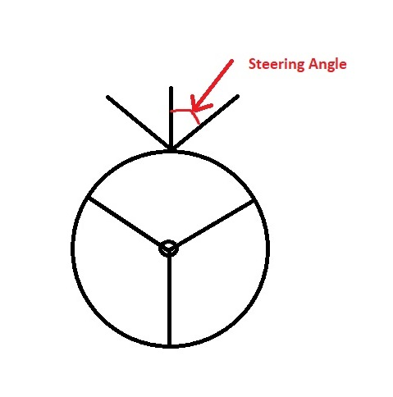

Below table describes the data for a typical **left turn** along the road:

|  |  |  |
| --- | --- | --- |
| **Car Rider EEG** | **Steering Angle** | **New Steering Angle** |
| STRAIGHT | 0 | 0 |
| STRAIGHT | 0 | 0 |
| STRAIGHT | 0 | 0 |
| STRAIGHT | 0 | 0 |
| LEFT | 0 | -10 |
| LEFT | -10 | -20 |
| LEFT | -20 | -30 |
| RIGHT | -30 | -20 |
| RIGHT | -20 | -10 |
| STRAIGHT | -10 | 0 |
| STRAIGHT | 0 | 0 |
| STRAIGHT | 0 | 0 |
| STRAIGHT | 0 | 0 |
| STRAIGHT | 0 | 0 |

Below table describes the data for a typical **right turn** along the road:

|  |  |  |
| --- | --- | --- |
| **Car Rider EEG** | **Steering Angle** | **New Steering Angle** |
| STRAIGHT | 0 | 0 |
| STRAIGHT | 0 | 0 |
| STRAIGHT | 0 | 0 |
| STRAIGHT | 0 | 0 |
| RIGHT | 0 | 10 |
| RIGHT | 10 | 20 |
| RIGHT | 20 | 30 |
| LEFT | 30 | 20 |
| LEFT | 20 | 10 |
| STRAIGHT | 10 | 0 |
| STRAIGHT | 0 | 0 |
| STRAIGHT | 0 | 0 |
| STRAIGHT | 0 | 0 |
| STRAIGHT | 0 | 0 |

**Future Results:**

**We have been given the following data:**

* 10 subjects x 4 left turn= 40 left turns data across all subjects
* 10 subjects x 4 right turns = 40 right turns data across all subjects
* Similarly we will identify 40 straight segments across all subjects
* We will have total 120 EEG segments to classify

**We will split the segments between training and testing data as follows:**

* 120 x 80/100 = 96 segments will be training segments in order to train the model
* 120 - 96 = 24 segments will be testing segments in order to get model predictions

**Finally, we will showcase the below results:**

* Categorizing/Predicting 24 testing segments with 80% accuracy. Hence, 20 segments should be classified properly as Left, Right or straight segments

**Plan for Experiments and Results:**

This plan is subjected to getting the *trigger setup* ready

1. Get the EEG recordings for 10 subjects – 30 days (Aug 15, 2022 to Sep 15, 2022)
2. Train the model – 15 days (Sep 15, 2022 to Sep 30, 2022)
3. Test and retrain the model if required – 15 days (Oct 1, 2022 to Oct 15, 2022)

I am assuming that we can spend nearly 2 hours per day for the project. **The dates mentioned are tentative.**

**Notes:**

* We are going to work ONLY UPTO classification phase for Master’s project work. The deployment of model and the actual steering will not be done in this semester
* We will consider the data for around 10 subjects for this project

**References:**

Paper 1 - [(PDF) Mind Controlled Electric Power Steering (researchgate.net)](https://www.researchgate.net/publication/345246533_Mind_Controlled_Electric_Power_Steering)

Paper 2 - [(PDF) Queuing Network Modeling of Driver EEG Signals-Based Steering Control (researchgate.net)](https://www.researchgate.net/publication/308784645_Queuing_Network_Modeling_of_Driver_EEG_Signals-Based_Steering_Control)

Paper 3 - [EEG–EMG coupling as a hybrid method for steering detection in car driving settings | SpringerLink](https://link.springer.com/article/10.1007/s11571-021-09776-w)

Paper 4 - [(PDF) A graphical user interface for infant ERP analysis (researchgate.net)](https://www.researchgate.net/publication/258447333_A_graphical_user_interface_for_infant_ERP_analysis)