PROJECT AND TEAM INFORMATION

Project Title
Skill Bridge : Smart Career & Skill Gap Analysis System

Student/TeamInformation

TeamName: SKILL-GRID | IJP-V-2026-T091
Teammember 1 (TeamLead) | Swati–  24152218  swatirajput0128@gmail.com
Teammember 1 (TeamLead) |  | 
Teammember 2 | Vidhi–24152031    vidhisharma536@gmail.com
Teammember 3 | Paritosh –24151187  paritoshonly01@gma il.com
Teammember 3 |  | 

PROPOSAL DESCRIPTION(10pts)

Motivation(1pt)
Skill Bridge is a Java-based project aimed to create a bridge between students’ skills and their desired career. The user will be able to enter the skills that he/she possesses and choose the desired career path; the application will compare these two aspects and inform the user about his/her skill match percentage, missing skills, and advice on what to do next. The project will use the principles of client-server technology to ensure that every student can use the tool, while multithreading will be employed to ensure multiple requests are handled accurately. The overall objective of the project is to facilitate career mapping and skill management among students.

State of the Art/Current solution(1pt)
Currently, students can use career guidance websites, skill assessment websites, online learning websites, and job portals to research career requirements. Such portals offer career guidance, information on required skills and courses, job descriptions, and other services. Some of these portals allow students to take skill assessments and offer career recommendations. However, students may find it necessary to use different portals for different purposes, and the information provided may not be in the form of a simple comparison. SkillBridge takes a different approach from such existing products by focusing on a streamlined interface where the user can enter information regarding their skills, select a profession, and compare their skills, receive suggestions and recommendations.

Project Goals and Milestones(2pts)
The key idea behind the development of the system is its ability to allow users to identify the skills required for their desired position and determine their level of proficiency in these skills. The application will provide a simple skill matching percentage and some suggestions on improving skills. Initial Milestones Finalize project requirements and career categories.
Design the basic elements of the system and its interface, establish the connection between the client and the server, define the basic algorithm of the skill comparator. Further Milestones Develop multithreading for multiple clients, add the necessary data about careers and skills, finalize match and suggestion algorithms, connect front-end and back-end. Testing the work of the application with multiple clients, editing the final version of the interface, documentation, and presentation.

Project Approach(3pts)
We intend to develop SkillBridge as a java based application which enables the students to determine the required skills for the desired career. The software will be designed using a simple interface where the users will state their skills and select the desired career. Java socket programming will be utilized to enable the communication between the client and the server. The information provided by the student in the client interface will be sent to the server through socket programming. In the server, the information provided by the student will be compared to the data of the required skills for the selected career. The server will also calculate the percentage match of the student’s skills against the required skills, and indicate the deficient skills. Using multithreading, multiple students will be able to access the application at the same time. The results from the server will then be sent to the client interface to display the information. Some of the technologies that will be used to develop this application include;
Technologies
Java Socket Programming
Client-Server Architecture
Multithreading
MySQL

SystemArchitecture(HighLevelDiagram)(2pts)
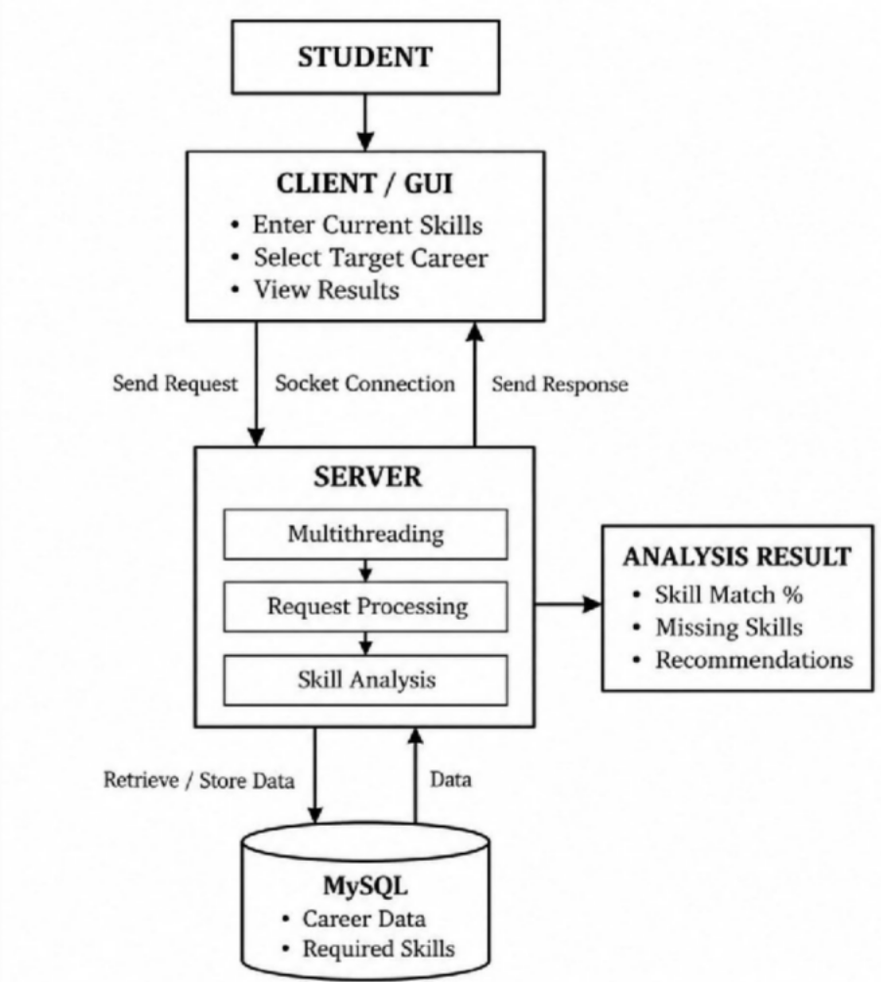

Project Outcome/Deliverables(1pts)
The primary output of the SkillBridge is the working Java-based skill gap analysis system for students. The product will allow users to enter their current skill level and desired career, compare it to the necessary skills, and calculate the percentage of the skill gap.
Main Deliverables
1.User-friendly client interface
2.Client-server communication
3.Multithreading for the multiple users
4.Career and skill database
5.Skill match percentage

Assumptions
The project uses the students’ current skills accurately and chooses the right career for them. For our first project version, we will create a list of the given careers and their required skills. The skills analysis feature will be based on this data. We suppose that the user will be able to have a computer and internet connection for client-server interaction. Our system will mainly focus on fundamental skill gap analysis and offer some recommendations instead of providing the whole career or job placement service.

References
Oracle Java Documentation
https://docs.oracle.com/en/java/
Java Socket Programming Documentation
https://docs.oracle.com/en/java/javase/26/docs/api/java.base/java/net/Socket.html
Java Thread Documentation
https://docs.oracle.com/en/java/javase/26/docs/api/java.base/java/lang/Thread.html
MySQL Documentation
https://dev.mysql.com/doc/
GeeksforGeeks – Java Networking
https://www.geeksforgeeks.org/java/socket-programming-in-java/
Java Networking and Multithreading Learning Resources
https://www.geeksforgeeks.org/java/java-networking/

