ShopNest Store

1. **Top Categories by Total Price**  
     
   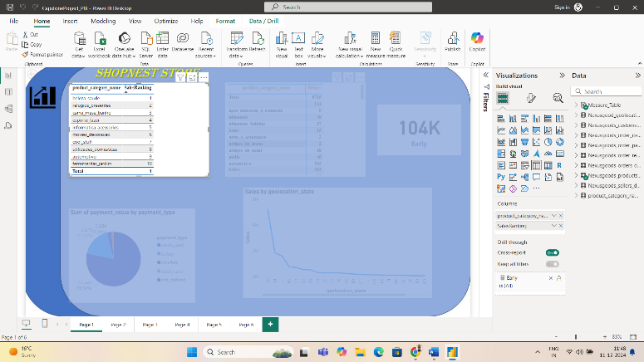   
   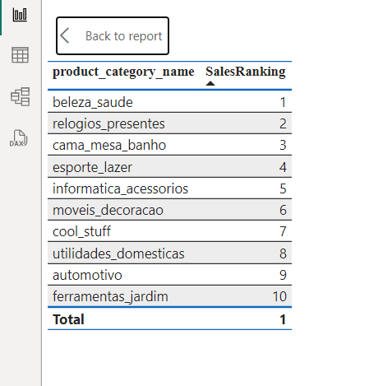  
     
   We get sales on summing up the price. We then apply RANKX function and Filter to further filter ranks to Top 10 only. Thus, we see our top selling product categories by total price.
2. **Delayed Order Analysis  
     
   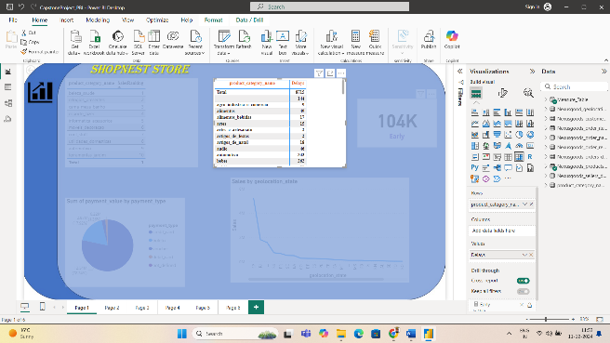 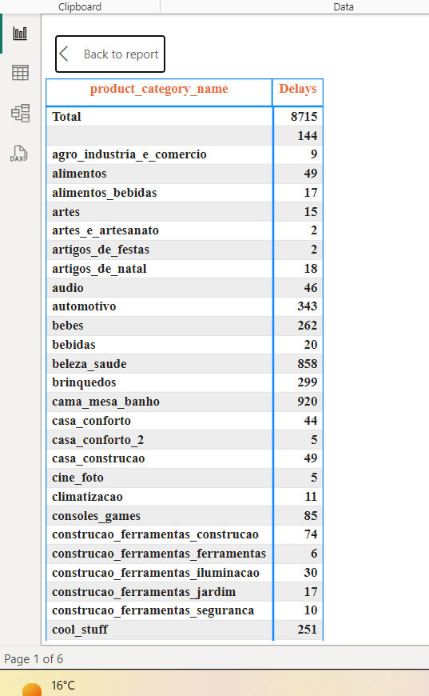**The second tile on the dashboard shows us the No of delays in our product delivery based on product category.  
     
   By identifying which category products have maximum delays we can identify if there is an issue with delivery partner or in supply chain due to which these products are frequently getting delayed. As delayed products can lead to customer dissatisfaction.
3. **Monthly Comparison of Delayed and On-Time orders  
     
   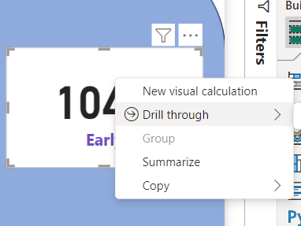  
     
   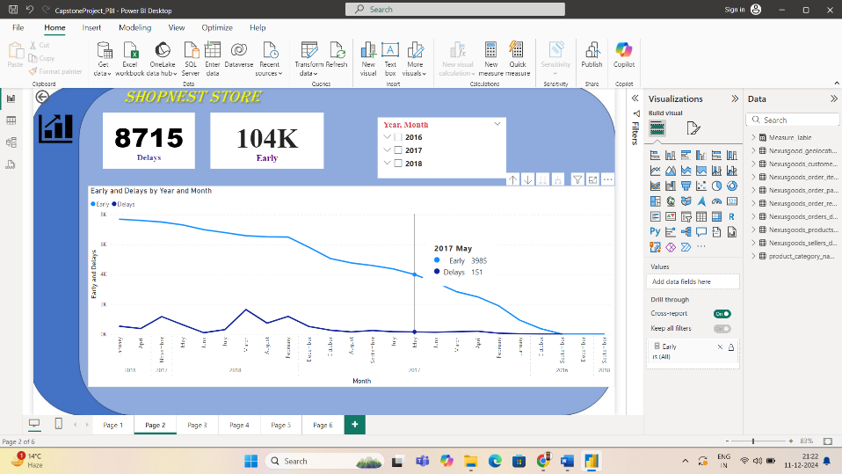**We Apply Early orders card which is drilled through further to a detailed report where we compare the early orders and delayed orders. We also apply various filters on it like year and month so we can further analyse which month sees maximum delays.   
     
   On realising this we can identify reasons why the delays are seen. Is it because of too many orders or is it because of some issue in the supply chain.
4. **Payment Method Analysis  
     
   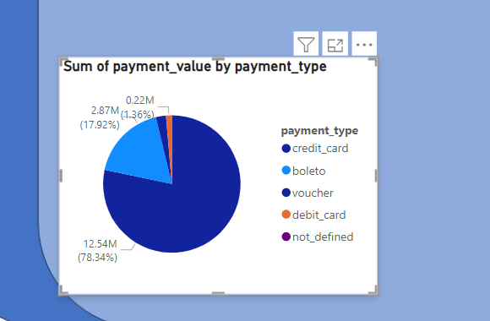**A visual representation of payment type and value. This helps us identify which payment method generates maximum revenue for us. This is helpful for the organisation during the time of giving offers. As we can see here credit card payments are the main source of revenue generation for ShopNest Store.
5. **Product Rating Analysis  
     
   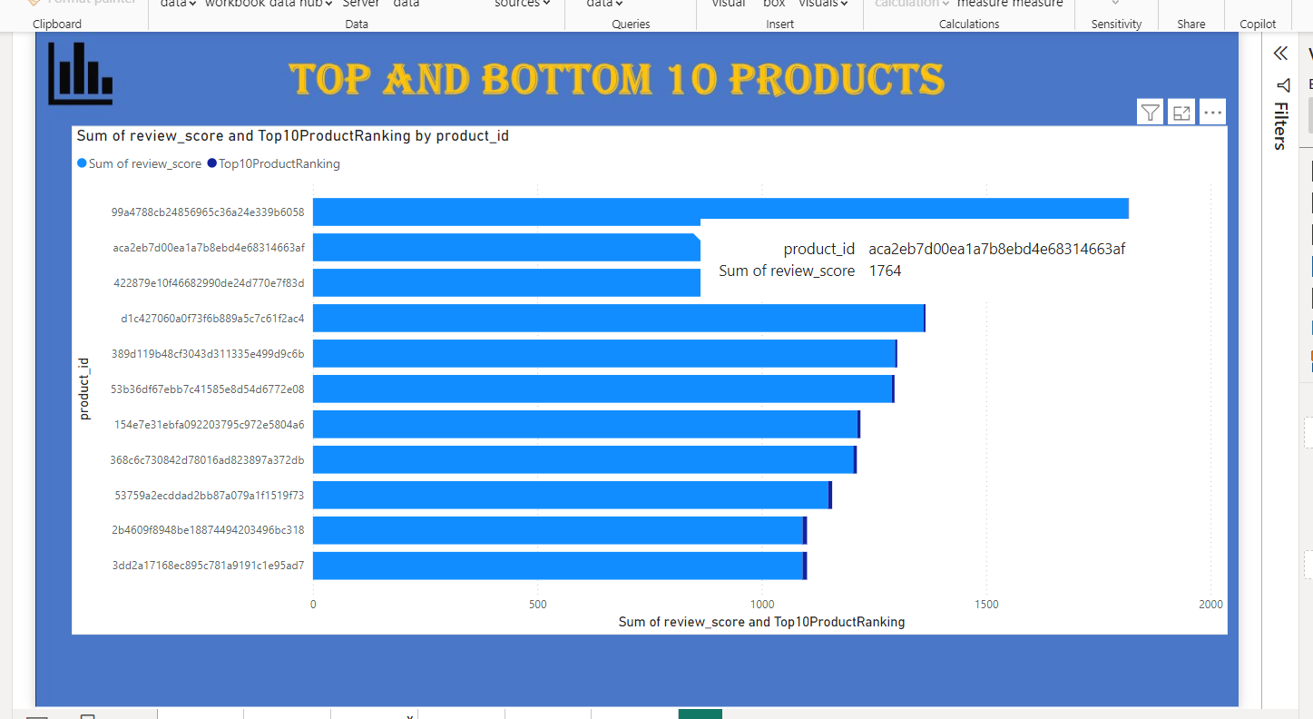**This graph shows Top 10 products based on rating reviews. It shows which are the cream products which are highly rated. It helps us to be in stock for such products/ boost their sale more.  
     
   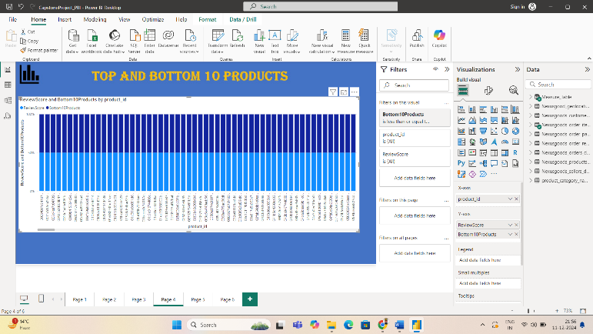   
     
   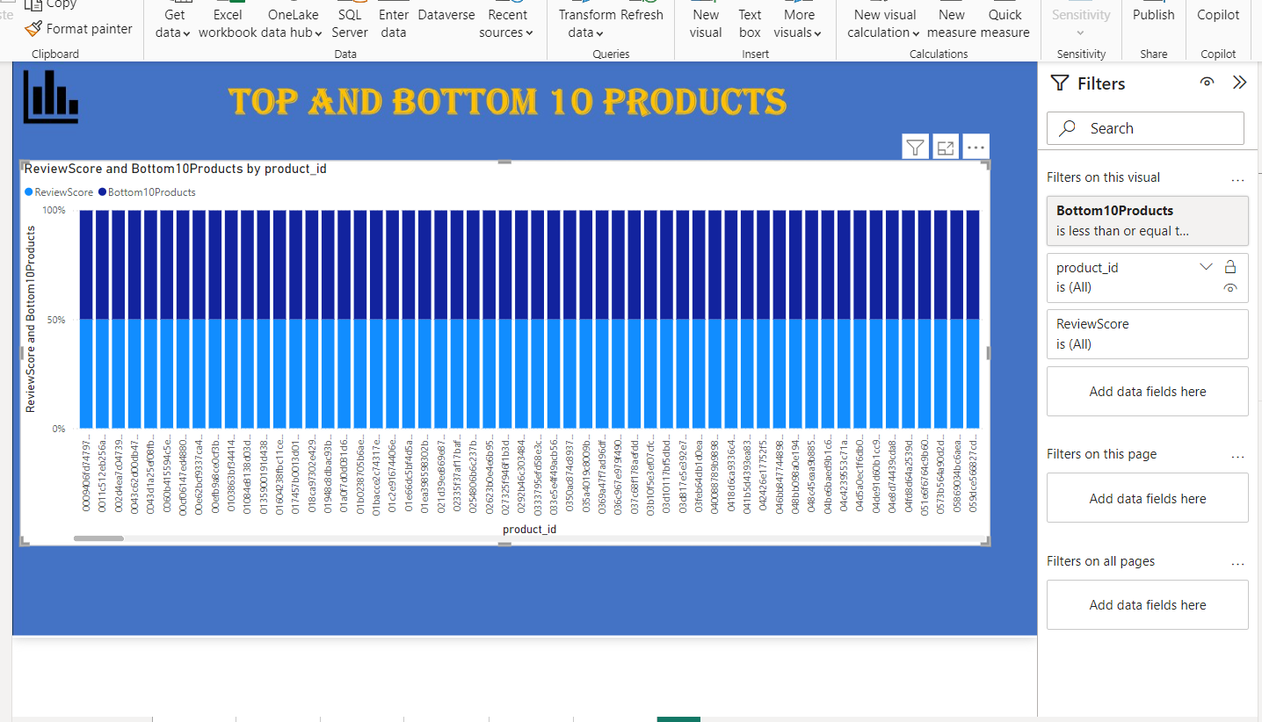  
     
   Here are bottom 10 products. Since there are no of products that are very low rated we apply filter each time to see which product ranks 2nd, 3rd and so on to understand review score and products.   
     
   Low scoring products needs to be scrutinised whether it is a quality issue or time issue or stock availability issue or money is the problem. This helps in analysing why the product is lowly rated and re organise our marketing strategies for these products to improve their score and sales.   
     
   It might also happen that some marketing campaigns are running and exhausting our cost but there is no review score improvement. In such situations we can remove the product from our stocks or warehouse in turn increasing more sold product quantity or introducing new product in the store house.
6. **State-wise Sales Analysis**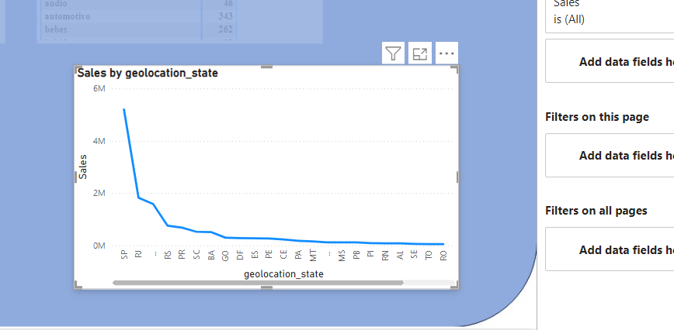This graph on the dashboard shows state-wise sales. This can further be drilled yearly, monthly, and quarterly to see which state sees how much of sales.   
     
   This helps us to identify where we are going good and strong and where we need to work more to do better. We can also identify the issues in our funnel or supply chain and eradicate them to perform better.
7. **Seasonal Sales Pattern**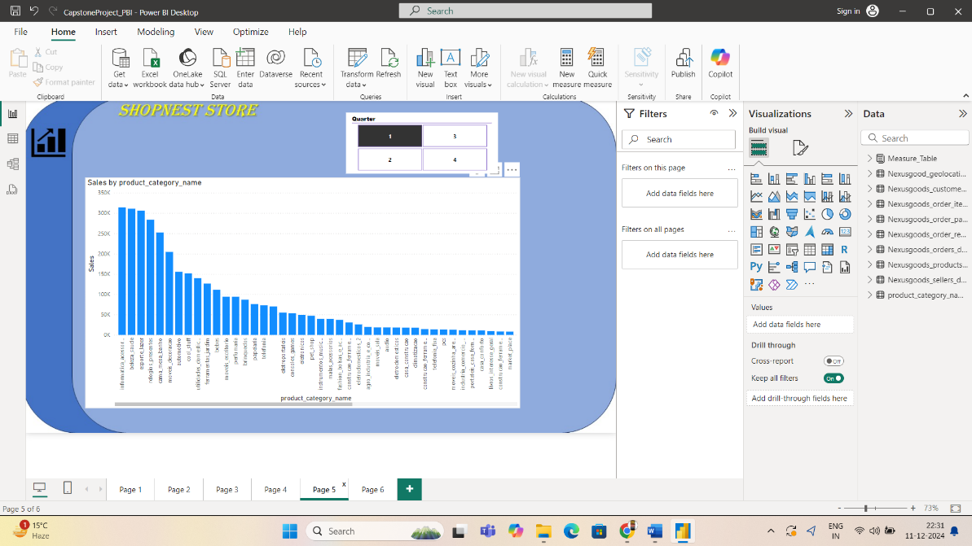This is a quarterly analysis. Here we see which product is sold maximum in which quarters. This help us identify seasonal patterns.  
     
   It helps identifying whether products are sold maximum during sales or whether festivities. It also helps us identifying if there is a downfall in the revenue and since how long that downfall is persistent to identify issues and correct them.
8. **Revenue Analysis   
     
   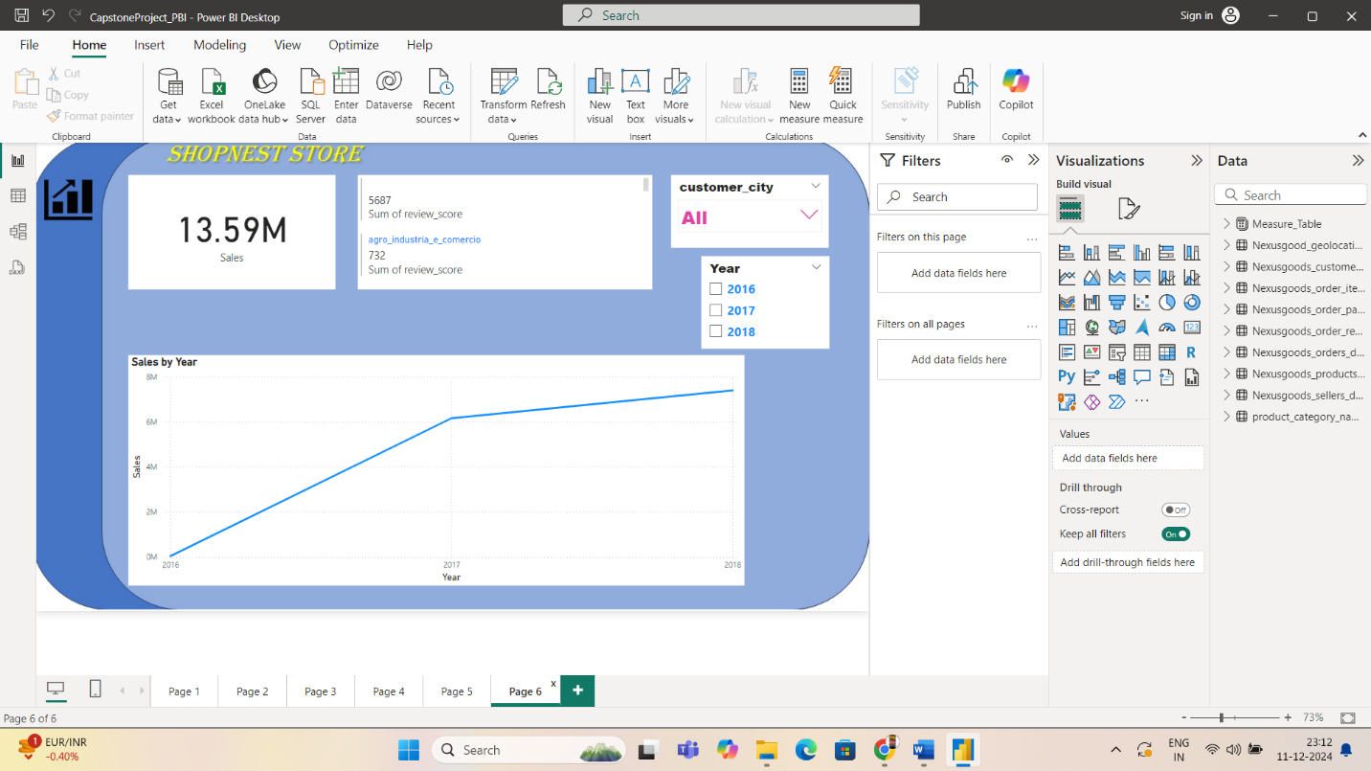**The dashboard does a comprehensive study on Sales over the years.   
     
   We filter our sales through years, cities, Review Score and see which city has maximum sales over the years and where the sales has either gone down or has minutely increased to work more on that areas.