How to run the project:

1. Step 1: Download the zip folder of source file

This folder contains:

* 1. 9 python modules
  2. Disease List – a text file
  3. AALaunchProject.py is the module that will call other modules .
  4. Open the cmd in the folder by shift+ right click on the src folder and then click open command prompt here.

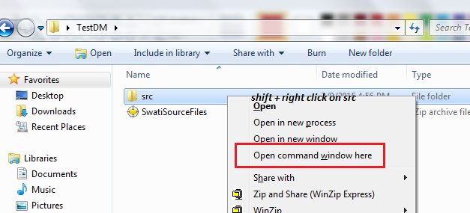

* 1. Launch AALaunchProject.py

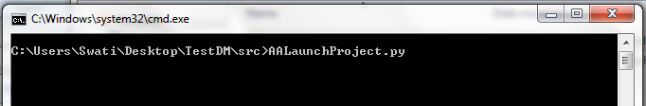

1. Step 2: please input the directory path to data files on prompted :

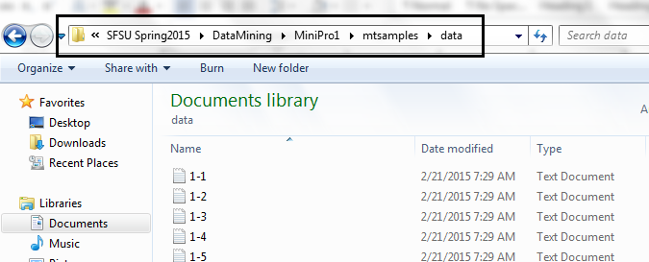

1. Step 3: Input 2: Create an empty folder and when prompted “Enter OutPut directory:” Please put the path of the folder where results can be stored.

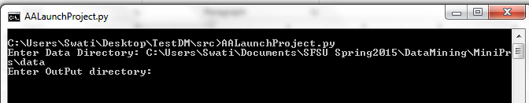

1. Step 4: Let the Program run, the prompts on the command window will display messages and steps complete. Total six steps will be run and output directory will be displayed at the end.

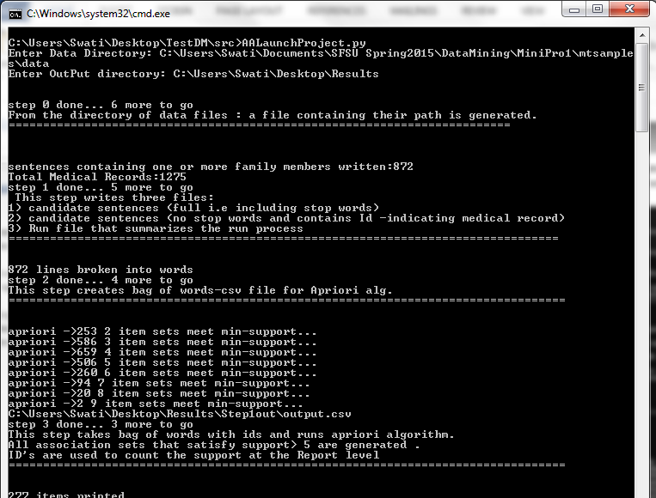

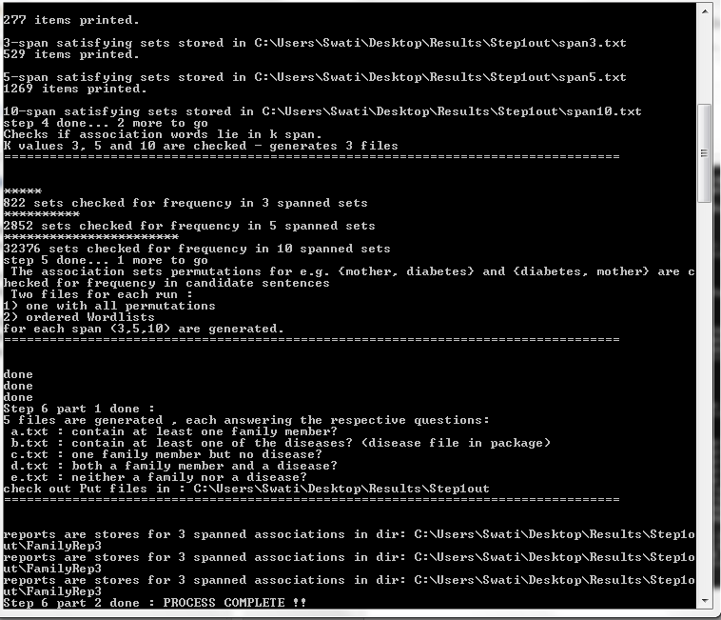

Note : Step 5 may take upto 10 minutes to complete, I have added visual cues like “\*” to hint the progress.